CS550 Assignment 4

1. Write a constraint satisfaction problem specification for a 4-color map problem with colors: pink, green, blue, and red as per the following map:

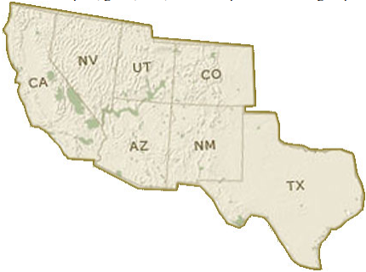

X = {CA,NV,UT,AZ,NM,CO,TX}

D = {Pink,Green,Blue,Red}

C = {CA≠NV, CA≠AZ, NV≠UT, NV≠AZ, UT≠CO, UT≠NM,

UT≠AZ, AZ≠NM, AZ≠CO, , CO≠ NM, NM≠TX}

1. Given the vehicle assembly example given in slides 7-9, draw the constraint graph.
2. Explain in your own words how conflict-directed backjumping works. As always, be very careful to avoid plagiarizing.
   1. Conflict-directed backjumping uses a conflict set of certain constraints that have values consistent with the preceding variables plus any subsequent variables. With this set, we know how far back to jump so we don’t waste time checking failed branches that the normal backjump algorithm may cause when certain constraints have values consistent with preceding assigned variables.