CS550 Assignment 5

1. Compute the empirical distribution of the three types of irises in the iris dataset (see part II). Using the empirical distribution, compute the entropy of the iris species.
   1. Each species => (1/150) (50) = 1/3 = 33.3%
   2. Plug in entropy EQ: -1/3 log( 1/3 – (1 - 2/3)) log (1 – 1/3)
   3. -1/3 log (2/3) = 0.0587
2. Regularization is very likely to result in a learner not learning the training data as well, yet it is an important component of machine learning algorithms. What is regularization and why is it important?
   1. Regularization is the process of looking for regular, or simpler, hypotheses rather than complex ones. It is important because having simpler hypotheses to process will minimize empirical loss, which strengthens the learning process.
3. Assume the following knowledge base:

*nutrients ∧ water ∧ sun ⇒ flower*

*flower ∧ pollinator ⇒ fruit*

*bat ∨ bird ∨ bee ⇒ pollinator*

*irrigation ⇒ water*

and the current set of facts:

*irrigation ∧ nutrients ∧ sun ∧ bat*

Without using the resolution rule, prove that fruit will be borne.

Irrigation 🡪 (water) ∧ nutrients ∧ sun ∧ bat

Bat 🡪 (water ∧ nutrients ∧ sun) ∧ (pollinator)

Flower ∧ pollinator 🡪 fruit

1. Given the wumpus world of Figure 7.2 from your book where position (x, y) denotes the cave in column x, row y (e.g. wumpus is at 1,3):

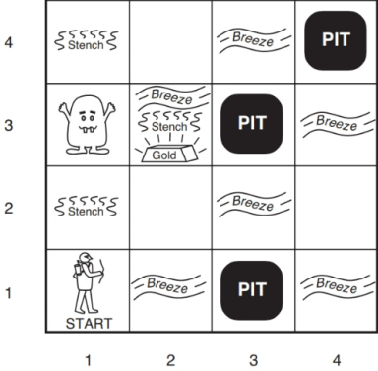

* 1. What are the percepts for an agent at 2,3?
     1. Stench, Breeze, Glittery
  2. Write a set of logical sentences (see section 7.4.3) that describe the predicates that can be inferred by percepts at 2,3. Do not include knowledge from any other position that could infer more details.
     1. B2,3 ⬄ (P22,P24,P13,P33)
     2. S2,3 ⬄ (W22,W24,W13,W33)
     3. G2,3 ⇒ Grab gold and go home

1. In addition to what we know about the starting conditions of a wumpus world, assume that a stench has been observed at locations (2,1) and (1,2). Write the knowledge base in conjunctive normal form and show whether or not the question W2,2 (there is a wumpus at location 2,2) is entailed by the knowledge base using the resolution rule.

