RPS Inverted Game Design Document

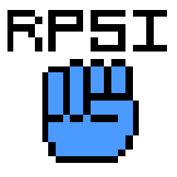

***‘Be the victor of this inversion’*** – Alexander Giang

Table of Contents and Team Member Listing

|  |  |  |
| --- | --- | --- |
| Table of Contents  [1 Game Overview](https://n-xovwktmtjsnaxyc2mwes2xu7pohqedmdm6zjw5q-2lu-script.googleusercontent.com/userCodeAppPanel)  [2 High Concept](https://n-xovwktmtjsnaxyc2mwes2xu7pohqedmdm6zjw5q-2lu-script.googleusercontent.com/userCodeAppPanel)/Synopsis  [3 Game Objectives](https://n-xovwktmtjsnaxyc2mwes2xu7pohqedmdm6zjw5q-2lu-script.googleusercontent.com/userCodeAppPanel)  [4 Game Rules](https://n-xovwktmtjsnaxyc2mwes2xu7pohqedmdm6zjw5q-2lu-script.googleusercontent.com/userCodeAppPanel)  [5 Game Play](https://n-xovwktmtjsnaxyc2mwes2xu7pohqedmdm6zjw5q-2lu-script.googleusercontent.com/userCodeAppPanel)  [6 Art](https://n-xovwktmtjsnaxyc2mwes2xu7pohqedmdm6zjw5q-2lu-script.googleusercontent.com/userCodeAppPanel)  [7.1 Audio](https://n-xovwktmtjsnaxyc2mwes2xu7pohqedmdm6zjw5q-2lu-script.googleusercontent.com/userCodeAppPanel)  [7.2 What](https://n-xovwktmtjsnaxyc2mwes2xu7pohqedmdm6zjw5q-2lu-script.googleusercontent.com/userCodeAppPanel) I Developed     |  | | --- | |  | | Game Development Team Members    PRODUCER  Alexander Giang    PRODUCTION MANAGER  Alexander Giang    PRODUCTION COORDINATOR  Alexander Giang  GAME DESIGNERS  Alexander Giang  SYSTEMS/IT COORDINATOR  Alexander Giang  PROGRAMMERS  Alexander Giang  TECHNICAL ARTISTS  Alexander Giang  AUDIO ENGINEERS  Alexander Giang  UX TESTERS  Alexander Giang |

|  |
| --- |
|  |

# 1 Game Overview

**Title**: RPS Inverted

**Platform**: PC Standalone + iOS & Android

**Genre**: Mind game/Brainteaser

**Rating**: E for Everyone

**Target**: Casual gamer

**Release date**: TBD

**Publisher**: Unity Technologies

RPS Inverted is a simple brain teaser game of Rock-Paper-Scissors, except the rules are reversed than the game people usually grow up playing. The Player must lose, according to the rules we play in real life, to gain points as the time they must react gets shorter and shorter. There is a possibility to beat the system, since time does not get shorter forever, but players can find out for themselves when they play the game.

# 2 High Concept/Synopsis

Players fight with their minds to beat the normal rules of Rock-Paper Scissors by losing to win.

# 3 Game Objectives

Players must react faster and faster to get more points and ultimately beat the system.

# 4 Game Rules

The main rules are: Rock beats Paper, Paper beats Scissors, and Scissors beats Rock. To ultimately beat the system, you must be able to react within a short amount of time once you hit the last round.

# 5 Game Play

Players can use their mouse to left-click on the hand they wish to play. If they have a touchscreen, they can also use that to play the desired hand.

Game Controls

Choose hand

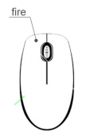

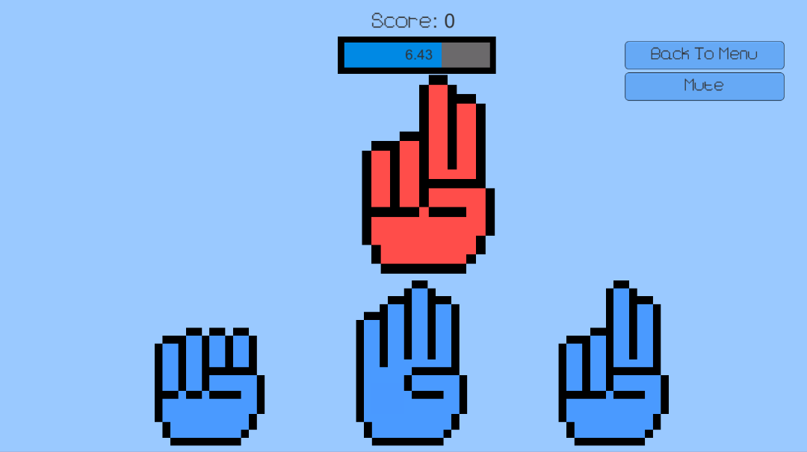UI

Time Bar

ENEMY HAND

Indicates the hand the Player must “lose” against.

Enemy Hand

PLAYER HANDS

These are the hands that the Player can choose from.

TIME BAR

Displays how much time the Player must choose a hand.

Player Hands

# 6 Art

## 6.1 Audio

|  |  |  |
| --- | --- | --- |
| **NAME** | **CATEGORY** | **DESCRIPTION** |
| BGM | Background Music | Always playing |
| WinSound | FX | Player chooses winning hand |
| LoseSound | FX | Player chooses losing hand |

6.2 What I Developed

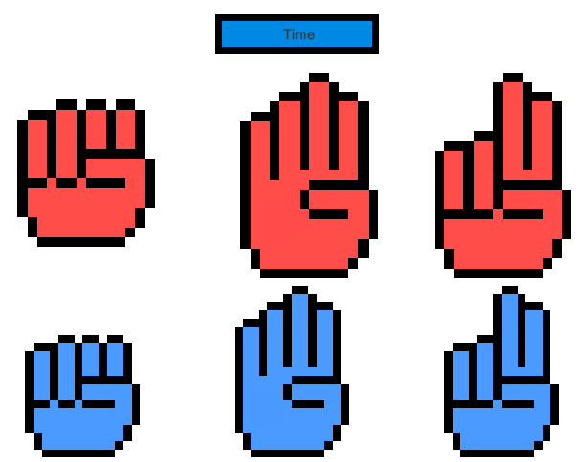

All the sprites were created using Piskel.