Adam Gibbs
6/6/2020
IT FDN 100 A Sp 20: Foundations of Programming: Python
Assignment 08

https://github.com/agibbs-uscg/IntroToProg-Python-Mod08

Use of Classes in Python

Introduction
This paper will discuss how to create a python script in Pycharm using custom classes. Classes are a way to organized functions and have several advanced features. Within a class, variables and constants are called fields. Functions are called methods. Classes typically have Fields, Constructors, Properties, and Methods. Constructors are methods often used to set the initial values of field data. Properties are functions used to manage field or attribute data. Each field of attribute usually had two properties, one to get the data and one to set the data.
The script for this module will use these structures within classes to store and recall input from a user to a file and back to the user. The user can save the data to file if they wish.
Class Product
The first class in my script is the “Product” class. This class sets the initial properties of my variables ‘product_name’ and ‘product_price’. I use the __init__ function to set the initial values within the constructor. I then use properties to get and set the values for these variables. Figure 1. Shows this set of script with my class ‘Product’.
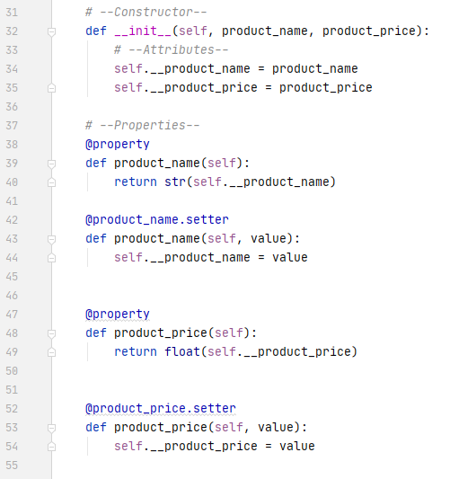
Figure 1.
Class FileProcessor
My next class is called ‘FileProcessor’. This class is used hold methods that allow data to be written to or read from a file. It also contains a method that appends a list stored in memory. The read data methos opens a saved .txt file, assigns each product + price to a dictionary called row, and appends a table called list_or_product_objects. It then closed the file. This newly created list_or_product_objects is now in memory and ready for use, see Figure 2. The write file method writes the table currently saved in memory to a .txt file. This function opens the file and writes the table in rows, with each row having a product, comma, price, and character turn.
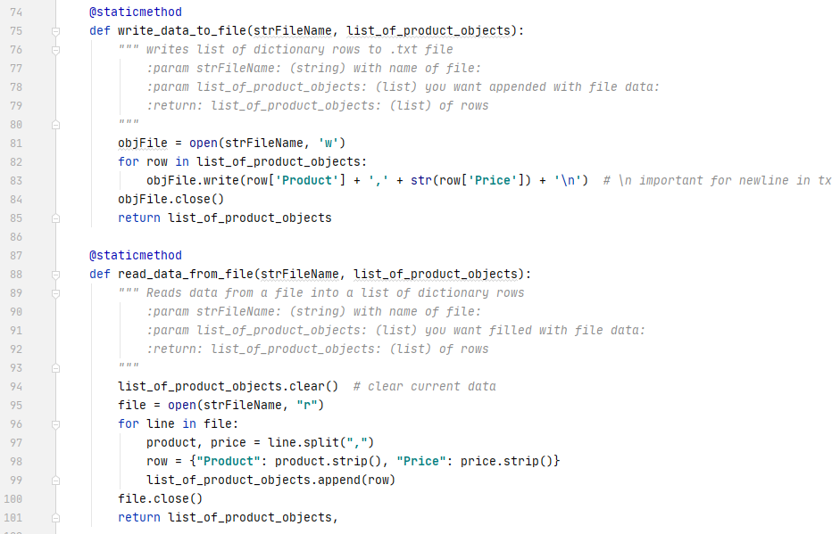
Figure 2.
The final method under class ‘FileProcessor’ adds new products and prices to the list when called. This function has parameters procduct_name, product_price and list_of_product_objects. The first two parameters are defined in a later class and methods through user input while the list_of_product_objects is the table in memory that was created earlier. I used the ‘append’ tool to append the current list with the new input as shown in Figure 3.
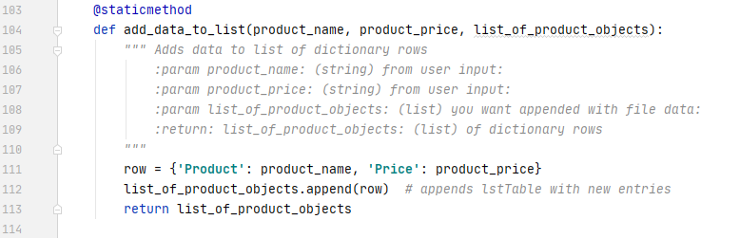
Figure 3.
Class IO
My final class is called ‘IO’. This class holds methods that either take in input for the user or present data back to the user. The print_menu_Tasks function uses the print tool to display a menu of options when called. The Input_menu_choice function uses input to prompt the user to choose a menu option. The print_current_Products_in_list function has parameter ‘list_of_product_objects’ and displays this table in rows with a product and price in each row. Figure 4 show the script for these three functions.
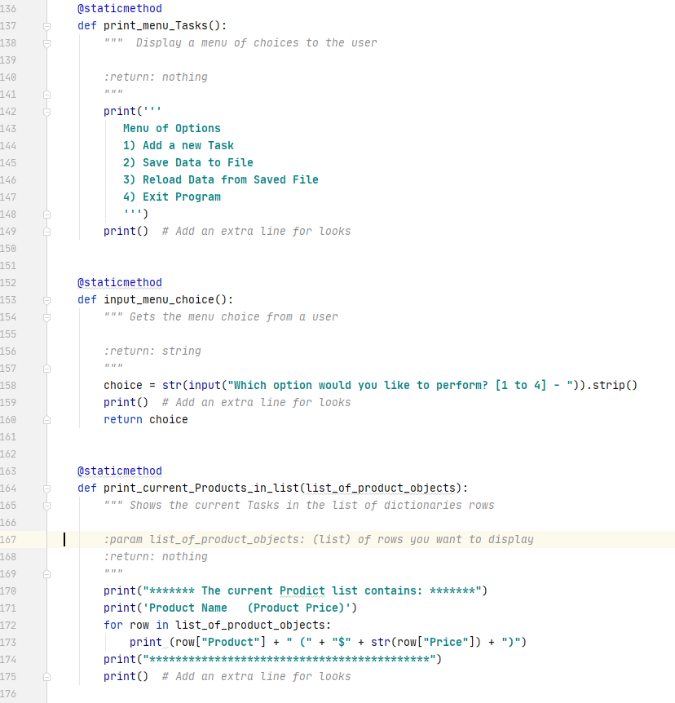
Figure 4.
Next, the input_yes_no_message asks the user to input a y or n. the input_press_to_continue method prompts the user to hit the enter key before moving on in the script. This is shown in Figure 5. Finally, the input_new_product_and_price method asked for the user to input a new product with its price. These inputs set the values for variables product_name and product_price.
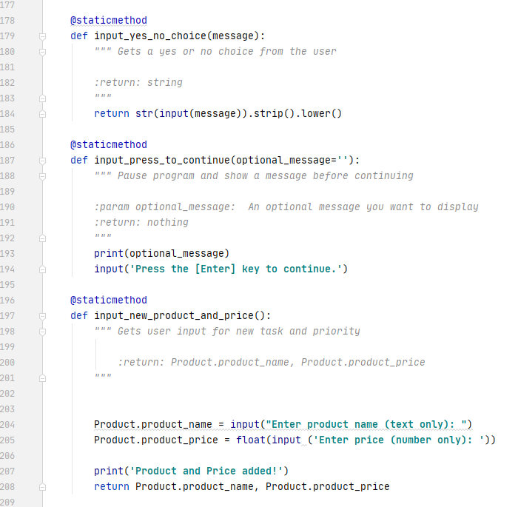
Figure 5.
Main Body of Script
With these classes and methods set, I then move to the body of the script. First, the script calls for function read_data_from_file in class ‘FileProcessor’. This, as discussed above, reads data from a file and creates a table in memory. The remainder of the script is a ‘while’ loop that continues to run until the user asks to exit. The loop first calls for the display of the current list, followed by the menu and finally the prompt for the user to choose from the menu. This is accomplished by calling for functions print_current_Products_in_list, print_menu_Tasks, and input_menu_choice which are all in the class ‘IO’ (shown in Figure 6.). This will display upon completion for each ‘if’ statement until exited.
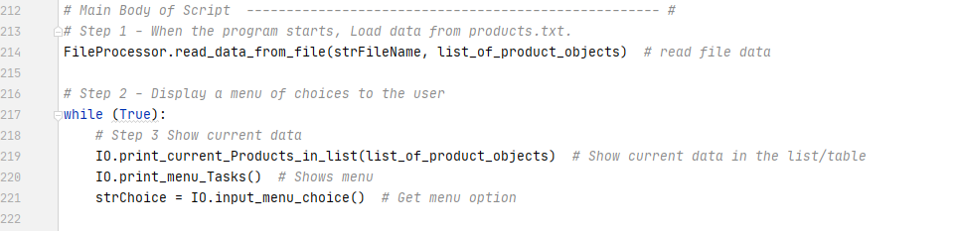
Figure 6.
A series of ‘If’ statements follows corresponding to the menu choice by the user. Each if statement ends with the input_press_to_continue method to prompt the user to hit enter to continue the script. Choice 1 calls the functions input_new_Product and price and add_data_to_list. Choice 2 calls the methods IO.input_yes_no_choice. A nested ‘If’ statement then calls function write_data_to_file if the user answered ‘y’ or function input_press_to_continue is the user enter anything but ‘y’. If the user chooses 3, the script warns the user that reloading the data will delete unsaved data the calls function input_yes_no_choice. A nested ‘If’ statement then calls functions read_data_from_file, print_current_products_in_list, and input_press_to_continue if the user types ‘y’. If the user types anything else the script calls function input_press_to_continue with the message ‘File Reload Cancelled’. A choice of 4 will simply exit the loop and close the script. If the user types anything but 1-4, a statement prints that they must choose from the menu. This is accomplished with an ‘else’ statement at the end of the script. See Figure 7.
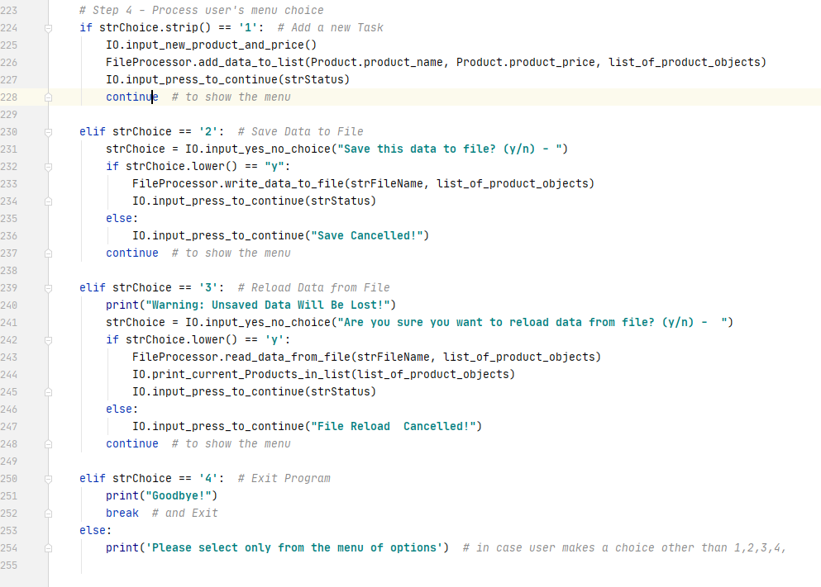
Figure 7.
Running the Script
Figure 8. and Figure 9. below shows the script running in Pycharm. While running this script you will see what is already listed in the file. I will then add a product named eggs with a price of 3. The new list will show on the screen. I will save the list to the file and exit.
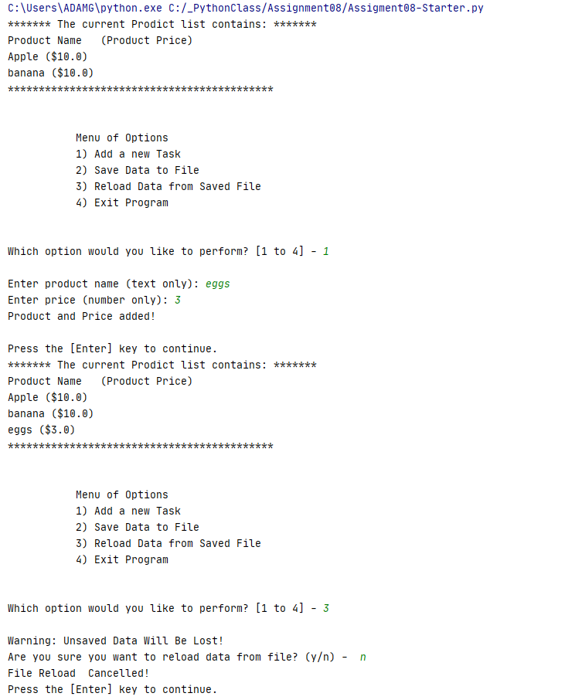
Figure 8.
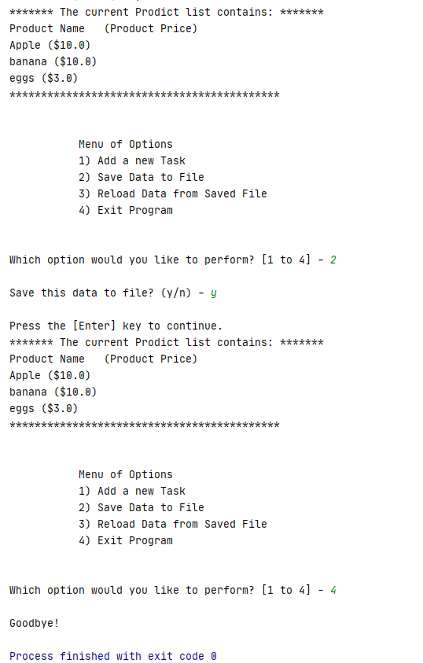
Figure 9.
Figure 10. shows the newly created .txt file after running the script.
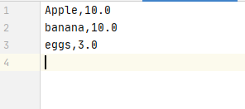
Figure 10.

Figure 11. below shows the script running in cmd. While running this script you will see what is already listed in the file. I will then add a product named flour with a price of 8. The new list will show on the screen. I will save the list to the file and exit.
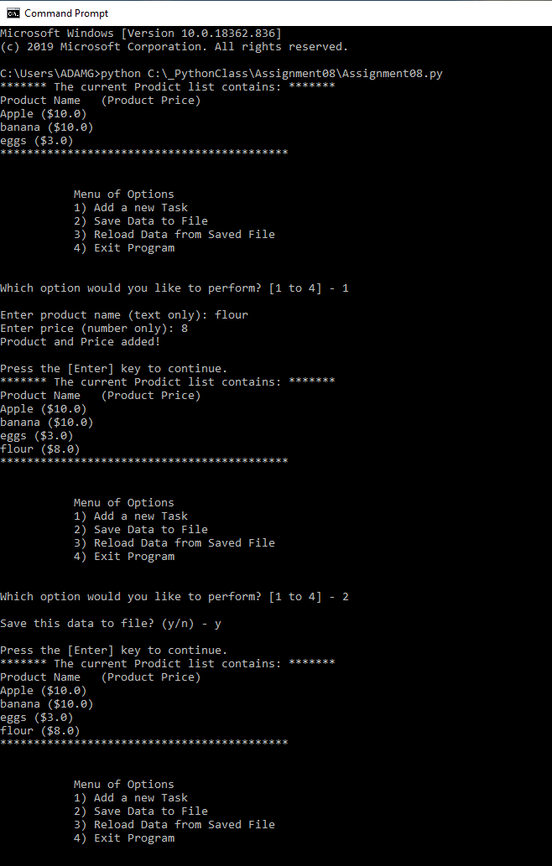
Figure 11.
Figure 10. shows the newly created .txt file after running the script.

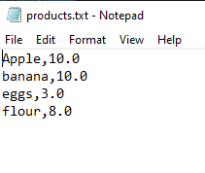
Figure 12.

Summary
Through this assignment I created used classes to organize methods to create a menu file in Python that allows a user to choose options from a menu on what they want to do with their product table. The user can enter data, view data, or save/exit.

