**Praktikum 13**

**Agiftsany Azhar**

**D3-Sistem Informasi**

LATIHAN MERGER SORT

Soal 1

Tuliskanlah algoritma MERGER SORT dengan menggunakan flow chart

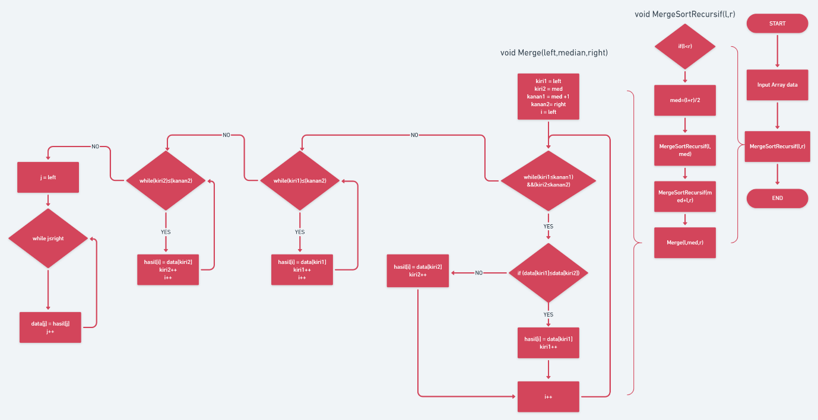

Soal 2

Tuliskanlah algoritma MERGER SORT dengan menggunakan pseudo code

void MergeSortRekursif(l,r)

1. jika (l<r) maka kerjakan baris 2 – 5
2. med = (l+r)/2
3. MergeSortRekursif(l,med)
4. MergeSortRekursif(med+l,r)
5. Merge(l,med,r)

void Merge(left, median, right)

1. kiri1 🡨 left
2. kanan1 🡨 median
3. Kiri2 🡨 median+1
4. Kanan2 🡨 right
5. i 🡨 left
6. selama (kiri1<=kanan1) && (kiri2<=kanan2) kerjakan baris 7 – 13
7. if (Data[kiri1] <= Data[kiri2]) kerjakan baris 8 – 9
8. hasil[i] = Data[kiri1]
9. kiri1++
10. jika tidak kerjakan baris 11 – 12
11. hasil[i] = Data[kiri2]
12. kiri2++
13. i++
14. selama (kiri1 <= kanan1) kerjakan baris 15 – 17
15. hasil[i] = Data[kiri1]
16. kiri1++
17. i++
18. selama (kiri2 <= kanan2) kerjakan baris 19 – 21
19. hasil[i] = Data[kiri2]
20. i++
21. kiri2++
22. j 🡨 left
23. selama (j <= rigt) kerjakan baris 24 – 25
24. Data[j] = hasil[j]
25. j++

Soal 3

Implementasikan algoritma MERGER SORT dalam bentuk function di dalam class array

package tugas13_152011513020;

public class Tugas13_152011513020 {

public static void main(String[] args) {

// BubbleSort(5,10);

// SelectionSort(5,10);

// InsertionSort(5,10);

MergeSort(200000,1000000);

}

public static void BubbleSort(int data, int nilai){

//bubelsrot

Array bS;

bS=new Array(data); //banyak data

bS.input(nilai); //batas nilai data

bS.bubbleSort();

// bS.print();

}

public static void SelectionSort(int data, int nilai){

//seleksensrot

Array sS;

sS=new Array(data); //banyak data

sS.input(nilai); //batas nilai data

sS.selectionSort();

// sS.print();

}

public static void InsertionSort(int data, int nilai){

//insertsrot

Array iS;

iS=new Array(data); //banyak data

iS.input(nilai); //batas nilai data

iS.insertionSort();

// iS.print();

}

public static void MergeSort(int data, int nilai){

//insertsrot

Array mS;

mS=new Array(data); //banyak data

mS.input(nilai); //batas nilai data

System.out.println("===== MERGERSORT =====");

long mulai = System.currentTimeMillis();

mS.mergerSort(mS.getArray(),1,mS.getArray().length);

long kelar = System.currentTimeMillis()-mulai;

System.out.println("Waktu :"+kelar+" ms");

}

}

package tugas13_152011513020;

import java.util.Random;

public class Array {

int[] a;

int maxsize;

Random rand = new Random();

Array(int size){

this.a = new int[size];

this.maxsize = size;

}

int[] getArray(){

return this.a;

}

void print(){

for(int i=0; i<this.maxsize; i++){

System.out.print(this.a[i]+" ");

}

System.out.println("");

}

void swap(int i, int j){

int z = this.a[i];

this.a[i] = this.a[j];

this.a[j] = z;

}

void input(int n){

for (int i=0;i<this.maxsize;i++){

this.a[i]=rand.nextInt(n)+1;

}

}

void bubbleSort(){

long swap = 0;

for (int i=2;i<this.maxsize;i++){

for (int j=0;j<=this.maxsize-i;j++){

if(this.a[j]>this.a[j+1]){

swap(j+1,j);

swap++;

}

}

}

System.out.println(swap);

}

void selectionSort(){

long swap = 0;

for(int i=this.maxsize-1; i>=1; i--){

int max=i;

for(int j=i-1; j>=0;j--){

if(this.a[j]>this.a[max]){

max=j;

}

}

swap(i,max);

swap++;

}

System.out.println(swap);

}

void insertionSort(){

long swap=0;

for (int i=0; i<this.maxsize; i++){

int j=i-1;

int tmp = this.a[i];

while(j>=0 && this.a[j]>tmp){

swap(j,j+1);

swap++;

j--;

}

this.a[j+1]=tmp;

}

System.out.println(swap);

}

void mergerSort(int[] a, int start, int end) {

int n = end - start + 1;

if (n <= 1)

return;

int middle = start + (n / 2) - 1;

mergerSort(a, start, middle);

mergerSort(a, middle + 1, end);

merge(a, start, middle, end);

}

void merge(int[] a,int start, int middle, int end){

int[] b = new int[end - start + 1];

int i = start;

int j = middle + 1;

for (int k = 0; k < b.length; k++) {

if (j > end) {

b[k] = a[i - 1];

i++;

}

else if (i > middle) {

b[k] = a[j - 1];

j++;

}

else if (a[i - 1] < a[j - 1]) {

b[k] = a[i - 1];

i++;

}

else {

b[k] = a[j - 1];

j++;

}

}

for (int k = 0; k < b.length; k++) {

a[start - 1 + k] = b[k];

}

}

}

Soal 4

Generate 200.000 data dan hitunglah waktu yang diperlukan untuk mengurutkan data tersebut dengan menggunakan program yang dihasilkan di soal 3

run:

Waktu :78 ms

BUILD SUCCESSFUL (total time: 0 seconds)