# Case Study – Summary of Parks Canada, Trent Severn Waterway, Dam at Lock 23 Replacement (medium)

## Authorization issued **November 9, 2018** for:

* Serious Harm associated with phase 1 cofferdam footprint and dewatering – 2417 m2 **November 1, 2018** to **July 15, 2019**
* Serious Harm associated with phase 2 cofferdam footprint and dewatering – 1867 m2 **July 15, 2019** to **July 15 2020**
* Serious Harm associated with 1088 m2 of infill associated with moving the dam downstream
* The works resulting in serious harm must be completed by **March 15, 2021** – Otherwise DFO must be notified

## Monitoring and Report for Avoidance and Mitigation

* Fourteen conditions relating to avoiding and mitigating serious harm with 6 contingency measures should monitoring show mitigation are not successful
* Report due **December 31 for each year of construction (2018-2020)**

## Offsetting

* Habitat enhancement - creating a Walleye spawning shoal (760m2) at an offsite location
* Reinstating 1080m2 of habitat upstream of the dam
* 5 criteria to assess the implementation and effectiveness of the measures
* Contingency measures to be implemented if found not to be stable or deficient – determination date of **December 31, 2020**, with implantation of new measures **December 31, 2021** and 3 additional years of monitoring for stability (2022-2024)
* Contingency measures to be implemented If found not to be functional – determination date **December 31, 2021**

## Monitoring and reporting of offsetting measures

* As constructed report due within **12 months of installation**
* Interim report 1 on effectiveness **Due December 31, 2019 Received**
* Interim report 2 on effectiveness **Due December 31, 2020 Received**
* Final report on effectiveness due **December 31, 2021**

## Path

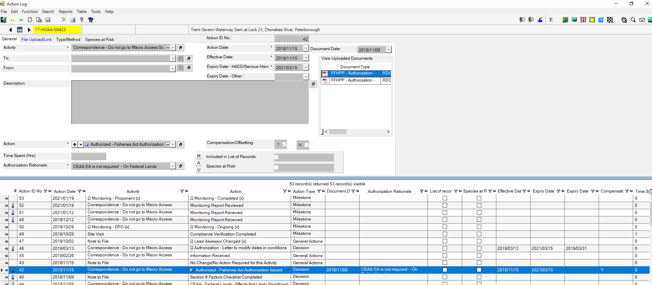

Action Item 48 – Offsetting Monitoring Report Dated November 29, 2019

Action Item 51 – Offsetting Monitoring Report Dated December 22, 2020

Action Item 50 – DFO site monitoring conducted October 29, 2019

No other reports received or not entered into PATH