Results

The various outcome measures collected throughout the study, both quantitative and qualitative, are presented in this section using the well-established framework for usability which consists of efficiency, effectiveness, and satisfaction. Each of these three will now be defined and all outcome measures classed under each category listed.

|  |  |  |
| --- | --- | --- |
| **Efficiency** | **Effectiveness** | **Satisfaction** |
| Time for setup | EEG assessments | ~~Stress + Satisfaction measure~~ |
| ~~Time for each activation~~ | MMT | ~~QUEST~~ |
| ~~NASA TLX~~ | ROM | Interviews |
| ~~FES parameter repeatability~~ | SCIM | ~~Perceived Usefulness Q~~ |
| ~~Threshold repeatability~~ |  |  |
| ~~TPR/FPR/TNR~~ |  |  |
| ~~Number of sessions with OT~~ |  |  |

## Efficiency

Time for setup

Donning time was measured at each BCIFES session. It was defined as the complete process of placing headset, achieving good contact of electrodes, setting up the training threshold, placing FES electrodes, setting FES current, and testing the threshold and parameters to make sure they are correct. After finishing donning users occasionally needed to further readjust the parameters, but these additional changes were not included in the time for initial set up presented here.

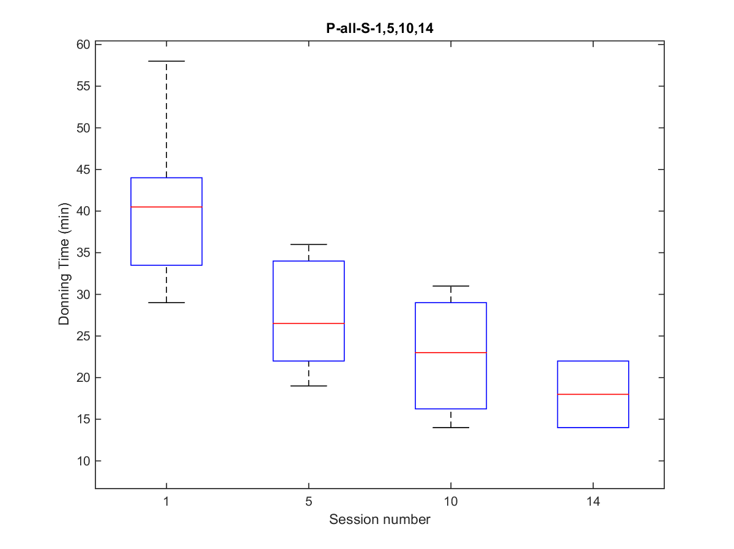

Figure XX. Donning times for all patients for sessions 1, 5, 10 and 14. The number of users presented here are as follows: session 1 – 8 users, session 5 – 6 users, session 10 – 3 users, session 14 – 2 users.

In Figure XX above, session 1 represents the first training session with an OT, session 5 is the last training session with an OT for some patients or the first independent (without OT) for others, and sessions 10 and 14 are independent sessions for all users who chose to continue with optional therapy sessions. A clear trend of decreasing donning time can be observed with the subsequent sessions down from approximately 30-60 min to approximately 15-25 min.

In the next figure, all sessions completed by the three users who chose to continue independent therapy are shown.

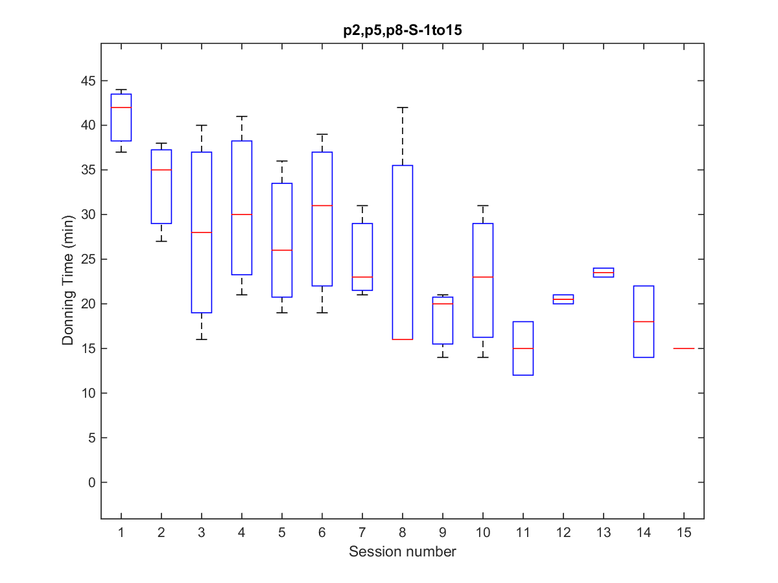

Figure XX. Donning times for users P2, P5, and P8, who completed 14, 15, and 10 sessions respectively.

Again the trend of decreasing donning times can be seen with a sub-sample of 3 users. It is interesting to note, that the boxplots for sessions 11-14 are based on just two users, one of whom was a male with a large head and no hair, while the other was a petite female with a significantly smaller head and long hair. Therefore the head size and hair length do not seem to be an obstacle in donning once the users have practiced the technique enough.

Time for each activation

NASA

Workload during the sessions was measured using the NASA TLX questionnaire [1]. The figures below show selected results for both patients and carers, however because each user pair completed a different number of trials, the plots presented do not all have equal number of data points.

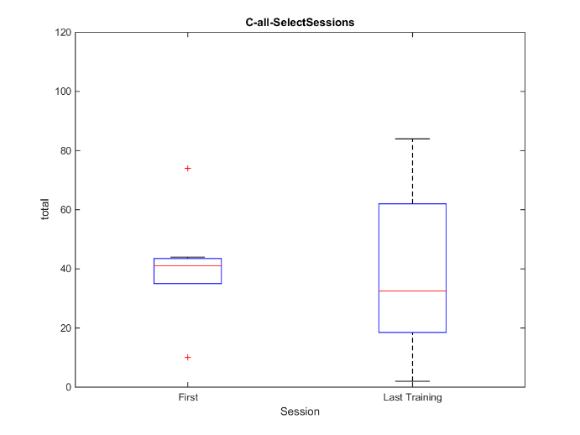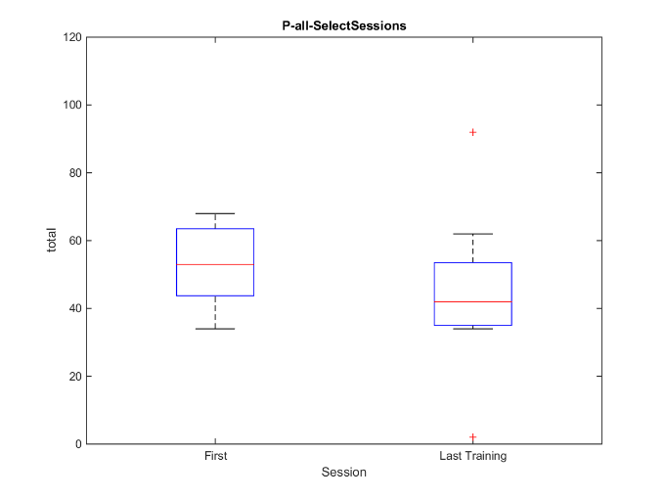

Figure XX. Overall Workload for the first and last training session for all carers (A) and all patients (B).

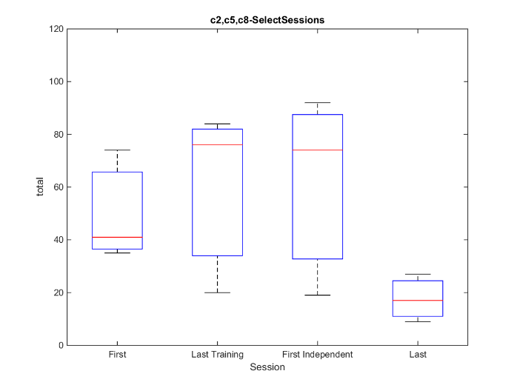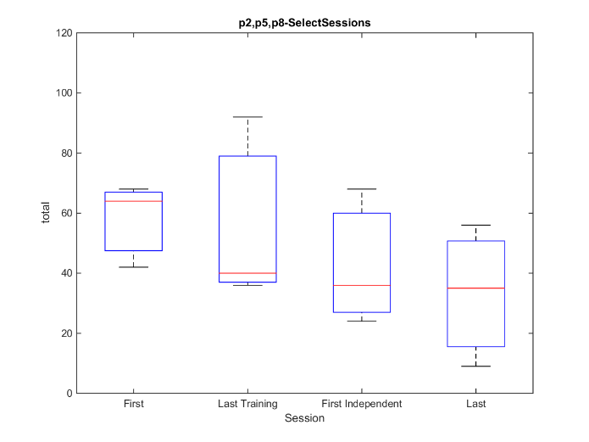

Figure XX. Overall Workload for selected sessions for carers (A) and patients (B) who continued with optional therapy. Last Training session was the 4th for two of the user pairs and the 5th for one pair. Consequently the First Independent session was the 5th for two pairs and the 6th for one. The Last session was 14th (10th independent), 15th (10th independent) and 10th (6th independent) for P2, P5, and P8 respectively.

As expected, Figure XX shows that the workload is lowest during the very last session after the users have had enough practice. Interestingly, for carers the workload increases with each subsequent session with the highest at the first independent session.

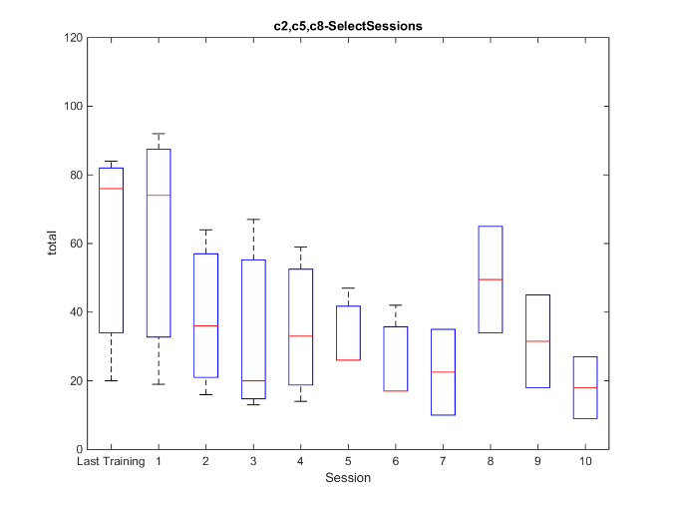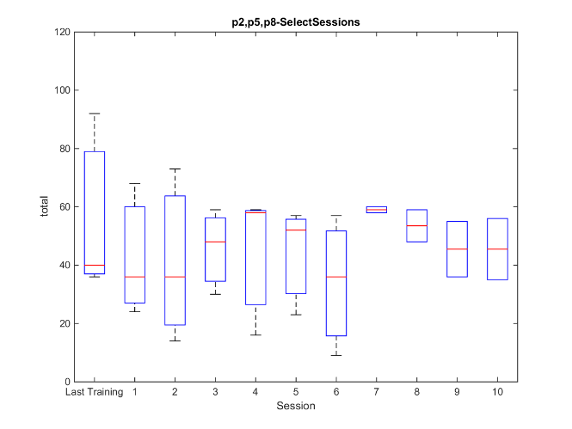

Figure XX. Last Training session and all the following independent sessions for user pairs who continued with optional therapy. Two user pairs completed 10 independent sessions and one pair completed 6.

The workload appears to decrease for the carers from with each subsequent independent session, until session number 7, and then jumps back up for the last few sessions, but because these last few boxplots are based on just two data points (as opposed to still only three for the previous sessions), more data is needed to determine the number of sessions after which the carers feel sufficiently comfortable using the system in order for the reported workload to stay at the plateau.

On the other hand, the workload for the patients seems to stay more constant. This is not surprising as the patients’ have less learning to do in their task of neurofeedback hand therapy.

FES parameters repeatability

The FES parameters used by each patient and caregiver pair were initially established by the OT during the training sessions. It was found that these remained unchanged for the overwhelming majority of the BCIFES sessions.

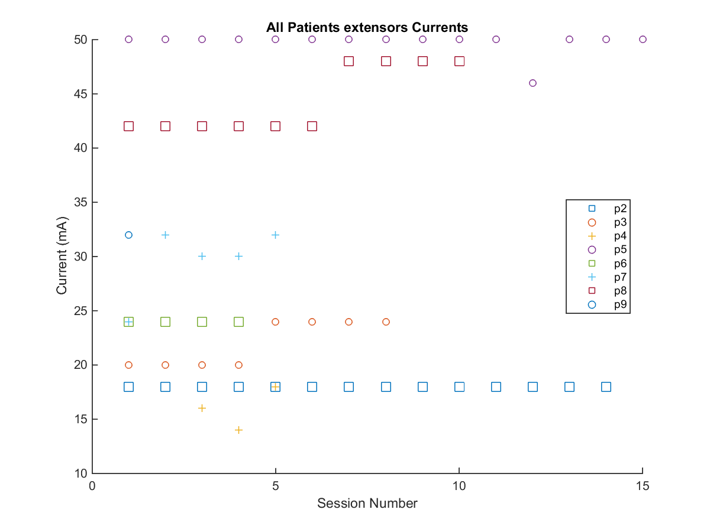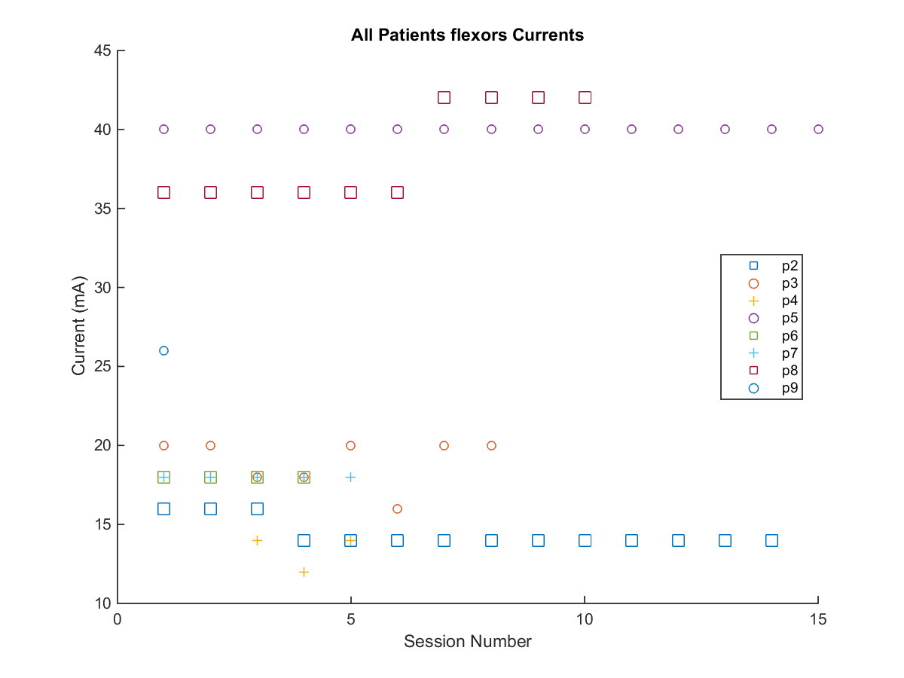

Repeatability of threshold

Number of sessions with OT

TPR/FPR/TNR

## Effectiveness

EEG assessment

MMT

ROM

SCIM

## Satisfaction

Stress and Satisfaction

The patients and caregivers were asked rate their stress and satisfaction levels after each BCIFES session on a scale from 0 to 10.

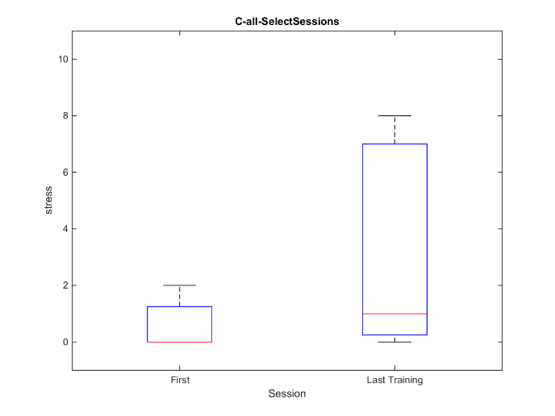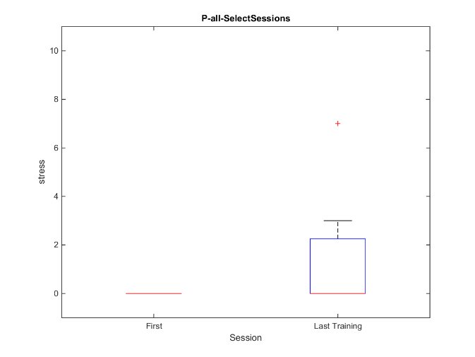

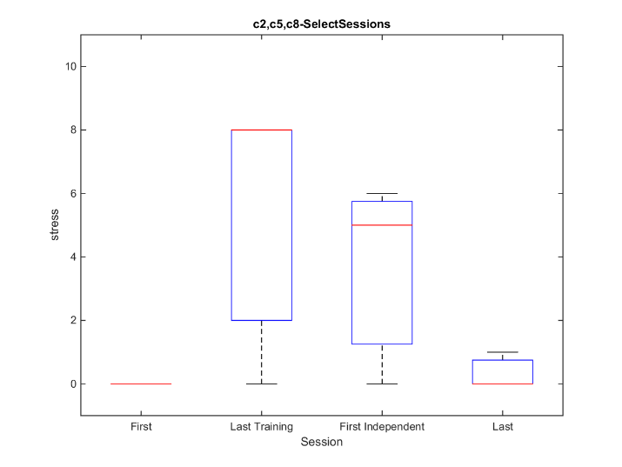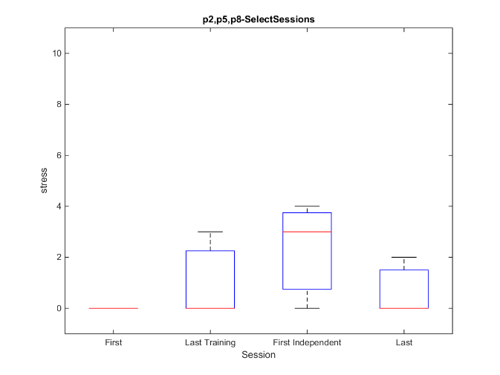

Satisfaction

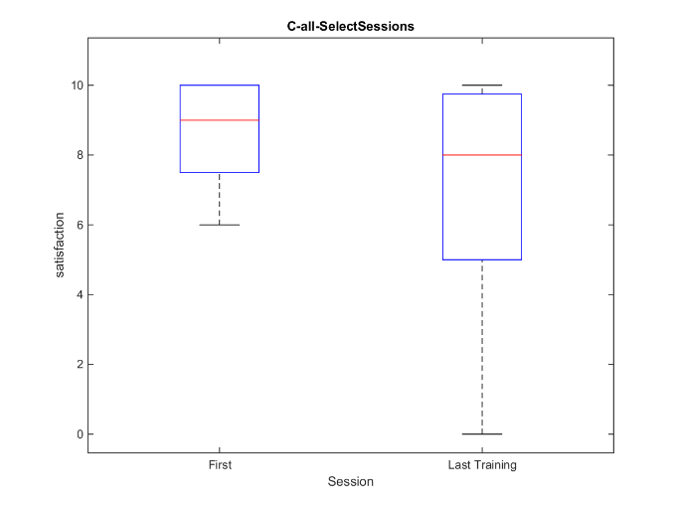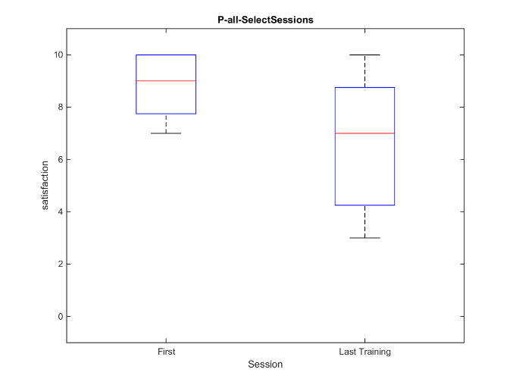

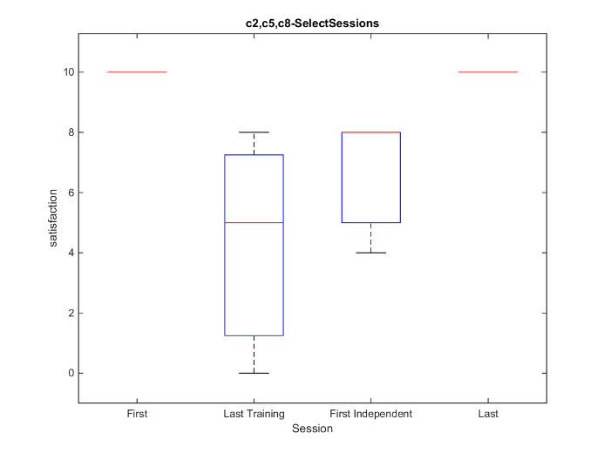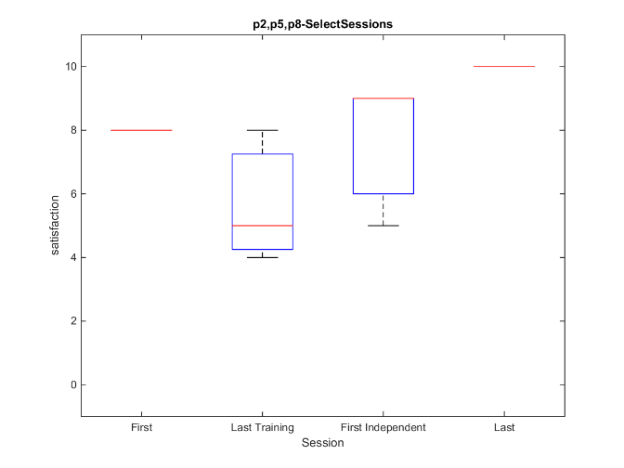

QUEST

The results of the QUEST questionnaire patients and carers filled out after the last training session with OT (either 4th or 5th session total) are presented below.

When rating the three most important aspects to the users, the most commonly chosen was ‘Easy to Use’ and ‘Effective’. Details of the results are shown in Figure XX below.

Figure XX. Most important factors chosen by users. Maximum for each category is 6. Categories which were not chosen by any user are not shown.

Figure XX. User satisfaction with each aspect from the QUEST. Maximum in each category is 5.

Across users, the satisfaction with ‘Easy to Use’ and ‘Effective’ was rated as 3.43 ± 0.90 and 3.29 ± 0.70 respectively. The highest rated fields were ‘Safe and Secure’ at 4.43 ± 0.9, ‘Weight’ at 4.43 ± 0.9, and ‘Professional Services’ at 4.43 ± 0.73.

The average satisfaction with various aspects of the device itself (‘Dimensions’ through ‘Effective’ in Figure XX above) was 3.68 out of 5, and with services provided relating to the device (‘Service Delivery’ through ‘Follow-up Services’ in Figure XX) was 4.14 out of 5.

Interviews

[Nina]

Perceived Usefulness Questionnaire

After the initial training session with an OT, each patient and caregiver pair answered questions aimed at gauging their first impression of the system and general attitude towards new technology. The general findings were as follows.

*Understanding* – The patients and caregivers stated that the main purpose of the system is neither very easy nor very hard to understand, however when asked to describe the purpose of each component (EEG, software, FES) most had some understanding but not a complete grasp of the purpose and concepts involved.

*Perceived Ease of Use* – When asked about the ease of use of the system, participants generally reported that it is fairly easy to use given proper training. Most commonly they reported the hardest part would be the EEG headset and its correct positioning (3 pairs), one pair reported FES, and two pairs mentioned other factors.

*Perceived Effectiveness* – Patients and caregivers were moderately convinced (approximately 8/10) that the BCIFES system would improve their muscle strength and hand function.

*Potential Continued Use* – Most patients and caregivers (4) expressed the wish for potential future use of the system at home, while some (2) stated it would depend on the level of support given.

*Self-Consciousness* – Patients reported they would feel neutral to amused (as opposed to embarrassed) if others would know about/see them using the BCIFES at home.

*Attitude Towards New Technology* – Generally participants reported excitement towards new technology (as opposed to avoidance), stating that price, size, and technical support would be the most important factors to take into account when buying new technology.