Arely Gil

Assignment: GitHub Repository Setup

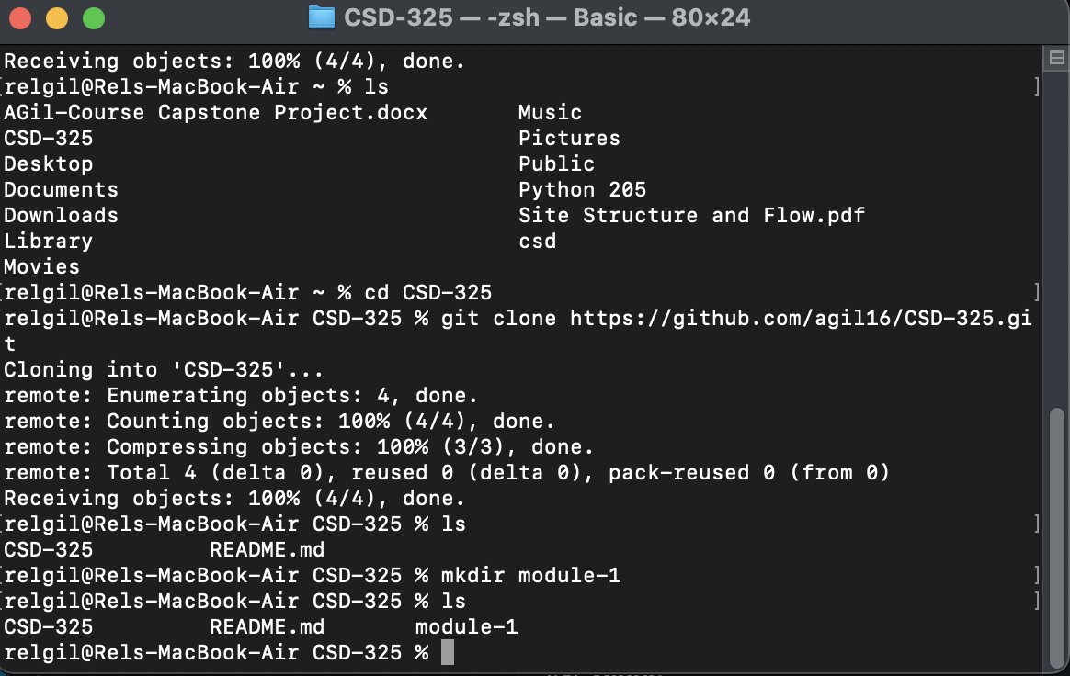

https://github.com/agil16/CSD-325.git