Microservices Best Practice:

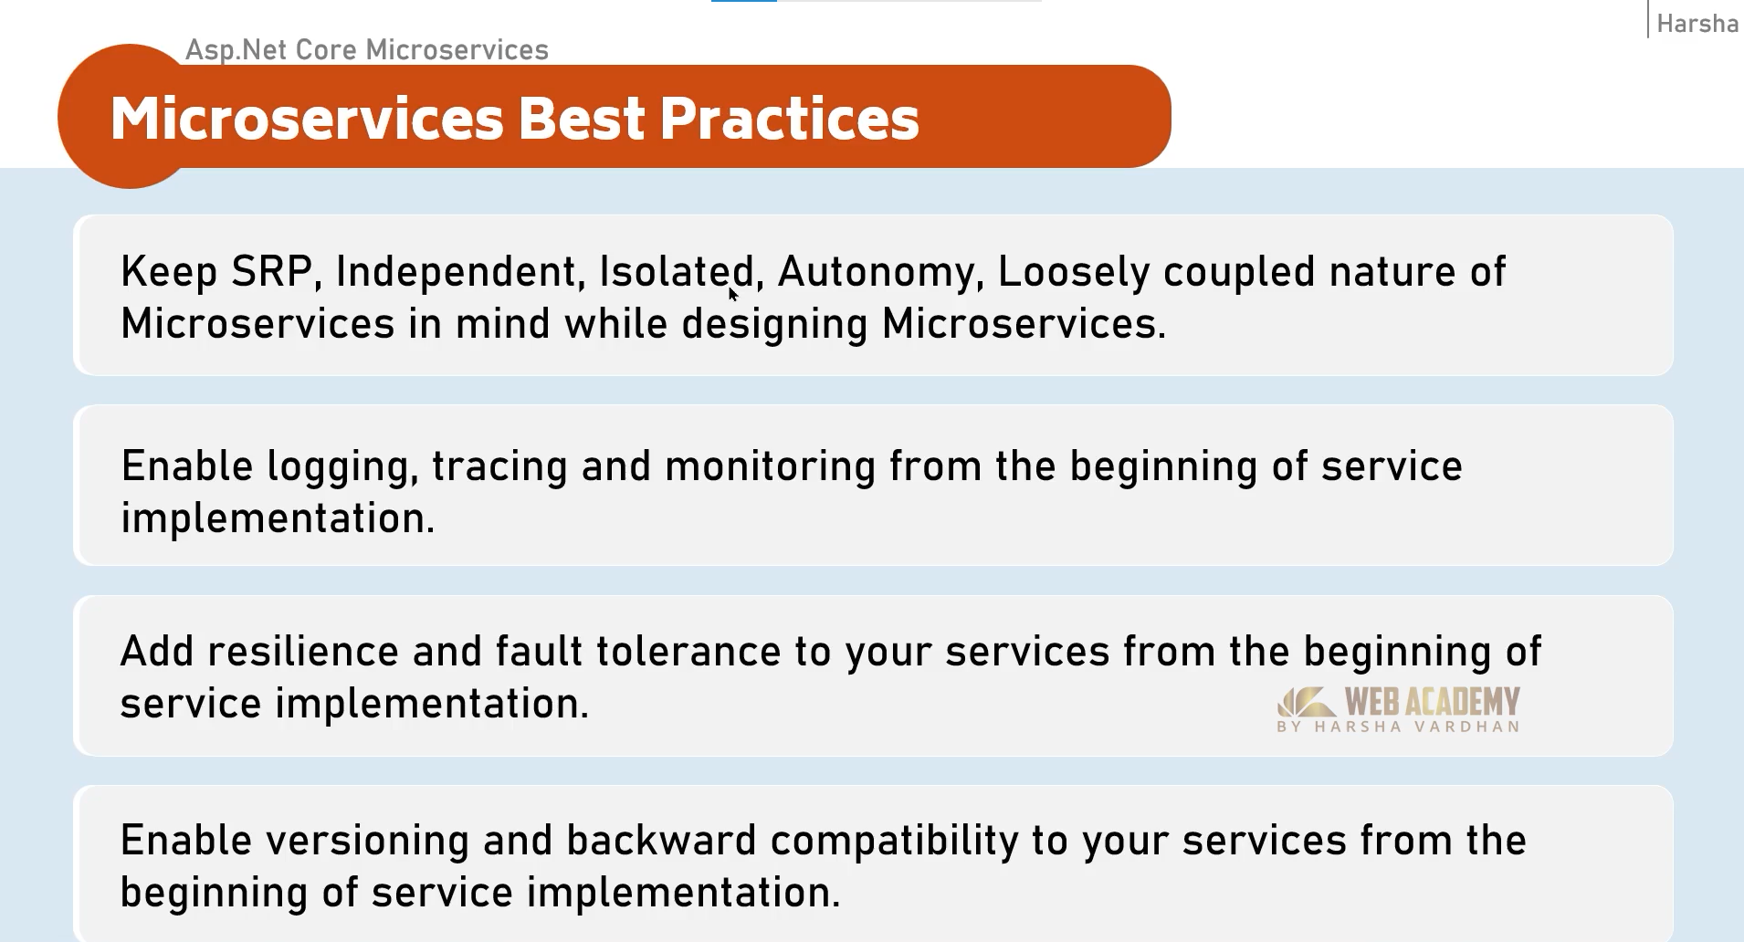

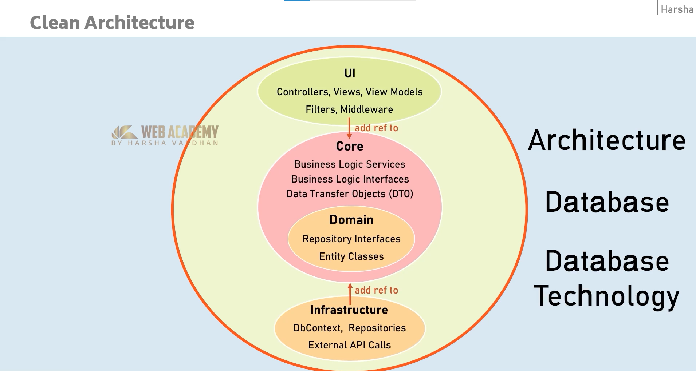

DDD is different from the clean architecture.

DDD is much more complex and very much suitable for large scale applications only.

But for small to medium architecture Clean is more than enough.

Dapper

AutoMapper

Fluent Validation

Docker and Container

IQ:

1. What is difference between WebAPI and Minimal API?
2. What is difference between PostgreSQL and SQLServer