Inventory Management System (IMS)
Standard Operating Procedure & User Manual

——————————————————————————————

Prepared For: Agile Tech Solutions
System: Agile Tech IMS — Asset, Inventory & User Management Platform
Document Type: Standard Operating Procedure (SOP) / User Manual
Version: 1.1
Status: Final — Client Release

CONFIDENTIAL — For authorized internal use only

Document Control

Version History
Version | Date | Author | Description
1.0 | 2026-09-08 | Agile Tech Solutions — Implementation Team | Initial release. Documents the IMS platform as implemented in the current codebase: asset lifecycle, master data (Department, Sub Department, Type, Subtype, Brand), the Type → Subtype → Parameters configuration model, Excel import/export, roles & permissions, centre/location scoping, dashboard, reports, and search.
1.1 | 2026-09-22 | Agile Tech Solutions — Implementation Team | Updated to match the codebase as of 2026-09-21: the Vendor module and Asset Category were removed; Roles & Permissions are now configured separately per Centre; Global Search adds an Access Accounts result group; and a new Asset unassignment alert notification was added.
1.2 | 2026-09-23 | Agile Tech Solutions — Implementation Team | Updated Section 9 (Asset Assignment & Status) and Section 15 (Validations) to match the current codebase and UI, with new screenshots: the Assign Asset workflow now documents multi-select assignment/unassignment from the User directory (Section 9.2), the per-user Asset History tab is documented in full (Section 9.3), and a new Client-Side Form Validation reference (Section 15.1) documents the shared real-time Name/Email/Phone validation (validation.js) and the letters-only Name Picker used across Department, Sub Department, Brand and other forms.

Purpose of this Document
This manual documents the Inventory Management System (IMS) exactly as it is built and configured today. Every field name, validation rule, permission, and workflow described in this document was verified directly against the application's source code and live screens. No feature described here is planned, assumed, or aspirational — if it is in this manual, it exists in the system.

Audience
- Administrators responsible for configuring master data, roles, and centres.
- Asset Managers, Admins, Auditors, and Viewers who use the system day-to-day.
- New employees being onboarded to the IMS platform.
- IT/Support staff troubleshooting user-reported issues.

Table of Contents
Document Control 2
Version History 2
Purpose of this Document 2
Audience 2
Table of Contents 3
1. System Overview and Purpose 6
1.1 What the System Does 6
1.2 Who Uses It 6
2. Login and Navigation 7
2.1 Logging In 7
How to Use 7
Validation & Errors 7
2.2 Signing Out 8
2.3 Navigation Layout 8
Sidebar Groups 9
Top Bar 10
3. User Roles & Permissions 11
3.1 Roles 11
3.2 How to Access 11
3.3 How to Use 12
3.4 Modules Governed by Permissions 13
4. Dashboard 14
4.1 Period Filter 15
4.2 Stat Cards 16
4.3 Charts and Panels 16
5. Master Data Modules 17
6. Asset Type → Subtype → Parameters Workflow 18
6.1 Step 1 — Define Parameters on the Asset Type 18
Required / Optional Fields 19
Validation 19
6.2 Step 2 — Create a Subtype and Fill In Values 19
Required / Optional Fields 20
Validation 20
6.3 Different Types Carry Different Parameters 20
6.4 How This Appears on the Asset Form 20
7. Brand, Department & Sub Department 21
7.1 Department 21
Purpose 21
How to Access 21
How to Use 21
Required / Optional Fields 21
Validation Rules 22
Example 22
7.2 Sub Department 22
Purpose 22
How to Access 22
How to Use 22
Required / Optional Fields 23
Validation Rules 23
Example 23
7.3 Brand 24
Purpose 24
How to Access 24
How to Use 24
Required / Optional Fields 24
Validation Rules 25
Example 25
8. Asset Creation & Editing 26
8.1 How to Use 26
8.2 Required / Optional Fields 27
8.3 Validation Rules 27
8.4 Asset Details Page 27
9. Asset Assignment & Status 28
9.1 Assigning an Asset from the Asset Form 28
9.2 Assigning an Asset from the User Directory 28
9.3 Assignment History 28
9.4 Asset Status Values 29
10. Warranty & AMC 30
How to Use 30
Where Coverage Is Surfaced 30
11. Asset Import / Export 31
11.1 Bulk Asset Import & Export 31
Column Structure (per Type sheet) 31
Import Behaviour 31
Example Import Errors 31
11.2 Bulk Asset Subtype Import & Export 32
11.3 Reading the “Expected CSV Columns” Panel 32
12. Centre / Location Workflow 33
12.1 For Access Accounts (Manager/Admin/Auditor/Viewer) 33
12.2 For Administrators 33
13. Search, Filters and Reports 34
13.1 Global Search 34
13.2 Asset List Filters 34
13.3 Reports 34
Coverage Filter Options (Warranty and AMC, independently) 35
14. Notification & SMTP Settings 36
14.1 Notification Settings 36
Purpose 36
How to Access 36
How to Use 36
Available Alert Events 36
Validation Rules 37
14.2 SMTP Settings 37
Purpose 37
How to Access 37
How to Use 37
Required / Optional Fields 37
Validation Rules 38
Example 38
15. Validations and Common Errors 38
15.1 Client-Side Field Validation (Real-Time) 38
15.2 Server-Side Validation Messages 39
16. Complete Recommended Workflow 41
17. FAQ and User Best Practices 42
Best Practices 42

1. System Overview and Purpose
The Agile Tech Inventory Management System (IMS) is a web-based platform for tracking an organization's physical assets — laptops, desktops, printers, cameras, and any other equipment type an administrator configures — from the moment they are added to inventory through assignment, warranty/AMC coverage, and eventual retirement.

1.1 What the System Does
- Maintains a master catalogue of Asset Types, Subtypes, Brands, Departments and Sub Departments.
- Lets each Asset Type define its own set of Subtype Parameters (e.g. RAM, Processor, Storage for Laptops; Print Type, Paper Size, Connectivity for Printers) — different Types can have completely different parameter sets.
- Records every physical Asset against a Type, an optional Subtype (which carries its own fixed Brand and configured parameter values), a Department/Sub Department, and an assigned user.
- Tracks Warranty and AMC (Annual Maintenance Contract) coverage per asset, with dashboard alerts for coverage expiring within 30/60/90 days.
- Supports bulk Excel import and export of both Assets and Asset Subtypes, one worksheet per Asset Type, with the same Type/Subtype/Brand/Parameter validation as the manual forms.
- Enforces role-based permissions per module and per action (View, Create, Update, Delete, Assign, Import, Export, Download, Verify, Restore).
- Scopes almost all data — Assets, Types, Subtypes, Brands, Departments, Sub Departments, Users, Notifications, Backups, Audit Logs — to a Centre/Location (currently Noida and Lucknow), so each centre only ever sees its own records.
- Provides a live Dashboard, a filterable Reports module, and an instant global search across Assets and Users.

1.2 Who Uses It
Account Type | Logs in as | Typical Use
Super Admin | Super Admin (separate Admin login, not an Access Account) | Full unrestricted access to every module, every Centre, and Roles & Permissions configuration.
Asset Manager | Access Account (User, role = Asset Manager) | Day-to-day asset creation, assignment, import/export, master data upkeep.
Admin | Access Account (User, role = Sub admin) | Administrative operations delegated by the Administrator, scoped by Roles & Permissions.
Auditor | Access Account (User, role = Auditor) | Read/verify-oriented access for compliance and audit review, per configured permissions.
Viewer | Access Account (User, role = Viewer) | Read-only access to permitted modules.

Note: “Administrator” is a separate account type (the Admin model) from the four dashboard roles above (which are User accounts). An Administrator always has full access to every module and every Centre; the four roles are governed entirely by whatever is configured on the Roles & Permissions screen (Section 3).

2. Login and Navigation

2.1 Logging In
Purpose: authenticate into the system as either an Administrator or an Access Account.
How to access: open the application URL — you are redirected to /login automatically if not already signed in.
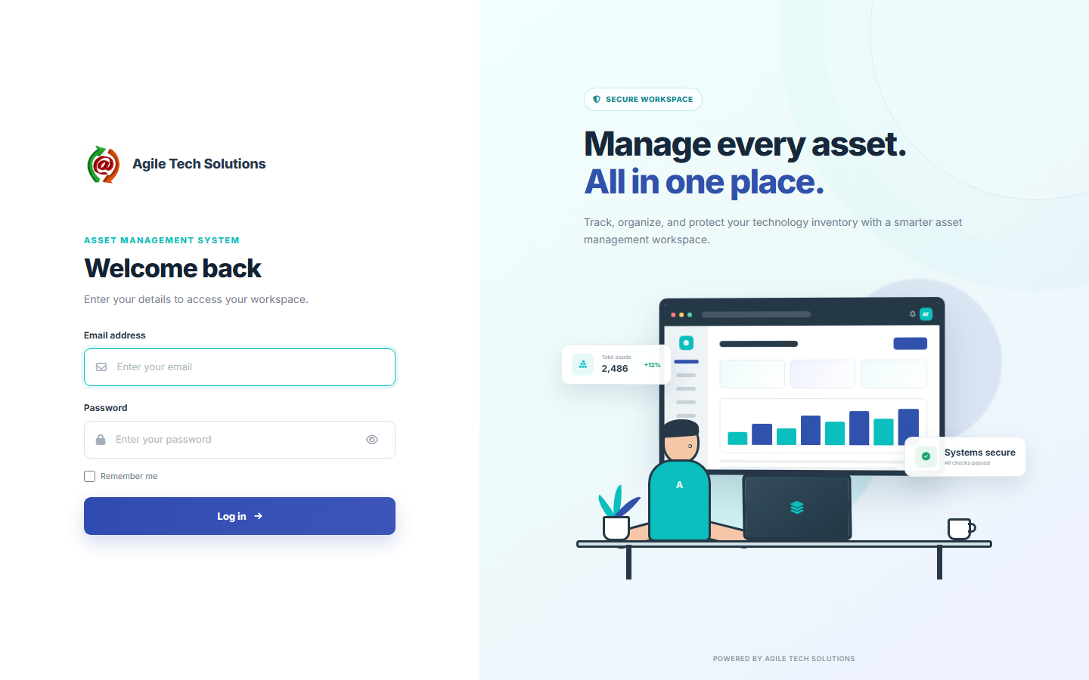
Figure 2.1 — Login screen

How to Use
1. Enter the account's Email address.
2. Enter the Password.
3. Click Sign In.
4. On success you are redirected to the first module your account has permission to view — normally the Dashboard.

Validation & Errors
- Email is required and must be a valid email format.
- Password is required.
- An incorrect email/password combination shows: “Invalid email or password.”
- An account whose Status is not Active, or an Access Account with login disabled, cannot sign in even with the correct password.
- If a valid account has no permission granted to any module at all, login is rejected with: “Your account does not have access to any module. Contact an administrator.”
Note: Repeated invalid login attempts against a non-existent Administrator email are written to the Audit Log as a blocked LOGIN FAILED event.

2.2 Signing Out
Click the account menu (top-right, showing your name/initials) and choose Logout. This ends the session and records a LOGOUT audit entry.

2.3 Navigation Layout
After login, the interface has a fixed left sidebar and a top bar. The sidebar is grouped into collapsible sections; only groups and items your account has View permission for are shown.
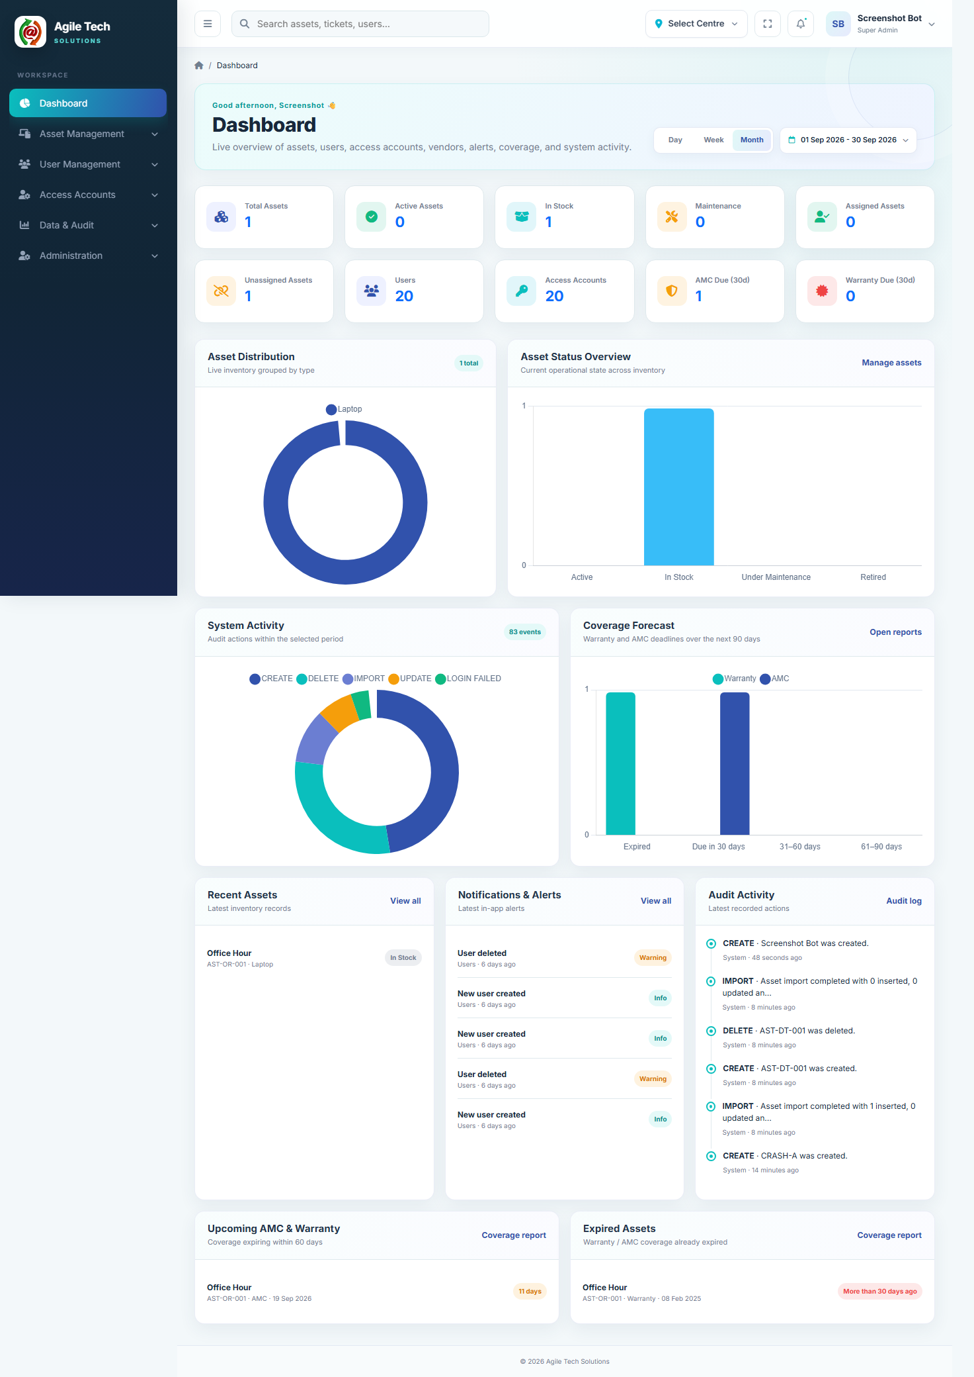
Figure 2.2 — Dashboard, showing the full sidebar navigation

Sidebar Groups
Group | Contains
Workspace | Dashboard
Asset Management | Department, Sub Department, Type, Subtype, Brand, Assets
User Management | Users (the employee/asset-holder directory)
Access Accounts | Manager, Admin, Auditor, Viewer login-account lists
Data & Audit | Reports, Audit Logs, Backup & Recovery
Administration | Roles & Permissions, Settings

Top Bar
- Global search box — searches Assets and Users as you type (Section 13).
- Select Centre — visible to Administrators only; switches the active Centre/Location (Section 12).
- Fullscreen toggle and Notifications bell.
- Account menu — profile initials, name, role, and Logout.
- “Recently Opened” — the sidebar remembers the last pages you visited for quick return.

3. User Roles & Permissions
Access to every module in the system is controlled by a permission matrix: for each Role, and each Module, up to ten possible actions can be independently switched on or off: View, Create, Update, Delete, Assign, Import, Export, Download, Verify, Restore. Not every module exposes every action — only the actions relevant to that module are shown.

3.1 Roles
Internal Role Name | Displayed As | Notes
Administrator | Administrator / Super Admin | Not managed on this screen — always has full access to everything, in every Centre.
Asset Manager | Manager | Typically the broadest of the four configurable roles.
Sub admin | Admin | Administrative operations delegated by the Administrator.
Auditor | Auditor | Read/compliance-oriented access.
Viewer | Viewer | Read-only access.

3.2 How to Access
Sidebar → Administration → Roles & Permissions. Requires the roles_permissions module View permission (Administrators always have it). Editing (not just viewing) also requires a specific Centre to be selected — each Centre keeps its own separate permission set per role (Section 12).
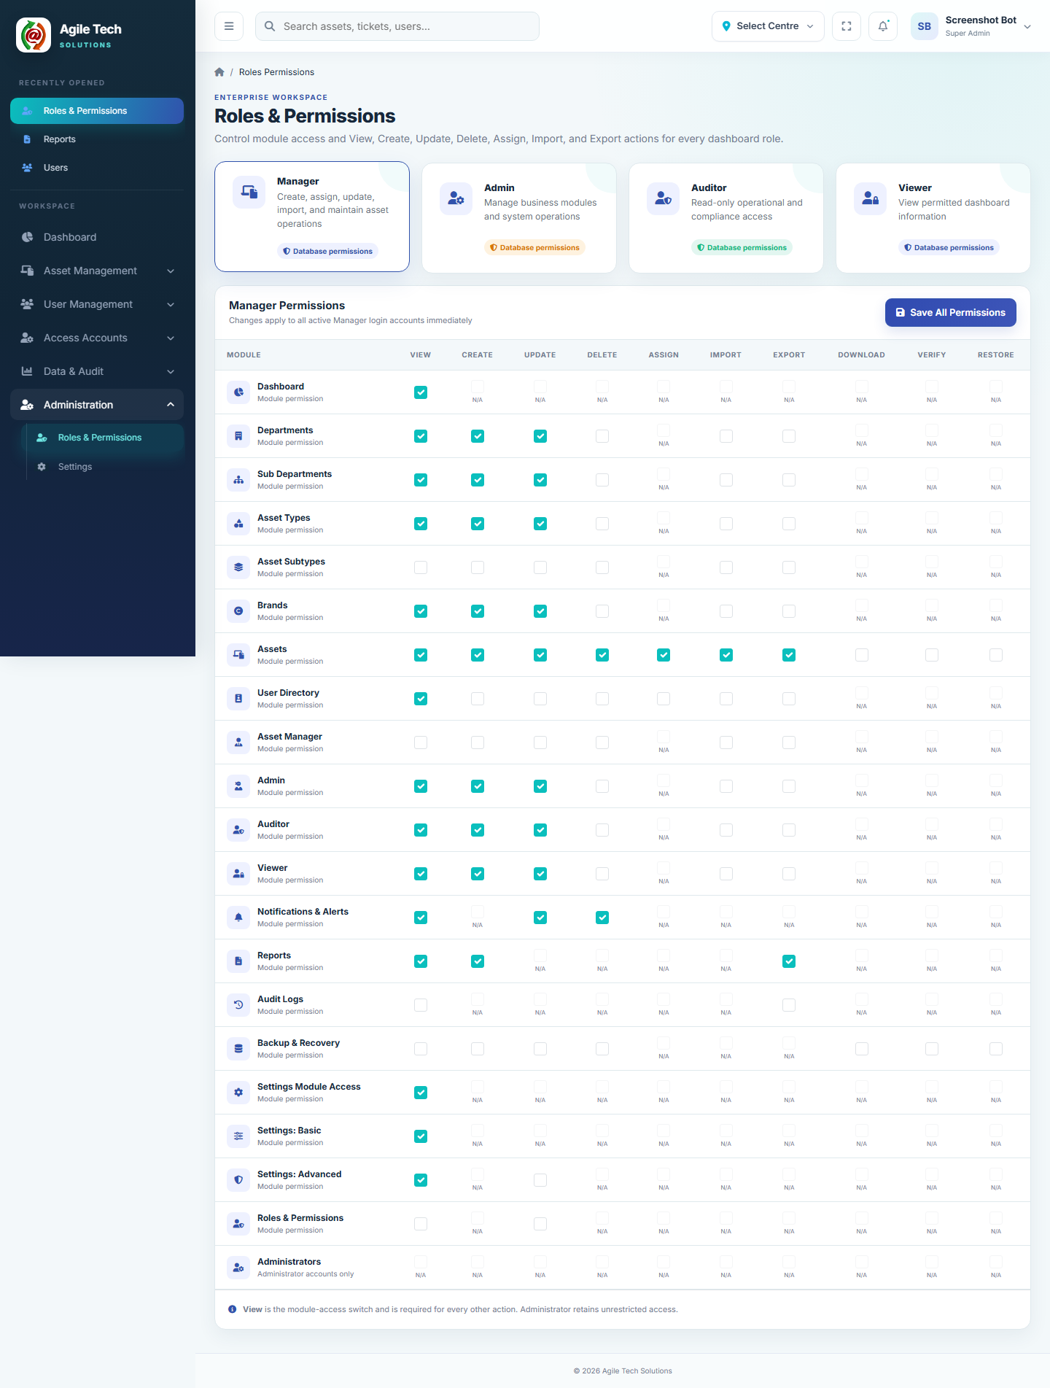
Figure 3.1 — Roles & Permissions screen

3.3 How to Use
1. Click one of the four role cards (Manager, Admin, Auditor, Viewer) to load its permission grid.
2. For each module row, tick the actions that role should be allowed to perform.
3. The View column is the master switch for that module — ticking any other action without View still restricts the role, since every other action check also confirms View.
4. For the two Settings sub-modules (Settings: Basic, Settings: Advanced), a role also needs the parent Settings Module Access box ticked or those permissions have no effect.
5. Click Save All Permissions to apply the changes immediately to every active login of that role.

3.4 Modules Governed by Permissions
Module Key | Label | Available Actions
dashboard | Dashboard | View
departments / sub_departments | Departments / Sub Departments | View, Create, Update, Delete, Import, Export
types / sub_types | Asset Types / Asset Subtypes | View, Create, Update, Delete, Import, Export
brands | Brands | View, Create, Update, Delete, Import, Export
assets | Assets | View, Create, Update, Delete, Assign, Import, Export
faculty | User Directory | View, Create, Update, Delete, Assign, Import, Export
access_accounts_asset_manager / _sub_admin / _auditor / _viewer | Access Accounts (per role) | View, Create, Update, Delete, Import, Export
notifications | Notifications & Alerts | View, Update, Delete
reports | Reports | View, Create, Export
audit_logs | Audit Logs | View, Export
backup | Backup & Recovery | View, Create, Update, Delete, Download, Verify, Restore
settings / settings_basic / settings_advanced | Settings | View (Advanced also has Update)
roles_permissions | Roles & Permissions | View, Update

Note: Each Access Account role tab (Manager/Admin/Auditor/Viewer) is governed by its own module key (access_accounts_asset_manager, etc.), so a role can be permitted to manage some Access Account tabs and not others.
Note: Every module and record in the system that carries a Centre value is still filtered by the signed-in user's own Centre regardless of permissions — permissions control what actions are allowed, Centre scoping controls which records are visible. See Section 12.

4. Dashboard
Purpose: a single landing page summarising asset inventory, coverage risk, user activity, and recent system events. Every card and chart only appears if your account has View permission on the underlying module (Assets, Users, Notifications, Reports, Audit Logs).
How to access: Sidebar → Dashboard, or automatically after login.
Figure 4.1 — Dashboard overview

4.1 Period Filter
The Day / Week / Month toggle (or a custom From–To date range) controls the System Activity chart and the activity total; it does not affect the asset counts, which are always current totals.

4.2 Stat Cards
Card | Meaning
Total Assets | Count of all Asset records.
Active Assets | Assets with Status = Active.
In Stock | Assets with Status = In Stock.
Maintenance | Assets with Status = Under Maintenance.
Assigned Assets | Assets with a non-empty Assigned To.
Unassigned Assets | Assets with a blank Assigned To.
Users | Count of records in the User Directory (Faculty).
Access Accounts | Count of login-enabled User accounts in the current Centre.
Unread Alerts | In-app notifications not yet marked read.
AMC Due (30d) | Assets whose AMC Expiry falls within the next 30 days.
Warranty Due (30d) | Assets whose Warranty Expiry falls within the next 30 days.

Every card is clickable and opens the matching filtered list.

4.3 Charts and Panels
- Asset Distribution — donut chart of assets grouped by Asset Type.
- Asset Status Overview — bar chart across Active / In Stock / Under Maintenance / Retired.
- System Activity — donut of Audit Log actions within the selected period.
- Coverage Forecast — Warranty vs AMC expiries bucketed into Expired / Due in 30 days / 31–60 days / 61–90 days.
- Recent Assets, Notifications & Alerts, Audit Activity — the five/six most recent records of each.
- Upcoming AMC & Warranty — coverage expiring within 60 days.
- Expired Assets — coverage that has already lapsed.

5. Master Data Modules
Five master data modules sit under Asset Management. Each follows the same pattern: a searchable, paginated directory table, an Add/Edit modal, a auto-generated Code, a Status of Active/Inactive, and (except Assets themselves) CSV/Excel Import and Export. Detailed field-by-field instructions for Department, Sub Department and Brand are in Section 7; Type and Subtype — the more involved two — have their own dedicated Section 6.
Module | Route | Code Prefix | Depends On | Import/Export
Department | asset-management/departments | DT | — | CSV
Sub Department | asset-management/sub-departments | ST | Department | CSV
Asset Type | asset-management/types | TE | — | CSV (with Subtype Parameters column)
Asset Subtype | asset-management/sub-types | SY | Asset Type, Brand | CSV (flat) and Excel workbook, one sheet per Type
Brand | asset-management/brands | BD | — | CSV

Note: Codes are generated automatically the moment a record is saved and cannot be typed in manually on the form — the Code field on Add/Edit is always shown read-only as “{PREFIX}-Auto” until saved.

6. Asset Type → Subtype → Parameters Workflow
This is the configuration model that drives everything else in the system: what specification fields an Asset shows, what a bulk Excel sheet's columns look like, and what gets validated on import. It has three layers:
Layer | Defines | Example
Asset Type | A category of equipment, plus the list of Subtype Parameter names that apply to every Subtype under it. | Type “Laptop” with parameters RAM, Processor, Storage.
Asset Subtype | A specific model/variant under a Type, with its own Brand and one fixed value per parameter the Type defines. | Subtype “Business Laptop” under Laptop, Brand Dell, RAM = 16GB, Processor = i7, Storage = 512GB SSD.
Asset | One physical unit. Selecting a Type and Subtype pulls in the Subtype's Brand and displays its parameter values as read-only reference — they are not retyped per asset. | Asset “John's Laptop”, Type Laptop, Subtype Business Laptop → shows Dell / 16GB / i7 / 512GB SSD automatically.

Note: Parameter values live on the Subtype, not on the Asset. If two assets share the same Subtype, changing that Subtype's configured value (e.g. correcting a typo in Processor) changes what is displayed for every asset using it.

6.1 Step 1 — Define Parameters on the Asset Type
How to access: Sidebar → Asset Management → Type → Add Type (or Edit an existing one).
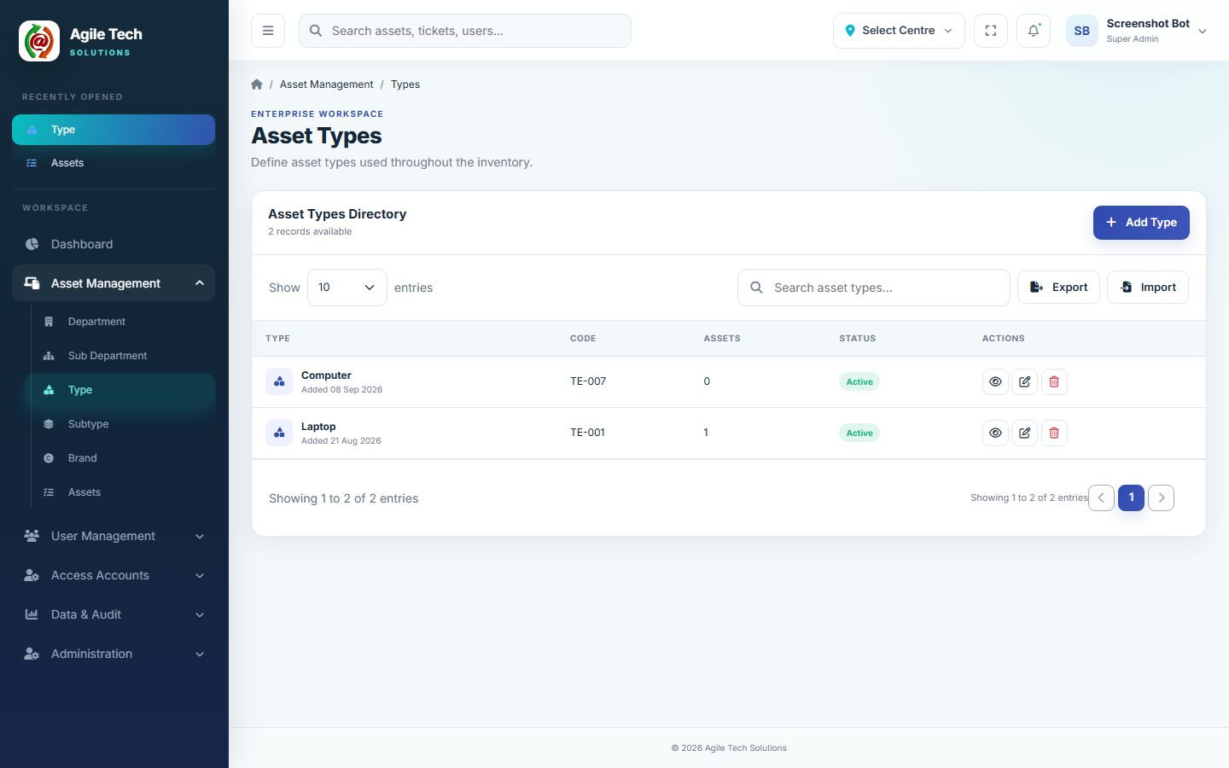
Figure 6.1 — Asset Types directory
1. Enter the Type Name (e.g. “Laptop”) and, optionally, a Description.
2. In the Subtype Parameters section, click + Add Parameter to add one blank row per parameter name you want this Type to carry (e.g. RAM, then Processor, then Storage).
3. Use the × button next to a row to remove a parameter you no longer need.
4. Set Status (Active/Inactive) and click Create Type / Save Changes.

Required / Optional Fields
Field | Required? | Notes
Name | Required | Max 255 characters.
Code | Auto-generated | Prefix TE, read-only.
Description | Optional | Max 2000 characters.
Subtype Parameters | Optional | Any number of free-text parameter names; blank rows are discarded and duplicate names are collapsed to one on save.
Status | Required | Active or Inactive.

Validation
- Name is required.
- Status must be Active or Inactive.
- Parameter rows left blank when saving are silently dropped — they do not produce an error.
Example: Type “Printer” with parameters Print Type, Paper Size, Connectivity.

6.2 Step 2 — Create a Subtype and Fill In Values
How to access: Sidebar → Asset Management → Subtype → Add Subtype.
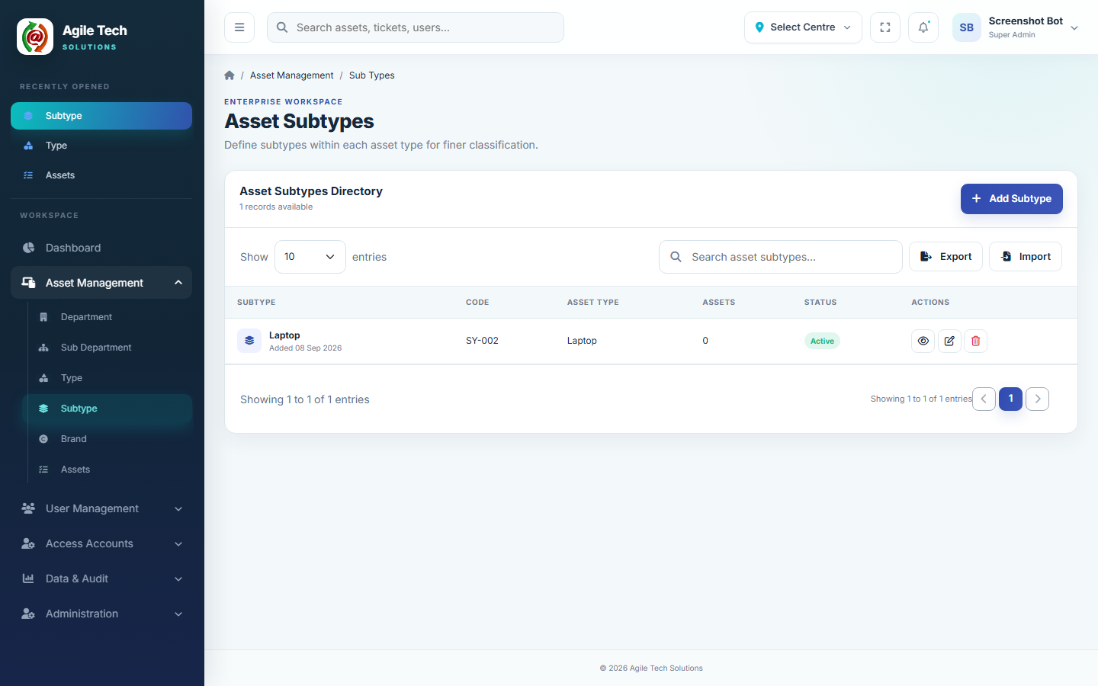
Figure 6.2 — Asset Subtypes directory
1. Enter the Subtype Name (e.g. “Business Laptop”).
2. Select the Asset Type it belongs to — this immediately loads that Type's configured parameter list.
3. Select the Brand (from the Brand master — Section 7.3).
4. Leave Required field in asset forms and imports ticked if every one of this Type's parameters must have a configured value before this Subtype can be used (see Section 14).
5. Under Subtype Parameters, type a value into each field shown (these fields are generated from the selected Type; if the Type has no parameters configured, you'll see a message to configure the Type first).
6. Set Status and Save.

Required / Optional Fields
Field | Required? | Notes
Name | Required | Max 255 characters.
Code | Auto-generated | Prefix SY, globally unique, read-only.
Asset Type | Required | Must be an existing Type.
Brand | Required | Must be an existing Brand.
Required field in asset forms and imports | Optional (default: checked) | Governs the completeness check described in Section 14.
Subtype Parameters (one field per Type parameter) | Optional per field | Free text; blank is allowed unless completeness is enforced.
Description | Optional | Max 2000 characters.
Status | Required | Active or Inactive.

Validation
- Name, Asset Type and Brand are required.
- Only parameters that belong to the selected Type are ever saved against the Subtype — stray values are ignored.
Example: Subtype “Sample Printer” under Type Printer, Brand HP, Print Type = Laser, Paper Size = A4, Connectivity = WiFi.

6.3 Different Types Carry Different Parameters
Because parameters are defined per Type, two Subtypes under different Types never share a parameter list unless the Types themselves share parameter names.
Type | Subtype | Parameters
Laptop | Business Laptop | RAM, Processor, Storage
Desktop | Office Desktop | RAM, Processor, Graphics
Printer | Sample Printer | Print Type, Paper Size, Connectivity

6.4 How This Appears on the Asset Form
On Add/Edit Asset, selecting a Type filters the Subtype dropdown to only that Type's Subtypes. Once a Subtype is chosen, a read-only Subtype Parameters panel appears showing every parameter the Type defines together with the value configured on that Subtype. The asset's Brand is not picked separately — it is taken automatically from the selected Subtype.
Note: If a Type has no Subtypes yet, the Subtype field simply has nothing to select — the Asset can still be created against the Type alone, with Brand left unset until a Subtype exists.

7. Brand, Department & Sub Department

7.1 Department

Purpose
Represents the top level of the organisational structure that Assets and Users belong to (e.g. Finance, IT, Transport). Every Sub Department and every Asset is linked to one Department.

How to Access
Sidebar → Asset Management → Department.

How to Use
1. Click Add Department.
2. Enter Name and, optionally, Description.
3. Set Status.
4. Click Create Department.
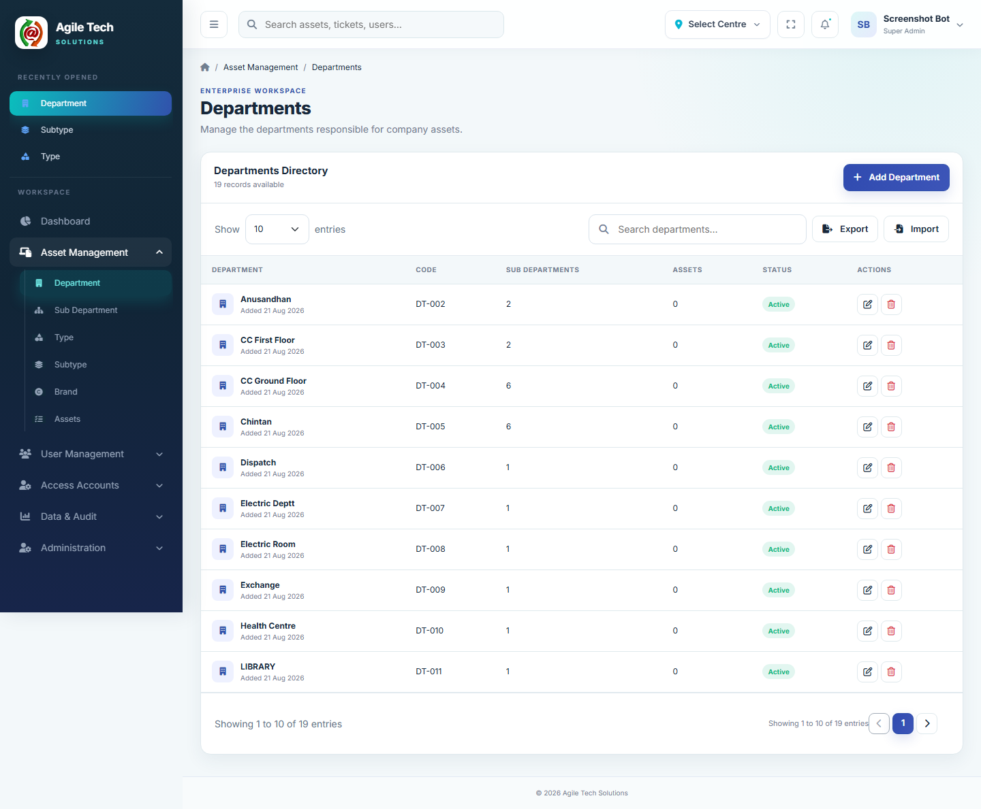
Figure 7.1 — Department directory

Required / Optional Fields
Field | Required? | Notes
Name | Required | Max 255 characters.
Code | Auto-generated | Prefix DT.
Description | Optional | Max 2000 characters.
Status | Required | Active or Inactive.

Validation Rules
- Name is required.
- A Department in use by Sub Departments or Assets cannot be deleted — the system shows “This Department is in use and cannot be deleted.”

Example
Department “Samadhan”.

7.2 Sub Department

Purpose
A finer subdivision within a Department, used for more precise asset ownership and reporting (e.g. Transport under Samadhan).

How to Access
Sidebar → Asset Management → Sub Department.

How to Use
1. Click Add Sub Department.
2. Enter Name and select the parent Department.
3. Optionally add a Description, set Status, and Save.
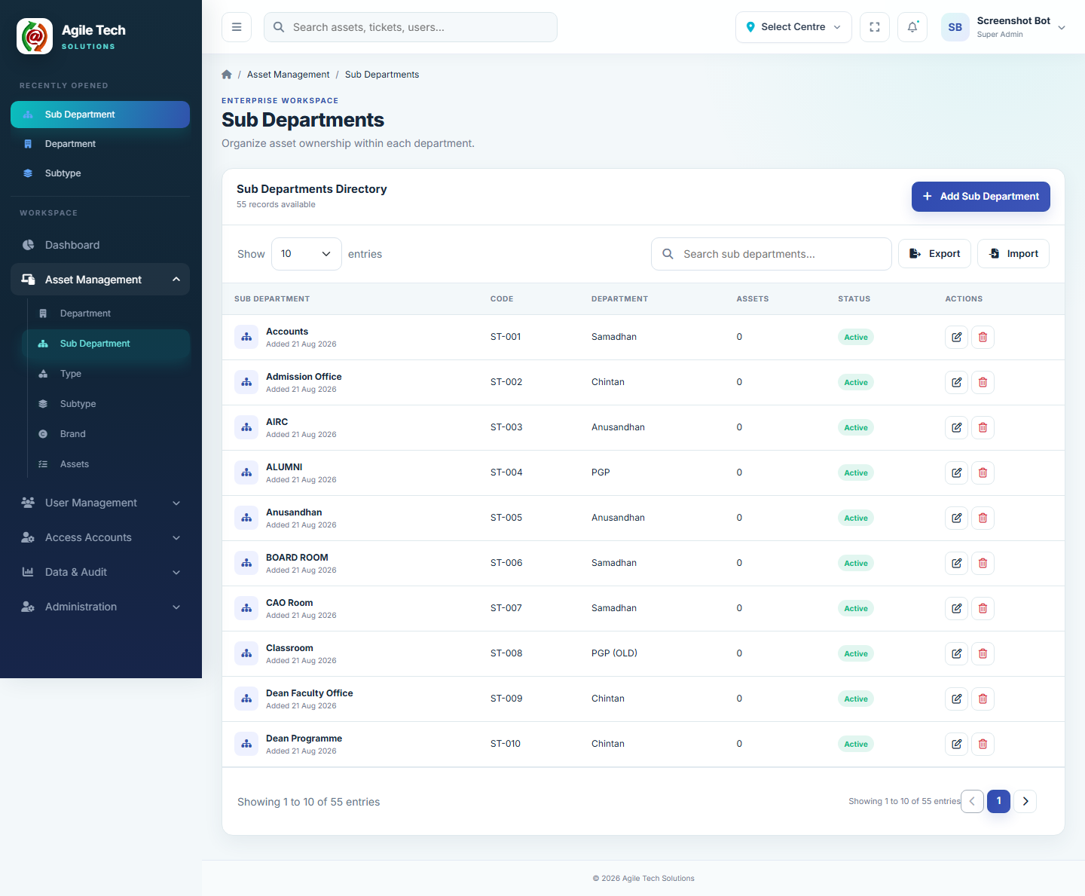
Figure 7.2 — Sub Department directory

Required / Optional Fields
Field | Required? | Notes
Name | Required | Max 255 characters.
Department | Required | Must be an existing Department.
Code | Auto-generated | Prefix ST.
Description | Optional | Max 2000 characters.
Status | Required | Active or Inactive.

Validation Rules
- Name and Department are required.
- On the Asset form, the Sub Department dropdown is filtered to the currently selected Department's own Sub Departments only.

Example
Sub Department “TRANSPORT” under Department “Samadhan”.

7.3 Brand

Purpose
The manufacturer/vendor master. Every Asset Subtype is tied to exactly one Brand, and that Brand flows through to every Asset that uses the Subtype.

How to Access
Sidebar → Asset Management → Brand.

How to Use
1. Click Add Brand.
2. Enter Name; optionally Country and Support Contact.
3. Optionally upload a Brand Logo (JPG/PNG/WebP, up to 2 MB).
4. Set Status and Save.
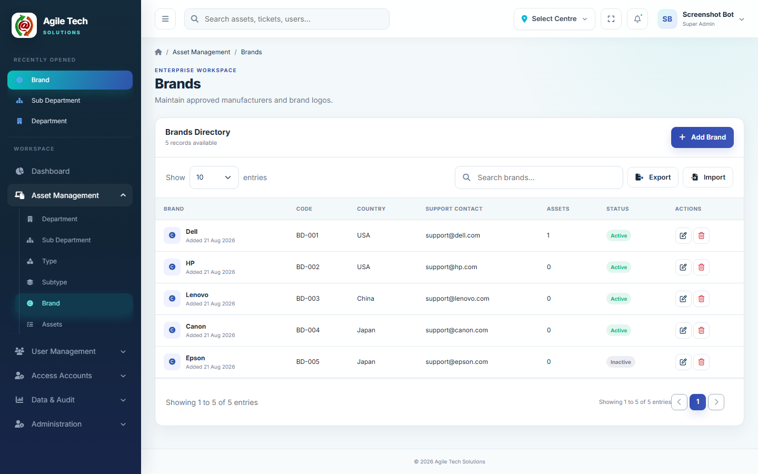
Figure 7.3 — Brand directory

Required / Optional Fields
Field | Required? | Notes
Name | Required | Max 255 characters.
Code | Auto-generated | Prefix BD.
Country | Optional | Max 100 characters.
Support Contact | Optional | Max 255 characters (email or phone).
Brand Logo | Optional | JPG, PNG or WebP, up to 2 MB.
Status | Required | Active or Inactive.

Validation Rules
- Name is required.
- Logo file, if provided, must be an image under 2 MB.

Example
Brand “Dell”, Country “United States”.

8. Asset Creation & Editing
Purpose: register a physical asset in inventory and keep its identification, ownership, and coverage details up to date.
How to access: Sidebar → Asset Management → Assets → Add New Asset (or the pencil icon on an existing row to edit).
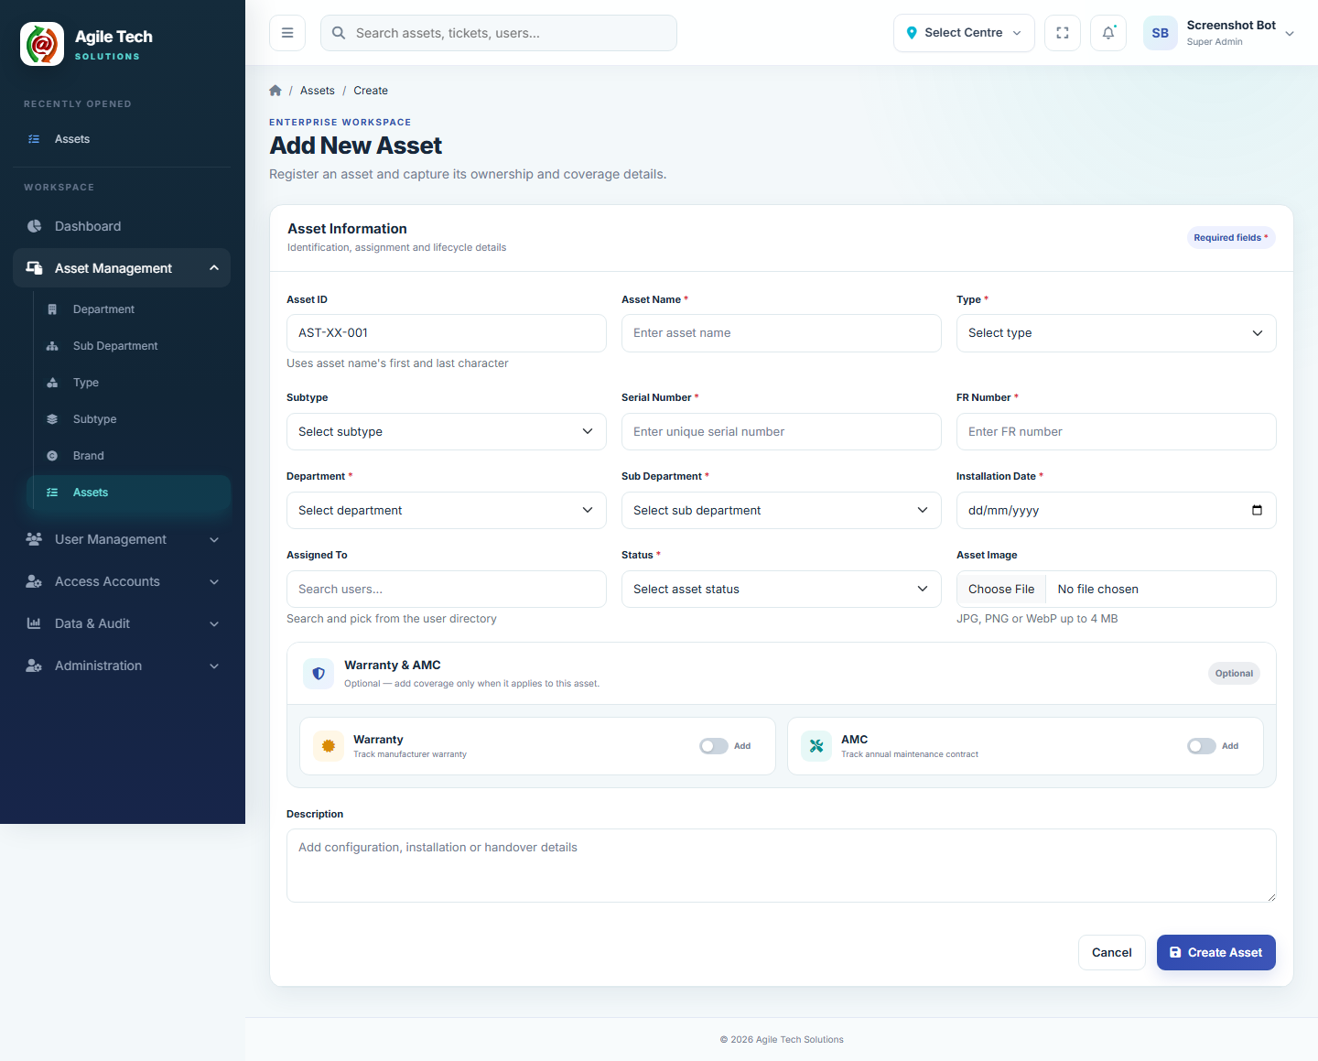
Figure 8.1 — Add New Asset form

8.1 How to Use
1. Enter the Asset Name.
2. Select Type. The Asset ID field is generated automatically from the asset name's first and last character plus a running sequence (e.g. AST-OR-001) — it cannot be typed.
3. Select Subtype (optional, filtered to the chosen Type). Once selected, the Subtype's configured parameters and their values are displayed as read-only reference underneath, and Brand is set automatically from the Subtype.
4. Enter Serial Number and FR Number (both required, Serial Number must be unique).
5. Select Department, then Sub Department (filtered to that Department).
6. Select Installation Date.
7. Optionally search and select Assigned To from the user directory.
8. Select Status.
9. Optionally attach an Asset Image (JPG/PNG/WebP up to 4 MB).
10. Optionally switch on Warranty and/or AMC and enter their expiry dates (Section 10).
11. Optionally add a Description.
12. Click Create Asset / Save Changes.

8.2 Required / Optional Fields
Field | Required? | Notes
Name | Required | Max 255 characters.
Type | Required | Must be an existing, Active Asset Type.
Subtype | Optional | Must belong to the selected Type; sets Brand automatically.
Brand | Set automatically | Taken from the selected Subtype; not entered directly.
Serial Number | Required | Must be unique across all Assets.
FR Number | Required | Max 255 characters.
Department | Required | Must be an existing, Active Department.
Sub Department | Required | Must belong to the selected Department.
Installation Date | Required | Valid date.
Assigned To | Optional | Free-text, populated by searching the user directory.
Status | Required | Active, In Stock, Under Maintenance, or Retired.
Asset Image | Optional | JPG, PNG or WebP, up to 4 MB.
Warranty Expiry | Optional | Only entered when the Warranty toggle is switched on.
AMC Expiry | Optional | Only entered when the AMC toggle is switched on.
Description | Optional | Max 5000 characters.

8.3 Validation Rules
- Name, Type, Serial Number, FR Number, Department, Sub Department, Installation Date and Status are all required.
- Serial Number must be unique — duplicate entries are rejected.
- Sub Department must belong to the selected Department, or the save is rejected.
- Subtype, if selected, must belong to the selected Type.
- Asset Tag/ID is never entered manually — it is always generated by the system.
Example: Name “Office Hour”, Type Laptop, Subtype Laptop (Brand Dell), Department Samadhan, Sub Department TRANSPORT, Serial Number 2354yrtjfd → Asset ID auto-generated as AST-OR-001.

8.4 Asset Details Page
Opening an Asset shows its full profile: identification fields, the Subtype's configured parameters and values, coverage dates, and (if permitted) a Delete Asset action in a clearly marked Danger Zone.

9. Asset Assignment & Status

9.1 Assigning an Asset from the Asset Form
The Assigned To field on Add/Edit Asset is a search box over the user directory. Typing filters the list live; selecting a name (or leaving it blank for Unassigned) sets that value directly on the asset.

9.2 Assigning an Asset from the User Directory
How to access: Sidebar → User Management → Users → open a user → Assign Asset (requires the faculty module's Assign permission).
1. Open Assign Asset for the user, and optionally set Filter by Asset Type to narrow the list.
2. Under “Available Assets to Add”, check one or more assets (only currently unassigned assets are listed). To remove an asset the user already holds, uncheck it under “Already Assigned to this User”.
3. Click Save Assignment Changes.
Assignment and unassignment are both handled in a single save, and multiple assets can be added to or removed from a user at once. For each newly checked asset, Assigned To is set to the user's name and its Status changes from In Stock to Active (any other status is left unchanged); for each unchecked asset, Assigned To is cleared and its Status reverts from Active to In Stock. Every assignment and unassignment is written to that user's Asset Assignment History and to the system Audit Log, and triggers a corresponding “asset assigned” or “asset unassigned” notification.
Note: An asset already assigned to someone is not offered again until it is unassigned.
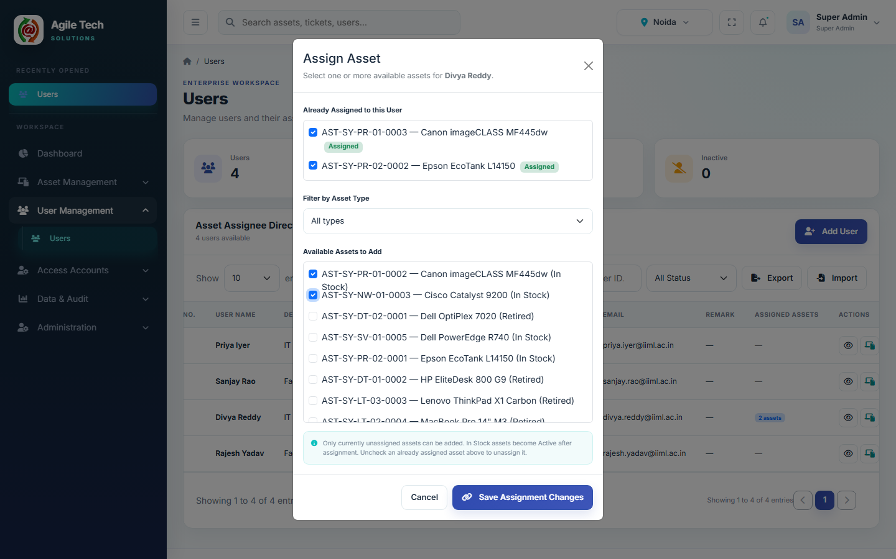
Figure 9.1 — Assign Asset modal: check multiple available assets to add them, or uncheck an already-assigned asset to remove it, then Save Assignment Changes.

9.3 Assignment History
Sidebar → User Management → Users → open a user (eye icon) to reach their Asset History page. It shows Total Assignments and Current Assets stat cards, a Current Assigned Assets table (every asset presently held, with type, serial number, assigned date and assigned by), and a full Assignment History table below it covering every past and current assignment (asset, department, assigned/unassigned date, assigned/unassigned by) — searchable and exportable to CSV. A user can hold, and this page will list, any number of currently assigned assets at once.
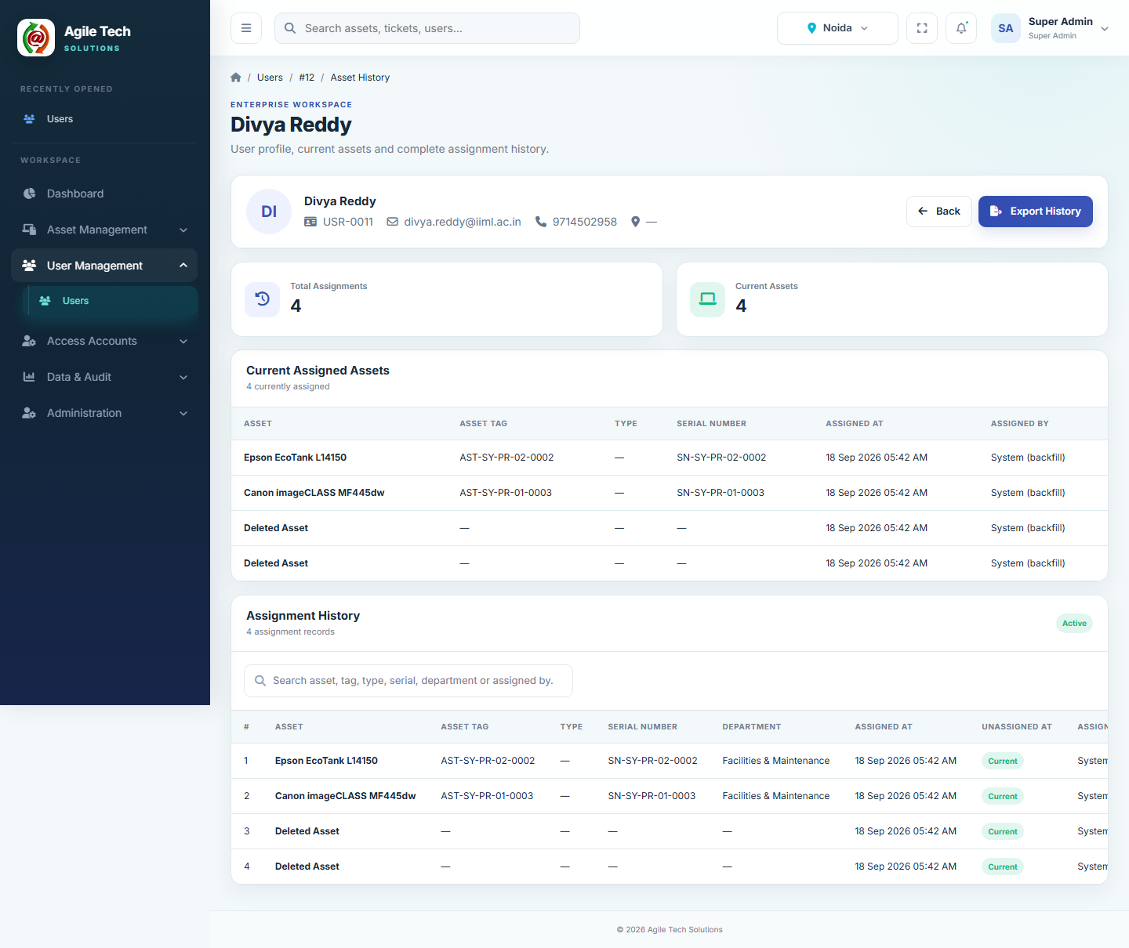
Figure 9.2 — Asset History page for a user with multiple currently assigned assets.

9.4 Asset Status Values
Status | Meaning
In Stock | Not yet assigned or deployed; the default for newly received assets.
Active | In active use — set automatically when an unassigned/In Stock asset is assigned.
Under Maintenance | Temporarily out of service for repair.
Retired | Decommissioned and no longer in active inventory rotation.

10. Warranty & AMC
Every asset can optionally track two independent coverage periods: manufacturer Warranty and Annual Maintenance Contract (AMC). Both are entirely optional — the Add/Edit Asset form shows them as two switchable cards under “Warranty & AMC”, add coverage only when it applies.

How to Use
1. On the Asset form, switch on Warranty and/or AMC.
2. Enter the corresponding Expiry Date.
3. Switching a toggle back off clears its date.

Where Coverage Is Surfaced
- Dashboard: AMC Due (30d) and Warranty Due (30d) stat cards, the Coverage Forecast chart (Expired / Due in 30 days / 31–60 days / 61–90 days), Upcoming AMC & Warranty panel (next 60 days), and Expired Assets panel.
- Assets list: a Coverage Due (30 days) filter for Warranty or AMC.
- Reports: Warranty and AMC filters with Available / Expiring (30 days) / Expired / No Coverage / Any Coverage options (Section 13).
Note: Both fields are plain optional dates — there is no reminder configuration beyond the fixed 30/60/90-day dashboard buckets and the Reports filters.

11. Asset Import / Export
Two independent bulk workflows exist: bulk Assets (Excel, one worksheet per Asset Type) and bulk Asset Subtypes (Excel, also one worksheet per Asset Type). Both reuse the exact same Type/Subtype/Brand master-data validation as the manual forms — nothing typed in a spreadsheet bypasses those checks.

11.1 Bulk Asset Import & Export
How to access: Assets list → Export / Import buttons.
Export and the sample download both open a Select Asset Types dialog (all types checked by default = “All”) before generating an .xlsx workbook with one sheet per selected Type.

Column Structure (per Type sheet)
Column | Required on Import? | Notes
Asset Tag | Optional | Leave blank to create a new asset; enter an existing tag to update that asset instead.
Name | Required
Asset Type | Required | Must match an existing Type, and must match the sheet it's on.
Subtype Code | Optional | Must belong to the sheet's Type.
Brand | Required | Must match an existing Brand.
Department | Required | Must match an existing Department.
Sub Department | Required | Must belong to the given Department.
Serial Number | Required
FR Number | Required
Installation Date | Required | Accepts YYYY-MM-DD, DD/MM/YYYY, DD-MM-YYYY, DD.MM.YYYY or MM/DD/YYYY — normalized automatically.
… one column per that Type's configured Subtype Parameters … | Optional | Value must match the selected Subtype's configured value if both are present.
Assigned To | Optional
Status | Required | Active, In Stock, Under Maintenance, or Retired.
Warranty Expiry / AMC Expiry | Optional | Same flexible date formats as Installation Date.
Notes | Optional

Import Behaviour
- Asset Tag blank → a new asset is created with an auto-generated tag.
- Asset Tag matches an existing asset → that asset is updated in place (never duplicated).
- Asset Tag provided but not found → a new asset is created using that exact tag.
- Every row is validated independently; valid rows are saved even if other rows in the same file fail — failing rows are listed with the sheet name, row number, and a plain-language reason.

Example Import Errors
- Row 12: Invalid Subtype Code: LAP-999
- Row 15: Subtype LAP-002 does not belong to Asset Type Desktop
- Row 18: Brand “XYZ” does not exist

11.2 Bulk Asset Subtype Import & Export
How to access: Asset Subtypes directory → Export / Import. Import also opens a Select Asset Types dialog (“All” by default) before downloading a sample; the resulting workbook has one sheet per selected Type.
Column | Required? | Notes
Name | Required
Code | Optional | Leave blank to create a new Subtype; enter an existing Code to update it.
Brand | Required | Must match an existing Brand.
Status | Required | Active or Inactive.
Description | Optional
… one column per that sheet's Type's configured parameters … | Optional

Because each sheet is dedicated to one Type, a Laptop sheet's Ram/Processor/cpu columns never mix with a Printer sheet's Color Support/Print Speed columns — there is no shared “parameter_values” text column to fill in.

11.3 Reading the “Expected CSV Columns” Panel
The Type and Subtype master modules also support a simpler flat CSV import (separate from the Excel workbook flows above), reached from their own Import buttons. Hover the (i) icon in that panel for a plain-language explanation of the column format, including that the Type module's Parameters column uses a pipe character ( | ) to separate multiple parameter names in one cell (e.g. RAM|Processor|Storage).
Note: Download Sample always reflects the live, current configuration — if you add a parameter to a Type, the next sample download for that Type includes the new column automatically.

12. Centre / Location Workflow
The system currently supports two Centres: Noida and Lucknow. Nearly every record type — Assets, Asset Types, Asset Subtypes, Brands, Departments, Sub Departments, the User directory, Notifications, Backups, and Audit Logs — carries a Centre value and is automatically filtered to it.

12.1 For Access Accounts (Manager/Admin/Auditor/Viewer)
- Each Access Account is created against exactly one Centre (set when the account is created).
- That user only ever sees and creates records in their own Centre — there is no Centre selector for them.

12.2 For Administrators
- A Select Centre dropdown appears in the top bar, offering All, Noida, and Lucknow.
- Choosing Noida or Lucknow scopes every screen to that Centre's records only, and any record the Administrator creates while that Centre is selected is automatically stamped with it.
- Choosing All removes the Centre filter, showing every record from every Centre at once.
- Certain create/update actions (for example, adding a User or Access Account, or editing Roles & Permissions) require the Administrator to have a specific Centre selected — with All selected, the system responds “Please select a specific Centre before performing this action.”
Note: Switching Centre does not move or duplicate data — it only changes which existing records the current view shows.

13. Search, Filters and Reports

13.1 Global Search
The search box in the top bar searches live as you type (minimum 2 characters), across three groups, each limited to 5 results:
Group | Matches On
Assets | Asset Tag, Name, Serial Number, FR Number.
Users | Name, Email, Unique ID, Contact number.
Access Accounts | Name, Email, Unique ID, Contact number — Manager/Admin/Auditor/Viewer login accounts, each only shown if your role has View on that role’s Access Accounts module.

Clicking a result opens that Asset's detail page, or — for a login-enabled user — that user's Access Account list filtered to them; a non-login user opens the User Directory instead.

13.2 Asset List Filters
- Search — Name, Asset Tag, Serial Number, or FR Number.
- Type, Department, Status.
- Installation Date range (From/To).
- Assigned filter — Assigned only or Unassigned only.
- Coverage Due (30 days) — Warranty or AMC expiring within the next 30 days.
- Sortable by Name, Serial Number, Installation Date, or Created date; page size of 10/25/50/100.

13.3 Reports
How to access: Sidebar → Data & Audit → Reports.
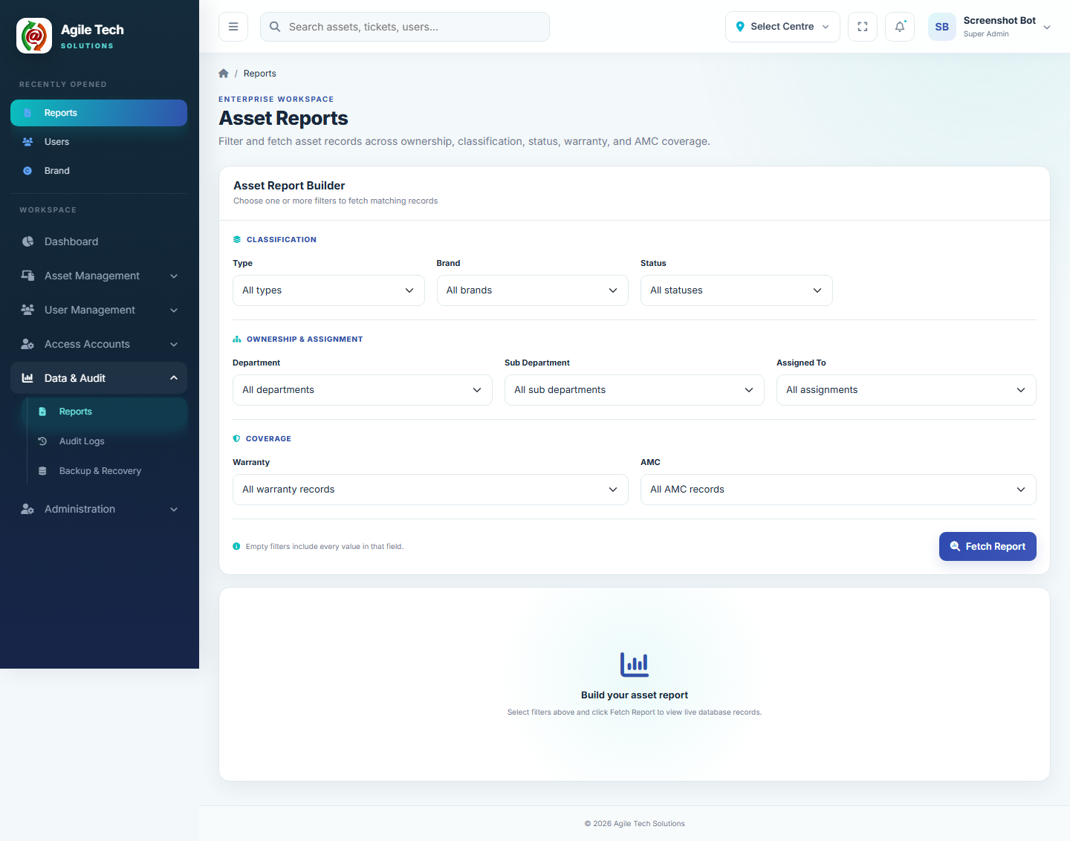
Figure 13.1 — Reports screen
1. Choose any combination of filters: Asset Type, Brand, Department, Sub Department, Assigned To, Status, Warranty coverage, AMC coverage.
2. Click Generate Report to run the filters and show a paginated result with summary counts (Total, Assigned, Warranty Due, AMC Due).
3. Export to CSV or Export to Excel to download the exact filtered result set.

Coverage Filter Options (Warranty and AMC, independently)
Option | Meaning
Available | Expiry date is more than 30 days away.
Expiring | Expiry date falls within the next 30 days.
Expired | Expiry date is in the past.
No Coverage | No expiry date set.
Any Coverage | An expiry date is set, regardless of when.

Note: Every report export is written to the Audit Log and triggers a system notification recording the filters used and the number of matching records.

14. Notification & SMTP Settings
Sidebar → Administration → Settings. Both tabs sit under the Settings: Advanced permission (settings_advanced) — a role needs the parent Settings module access box ticked as well as this sub-permission, or the tabs do not appear. View-only access shows the saved configuration with every field disabled; Update access is required to save changes.

14.1 Notification Settings

Purpose
Controls, per system event, whether an in-app notification and/or an email alert is sent, independently of one another. Preferences are scoped per Centre — each Centre keeps its own on/off switches for the same list of events.

How to Access
Sidebar → Administration → Settings → Notification Settings tab.

How to Use
1. For each Alert row, toggle the In-app switch and/or the Email switch.
2. For the two expiry alerts (AMC, Warranty), the fixed lead time — 30 days before expiry — is shown next to the alert name and is not editable from this screen.
3. Click Save Preferences to apply the changes.
4. Click Advanced Rules to open the full Notifications & Alerts centre for finer-grained alert rules (requires the notifications module View permission).

Available Alert Events
Event | Fires When | Default In-app | Default Email
AMC expiry alert | 30 days before an asset's AMC coverage expires. | On | On
Warranty expiry alert | 30 days before an asset's warranty expires. | On | On
New user alert | A User is created in the User Directory. | On | On
Deleted user alert | A User is deleted. | On | On
New access account alert | An Access Account (Manager/Admin/Auditor/Viewer) is created. | On | On
Deleted access account alert | An Access Account is deleted. | On | On
Asset assignment alert | An Asset is assigned to a user. | On | On
Report generation alert | A Report is generated or exported. | On | On
Asset unassignment alert | An Asset is unassigned from a user. | On | On
Backup completed alert | A Backup finishes successfully. | On | On
Backup failure alert | A Backup fails. | On | On
Backup health alert | The scheduled backup health check finds an issue. | On | On

Validation Rules
- Both switches can be off at once — the event still occurs, it simply is not surfaced.
- Email alerts are only actually delivered if SMTP Settings are Enabled with a working configuration — see Section 14.2.
Note: Turning Email on for an alert here does not itself add recipients — emails go to the Alert Recipient Emails configured on the SMTP Settings tab.

14.2 SMTP Settings

Purpose
Configures the outgoing mail server used for every notification email the system sends. Settings saved here are stored in the database and override the server's MAIL_* environment defaults at runtime, without requiring a redeploy.

How to Access
Sidebar → Administration → Settings → SMTP Settings tab.

How to Use
1. Turn on Enable email delivery to activate these settings for notification emails.
2. Enter SMTP Host and Port (e.g. smtp.office365.com, port 587).
3. Optionally enter a Username and Password for the mail account.
4. Choose Encryption — TLS, SSL, or None.
5. Enter From Name and From Email — shown as the sender on outgoing alert emails.
6. Enter one or more Alert Recipient Emails, separated by commas, semicolons, or spaces.
7. Click Save SMTP Settings.
8. Click Send Test Email to confirm delivery before relying on the configuration.

Required / Optional Fields
Field | Required? | Notes
Enable email delivery | — | Master switch; while off, no notification emails are sent regardless of other fields.
SMTP Host | Required if enabled | Max 255 characters.
Port | Required if enabled | Numeric, 1–65535.
Username | Optional | Max 255 characters.
Password | Optional | Stored encrypted; leave blank on edit to keep the saved password.
Encryption | Optional | TLS, SSL, or None.
From Name | Required if enabled | Max 255 characters.
From Email | Required if enabled | Must be a valid email address.
Alert Recipient Emails | Required if enabled | Comma/semicolon/space-separated list, max 2000 characters.

Validation Rules
- Host, Port, From Name, From Email, and Alert Recipient Emails are only mandatory while Enable email delivery is on — they can be left blank while it is off.
- Send Test Email requires the configuration to already be Enabled with a Host and at least one recipient saved, otherwise the system responds “Enable SMTP and provide a host and notification recipient first.”

Example
Host smtp.office365.com, Port 587, Encryption TLS, From Name “Agile Tech Solutions IIM”, From Email alerts@agiletechsolutions.com, Recipients admin@agiletechsolutions.com, assets@agiletechsolutions.com.
Note: The password field never re-displays a saved password — it always shows as blank with a “Saved — leave blank to keep” placeholder, and is only replaced if a new value is typed.

15. Validations and Common Errors
A consolidated reference of validation messages you may encounter and what causes them.

15.1 Client-Side Field Validation (Real-Time)
A shared script (validation.js) runs live on every Add/Edit form across Assets, Users, Backups and Settings, and a separate Name Picker component is used for name fields on Department, Sub Department, Brand and similar master-data forms. Both validate as you type, before the form is even submitted.
- Name fields (name="name"): up to 50 characters; an inline error appears the moment the limit is exceeded.
- Name Picker fields (e.g. Department Head, Sub Department Manager): letters and spaces only, 3–50 characters — enforced live as you type via a type-ahead combo box.
- Email fields (type="email"): must match a standard name@domain.tld pattern.
- Phone / Contact fields (name="contact" or "phone"): non-digit characters are stripped automatically as you type, and the field must end up exactly 10 digits.
- Any field marked required: the browser blocks submission and shows an inline “Please fill out this field” prompt on the first empty required field.
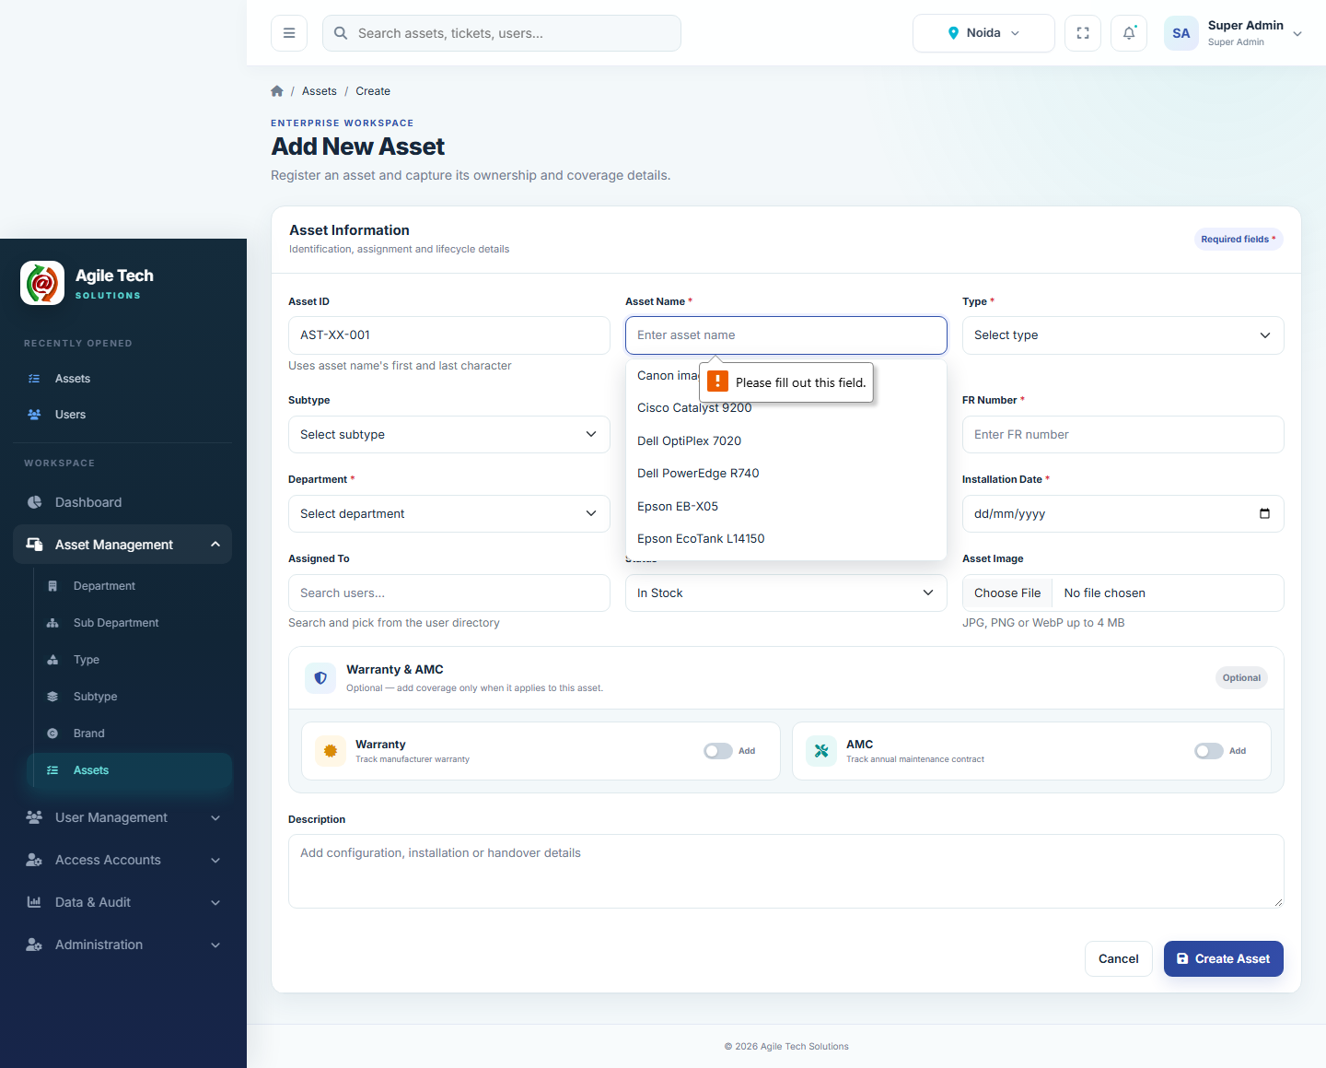
Figure 15.1 — Required-field validation on the Add Asset form.

15.2 Server-Side Validation Messages
If a rule above is bypassed (e.g. the request is submitted directly) or the issue can only be detected on the server, one of the following messages is returned instead:
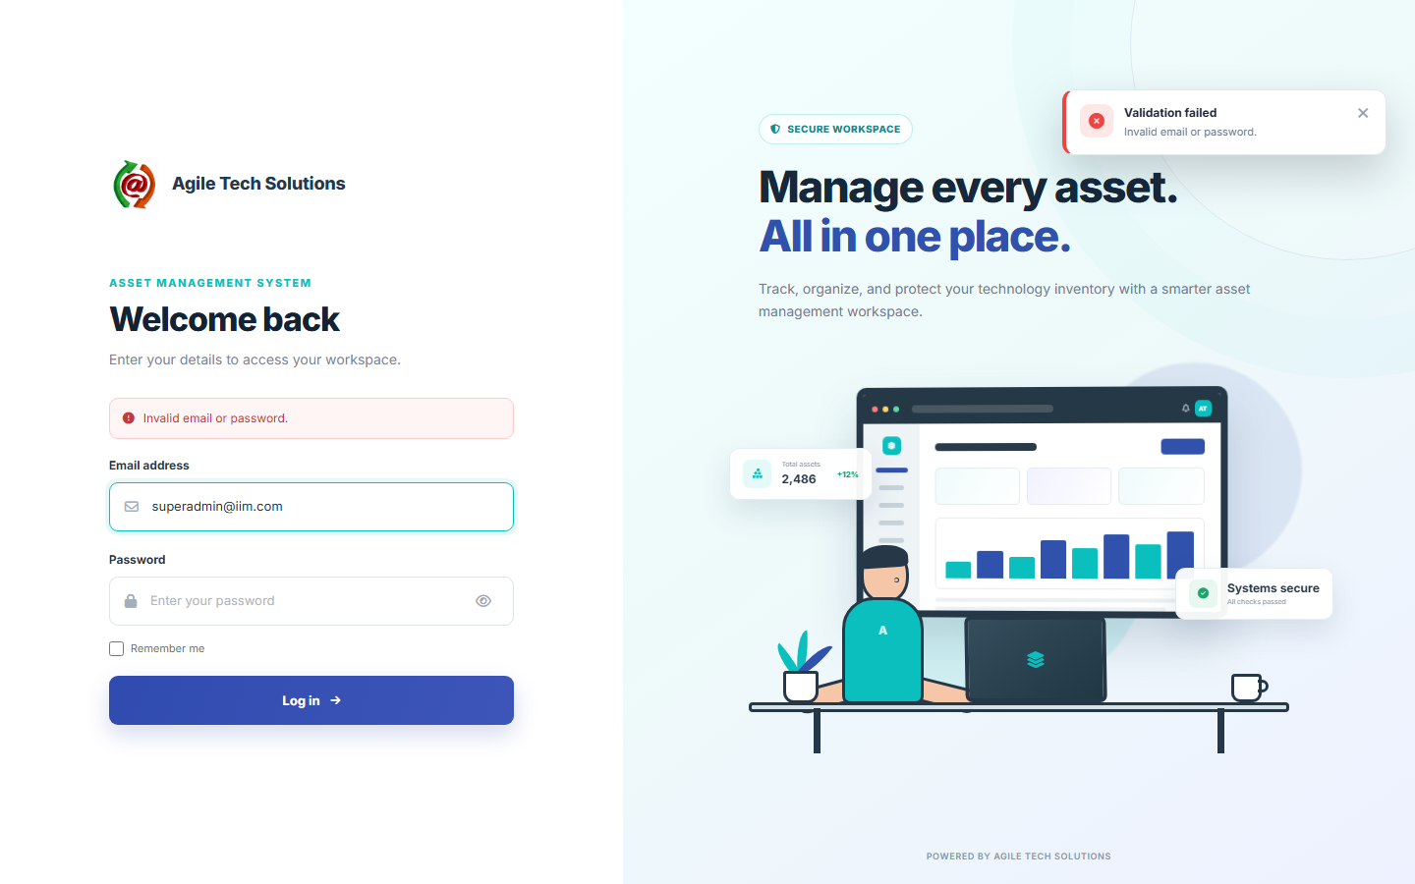
Figure 15.2 — Server-side validation error shown on the Login screen.
Message | Where | Cause / Fix
Invalid email or password. | Login | Wrong credentials, or the account is Inactive / login-disabled.
Your account does not have access to any module. Contact an administrator. | Login | The account exists but has no View permission on any module.
Please select a specific Centre before performing this action. | Various (Administrators) | Centre selector is set to All; pick Noida or Lucknow first.
This asset is no longer available for assignment. | Assign Asset | Someone else was assigned this asset in the meantime, or it changed Type.
Asset Type “…” does not exist. | Asset bulk import | The Asset Type column value does not match any existing Type name.
Asset Type “…” does not match this sheet's Asset Type “…”. | Asset bulk import | The row's Asset Type column disagrees with the sheet it is on.
Invalid Subtype Code: … | Asset / Subtype bulk import | The Subtype Code column value does not match any existing Subtype.
Subtype … does not belong to Asset Type … | Asset / Subtype bulk import | The Subtype exists but under a different Type than the sheet.
Brand “…” does not exist. | Asset / Subtype bulk import | The Brand column value does not match any existing Brand — brands are never auto-created.
… value “…” does not match the configured value “…” for Subtype “…”. | Asset bulk import | A parameter column's value disagrees with what is configured on that row's Subtype; fix the sheet or the Subtype configuration.
Parameter “…” is required for Subtype “…” but has no configured value. | Asset bulk import | The Subtype has “Required field” checked but one of its Type's parameters was left blank on the Subtype itself — fill it in on the Subtype form first.
… must be a recognized date … | Asset bulk import | The date column could not be parsed in any supported format — use YYYY-MM-DD, DD/MM/YYYY, DD-MM-YYYY, DD.MM.YYYY, or MM/DD/YYYY.
This {record} is in use and cannot be deleted. | Any master module | Another record (Sub Department, Asset, etc.) still references it.
Serial Number must be unique / Asset Tag ’…’ already exists. | Asset form / import | Another asset already uses that Serial Number or Asset Tag.

16. Complete Recommended Workflow
The order below sets up master data in the sequence each step depends on, then moves into day-to-day operation.
1. Administrator selects the correct Centre (or All, for cross-centre setup).
2. Configure Roles & Permissions for the four dashboard roles.
3. Create Departments, then their Sub Departments.
4. Create Brands.
5. Create Asset Types and define each one's Subtype Parameters.
6. Create Asset Subtypes under each Type, selecting Brand and filling in every parameter value.
7. Create Access Accounts (Manager/Admin/Auditor/Viewer) and add Users to the User Directory.
8. Add Assets one at a time, or prepare and import a bulk Asset workbook (download the sample for the relevant Types first).
9. Assign assets to users, either from the Asset form or from the user's Assign Asset action.
10. Add Warranty/AMC coverage where it applies.
11. Use the Dashboard and Reports to monitor coverage expiry, assignment status, and system activity on an ongoing basis.
12. Use Export (Assets, Subtypes, or Reports) whenever data needs to leave the system for offline review or another system.

17. FAQ and User Best Practices
Q: Why can't I type the Asset ID or a master record's Code myself?
A: Both are generated automatically when the record is saved, using a fixed prefix per module (e.g. TE for Types, SY for Subtypes, DT for Departments) so codes stay unique and consistent.
Q: Why is the Brand field missing from the Asset form?
A: Brand is no longer chosen directly on an Asset. It comes from the Subtype you select, since every Subtype already has its own fixed Brand.
Q: I selected a Type but no Subtypes appear — why?
A: That Type has no Subtypes configured yet. Create at least one Subtype under it (Section 6.2), or leave Subtype blank and create the Asset against the Type alone.
Q: Why does my bulk import say a value “does not match the configured value”?
A: The parameter value typed in your sheet disagrees with what is saved on that Subtype's own configuration. Update the Subtype record (or correct the sheet) so both agree.
Q: Can I import a brand new Asset Type or Brand through the Asset import?
A: No. Types and Brands are never created automatically during import — they must already exist in their own master modules first.
Q: What happens if I re-import a file with the same Asset Tag or Subtype Code?
A: The matching Asset or Subtype is updated in place, not duplicated. Leave the Tag/Code column blank to always create a new record instead.
Q: Why can't I see records another Centre created?
A: Almost all data is scoped to a Centre. As an Access Account you only see your own Centre; as an Administrator, switch Select Centre to All to see everything.
Q: Why don't my permission changes seem to apply to a user I'm testing with?
A: Permissions are checked live from the Roles & Permissions table by Role, not cached per user session in a way that requires re-login — double-check the correct role tab was saved.
Q: An asset I assigned still shows Status “Under Maintenance” — is that a bug?
A: No. Assignment only auto-changes Status from In Stock to Active; any other status (including Under Maintenance) is left exactly as it was.

Best Practices
- Set up Departments, Brands, and Asset Types/Subtypes completely before bulk-importing Assets — imports validate against these masters and never create them automatically.
- Keep Subtype parameter values accurate and complete; they are shown as the specification of record on every asset that uses that Subtype.
- Use Download Sample before every bulk import so the column set always matches your current configuration exactly.
- Reserve the All Centre view for genuinely cross-centre administrative work; do day-to-day data entry with a specific Centre selected so new records are stamped correctly.
- Review the Dashboard's Coverage Forecast and Reports' Warranty/AMC filters regularly so coverage renewals are never missed.
- Grant the narrowest permission set a role actually needs — View alone for reference-only roles, and reserve Delete/Import for the accounts that truly require them.

