**Step2:**

Deliverable 1: .idea, src, out and Lab1.iml

Deliverable2 : Java.base, Java.compiler and java.datatransfer

**Step5:**

Deliverable 3: This is the code in BuddyInfo.java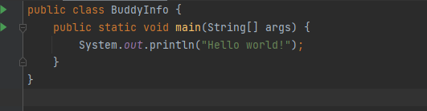

**Step7:**

Full path to execuatable : C:\Users\Administrator\IdeaProjects\Lab1\out\production\Lab1