

Benchmark

Charles Henderson



April 20, 2019

CST-235

Jackson

Classes: 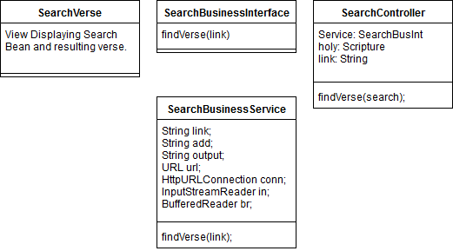

Here is the REST search interface that stores the JSON object as a string and displays it: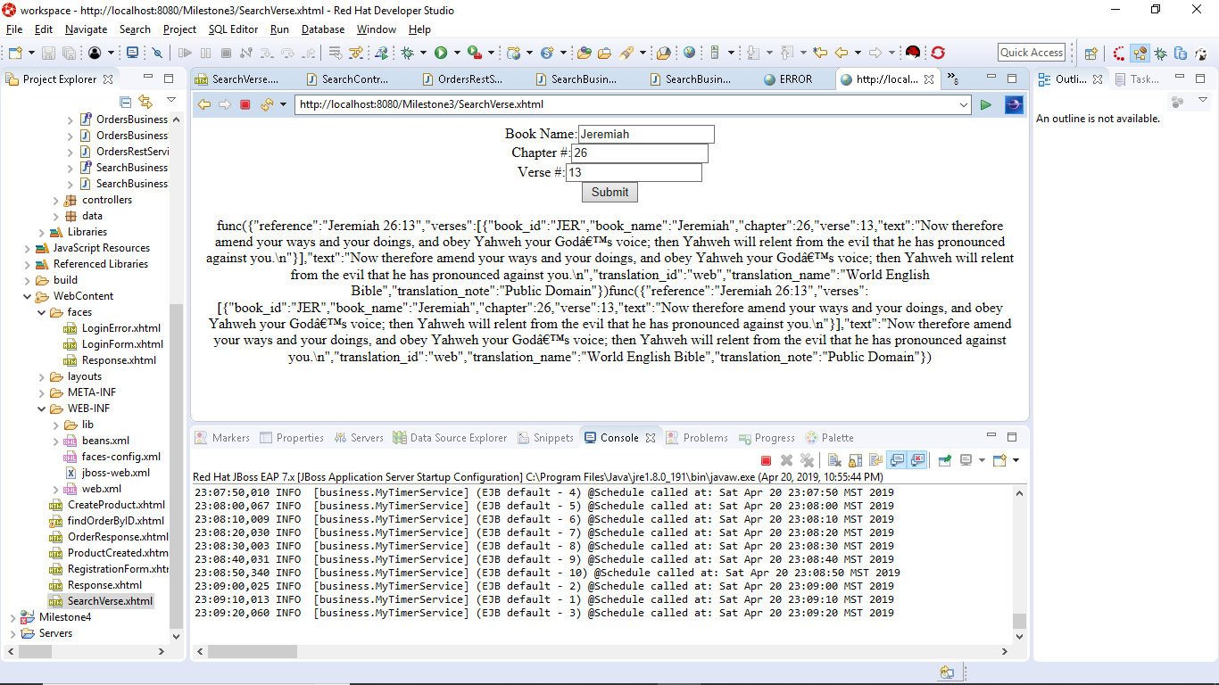

Main section of code that gets JSON from link and stores it in object: 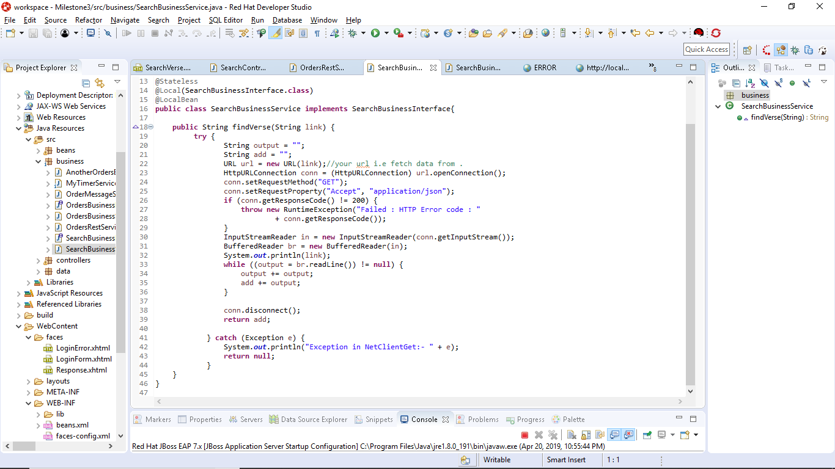

Theory of Operation:

In this fresh utilization of consuming an API, we separate ourselves a little bit from our previous attempts at displaying JSON’s in rest services. This one takes more of a deliberate approach and concatenates a search into a URL address which contains the JSON information. The flow of the information starts at the View, and sends the search as an object to the search controller. From here, I’ve injected an interface that also contains the find verse function in the implementation of the interface also known as the search service. The search service is actually very familiar to the method we used in the previous REST implementation for the in class activity. Once the sought after JSON object is read from the page, it then displays everything in a giant search block on the page. If I had more time, I would have cleaned up some of the results. As for now, however, this has been a great introduction to REST API services.

https://github.com/agingdanger/CST-235