Name(s)_______________________________________________ Period _______ Date _____________________

|  |  |  |
| --- | --- | --- |
|  | **Personal Web Page - Prepare** |  |

**Overview**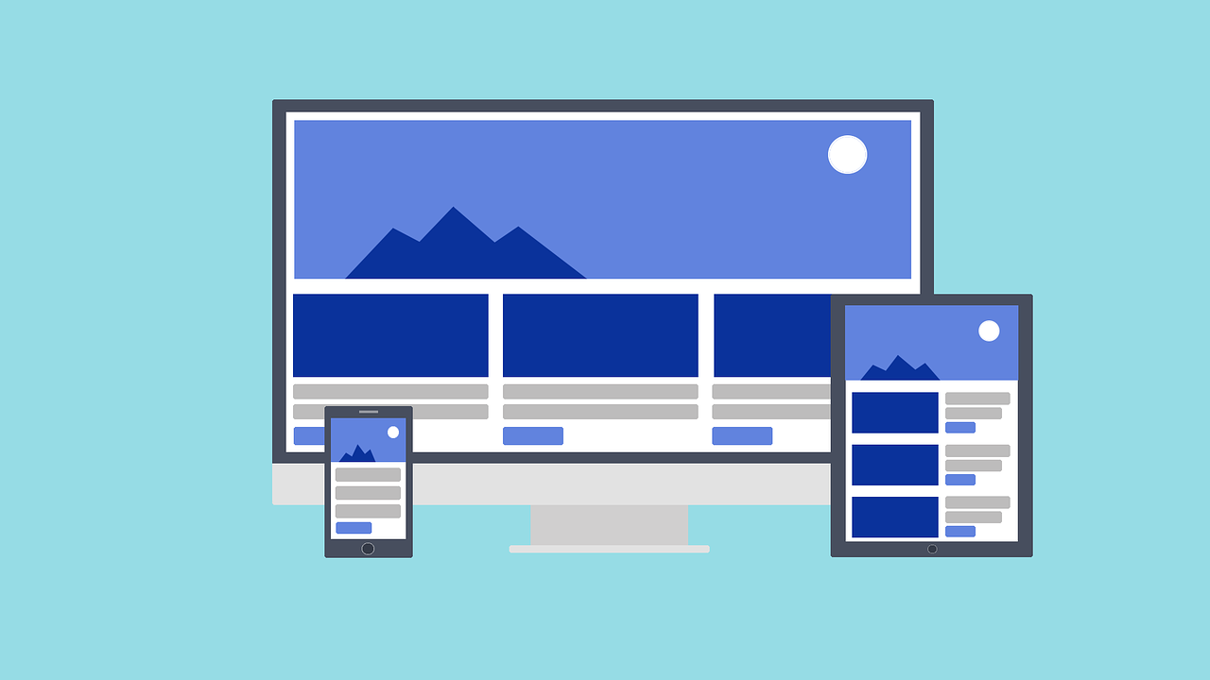

You’ve already **defined** your goal for your personal web page. Now you’ll have a chance to **prepare** to develop your page.

Your page will show that you can…

* Use HTML to structure a site
* Use CSS to style text and layout
* Respect copyright when using images
* Keep your personal information safe
* Write readable code and use good file names

## Step 1: Design your Page

**Describe your page**

_____________________________________________________________________________________________

_____________________________________________________________________________________________

**Sketch your page below.**

|  |
| --- |
|  |

## Step 2: Describe your Styles

Next, decide the tags that you will use on your page and how each tag will be styled.

|  |  |
| --- | --- |
| Tag | Style Description |
|  |  |
|  |  |
|  |  |
|  |  |
|  |  |

## 

## Step 3: Find Your Images

Next, you should find all the images that you need and download them to your computer. **Rename each image** and write the file name here. Don’t forget to write down all the information about the image, such as the author, title, source, and license it is covered under.

|  |  |
| --- | --- |
| Image File Name | Image Information (Author, Title, Source, License, etc.) |
|  |  |
|  |  |
|  |  |
|  |  |
|  |  |