### Electron + Angular 2 Application to Import CSV to mongoDb

#### Brief Users Guide

1. Set the connection string to your mongoDb database in file config/default.json.

It looks like:

{

"MongoDbParameters": {

"connectionString": "mongodb://<user_name>:<password>@ds019076.mlab.com:19076/<database_name>"

}

}

2. Run the program, using the command “npm start” and select the collection where you are going to import data:

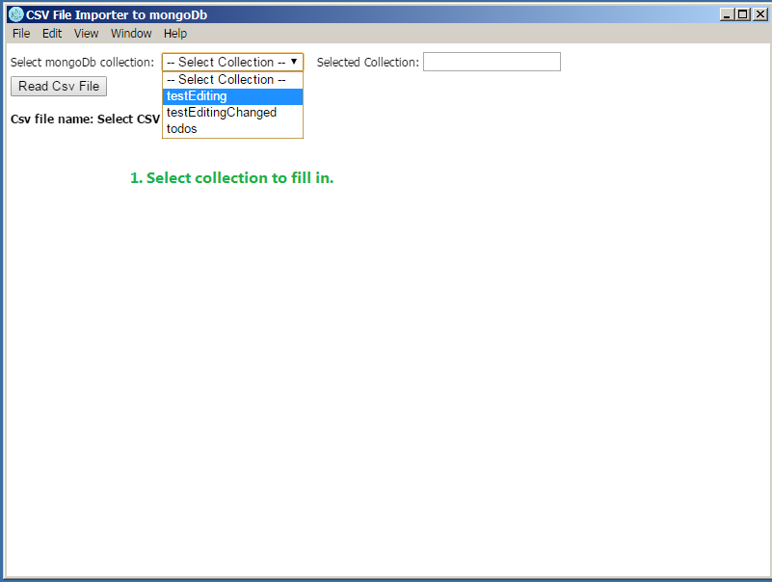

3. The collection name you have selected is editable (if collection is absent it will be created automatically):

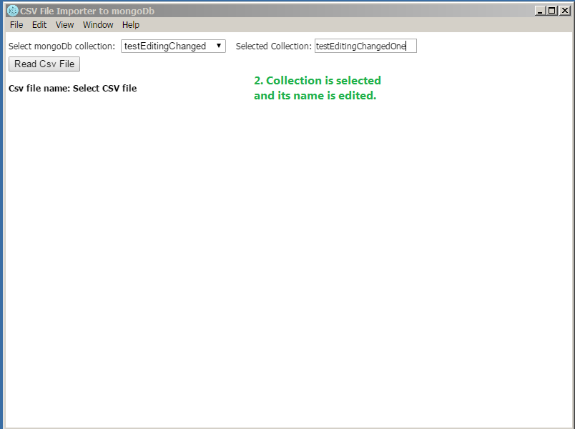

4. Select the csv file to import into selected collection (click the button “Read Csv File”:

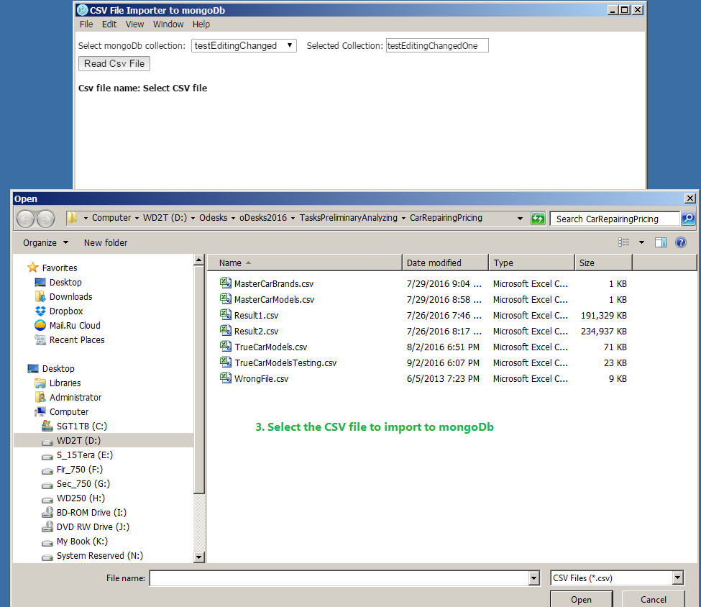

5. You will see the selected file name and its content. After content review click the button “Copy CSV to MongoDb”:

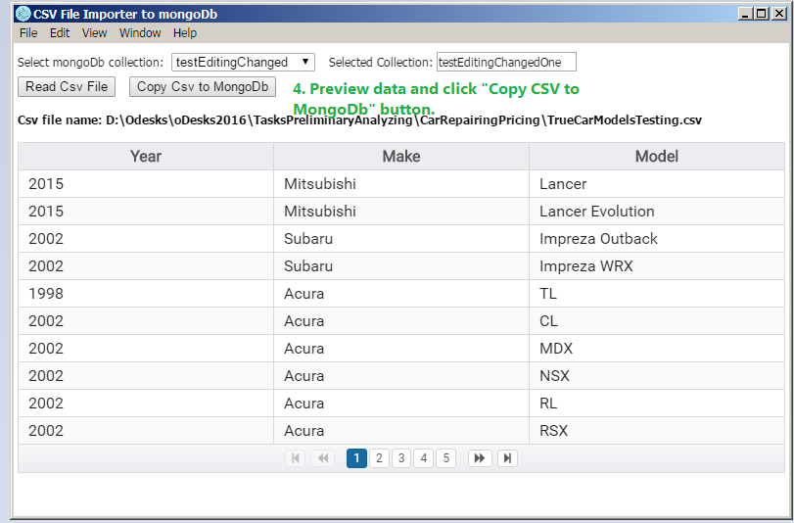

6. You can review the copied data using any mongoDb client:

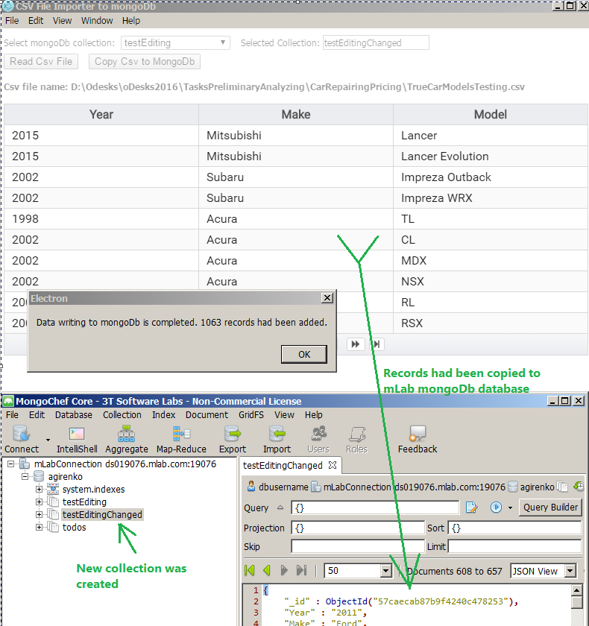

7. Program source code is available on github:

https://github.com/agirenko/CsvToMongoDbAngular2Electron