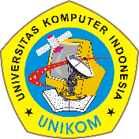Universitas Komputer Indonesia

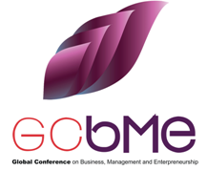

**Website: https://unikom.ac.id/  
Email:** [**timkonferensi@email.unikom.ac.id**](mailto:icobest@email.unikom.ac.id)

**­**

Date: 23 September 2022

Payment Receipt

The organizing committee recognizes the following payments for the Bibliometric Analysis Workshop and Paper Coaching:

**Paid By** :Mrs. Tuti Anggraeni

**Affiliation** :Universitas Winaya Mukti

**Payment** : IDR 1,000,000

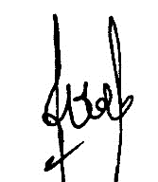Thank you.   
Best regards,

Senny Luckyardi, S.P., M.M.

Head of UNIKOM International Publication Team

Universitas Komputer Indonesia - 2022

­