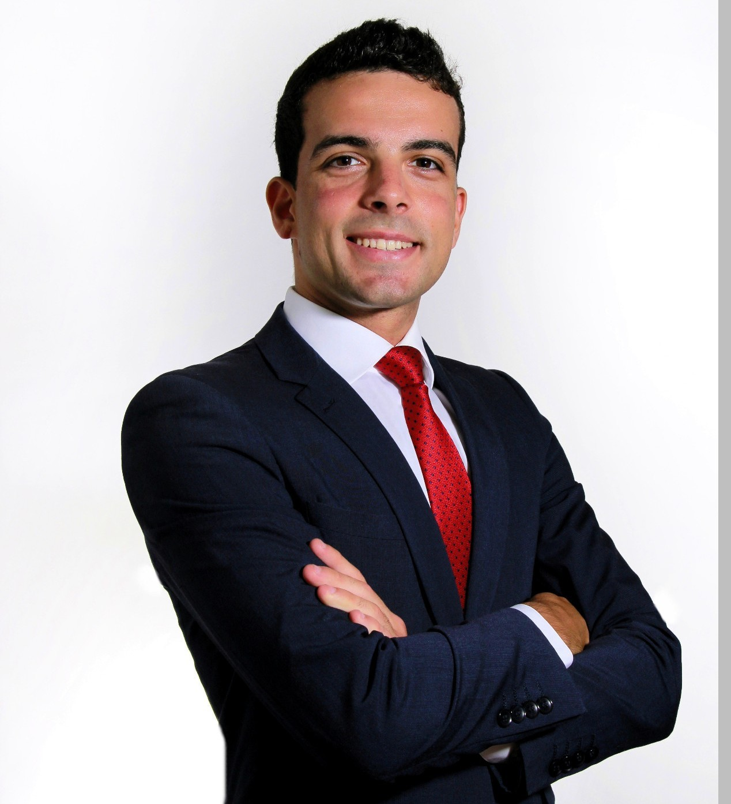


A. Giuliano Mirabella
+34 611150324
amirabella@us.es
22-years-old Biomedical Engineer, CS researcher & Physics student

Education
University of Seville
Biomedical Engineering Degree (best academic record) …………………………………………. 2016 – 2020
Master’s Degree in Software Engineering: Data Science …………………………………………… from 2020

Spanish Distance Education University
Physics Degree ………….…………………………………………………………………………………….. from 2018

Languages & Skills
• Spanish: native; Italian: native; English: advanced (Cambridge C1); Portuguese: basic
• Programming in Python, R, Java, MATLAB, C, etc... Experience with HTML, JS, Linux-based OS
• Specialized in images processing with Python: numpy, scikit-image, scipy.ndimage, etc..

Relevant Works
• AI and Digital Images Processing Techniques in Melanoma Detection
• Sternum Bone Marrow Segmentation
• Review4You: social network for Harvard CS50W’s course on web programming with Python and JS
• Topological Analysis of n-dimensional Images in Python
• Some toy automation apps

Professional Experience
• University of Seville
- Graduate Research Assistant @ Computer Languages and Systems Department ………. from 2020
- Undergraduate Research Assistant @ Applied Mathematics Department …………………………. 2019

• Personal Tutor …………………………………………………………………………………………… 2016 - 2018
- Object-oriented programming in Java, Algorithms & Data Structures in Java, Electronics
- Applied Mathematics, to economics students

Additional Information
• Big fond of music; I play the piano, ukulele, and classic and electric guitar
• Passionate science books reader
• “Introduction to Neuroimaging Computation Techniques” course, by Brain Dynamics SL
• Graduated in high school with honors

Yet More Additional Info
Despite having always been driven by medicine, when I began Bioengineering I discovered the formal knowledge – pure maths and philosophy – inspired me much more than the tangible one, so much so that I just felt bound to enroll in Physics: I wanted to learn fluent universe.

Some time afterwards I met Artificial Intelligence, which combines the best of both worlds: the theoretical mathematical-modelling challenge, and the encouraging potential to enhance healthcare, by improving diseases detection and treatment.

Since I began my journey at University of Serville as a researcher, I have dreamt of a day when I could devote my time to developing medical and bioinformatics technologies that could drastically impact millions of peoples’ lives.

