Calculator App using HTML & Javascript
Description:
A sleek, dark-themed digital calculator featuring a grid layout for numeric and operator buttons. The application provides a standard interface for mathematical operations, including division, multiplication, addition, and subtraction.
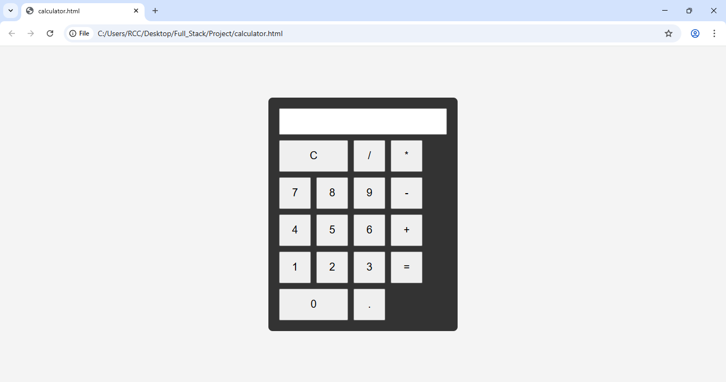
Sample website using HTML, CSS & Javascript
Description:
A sophisticated sample administrative dashboard branded as "ARCHITECT.OS" that monitors global infrastructure. It includes a sidebar for developer tools, a "System Health" monitor with a "Recent Activity" feed.
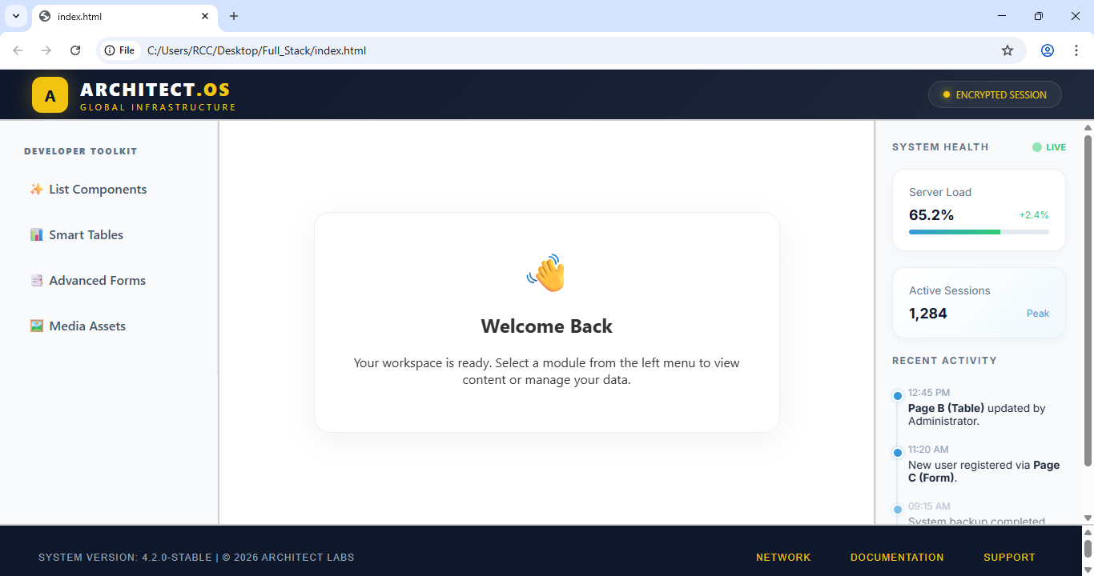
Simple Group chat Application using Angular
Description:
A multi-user communication interface built on the Angular framework that simulates three distinct chatboxes. Each "person" has an individual input field and send button to facilitate local group messaging.
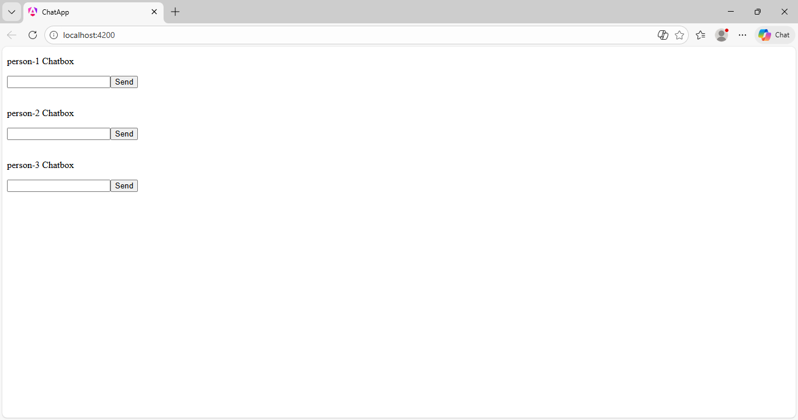
Simple Gaming Console App using Angular
Description:
A modern, interactive game selection hub that allows users to choose between four classic titles: Retro Snake, Brick Breaker, Tank Battalion, and Flappy Bird. Each game is presented in a stylized card with a "Press Start" prompt.
