**DATABASE MANAGEMENT SYSTEM**

**PROJECT - SET-1**

Submitted to

Dr Vishesh P. Gaikwad

**Group Members:**

* BT21CSE001 KESHAV AGARWAL
* BT21CSE060 NIRMIKA GAIKWAD
* BT21CSE072 BINIT GALA

**Problem Statement:**

A college contains many departments. Each department can offer any number of courses. Many instructors can work in a department, but an instructor can work only in one department. For each department, there is a head, and an instructor can be head of only one department. Each instructor can take any number of courses, and a course can be taken by only one instructor. A student can enroll for any number of courses and each course can have any number of students.

In the above-stated raw problem, you need to play the role of a user as well as the developer and develop the mini-project from scratch. The project should meet all design goals from the general user perspective from start to end. Therefore you should need to strictly adhere following conditions while developing the project:

1. Identify all of the entities which will be useful in order to complete the goal of the project with respect to the perspective of the general user. 2. Design an ER-Diagram to draw a relationship between each of the entities. 3. Convert the ER-Diagram to 3NF tables. 4. Design a working module which includes the front-end and back-end to achieve the goal of the project. Some of the goals are as follows:

a. Create a Web interface for data manipulation (insert, update and delete)

b. Create a web interface to access the records based on the role of users (such as account info can be accessed by account personal as well as by admin)

c. Develop a web interface to specify the schedule of exams and also show the performance of particular student marks.

d. Develop a web interface for faculty for marks evaluation as well as marks update.

e. Apart from this, please use your own intuition to add further modules.

5. Also add indexing concept to enhance the model performance.

**Requirement Analysis:**

● College has several departments. ● College has several instructors. ● Several instructors can work in one department. ● An instructor can work in only one department. ● Every department has a head who is an instructor. ● An instructor can head only one department. ● Each department can offer any number of courses. ● An instructor can only take a course offered by his department. ● Each instructor can take any number of courses. ● A course can be taken by only one instructor. ● College has several students. ● A student can enroll for any number of courses. ● Each course can have any number of students.

**ER Diagram:**

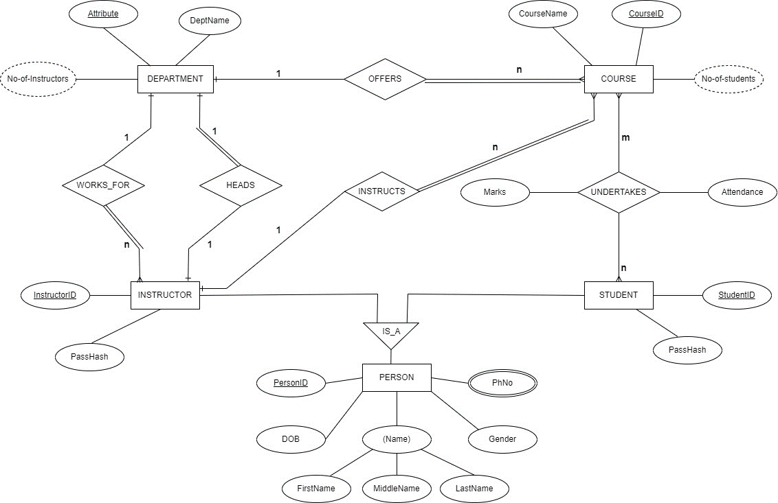

**Relational Schema:**

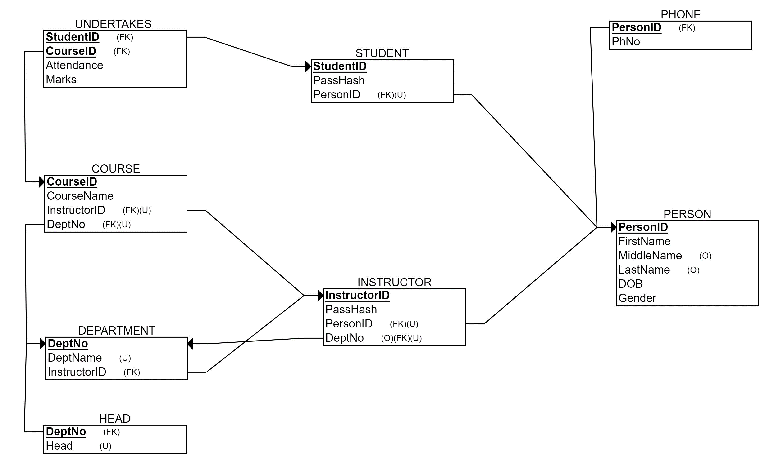

**Tables:**

**DEPARTMENT**

|  |  |
| --- | --- |
| DeptNo (PK) | DeptName |

**HEAD**

|  |  |
| --- | --- |
| DeptNo (PK) | Head (FK) |

**PERSON**

|  |  |  |  |  |  |
| --- | --- | --- | --- | --- | --- |
| PersonID(PK) | FirstName | MiddleName | LastName | DOB | Gender |

**PHONE**

|  |  |
| --- | --- |
| PersonID (PK,FK) | PhNo |

**INSTRUCTOR**

|  |  |  |  |
| --- | --- | --- | --- |
| InstructorID(PK) | PassHash | PersonId (FK) | DeptNo (FK) |

**COURSE**

|  |  |  |  |
| --- | --- | --- | --- |
| CourseID (PK) | CourseName | DeptNo (FK) | InstructorID(FK) |

**STUDENT**

|  |  |  |
| --- | --- | --- |
| StudentID (PK) | PassHash | PersonID (FK) |

**UNDERTAKES**

|  |  |  |  |
| --- | --- | --- | --- |
| StudentID(PK,FK) | CourseID(PK,FK) | Attendance | Marks |

**Proposed Application**

**Objectives:**

● Each user can login using respective ID and password.

● Privileges:

○ Administrator

* Admin can **view** all the students enrolled in a course. Admin can **edit** the personal details of student (name, gender).Admin has the privilege of **enrolling** a new student.
* Admin can **view** all the Instructors and their current department . Admin can also **change** the department of a faculty.
* Admin can **view** all the departments and the courses in that department .Admin can also **change** the **name** of the department. Admin has the privilege to **create** a **new department** and assign a HOD to it. Admin can also assign a new HOD to a department.

○ Instructors can **edit** attendance and marks of students in a course. If Instructor is **HOD** then the instructor can also **edit** the name of a course and change the faculty teaching that subject.

○ Students can **view** their attendance and marks in each course.

**Application:**

The application opens up to a login screen. Users enter their respective ID, password.

Each kind of user has their respective page. The student’s page lists information about the student as listed in Person table, and followingly lists information about his/her undertaken courses, attendance, and the marks obtained in it.

The instructor’s home page is similar to the students’. Apart from his/her information, it lists information about the courses he instructs. For every course there is a button to add attendance and marks of students in it. Clicking on such one button directs to list of students in the respective course, followed by fields to enter the attendance, or marks obtained per student.

The administrator’s page opens up to a few buttons controlling the state of the database . Editing is similar as instructors’. There is a respective list and corresponding fields. He/she can look up discrete and derived information about departments, courses, instructors, and students. Every user can also see the exam schedule.