Serial Interface Debug

Problem: Arduino Pro Mini with FTDI adapater will not respond or read serial commands, however it can download code and transmit serial with no issues (well there was one issue, when trying 9600 baud transmit showed up as garbage on serial terminal, so I increased to 115200 and it solved).

I have confirmed the following:
- Arduino settings match the board (3.3V 328P 8MHz)
- Added my user to the dialout group with “sudo usermod -a -G dialout adam”
  - USB Serial devices are part of the dialout group, this gives Arduino run by adam permissions to the device handle
- The serial output of the FTDI board that connects (TBD precisely) to the Pro Mini does receive proper serial
  - Using Waveforms and Analog Discovery 2
    - I ran a logic analyzer on the RX and TX pins and when typing Y into the Serial Monitor I can see the Y character and the line feed character being tranmitted properly; logic decoded characters and it matched expected.
    - I sniffed the RX line with the oscilloscope and captured the Y transmission and the levels are proper 0 – 3.3V.
- I am not using the RX0 in my circuit, the pin is untouched.
- I can download code just fine, which uses the RX pin to receive the code.

These confirmations prove that there is no issue with the Arduino Serial monitor, FTDI software, or Linux permissions as the FTDI USB→Serial is generating serial properly. The issue lies on the Arduino Pro Mini.

Y character loaded into Serial Monitor ready to transmit

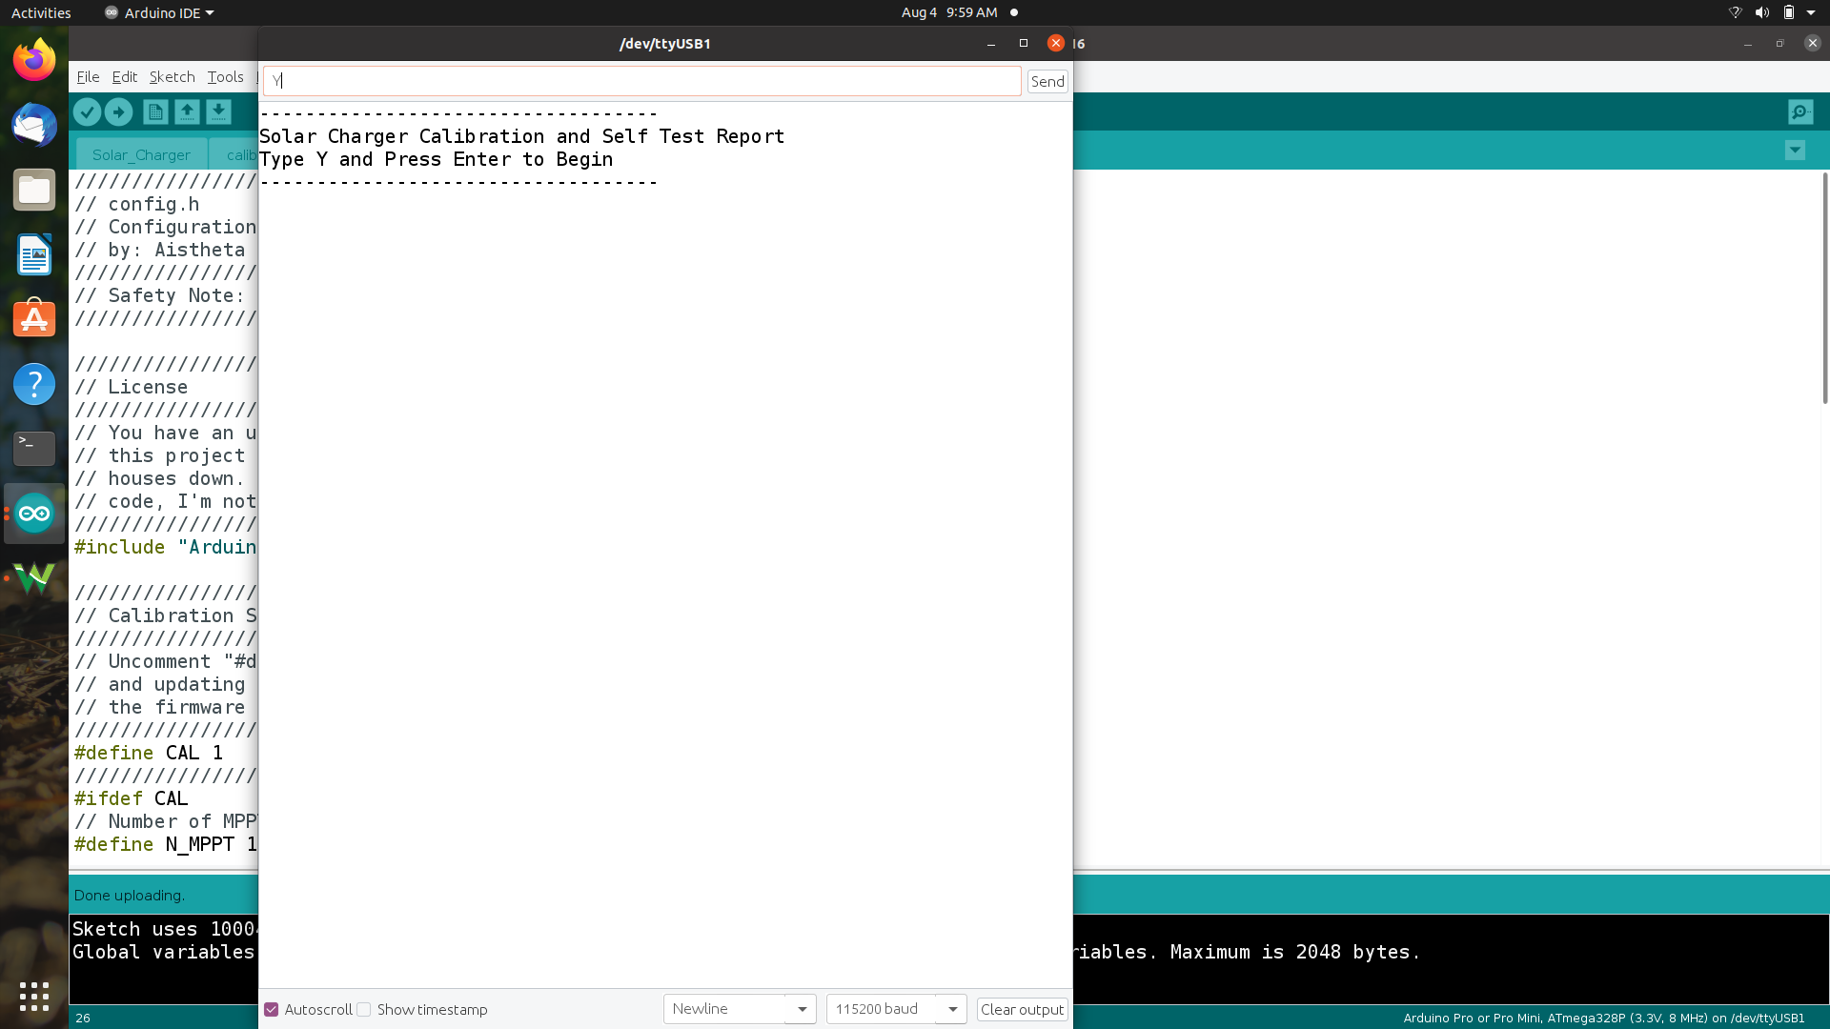
Y character ready to transmit with Waveforms logic ready to capture
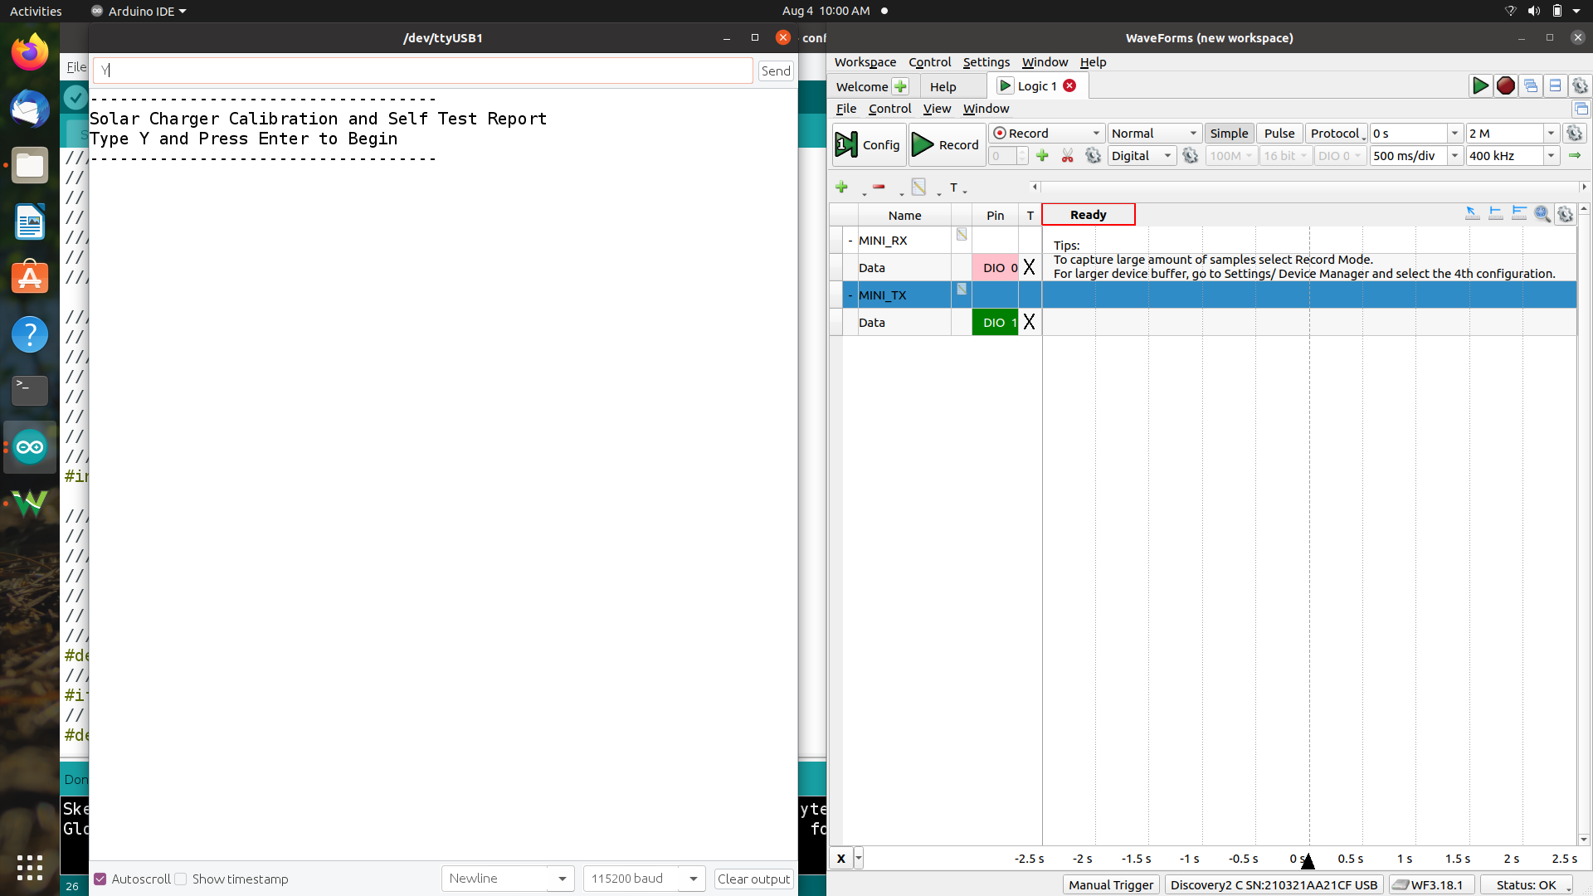

Logic capture showing decoded values (Y + LF)
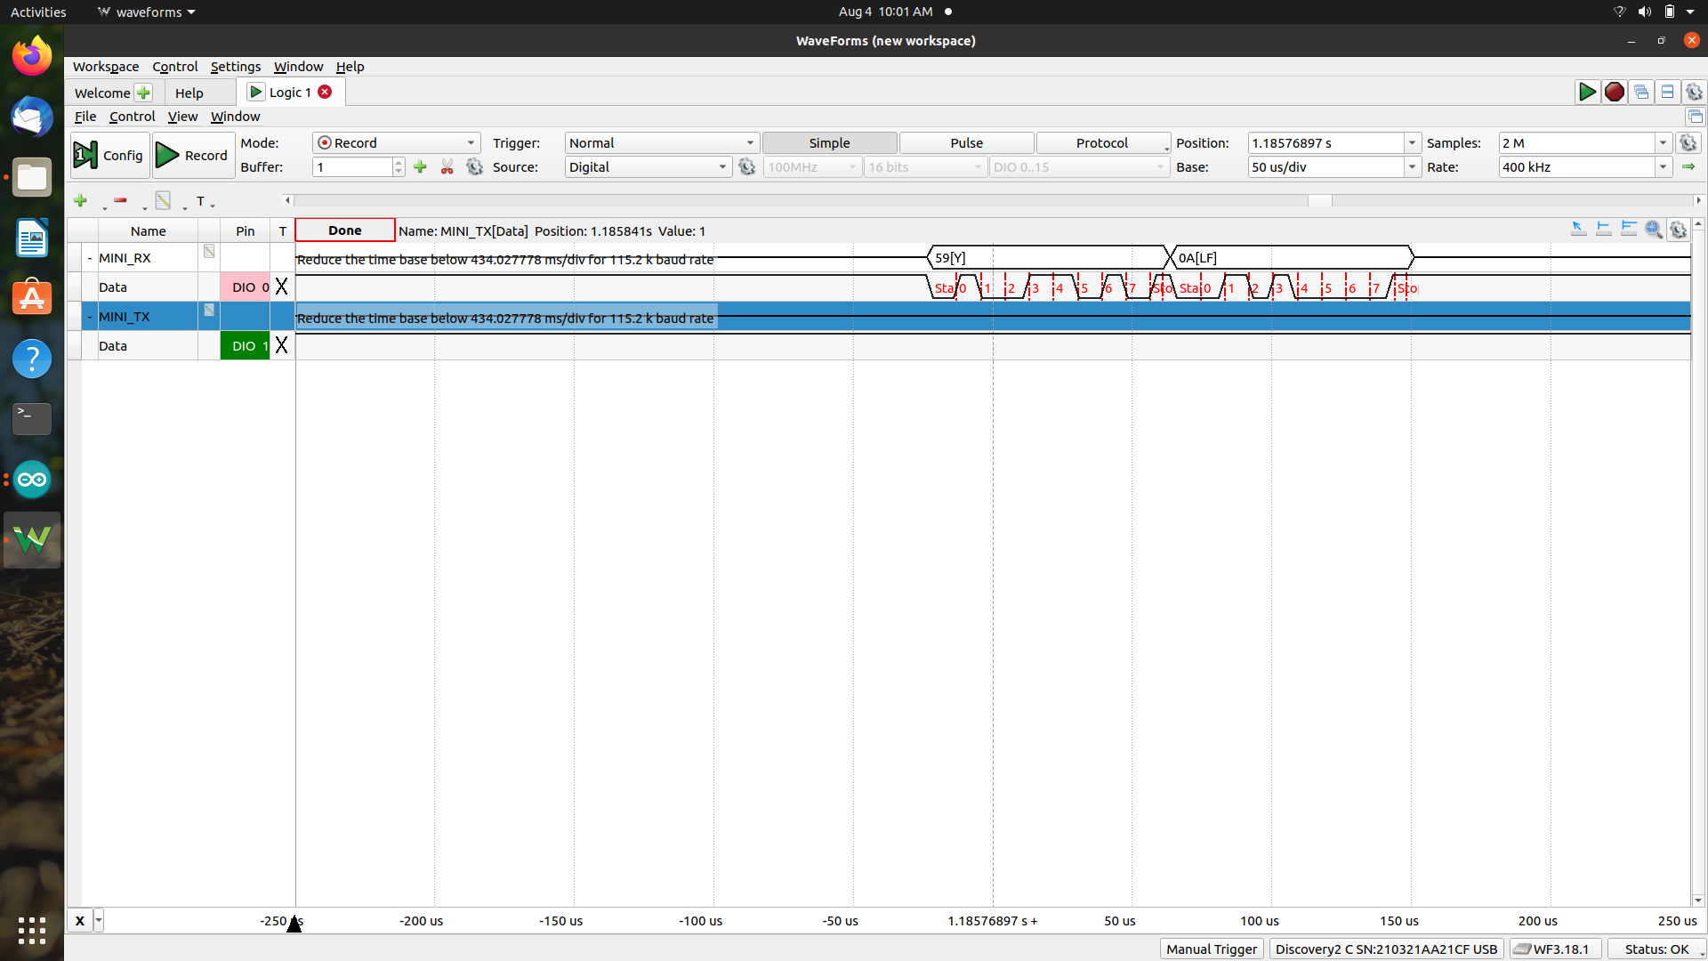

Close up of logic capture
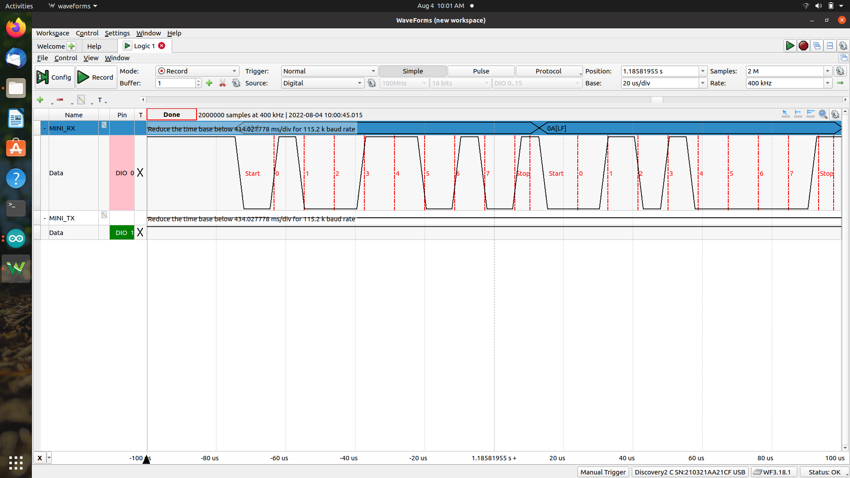

Serial Monitor showing no response
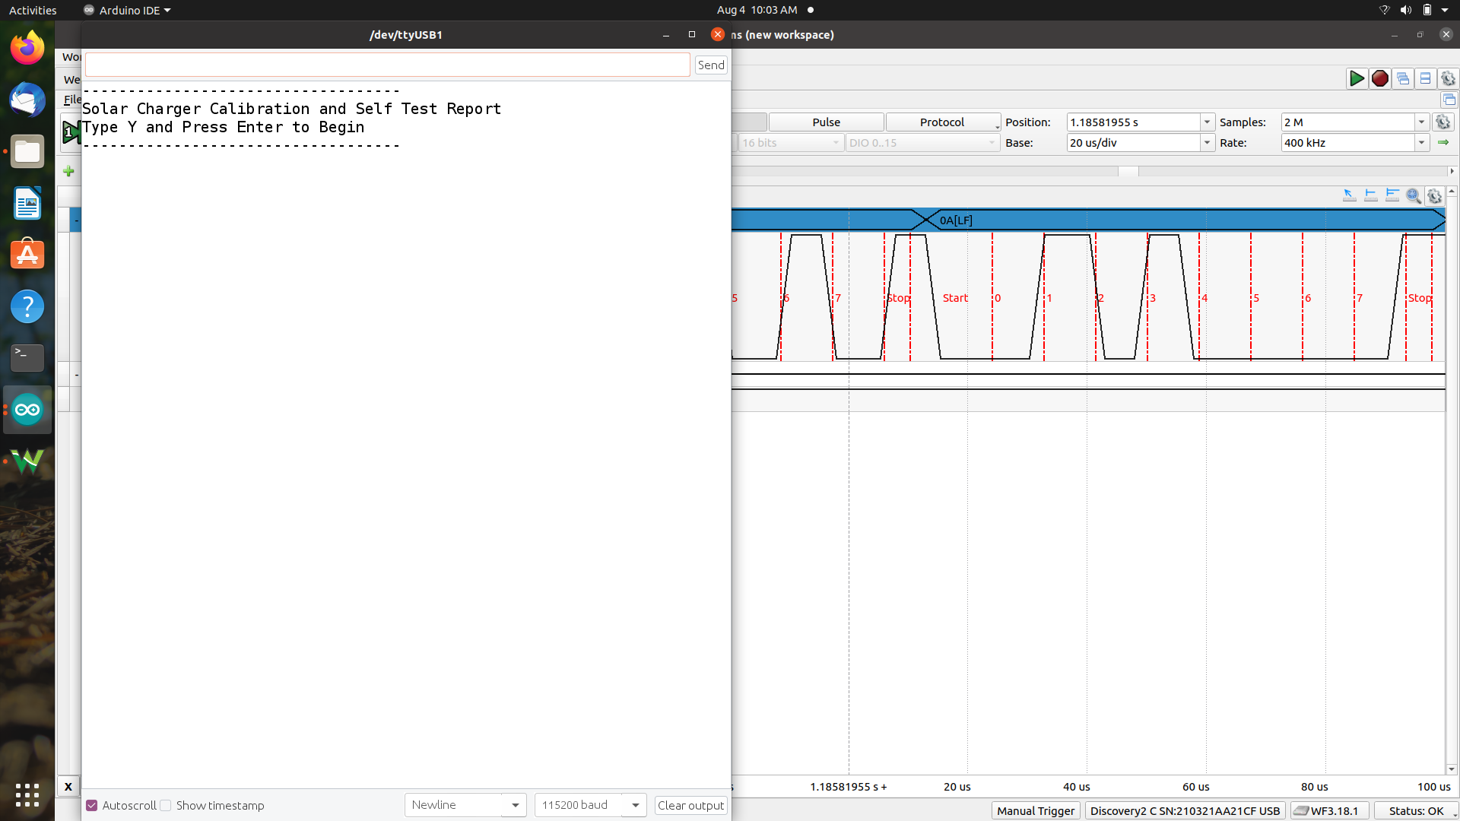
Scope capture of a new transmit (Y again)
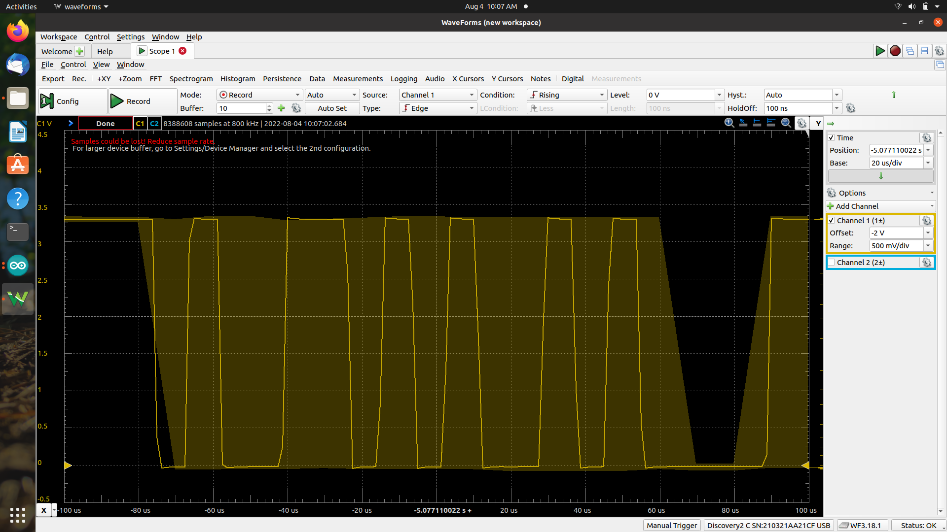

Scope capture with cursor showing 3.3V level
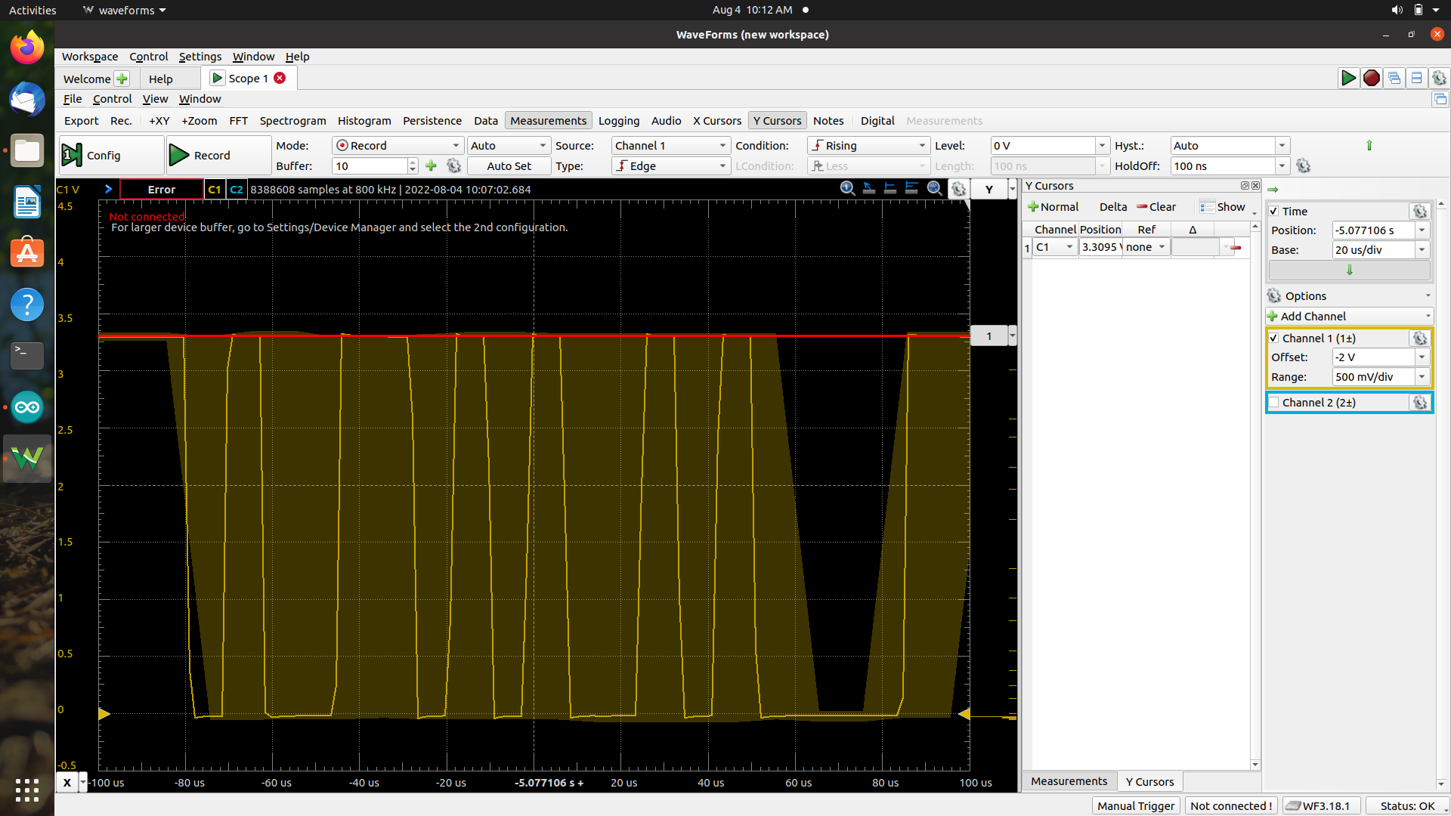
Snippit of code highlighting print line that would get printed if Serial was ready (received something). “Serial Monitor showing no response” above shows that nothing gets printed, hence Serial.available is never > 0 (nothing received).
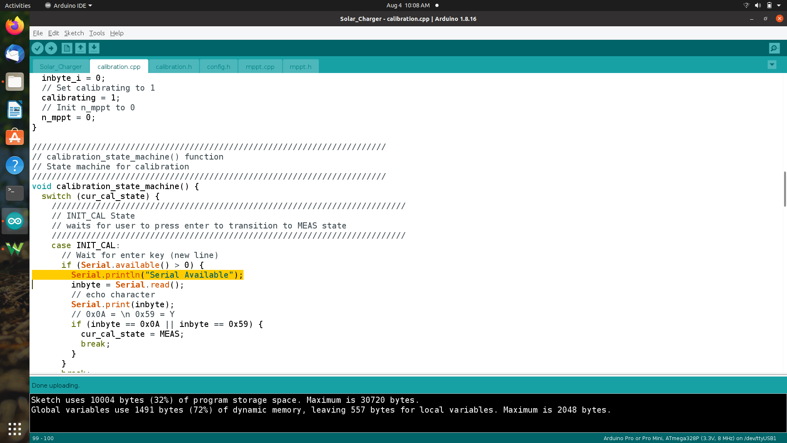

Modified code by adding print one level above the scope of Serial available to prove if code reaches the INIT_CAL state (printes Test if INIT_CAL)
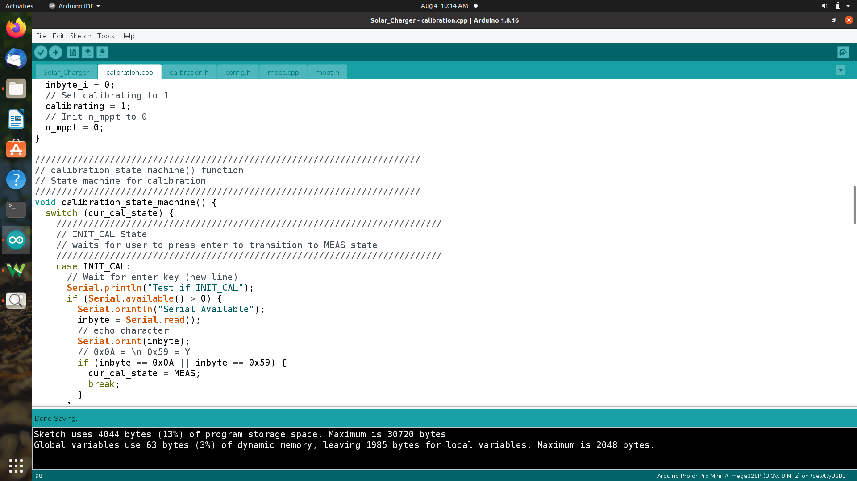
Log proving that it does reach that part of the code, no Y character was sent, it started printing on startup and didn’t stop.
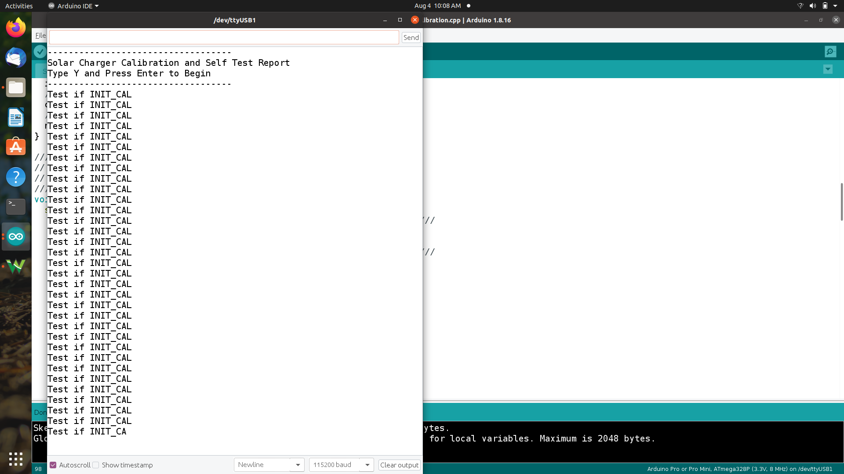

FTDI Adapter Schematic

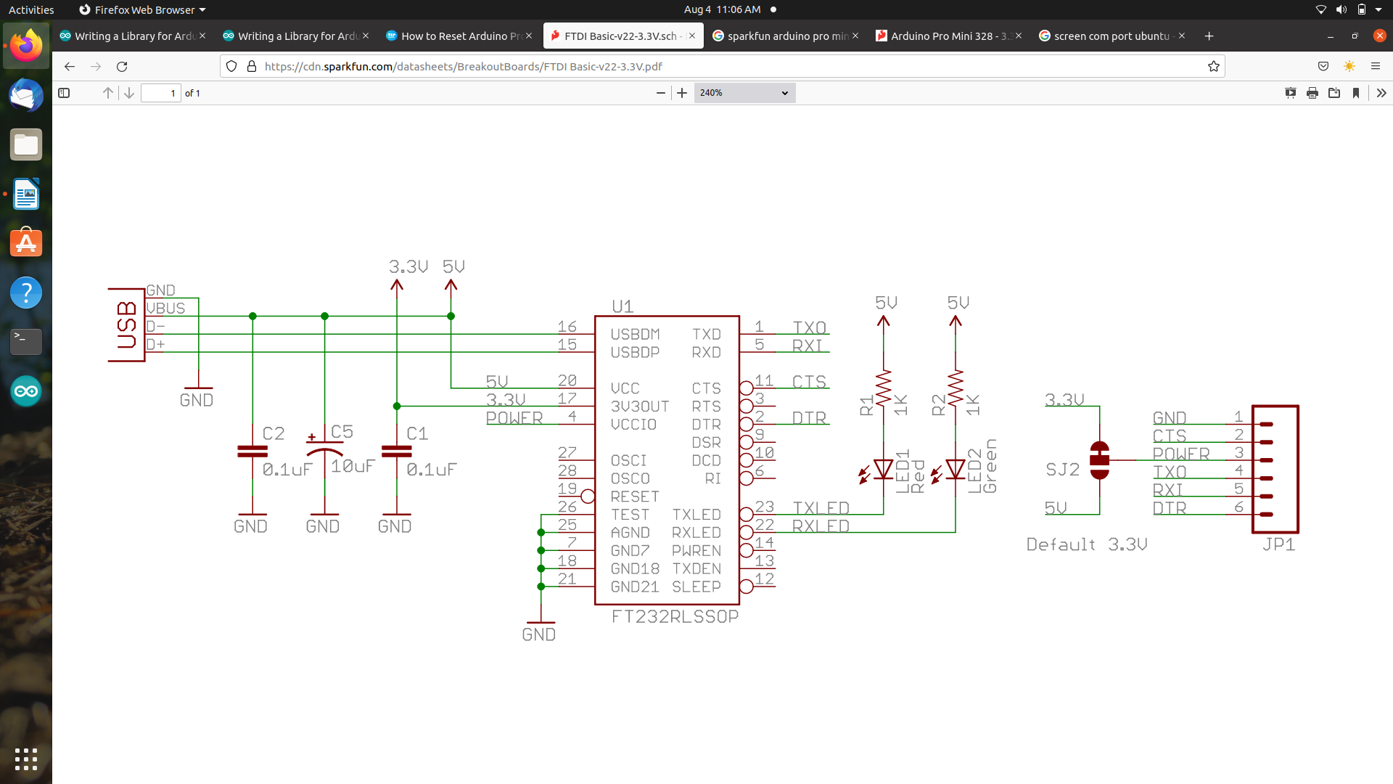
Arduino Pro Mini Schematic
