Foreign Table

All scripts are in the same directory.  
  
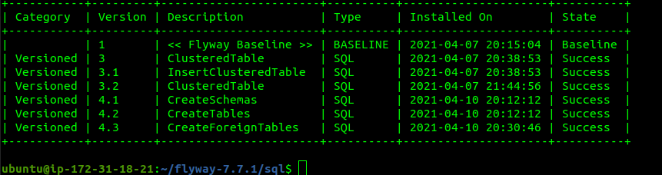  
  
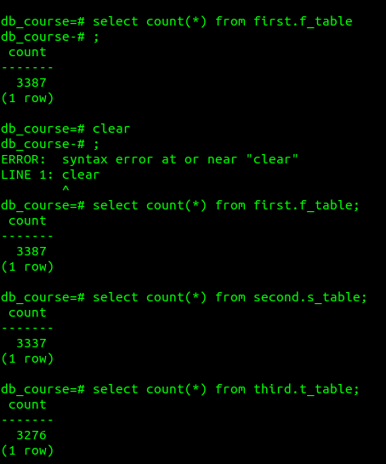  
  
Roughly even distribution of 10000 INSERT values

