pg_stat_statements

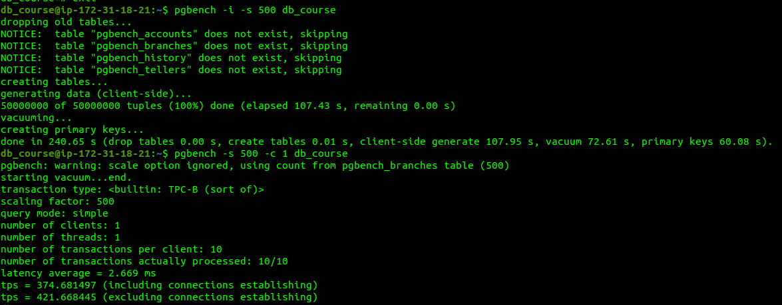

benchmark tps = 421.668445

top 20 queries

select query, calls, total_exec_time, rows, 100.0 * shared_blks_read / nullif(shared_blks_hit + shared_blks_read, 0) as read_percent

from pg_stat_statements order by total_exec_time desc limit 20;

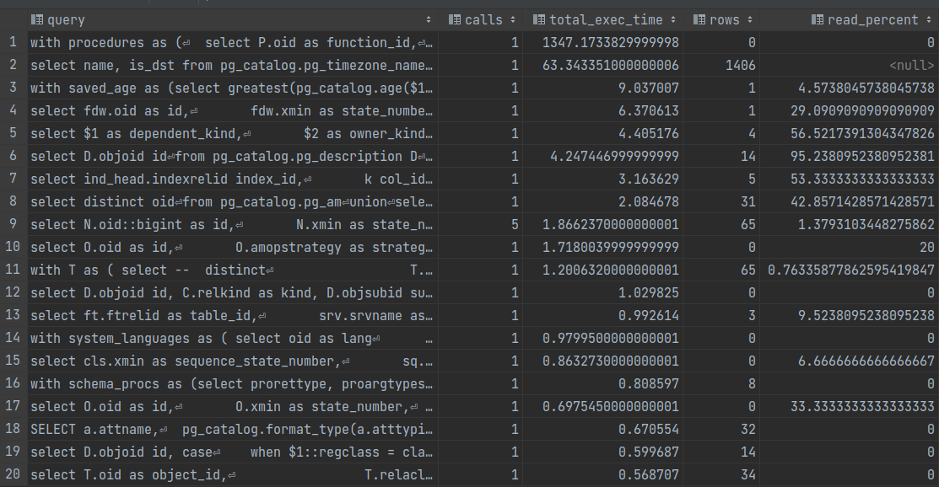

tps = 93.59999304878049

select sum(s.total_exec_time) / sum(s.calls) from (select total_exec_time, calls from pg_stat_statements order by total_exec_time desc limit 20) as s;

tps from standard benchmark is much over tps from pg_stat_statement