PgBadger

scripts - V8__Create_Insert.sql, test.sql

installed pgbadger, apache2, configured postgesql.conf  
  
pgbench -T 300 -c 100 -s 500 -f test.sql db_course  
  
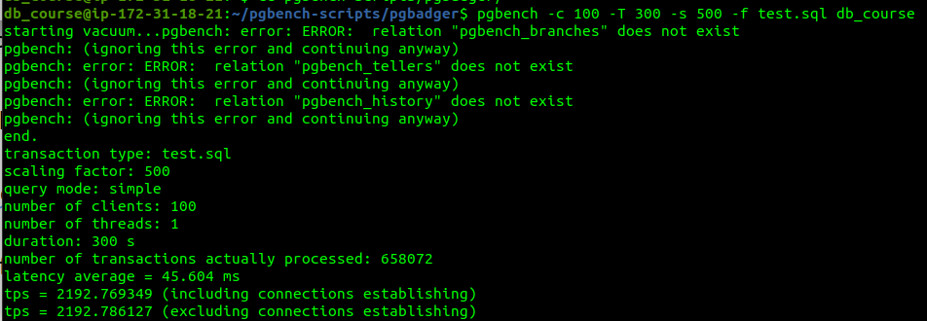  
  
test: tps = 2192.786127 latency = 45.604 ms (test.sql)  
  
pgBadger report:  
  
Write queries duration is 0, because there is only select query (test.sql)  
