SSL

Generated certs, keys, configured ssl as in lecture (postgresql.conf)  
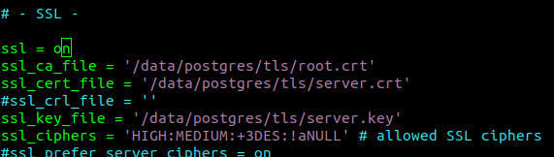

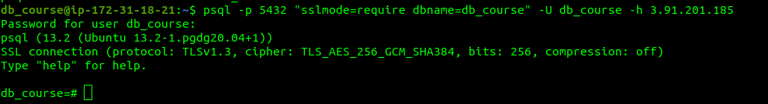  
  
benchmark comparison (ssl is off for second benchmark)



Due to disabled ssl second benchmark’s tps is over first benchmark’s tps