Vacuum

Scripts: prepare.sql, select.sql, update.sql

table size = 8192 bytes

select.sql (test1.sql renamed to select.sql)  
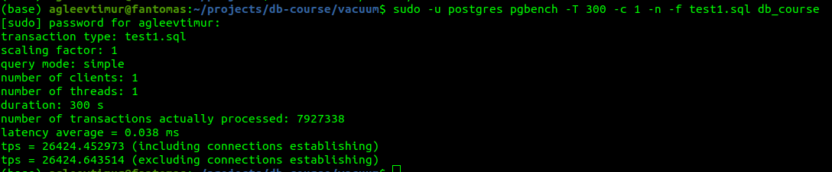  
tps = 26424.643514  
  
update.sql  
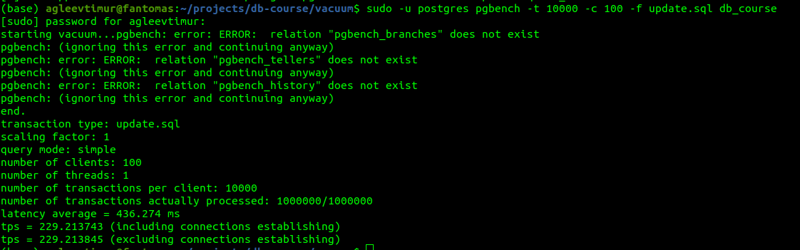

tps = 229.213845 (1000000 transactions total)

(now) table size = 29 MB  
  
select.sql  
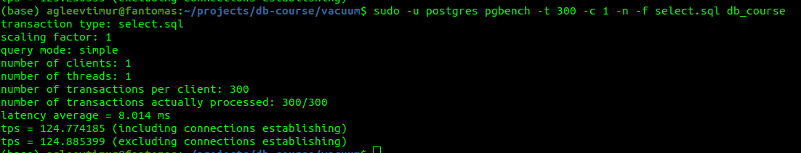  
tps = 124.885399  
  
-- vacuum vacuum.test  
size after vacuum = 29 MB  
select after vacuum  
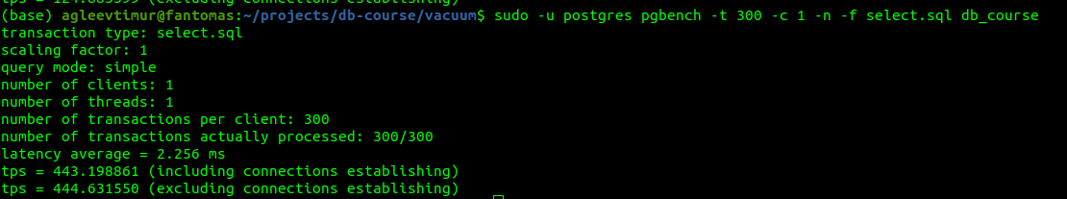  
tps = 444.631550 (has increased after vacuum)