**SPRINT RETROSPECTIVE MEETING RE-CAP NOTE**

**Meeting Participants:**

1. .
2. .
3. .
4. (Mentor)

**Meeting Date:** 21 MAY 2022 / 23:00- 24:00

**Purpose of Meeting:**

1. What went well ?
2. What didn't went well?
3. How we can improve them?
4. Action Items
5. **What went well?**

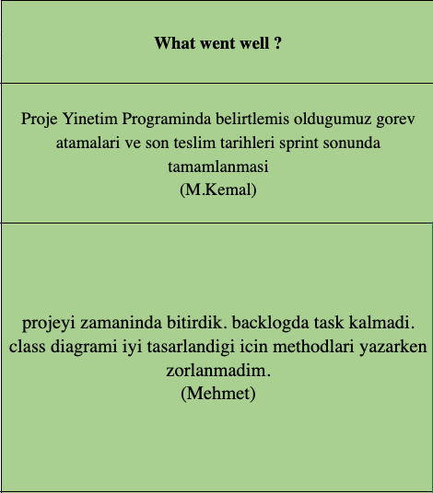

1. **What did’t went well?**

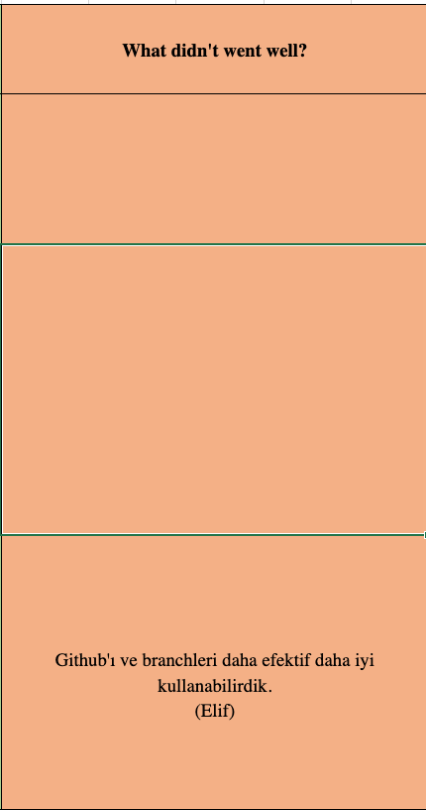

1. **How we can improve them?**

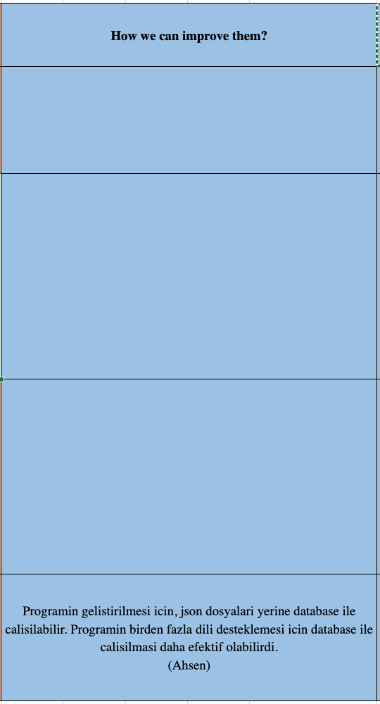

1. **ACTIONS:**

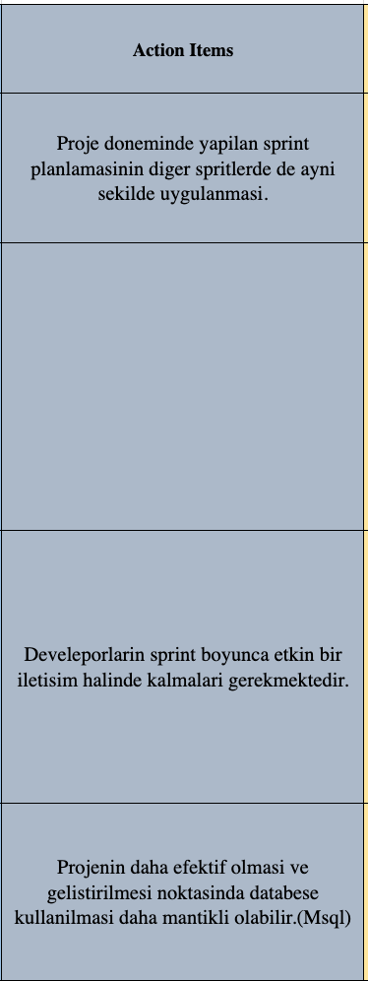

**Mentor Note:**

1. .
2. .
3. .

**Please Note:**

1. .
2. .