

**How to access CM65xx register through HID report**

Revision History

|  |  |  |
| --- | --- | --- |
| **Revision** | **Date** | **Description** |
| 0.1 | 2013/9/2 | First release |
|  |  |  |
|  |  |  |
|  |  |  |

**Index**

Summarize: 1

**1** **HID format for CM65xx:** 2

**1.1** **HID Input Report:** 2

**1.2** **HID Output Report:** 3

**2** **How to read register from HID report:** 4

**3** **How to write register from HID report:** 7

**4** **Example of changing GPIO_06 to control Ring LED.** 9

# Summarize:

This is the simple “How-To” document for using a utility “SimpleHIDWrite.exe” to control the CM65xx register through HID report interface. You can learn how to read/write register step by step. And an example of controlling Ring LED on CM6500/CM6502 demo board which is controlled by GPIO_06.

Please note that the example shows in this document is based on ROM code (i.e. No FW customization). The HID format night be different as described if customer change their firmware by themselves.

Below documentation is required for access the HID on CM65xx:

1. CM6500_CM6502_CM6510_CM6523_Programming Guide_v1.01.pdf: Given the HID report format for CM65xx platform.
2. CM65xx Registers Definition.pdf: Given the Register address for CM65xx platform.

[“SimpleHIDWrite.exe”](http://www.lvr.com/files/SimpleHIDWrite3.zip) is a utility provided by Robert Marquardt’s [HID Controller component suite for Delphi](http://www.soft-gems.net/index.php?option=com_content&task=view&id=30&Itemid=33).

1. **HID format for CM65xx:**
   1. **HID Input Report:**

The 16-bytes input report is defined as the following table. Host will be notified by an input report via interrupt pipe. Host can also get input report with class request “Get Report” via control pipe.

Host can read registers of CM65xx by HID input report’s byte 6~byte 15. Start address 35 and length of registers that host reads can be set by sending output report.

|  |  |  |
| --- | --- | --- |
|  | **Description** | **Size** |
| Byte 0 | Report ID (Always 1) | 1 |
| Byte 1~Byte 2 | For defined HID event, and each event occupies one bit (this depends on HID report descriptor) | 2 |
| Byte 3 | start address of returned data (H-start_addr) | 1 |
| Byte 4 | start address of returned data (L-start_addr) | 1 |
| Byte 5 | Interrupt source.  Bit 7: Reserved  Bit 6: UART_INT  Bit 5: GPI_INT  Bit 4: SPIS_INT  Bit 3: SPIM_INT  Bit 2: I2CS_INT  Bit 1: I2CM_INT  Bit 0: IR_INT | 1 |
| Byte 6~Byte15 | Register content | 10 |

* 1. **HID Output Report:**

HID output report is designed for writing registers to CM65xx. It is also used for setting start address and length of registers sent to host in input report.

|  |  |  |
| --- | --- | --- |
|  | Description | Size |
| Byte 0 | Report ID (Always 1) | 5 |
| Byte 1 | 1. 0x00: Set register read in input report  2. start address of returned data (H-start_addr) | 1 |
| Byte 2 | 1. 0xFE: Set register read in input report  2. start address of returned data (L-start_addr) | 1 |
| Byte 3 | Effective write data length (<= 12)  Effective read data length (<= 10) | 1 |
| Byte 4 | 1. If Byte1 is 0x00 and Byte2 is 0xFE, this byte is the value set to “Register Address(H)” in input report.  2. If Byte2 is not 0xFE, this byte is data written to register. | 1 |
| Byte 5 | 1. If Byte1 is 0x00 and Byte2 is 0xFE, this byte is | 1 |

1. **How to read register from HID report:**

To Read register content with HID report, you have to perform: “Set Output Report” and “Get Input Report”.

“Set Output Report” is to define register address and data length you are going to read the register. The start of the byte 1 and byte 2 must be “00 FE” to inform this is a Read Register index.

“Get Input Report” will return the register data in the register you defined in previous valid Read register index “Set Output Report” command.

Below is the example of reading back GPIO status register from address: C0 to C7 (8 bytes data length)

When you running the “SimpleHIDWrite.exe”, you will see the User Interface as below:

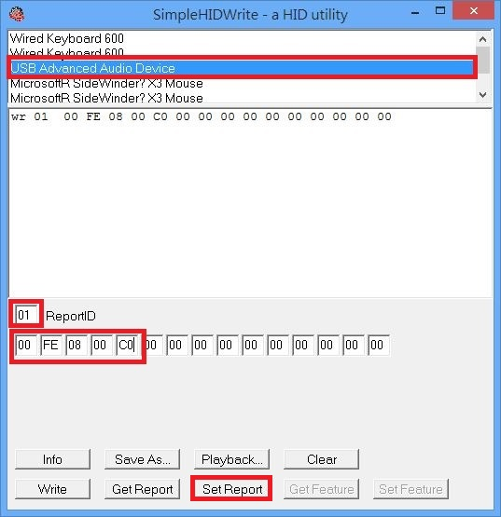

Set the report ID =”01”

Byte 1 and Byte 2 = “00 FE”: to perform a register read address set up.

Byte 3= “08”: to define the data length to read back based on the starting address defined as below.

Byte 4 and Byte 5=”00 C0”: high byte and low byte for the starting address.

Others bytes are don’t care when performing register read.

Press “Set Report”.

Press “Get Report” as below figure.

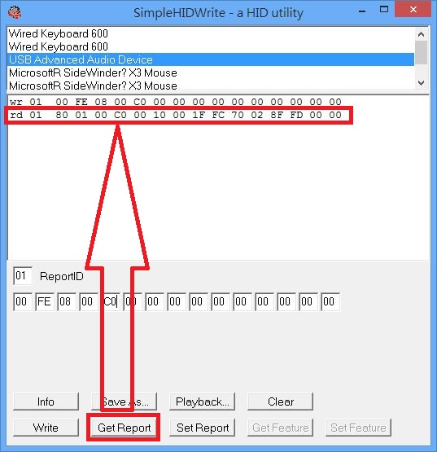

Byte 03 and 04=”00 C0”: Shows the Starting address of register content

Byte 05 should be ignored.

Byte 06~13 are the data returned (Please refer to “CM65xx Registers Definition.pdf” for Register mapping).

Register address C0= 0x10 🡪 GPO data register for GPO0~GPO7; only GPO4 are set to high.

Register address C1= 0x00 🡪 GPO data register for GPO8~GPO15;

Register address C2= 0x1F 🡪 GPI data register for GPI0~GPI7

Register address C3= 0xFC 🡪 GPI data register for GPI8~GPI15

Register address C4= 0x70 🡪GPIO direction control register for GPIO0~7; GPIO4, 5, and 6 are set as Output. Others are input.

Register address C5= 0x02 🡪GPIO direction control register for GPIO8~15; Only GPIO9 are set as Output. Others are input.

Register address C6= 0x8F 🡪 GPIO interrupt enable Mask Register for GPIO0~7.

Register address C7= 0xFD🡪 GPIO interrupt enable Mask Register for GPIO8~15.

1. **How to write register from HID report:**

To Write register content with HID report, you only have to perform “Set Output Report”. And you can check it with Read Register steps.

Below is the example of changing GPO mode control by writing “GPO Switch Source register” from address: DA to E0 (8 bytes data length)

Perform a register Read to check the initial value of register DA to E0:

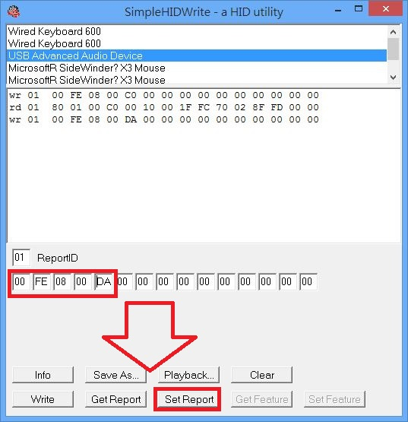 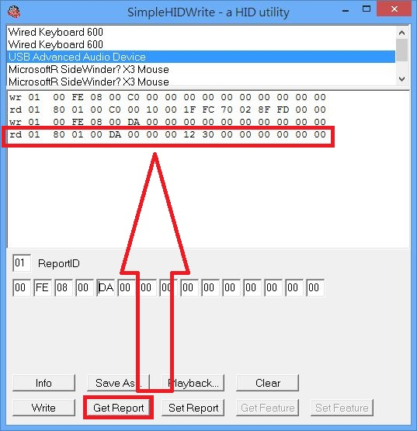

The Default value of register 0xDA to 0xE0 is: 00 00 12 30 00 00 00 00; Where:

0xDC defined GPO4 as Playback LED (LED1), GPO5 as Play Mute LED (LED2)

0xDD defined GPO6 as Record Mute LED (LED3), GPO7 as general purpose GPO

Others are all defined as GPOs.

Perform a Register write to change GPO6 behavior from LED3 to General purpose GPOs.

Byte 1 and Byte 2 = “00 DD” 🡪 set the initial register address to write

Byte3 = “01” 🡪 set the total data length to write

Byte4 = “00” 🡪 set the new value to Register 0xDD.

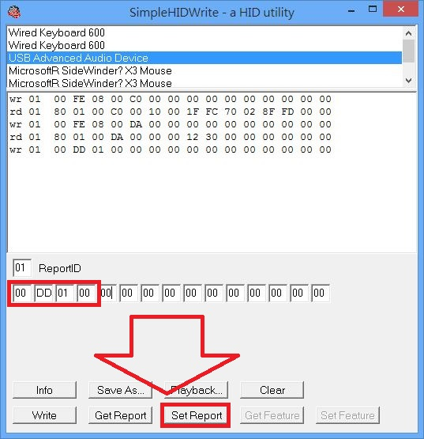

After the command above, the register 0xDD has been changed from 0x30 to 0x00.

Read back to see the change:

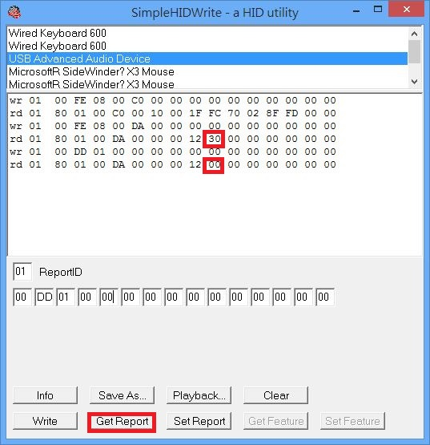

1. **Example of changing GPIO_06 to control Ring LED.**

Following above steps, you know how to read/write registers by HID report. Now, let’s try to control GPIO to turn on the Ring LED which is connected to GPIO_06 (pin38 of CM6500/CM6502).

Continue with changing 0xDD register value to 0x00; now, the GPIO_06 is set to General purpose GPO mode. And by default, GPIO_06 direction is set to output. So what we are going to do is to output GPIO_06 high level to turn on the LED:

Byte 1 and Byte 2 = “00 C0”: to set Register address to write

Byte 3= “01”: To set data length to write.

Byte 4 =”50”: To set GPIO_06 high.

Press “Set Report” 🡪 now the Ring LED is turn on.

