**Lab Sheet 2**

Date: - 25/03/2022

ASWIN G MENON

AM.EN.U4CSE20313

**Exercise for evaluation**

1. Accept two values from user and find the product of those two numbers.

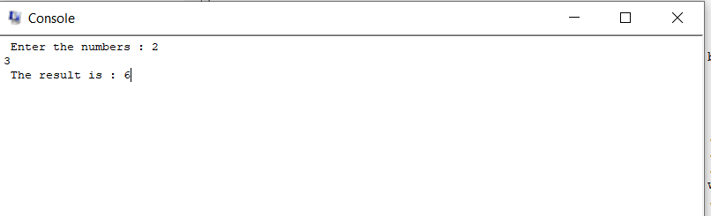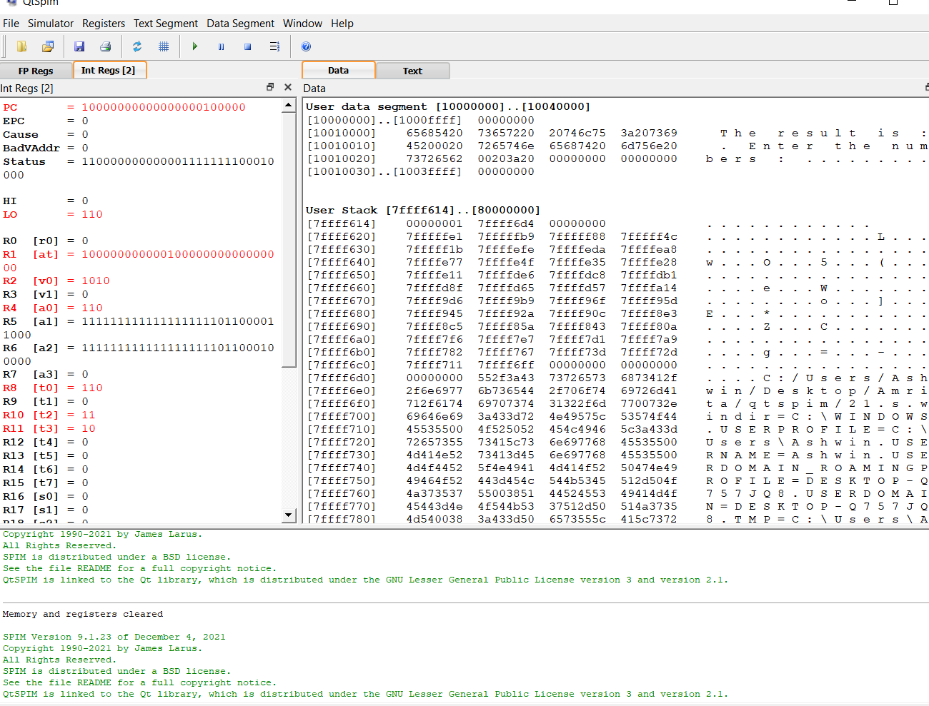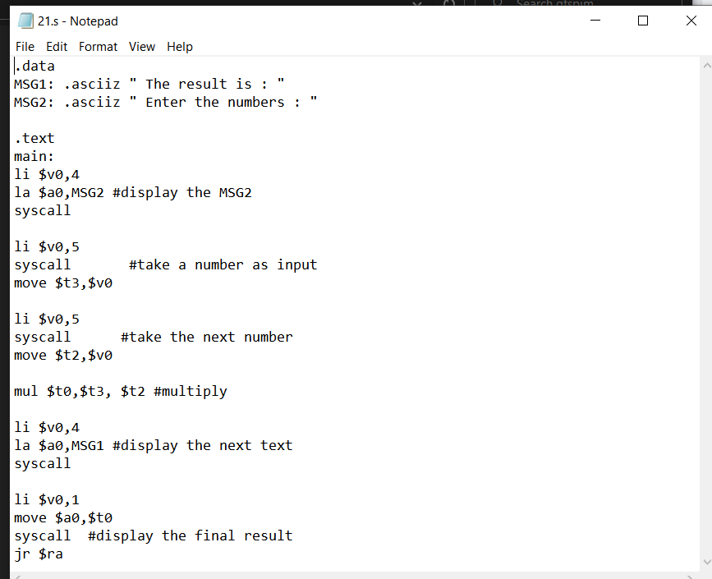

1. Write a program to find the product of first ‘n’ numbers and display it on screen.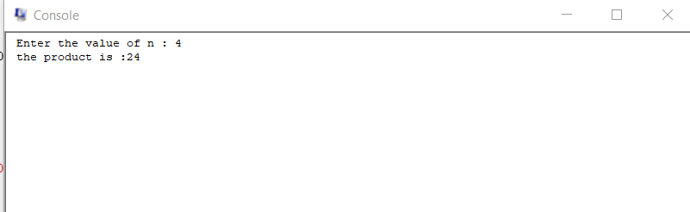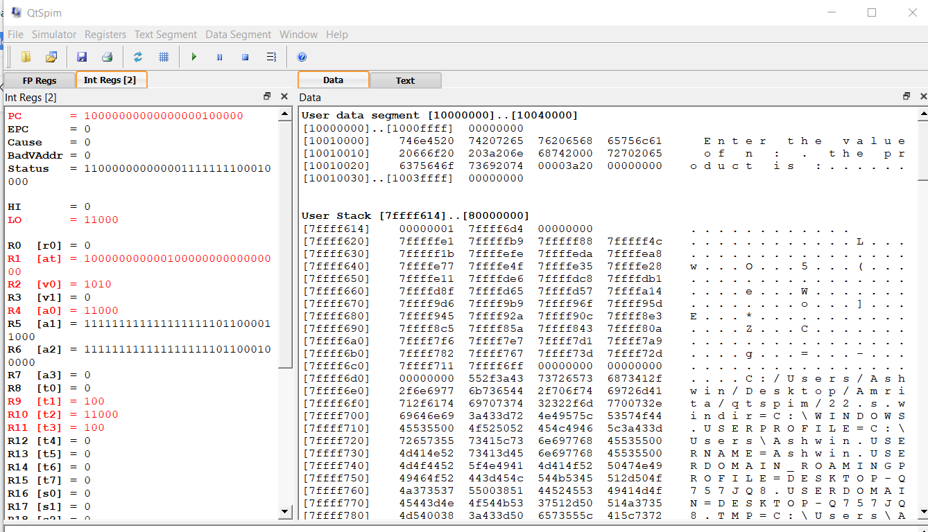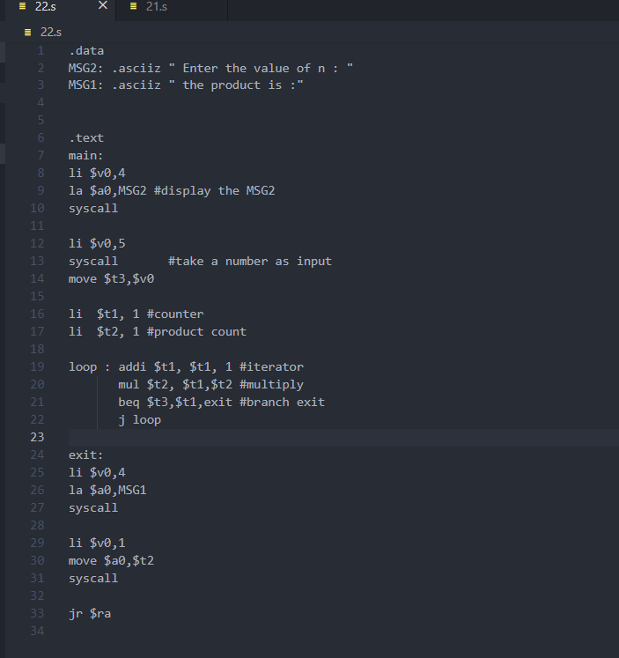
2. Perform division operation on two numbers.

Hint: - instruction is div

