Project Documentation

First page : Preprocessing steps and Data Analysis

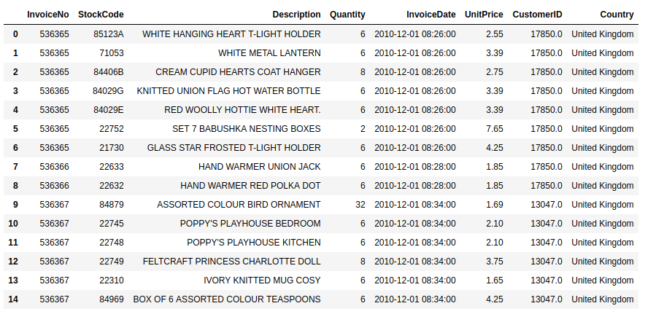

The dataset contains a total of 541,909 entries and 8 attributes. This figure shows a subset of the dataset

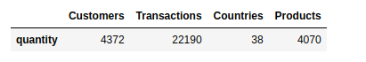

The total number of unique values for attributes in the dataset

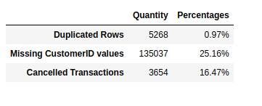

Preprocessing steps: This involved the removal of duplicated rows, rows with missing customer IDs and cancelled transactions.

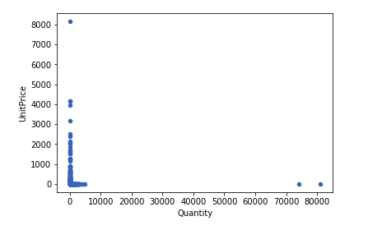

Preprocessing steps: Detection and removal of outliers

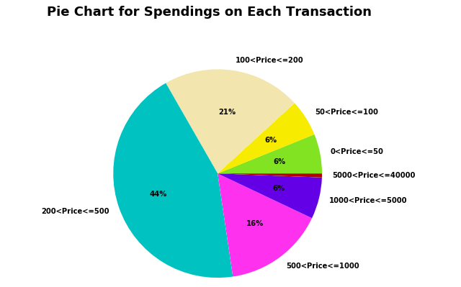

Distribution of the total amount spent on each transaction using a pie chart. This chart gives an estimation of the spending budgets of customers.

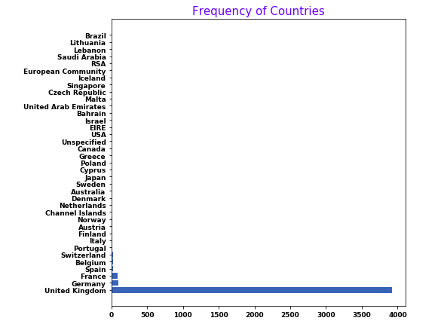

Frequencies of countries in the dataset, with United Kingdom having the highest frequency, followed by Germany and France.

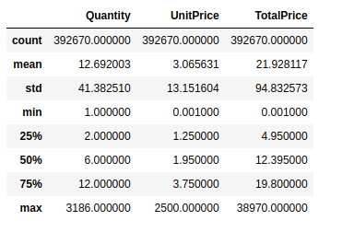

A descriptive statistic showing the mean, standard deviation, minimum and maximum values of the continuous variables in the dataset

Second Page: Results

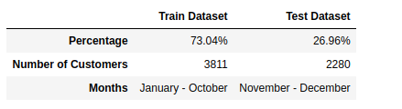

**Description of the Train and Test Dataset**

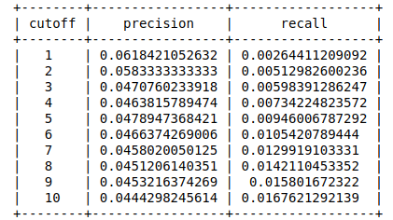

**Subset of the Precision and Recall Score for the Popularity Model**

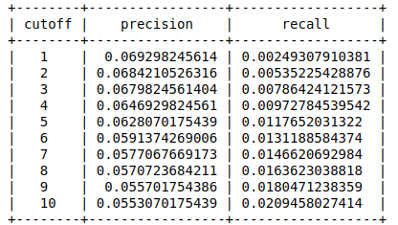

**Subset of the Precision and Recall Score for the Item-Item Based Similarity Model**

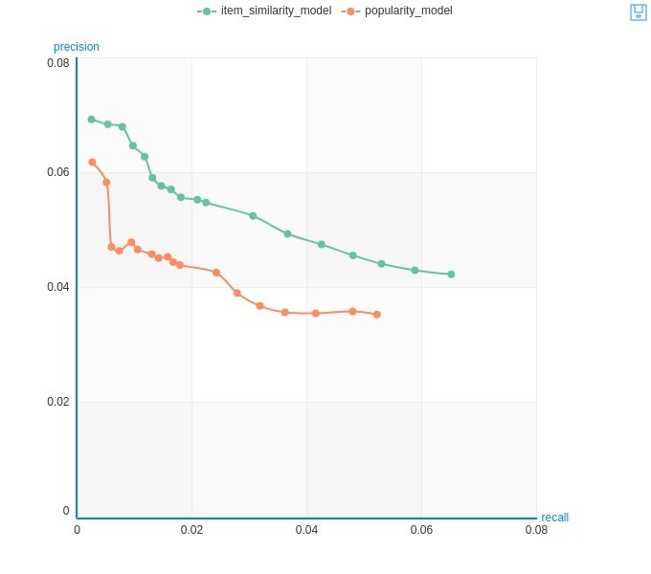

**Comparison of the Precision and Recall Score for the Popularity and Item-Item Similarity Model**

**Identification Number**

**['17850',  
 '13047',  
 '12583',  
 '13748',  
 '15100',  
 '15291',  
 '14688',  
 '17809',  
 '15311',  
 '16098',  
 '18074',  
 '17420',  
 '16029',  
 '16250',  
 '12431',  
 '17511',  
 '13705',  
 '13747',  
 '13408',  
 '13767',  
 '17924',  
 '13448',  
 '15862',  
 '15513',  
 '12791',  
 '16218',  
 '14045',  
 '14307',  
 '17908',  
 '17920',  
 '12838',  
 '13255',  
 '16583',  
 '18085',  
 '13758',  
 '13694',  
 '15983',  
 '14849',  
 '17968',  
 '16210',  
 '17897',  
 '17377',  
 '16552',  
 '17181',  
 '17951',  
 '14729',  
 '12748',  
 '15012',  
 '12868',  
 '17572',  
 '14078',  
 '14001',  
 '12662',  
 '15525',  
 '14237',  
 '17905',  
 '15485',  
 '12433',  
 '16955',  
 '15350',  
 '15605',  
 '18144',  
 '15922',  
 '14594',  
 '15165',  
 '14911',  
 '16456',  
 '17346',  
 '17643',  
 '17841',  
 '17873',  
 '13093',  
 '12921',  
 '13468',  
 '17760',  
 '16928',  
 '16048',  
 '16274',  
 '14496',  
 '14696',  
 '16539',  
 '17025',  
 '13777',  
 '17690',  
 '12947',  
 '17460',  
 '18229',  
 '14142',  
 '17069',  
 '13065',  
 '14606',  
 '16835',  
 '15235',  
 '13576',  
 '18011',  
 '13090',  
 '15694',  
 '14741',  
 '13715',  
 '17732']**

**Code Format**

**[{'CustomerID': {0: '17850', 1: '17850', 2: '17850', 3: '17850', 4: '17850'},  
 u'Description': {0: u'LUNCH BAG RED RETROSPOT',  
 1: u'SPOTTY BUNTING',  
 2: u'LUNCH BAG DOILEY PATTERN ',  
 3: u'PACK OF 72 RETROSPOT CAKE CASES',  
 4: u'LUNCH BAG PINK POLKADOT'},  
 'StockCode': {0: '20725', 1: '23298', 2: '23209', 3: '21212', 4: '22384'},  
 'rank': {0: 1, 1: 2, 2: 3, 3: 4, 4: 5},  
 'score': {0: 0.14798133373260497,  
 1: 0.13780474781990051,  
 2: 0.13445568323135376,  
 3: 0.13275419354438781,  
 4: 0.12937514185905458}},  
 {'CustomerID': {0: '17850',  
 1: '17850',  
 2: '17850',  
 3: '17850',  
 4: '17850',  
 5: '17850',  
 6: '17850',  
 7: '17850',  
 8: '17850',  
 9: '17850',  
 10: '17850',  
 11: '17850',  
 12: '17850',  
 13: '17850',  
 14: '17850',  
 15: '17850',  
 16: '17850',  
 17: '17850',  
 18: '17850',  
 19: '17850',  
 20: '17850'},  
 u'Description': {0: u'EDWARDIAN PARASOL BLACK',  
 1: u'EDWARDIAN PARASOL RED',  
 2: u'VINTAGE BILLBOARD LOVE/HATE MUG',  
 3: u'VINTAGE BILLBOARD DRINK ME MUG',  
 4: u'GLASS STAR FROSTED T-LIGHT HOLDER',  
 5: u'SAVE THE PLANET MUG',  
 6: u'JUMBO SHOPPER VINTAGE RED PAISLEY',  
 7: u'HAND WARMER RED POLKA DOT',  
 8: u'HAND WARMER UNION JACK',  
 9: u'SET 7 BABUSHKA NESTING BOXES',  
 10: u'IVORY EMBROIDERED QUILT ',  
 11: u'RETRO COFFEE MUGS ASSORTED',  
 12: u'WHITE METAL LANTERN',  
 13: u'WOODEN PICTURE FRAME WHITE FINISH',  
 14: u'WOOD 2 DRAWER CABINET WHITE FINISH',  
 15: u'WOOD S/3 CABINET ANT WHITE FINISH',  
 16: u'WOODEN FRAME ANTIQUE WHITE ',  
 17: u'RED WOOLLY HOTTIE WHITE HEART.',  
 18: u'KNITTED UNION FLAG HOT WATER BOTTLE',  
 19: u'CREAM CUPID HEARTS COAT HANGER',  
 20: u'WHITE HANGING HEART T-LIGHT HOLDER'},  
 'StockCode': {0: '15056BL',  
 1: '20679',  
 2: '21068',  
 3: '21071',  
 4: '21730',  
 5: '21871',  
 6: '22411',  
 7: '22632',  
 8: '22633',  
 9: '22752',  
 10: '22803',  
 11: '37370',  
 12: '71053',  
 13: '82482',  
 14: '82483',  
 15: '82486',  
 16: '82494L',  
 17: '84029E',  
 18: '84029G',  
 19: '84406B',  
 20: '85123A'},  
 'count': {0: 4,  
 1: 7,  
 2: 15,  
 3: 15,  
 4: 17,  
 5: 14,  
 6: 10,  
 7: 17,  
 8: 17,  
 9: 16,  
 10: 8,  
 11: 15,  
 12: 17,  
 13: 15,  
 14: 15,  
 15: 14,  
 16: 15,  
 17: 17,  
 18: 17,  
 19: 15,  
 20: 17}}]**