4-1 Term

**Project Manager:**

Dr. Kazi Masudul Alam

Associate Professor

Computer Science & Engineering Discipline

Khulna University, Khulna.

**Developed By,**

Amrita Ghosh Mugdha; ID: 170235

Md. Raihanoor Farid; ID: 170218

Md. A. Tuhin; ID: 170214

DOCUMENTATION ON USER ACCOUNT UI.

**Introduction:**

Our project is on user ui. We basically worked on the user profile appearance. Now the user account has new looks. User profile has his own profile picture. Profile picture can be updated by the user. We have created the Navigation Bar. Now from the Navigation Bar user can access any pages from any other pages. We have removed the overlapping problem on the Menu Bar.

**User Login Page:**



[Fig.1: User Login Page]

**User Home Page:**

After successful Login user can access the home page.

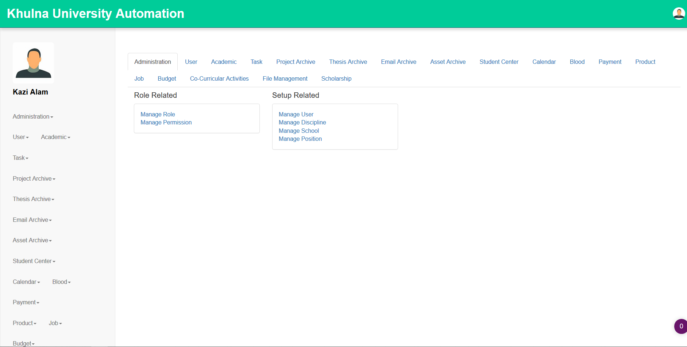

[Fig.2: User Home Page]

From Home page user can go to the User Menu. From User Menu user can go to User Details to change his personal information.

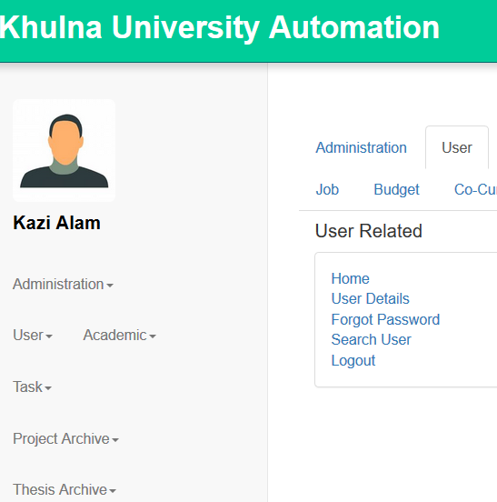

[Fig.3: User Menu]

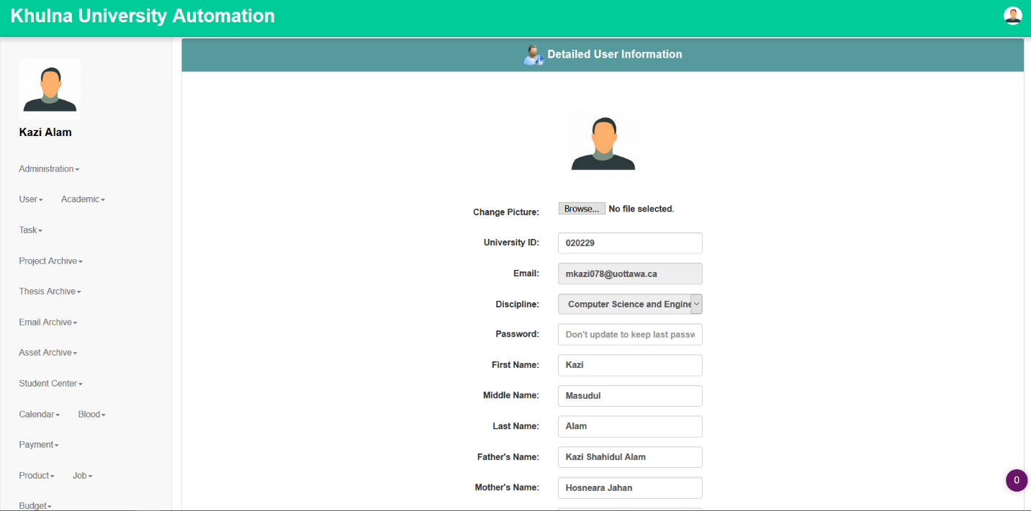

[Fig.4: User Detailed Information Form page]

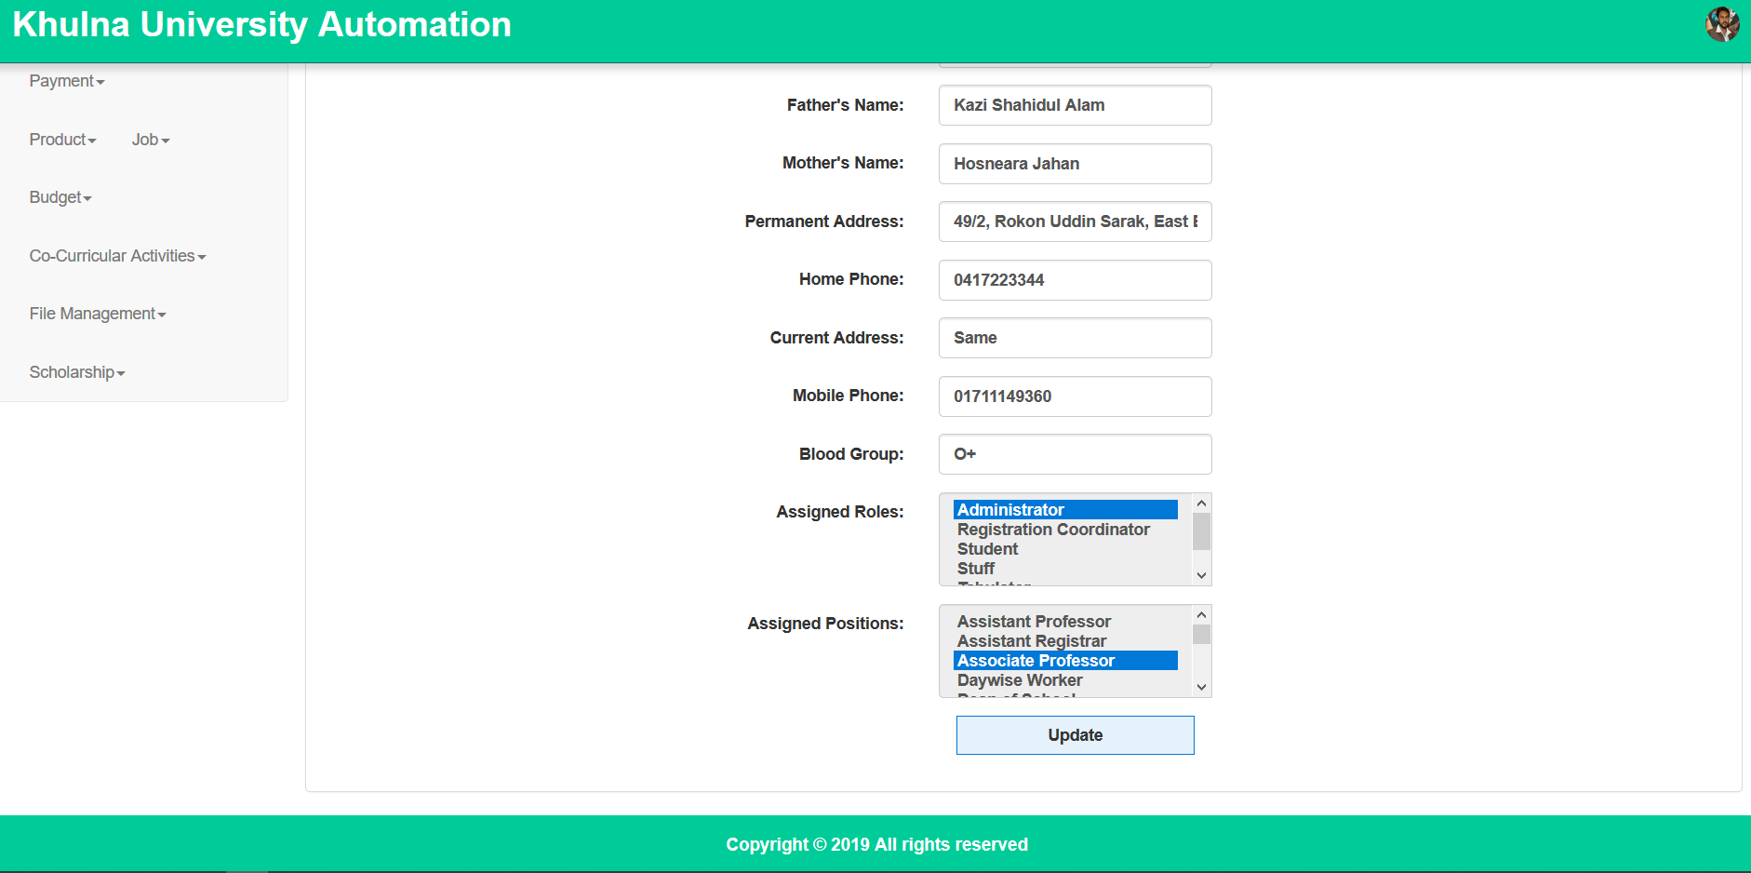[Fig.5: User Detailed Information Form page(Cont.)]

**Update User Detailed & Profile Picture:**

From this page User can change the profile picture & also update his personal information.

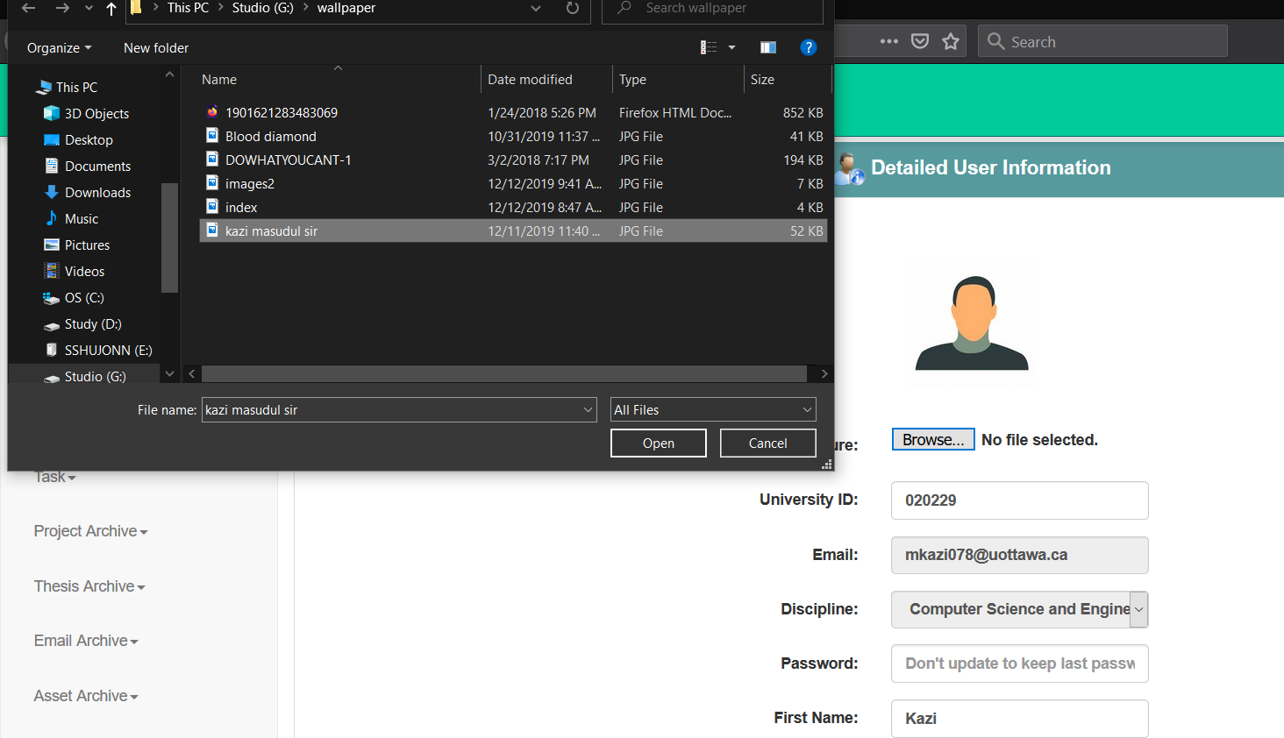

[Fig.6: Image Selection from Personal Storage]

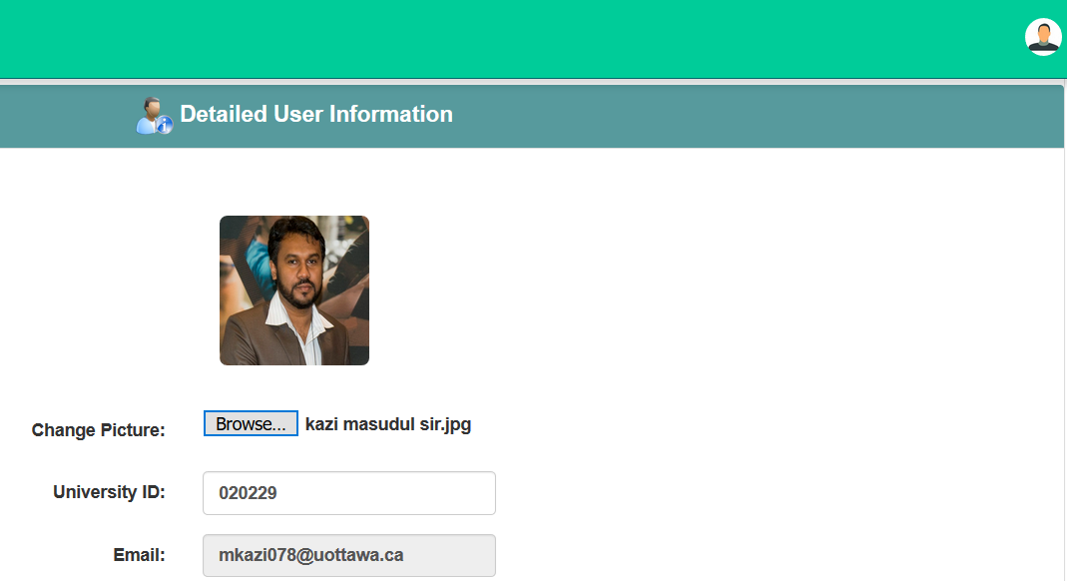

[Fig.7: Browsing Image File]

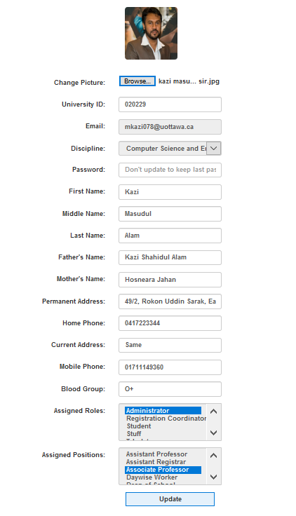

[Fig.8: Final Update]

**Navigation Bar:**

There are the Navigation Bar in every pages. Now from the Navigation Bar user can access any pages from any other pages.

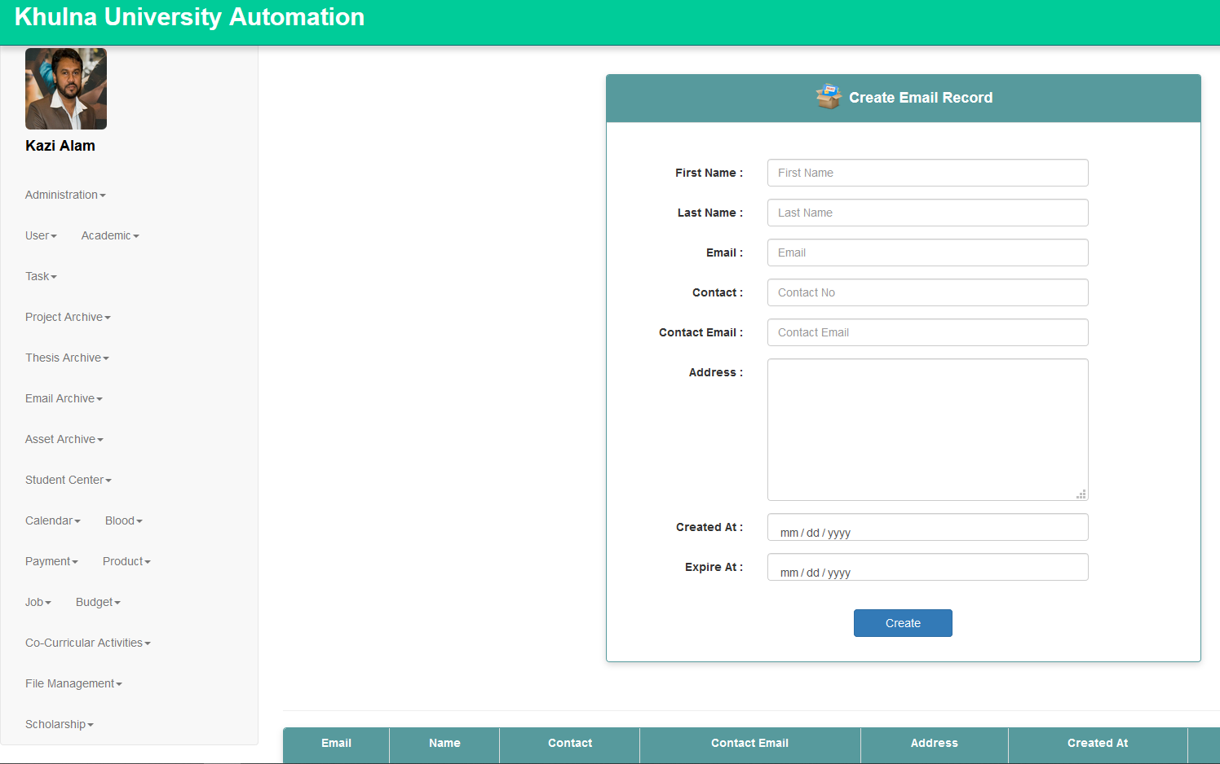

[Fig.9: Navigation Bar]