Department of Computer Science and Engineering
2024 CSE BATCH
23CSE463 – Quantum Computing

NAME : Agneay B Nair
REG NO : CH.SC.U4CSE24102

WORKSHEET
WORKSHEET- 2
EX.NO : 2
DATE :
TITLE : Implementation of Quantum Algorithms (Deutsch, Deutsch-Jozsa, Bernstein-Vazirani and Simon) Using Qiskit
AIM:
To implement the Deutsch, Deutsch-Jozsa, Bernstein-Vazirani and Simon algorithms in Qiskit, to construct the oracle for each, and to compare the number of oracle queries with the number a classical method needs.
APPARATUS REQUIRED:
- Python 3.10 or above
- Qiskit 2.x and Qiskit Aer simulator (pip install qiskit qiskit-aer)
- Matplotlib and pylatexenc (for circuit diagrams and histograms)
- Jupyter Notebook / Visual Studio Code (VS Code)
- Internet Connection (for package installation and documentation access)
- Quantum Computing Reference Material or Lab Manual
THEORY:
A quantum algorithm is useful when interference raises the probability of the correct answer before the measurement. The four algorithms in this experiment share one pattern: Hadamard gates, one call to an oracle, Hadamard gates again, and a measurement. An oracle is a circuit that computes a function $f$ without revealing how it does so. The cost of an algorithm is counted as the number of calls to the oracle, called queries. The standard oracle acts as
$$U_{f} |x⟩|y⟩=|x⟩|y⊕f\left(x\right)⟩$$
Phase kickback. When the last qubit is prepared in the state $|−⟩=\left(|0⟩−|1⟩\right)/\sqrt{2}$, the oracle leaves that qubit unchanged and writes the value of $f\left(x\right)$ into the sign of the input state:
$$U_{f} |x⟩|−⟩={\left(−1\right)}^{f\left(x\right)} |x⟩|−⟩$$
Deutsch's algorithm. A function $f$ from one bit to one bit is either constant, $f\left(0\right)=f\left(1\right)$, or balanced, $f\left(0\right)≠f\left(1\right)$. A classical method must compute both values, which takes two queries. The quantum circuit uses one query: the input qubit measures 0 when $f$ is constant and 1 when it is balanced.
Deutsch-Jozsa algorithm. The function now takes $n$ bits and is promised to be either constant or balanced (equal to 0 on exactly half of the inputs). A classical method that must be certain needs $2^{n−1}+1$ queries in the worst case. The quantum circuit needs one: the result is all zeros when $f$ is constant and anything else when it is balanced.
Bernstein-Vazirani algorithm. The function is built from a hidden bit string $s$:
$$f\left(x\right)=s⋅x=s_{1}x_{1}⊕s_{2}x_{2}⊕⋯⊕s_{n}x_{n}$$
A classical method needs $n$ queries, one for each bit of $s$. The quantum circuit returns $s$ itself in one query.
Simon's algorithm. The function satisfies $f\left(x\right)=f\left(y\right)$ exactly when $y=x⊕s$ for a hidden string $s$. Each run of the circuit returns a random string $z$ with $z⋅s=0$ (mod 2). About $n$ runs give enough independent equations to solve for $s$ on a classical computer, while a classical search needs on the order of $2^{n/2}$ queries. Simon's algorithm was the first to show an exponential separation in the number of queries, and it led directly to Shor's algorithm.
The Deutsch-Jozsa advantage holds against classical methods that must be certain. A classical method that accepts a small chance of error needs only a few random queries. These algorithms matter because they are the clearest demonstrations of superposition, phase kickback and interference.
Bit ordering in Qiskit. Qiskit prints qubit 0 as the rightmost bit. When a secret string is written into an oracle, place its rightmost character on qubit 0 so that the printed result reads the same as the string.
PROCEDURE:
- Install Qiskit and the Aer simulator with pip install qiskit qiskit-aer matplotlib pylatexenc, and print the installed version with qiskit.__version__.
- Open Jupyter Notebook or Visual Studio Code.
- Import QuantumCircuit and transpile from qiskit, Statevector and Operator from qiskit.quantum_info, AerSimulator from qiskit_aer and plot_histogram from qiskit.visualization.
- Create a circuit with $n$ input qubits, the required output qubits and $n$ classical bits.
- For Deutsch, Deutsch-Jozsa and Bernstein-Vazirani: apply X and then H to the output qubit to prepare $|−⟩$, and apply H to every input qubit.
- Build the oracle from X and CNOT gates and place it between two barriers so that it is easy to see in the circuit diagram.
- Apply H to every input qubit again and measure the input qubits only.
- Draw the circuit with qc.draw("mpl") before running it. Add measurements and run the circuit on AerSimulator with 1024 shots: sim.run(transpile(qc, sim), shots=1024).result().get_counts(). Plot the counts with plot_histogram.
- Interpret the measured bit string according to the algorithm (constant or balanced, the secret string, or an equation for the secret string).
- Compare the result with the hand calculation. Remember that Qiskit prints qubit 0 as the rightmost bit. Record the code, the circuit diagram, the output and a one-line inference under each program.
PROGRAM:
Common setup (imports and helper functions used by every program):
# Common setup for all programs in this worksheet
%matplotlib inline
import qiskit, numpy as np, matplotlib.pyplot as plt
from qiskit import QuantumCircuit, transpile
from qiskit.quantum_info import Statevector, Operator
from qiskit_aer import AerSimulator
from qiskit.visualization import plot_histogram
from IPython.display import display
print("Qiskit version:", qiskit.__version__)
sim = AerSimulator()
_seed = 2024 # seeds incremented per run -> reproducible counts
np.set_printoptions(precision=3, suppress=True, linewidth=110)
plt.rcParams["figure.dpi"] = 100
def show(fig):
"""display a matplotlib figure (circuit diagram / histogram) and close it"""
display(fig); plt.close(fig)
def run(qc, shots=1024):
global _seed
_seed += 1
return sim.run(transpile(qc, sim), shots=shots, seed_simulator=_seed).result().get_counts()
def amps(sv, tol=1e-9):
"""print the non-zero amplitudes of a statevector with Qiskit labels (qubit 0 rightmost)"""
n = sv.num_qubits
for i, a in enumerate(sv.data):
if abs(a) > tol:
print(f" |{i:0{n}b}> : {a.real:+.3f}{a.imag:+.3f}j P = {abs(a)**2:.3f}")
import itertools
REG_NO = "CH.SC.U4CSE24102"

Qiskit version: 2.5.2

Program 1: Implement Deutsch's algorithm for all four one-bit functions: $f\left(x\right)=0$, $f\left(x\right)=1$, $f\left(x\right)=x$ and $f\left(x\right)=\text{NOT }x$. Show the circuit and the measurement for each, and classify each function as constant or balanced.
Code:
# Program 1: Deutsch's algorithm. q0 = input x, q1 = output y
def deutsch_oracle(kind):
o = QuantumCircuit(2, name=f"Uf:{kind}")
if kind == "f(x)=1":
o.x(1)
elif kind == "f(x)=x":
o.cx(0, 1)
elif kind == "f(x)=NOT x":
o.cx(0, 1); o.x(1)
return o # f(x)=0 -> identity
def deutsch(kind):
qc = QuantumCircuit(2, 1)
qc.x(1); qc.h(1) # output qubit in |->
qc.h(0)
qc.barrier(); qc.compose(deutsch_oracle(kind), inplace=True); qc.barrier()
qc.h(0)
qc.measure(0, 0)
return qc
print(f"{'function':<12} counts result")
for kind in ["f(x)=0", "f(x)=1", "f(x)=x", "f(x)=NOT x"]:
qc = deutsch(kind)
c = run(qc)
res = "constant" if list(c.keys()) == ["0"] else "balanced"
print(f"{kind:<12} {str(c):<17} {res}")
show(qc.draw("mpl"))

OUTPUT:
function counts result
f(x)=0 {'0': 1024} constant

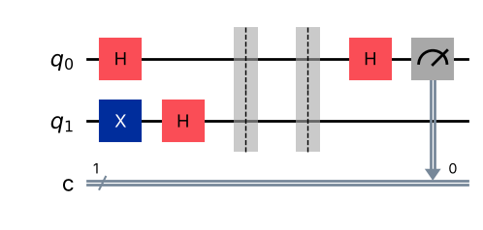
f(x)=1 {'0': 1024} constant

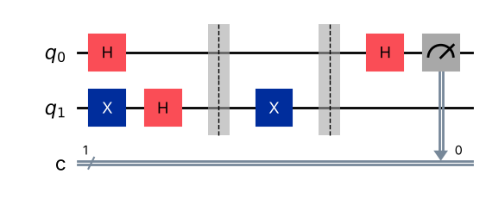
f(x)=x {'1': 1024} balanced

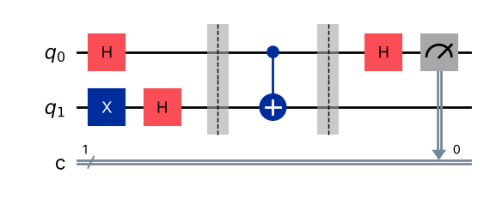
f(x)=NOT x {'1': 1024} balanced

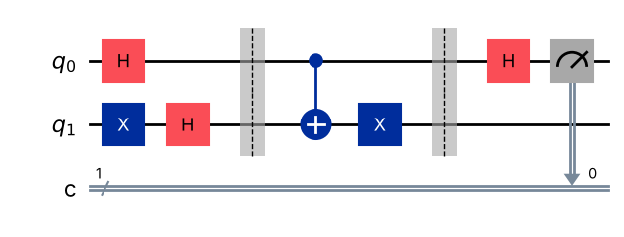
Inference: With one oracle query the input qubit reads 0 for the constant functions f(x)=0 and f(x)=1 and 1 for the balanced functions f(x)=x and f(x)=NOT x, in all 1024 shots. Classically two evaluations would be required.
Program 2: Implement the Deutsch-Jozsa algorithm with three input qubits and a constant oracle. Show that the measurement is always 000.
Code:
# Program 2: Deutsch-Jozsa, n = 3, constant oracle f(x) = 1
n = 3
qc = QuantumCircuit(n + 1, n)
qc.x(n); qc.h(n)
qc.h(range(n))
qc.barrier()
qc.x(n) # constant oracle: f(x) = 1 for every x
qc.barrier()
qc.h(range(n))
qc.measure(range(n), range(n))
show(qc.draw("mpl"))
counts = run(qc)
print("Counts:", counts)
print("Function is", "CONSTANT" if list(counts) == ["000"] else "BALANCED")
show(plot_histogram(counts, title="Deutsch-Jozsa, constant oracle"))

OUTPUT:
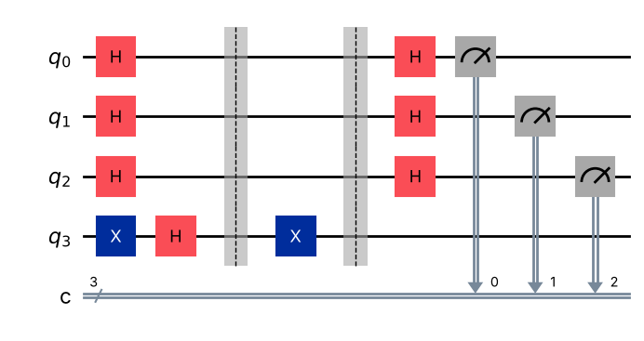
Counts: {'000': 1024}
Function is CONSTANT

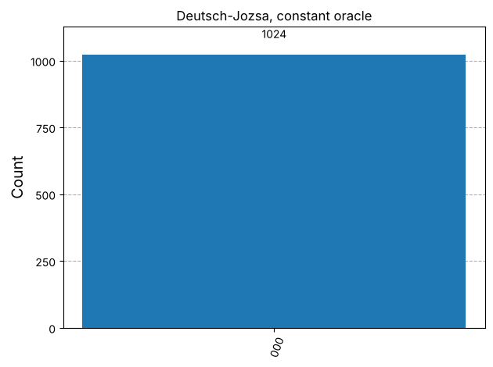
Inference: All 1024 shots give 000. A constant oracle only adds a global phase (−1)^f, so the final Hadamards return every input qubit to |0>; the amplitude of 000 is 1.
Program 3: Implement the Deutsch-Jozsa algorithm with three input qubits and the balanced oracle $f\left(x\right)=x_{0}⊕x_{1}⊕x_{2}$. Plot the histogram and explain the result.
Code:
# Program 3: Deutsch-Jozsa, n = 3, balanced oracle f(x) = x0 xor x1 xor x2
n = 3
qc = QuantumCircuit(n + 1, n)
qc.x(n); qc.h(n)
qc.h(range(n))
qc.barrier()
for i in range(n):
qc.cx(i, n)
qc.barrier()
qc.h(range(n))
qc.measure(range(n), range(n))
show(qc.draw("mpl"))
counts = run(qc)
print("Counts:", counts)
print("Function is", "CONSTANT" if list(counts) == ["000"] else "BALANCED")
show(plot_histogram(counts, title="Deutsch-Jozsa, balanced oracle x0^x1^x2"))

OUTPUT:
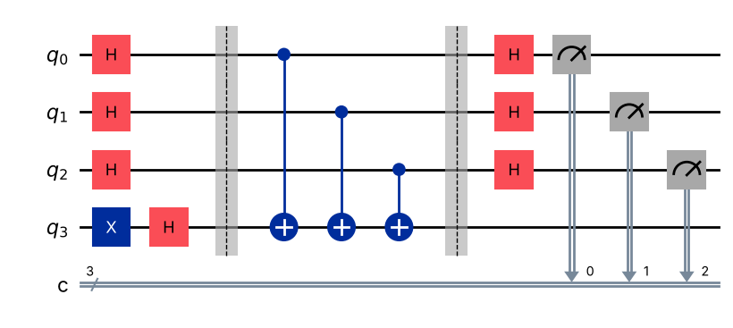
Counts: {'111': 1024}
Function is BALANCED

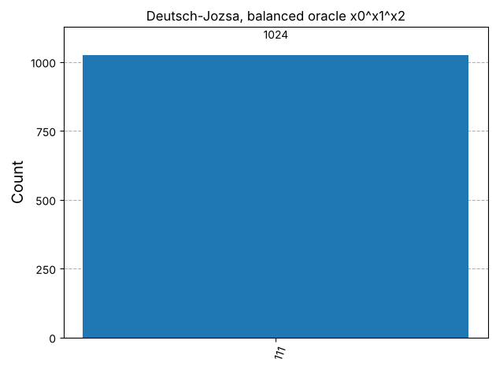
Inference: The result is always 111, never 000, so the function is balanced. Phase kickback gives (−1)^(x0⊕x1⊕x2)|x>, which the final Hadamards map to |111>; the amplitude of |000> is (1/8)Σ(−1)^f(x) = 0 for any balanced f.
Program 4: Write a function that returns the Deutsch-Jozsa circuit for any number of input qubits and a chosen oracle type (constant or balanced). Test it for n = 2, 3 and 4.
Code:
# Program 4: general Deutsch-Jozsa circuit generator
rng = np.random.default_rng(7)
def dj_oracle(n, kind):
o = QuantumCircuit(n + 1, name=f"Uf:{kind}")
if kind == "constant":
if rng.integers(2): # f(x)=1 or f(x)=0 at random
o.x(n)
else: # balanced: f(x) = b.x (+ optional NOT), b != 0
b = rng.integers(1, 2**n)
flip = rng.integers(2)
for i in range(n):
if (b >> i) & 1:
o.cx(i, n)
if flip:
o.x(n)
return o
def dj_circuit(n, kind):
qc = QuantumCircuit(n + 1, n)
qc.x(n); qc.h(n); qc.h(range(n)); qc.barrier()
qc.compose(dj_oracle(n, kind), inplace=True)
qc.barrier(); qc.h(range(n))
qc.measure(range(n), range(n))
return qc
print(" n oracle counts decision")
for n in [2, 3, 4]:
for kind in ["constant", "balanced"]:
qc = dj_circuit(n, kind)
c = run(qc)
dec = "constant" if list(c) == ["0" * n] else "balanced"
print(f" {n} {kind:<10} {str(c):<24} {dec}")
show(dj_circuit(4, "balanced").draw("mpl"))

OUTPUT:
n oracle counts decision
2 constant {'00': 1024} constant
2 balanced {'10': 1024} balanced
3 constant {'000': 1024} constant
3 balanced {'101': 1024} balanced
4 constant {'0000': 1024} constant
4 balanced {'0100': 1024} balanced

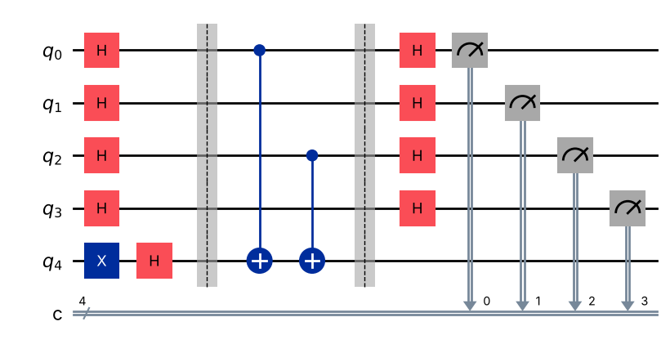
Inference: For n = 2, 3 and 4 the generator gives the correct answer every time: constant oracles always return the all-zero string and balanced oracles never do. One query suffices regardless of n.
Program 5: Implement the Bernstein-Vazirani algorithm for the secret string s = 101. Verify that a single shot returns the secret string.
Code:
# Program 5: Bernstein-Vazirani, s = 101
def bv_circuit(s):
n = len(s)
qc = QuantumCircuit(n + 1, n)
qc.x(n); qc.h(n); qc.h(range(n)); qc.barrier()
for i, bit in enumerate(reversed(s)): # rightmost character -> qubit 0
if bit == "1":
qc.cx(i, n)
qc.barrier(); qc.h(range(n))
qc.measure(range(n), range(n))
return qc
s = "101"
qc = bv_circuit(s)
show(qc.draw("mpl"))
one = run(qc, shots=1)
print("Single shot result:", one)
print("Recovered secret string:", list(one)[0], " correct:", list(one)[0] == s)
print("1024 shots:", run(qc))

OUTPUT:
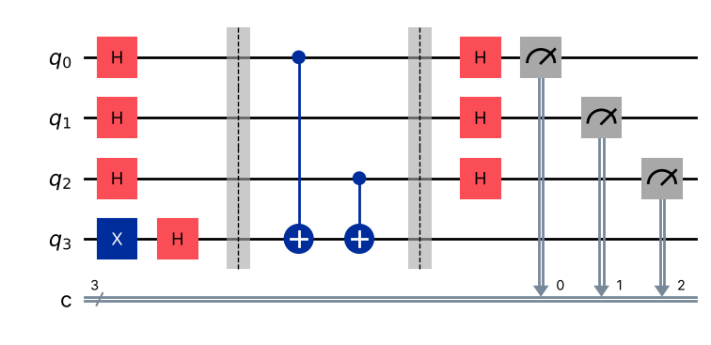
Single shot result: {'101': 1}
Recovered secret string: 101 correct: True
1024 shots: {'101': 1024}

Inference: A single shot returns 101, the secret string itself. Phase kickback gives (−1)^(s·x)|x>, which is exactly H^⊗n|s>, so the final Hadamards produce |s> with probability 1. A classical method needs 3 queries.
Program 6: Take the last two digits of your register number, find the remainder on division by 16 and write it as a 4-bit string. Use this as the secret string in the Bernstein-Vazirani algorithm and verify the result.
Code:
# Program 6: Bernstein-Vazirani with the register-number secret
last_two = int(REG_NO[-2:])
r = last_two % 16
s = format(r, "04b")
print(f"Register number: {REG_NO} -> last two digits = {last_two:02d} -> {last_two} mod 16 = {r} -> s = {s}")
qc = bv_circuit(s)
show(qc.draw("mpl"))
counts = run(qc)
print("Counts:", counts)
print("Recovered:", max(counts, key=counts.get), " correct:", max(counts, key=counts.get) == s)

OUTPUT:
Register number: CH.SC.U4CSE24102 -> last two digits = 02 -> 2 mod 16 = 2 -> s = 0010

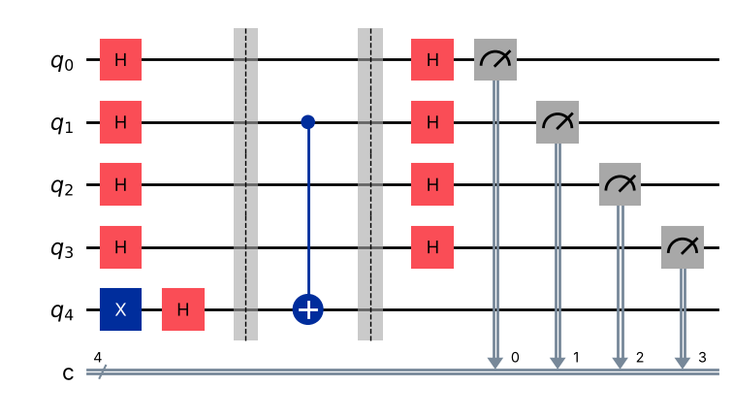
Counts: {'0010': 1024}
Recovered: 0010 correct: True

Inference: For register number CH.SC.U4CSE24102 the last two digits are 02, 02 mod 16 = 2, so s = 0010. The circuit returns 0010 in every shot with one oracle query (classically 4 queries).
Program 7: Implement Simon's algorithm for n = 2 with the hidden string s = 11. One valid oracle copies the input register to the output register with CNOT gates and then, controlled on one input qubit where $s$ has a 1, applies CNOT gates to the output qubits where $s$ has a 1. Show that every measured string $z$ satisfies $z⋅s=0$ (mod 2).
Code:
# Program 7: Simon's algorithm, n = 2, s = 11
def simon_oracle(s):
n = len(s)
o = QuantumCircuit(2 * n, name="Uf")
for i in range(n):
o.cx(i, n + i) # copy x -> output register
sr = s[::-1] # sr[j] = bit on qubit j
if "1" in sr:
j = sr.index("1") # first input qubit where s has a 1
for k in range(n):
if sr[k] == "1":
o.cx(j, n + k)
return o
def simon_circuit(s):
n = len(s)
qc = QuantumCircuit(2 * n, n)
qc.h(range(n)); qc.barrier()
qc.compose(simon_oracle(s), inplace=True)
qc.barrier(); qc.h(range(n))
qc.measure(range(n), range(n))
return qc
def dot(a, b):
return sum(int(x) * int(y) for x, y in zip(a, b)) % 2
s = "11"
qc = simon_circuit(s)
show(qc.draw("mpl"))
counts = run(qc)
print("Counts:", counts)
for z in counts:
print(f" z = {z}: z.s = {dot(z, s)} (mod 2)")
show(plot_histogram(counts, title="Simon, s = 11"))

OUTPUT:
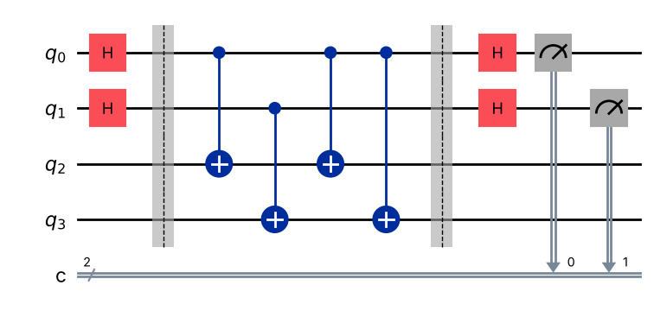
Counts: {'11': 511, '00': 513}
z = 11: z.s = 0 (mod 2)
z = 00: z.s = 0 (mod 2)

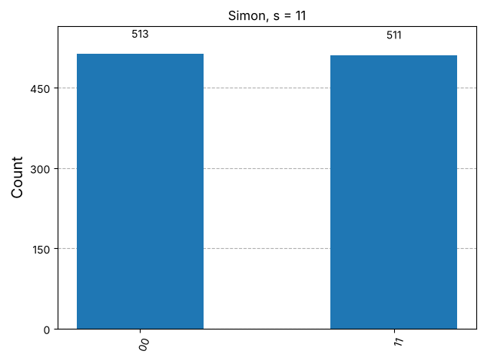
Inference: Only z = 00 and z = 11 occur (≈50% each), and both satisfy z·s = 0 (mod 2). The non-trivial equation z = 11 gives s1 ⊕ s0 = 0, whose only non-zero solution is s = 11.
Program 8: Implement Simon's algorithm for n = 3 with the hidden string s = 110. List the distinct measured strings and solve the equations $z⋅s=0$ by hand to recover $s$.
Code:
# Program 8: Simon's algorithm, n = 3, s = 110
s = "110"
qc = simon_circuit(s)
show(qc.draw("mpl"))
counts = run(qc)
print("Counts:", counts)
print("Distinct measured strings z and z.s:")
for z in sorted(counts):
print(f" z = {z} -> z.s = {dot(z, s)}")
# classical post-processing: non-zero s' orthogonal to every measured z
cands = [format(v, "03b") for v in range(1, 8)
if all(dot(z, format(v, "03b")) == 0 for z in counts)]
print("Solutions of z.s = 0 for all z:", cands)
show(plot_histogram(counts, title="Simon, s = 110"))

OUTPUT:
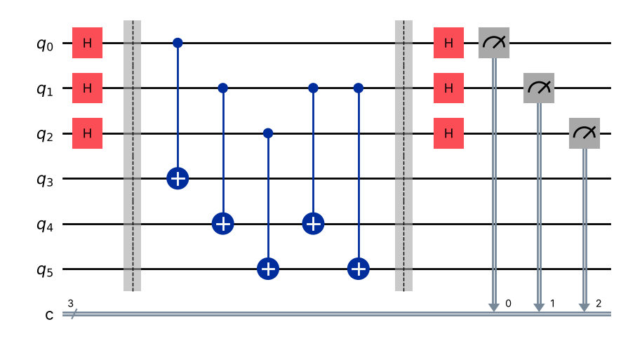
Counts: {'001': 264, '110': 256, '111': 259, '000': 245}
Distinct measured strings z and z.s:
z = 000 -> z.s = 0
z = 001 -> z.s = 0
z = 110 -> z.s = 0
z = 111 -> z.s = 0
Solutions of z.s = 0 for all z: ['110']

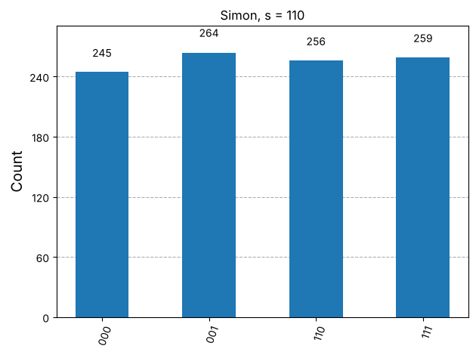
Inference: Only 000, 001, 110 and 111 appear, each satisfying z·s = 0. By hand (s = s2 s1 s0): z = 001 gives s0 = 0; z = 110 gives s2 ⊕ s1 = 0; z = 111 gives s2 ⊕ s1 ⊕ s0 = 0. The only non-zero solution is s2 = s1 = 1, s0 = 0, i.e. s = 110.
Program 9: Tabulate the number of oracle queries needed classically and with the quantum algorithm for Deutsch, Deutsch-Jozsa, Bernstein-Vazirani and Simon for n = 3, and comment on the comparison.
Code:
# Program 9: query comparison for n = 3
n = 3
rows = [
("Deutsch (n=1)", "2", "1"),
("Deutsch-Jozsa", f"2^(n-1)+1 = {2**(n-1)+1}", "1"),
("Bernstein-Vazirani", f"n = {n}", "1"),
("Simon", f"~2^(n/2) = {2**(n/2):.1f} (prob.), 2^(n-1)+1 = {2**(n-1)+1} (certain)", f"~n = {n} runs (O(n))"),
]
print(f"{'Algorithm':<20} | {'Classical queries':<48} | Quantum queries")
print("-" * 92)
for r in rows:
print(f"{r[0]:<20} | {r[1]:<48} | {r[2]}")

OUTPUT:
Algorithm | Classical queries | Quantum queries
--------------------------------------------------------------------------------------------
Deutsch (n=1) | 2 | 1
Deutsch-Jozsa | 2^(n-1)+1 = 5 | 1
Bernstein-Vazirani | n = 3 | 1
Simon | ~2^(n/2) = 2.8 (prob.), 2^(n-1)+1 = 5 (certain) | ~n = 3 runs (O(n))

Inference: For n = 3 the quantum algorithms need 1 query (Deutsch, DJ, BV) or about n runs (Simon) against 2, 5, 3 and up to 5 classically. The gap is small at n = 3 but grows exponentially with n for Deutsch-Jozsa (exact) and Simon (even against randomised algorithms), and linearly for Bernstein-Vazirani.
VIVA Q&A:
- What is a quantum oracle?
Ans: A quantum oracle is a black-box unitary that evaluates a function f reversibly, U_f|x>|y> = |x>|y⊕f(x)>, without revealing how f is computed. The cost of an algorithm is counted as the number of oracle calls (queries).
- What is phase kickback, and which state of the output qubit produces it?
Ans: When the output qubit is in |−> = (|0>−|1>)/√2, applying U_f leaves it unchanged and multiplies the input state by (−1)^f(x). The function value is 'kicked back' into the phase of the input register. It is produced by the |−> state of the output qubit.
- What is the difference between a constant function and a balanced function?
Ans: A constant function returns the same value for every input (all 0s or all 1s). A balanced function returns 0 for exactly half of the inputs and 1 for the other half.
- How many queries does a classical method need to solve the Deutsch-Jozsa problem with certainty for n input bits?
Ans: In the worst case 2^(n−1)+1 queries: a classical algorithm may see 2^(n−1) identical outputs from a balanced function before the next query decides.
- In the Deutsch-Jozsa algorithm, why does the result 00...0 mean that the function is constant?
Ans: The amplitude of |00…0> after the final Hadamards is (1/2ⁿ)Σ(−1)^f(x). For a constant f this is ±1, so 00…0 is certain; for a balanced f the terms cancel to 0, so 00…0 never occurs.
- What problem does the Bernstein-Vazirani algorithm solve?
Ans: It finds a hidden n-bit string s, given an oracle for f(x) = s·x (mod 2), using a single query instead of n.
- Why can the Bernstein-Vazirani algorithm find the secret string in one query?
Ans: Phase kickback produces (1/√2ⁿ)Σ(−1)^(s·x)|x>, which is exactly H^⊗n|s>. Applying H^⊗n again gives |s> with certainty, so all n bits are obtained in one query by interference.
- State Simon's problem.
Ans: Given f: {0,1}ⁿ → {0,1}ⁿ with the promise that f(x) = f(y) if and only if y = x ⊕ s for a hidden string s, find s.
- Why does Simon's algorithm need several runs and classical post-processing?
Ans: Each run returns only one random string z with z·s = 0 (mod 2), which gives one linear equation. About n−1 linearly independent equations are needed, so the circuit is run about n times and the system is solved classically (Gaussian elimination over GF(2)).
- Is the Deutsch-Jozsa speed-up useful in practice? What happens if a small probability of error is allowed?
Ans: Not very: it is a speed-up only over deterministic classical algorithms that must be certain. If a small error is allowed, a classical algorithm that queries k random inputs fails with probability at most 2^(1−k), so a constant number of queries suffices. Its value is as a demonstration of superposition, phase kickback and interference.
RESULT:
The Deutsch, Deutsch-Jozsa, Bernstein-Vazirani and Simon algorithms were implemented in Qiskit with explicit oracles and simulated on AerSimulator. Deutsch and Deutsch-Jozsa classified constant and balanced functions with a single query, Bernstein-Vazirani recovered the secret strings 101 and 0010 (from register number CH.SC.U4CSE24102) in one query, and Simon's algorithm produced strings z with z·s = 0 from which s = 11 and s = 110 were recovered. The query comparison confirmed the quantum advantage. Hence the experiment was successfully completed.

EVALUATION (for faculty use):

Evaluation method | Prep | Program | Output | Inference | Viva | Timely | Total
Maximum marks | 2 | 5 | 3 | 2 | 2 | 1 | 15
Marks awarded
Faculty signature with date:

