Department of Computer Science and Engineering
2024 CSE BATCH
23CSE463 – Quantum Computing

NAME : Agneay B Nair
REG NO : CH.SC.U4CSE24102

WORKSHEET
WORKSHEET- 3
EX.NO : 3
DATE :
TITLE : Quantum Communication Protocols: Superdense Coding and Quantum Teleportation Using Qiskit
AIM:
To implement the superdense coding and quantum teleportation protocols in Qiskit using a shared Bell pair, and to verify that two classical bits can be sent with one qubit and that the state of a qubit can be transferred with two classical bits.
APPARATUS REQUIRED:
- Python 3.10 or above
- Qiskit 2.x and Qiskit Aer simulator (pip install qiskit qiskit-aer)
- Matplotlib and pylatexenc (for circuit diagrams and histograms)
- Jupyter Notebook / Visual Studio Code (VS Code)
- Internet Connection (for package installation and documentation access)
- Quantum Computing Reference Material or Lab Manual
THEORY:
Both protocols in this experiment use one shared pair of entangled qubits, called a Bell pair, prepared with a Hadamard gate and a CNOT gate. Alice holds one qubit of the pair and Bob holds the other.
$$|Φ^{+}⟩=\frac{|00⟩+|11⟩}{\sqrt{2}}$$
Superdense coding sends two classical bits by transmitting one qubit. Alice applies one of four operations to her half of the pair, chosen by the two bits $b_{1}b_{0}$ she wants to send: an X gate if $b_{0}=1$, followed by a Z gate if $b_{1}=1$. The messages 00, 01, 10 and 11 therefore use I, X, Z and ZX. These turn the pair into four different Bell states, which can be told apart with certainty.
Alice then sends her qubit to Bob. Bob applies a CNOT gate with Alice's qubit as the control, applies a Hadamard gate to Alice's qubit, and measures both qubits to read the two bits. Someone who intercepts only the travelling qubit learns nothing: measured on its own, it gives 0 or 1 with equal probability whatever the message is.
Quantum teleportation does the reverse: it transfers the state of one qubit by sending two classical bits. Alice holds a qubit in an unknown state $|ψ⟩=α|0⟩+β|1⟩$ and her half of a Bell pair. She applies a CNOT gate from the unknown qubit to her half of the pair, applies a Hadamard gate to the unknown qubit, and measures both. Just before the measurement the three qubits are in the state
$$\frac{1}{2}\left[ |00⟩\left(α|0⟩+β|1⟩\right)+|01⟩\left(α|1⟩+β|0⟩\right)+|10⟩\left(α|0⟩−β|1⟩\right)+|11⟩\left(α|1⟩−β|0⟩\right)\right]$$
Here the first two positions are Alice's qubits (the unknown qubit, then her half of the pair) and the third is Bob's qubit. Alice's measurement gives two bits $m_{1}m_{2}$ and leaves Bob's qubit in one of the four states in the brackets. Alice sends the two bits to Bob, who applies an X gate if $m_{2}=1$ and then a Z gate if $m_{1}=1$. His qubit is then exactly $|ψ⟩$.
Three facts follow. The state is moved, not copied: Alice's measurement destroys her original, so the no-cloning theorem holds. Nothing travels faster than light: without the two classical bits, Bob's qubit gives random results. Only the state is transferred; no matter moves.
The two protocols are mirror images of each other. One shared Bell pair and one transmitted qubit carry two classical bits. One shared Bell pair and two transmitted classical bits carry one qubit.
In Qiskit, a gate that depends on a measurement result is written inside with qc.if_test((creg, 1)):, and such circuits are run on AerSimulator. Use a separate classical register for each measured bit so that each condition is easy to write. Qiskit prints qubit 0 as the rightmost bit.
PROCEDURE:
- Install Qiskit and the Aer simulator with pip install qiskit qiskit-aer matplotlib pylatexenc, and print the installed version with qiskit.__version__.
- Open Jupyter Notebook or Visual Studio Code.
- Import QuantumCircuit and transpile from qiskit, Statevector and Operator from qiskit.quantum_info, AerSimulator from qiskit_aer and plot_histogram from qiskit.visualization. Import QuantumRegister and ClassicalRegister as well.
- Create the Bell pair with a Hadamard gate and a CNOT gate, and decide which qubit belongs to Alice and which to Bob.
- Superdense coding: apply Alice's encoding gates for the chosen message, then Bob's CNOT and Hadamard gates, and measure both qubits.
- Teleportation: prepare the state to be sent on a third qubit, apply Alice's CNOT and Hadamard gates, and measure her two qubits into separate classical registers.
- Apply Bob's corrections inside with qc.if_test(...) blocks: X if the second measured bit is 1, then Z if the first measured bit is 1.
- Draw the circuit with qc.draw("mpl") before running it. Use barriers to separate the stages of the protocol.
- Run the circuit on AerSimulator with 1024 shots and plot the histogram of the relevant bits.
- Compare the result with the hand calculation. Remember that Qiskit prints qubit 0 as the rightmost bit. Record the code, the circuit diagram, the output and a one-line inference under each program.
PROGRAM:
Common setup (imports and helper functions used by every program):
# Common setup for all programs in this worksheet
%matplotlib inline
import qiskit, numpy as np, matplotlib.pyplot as plt
from qiskit import QuantumCircuit, transpile
from qiskit.quantum_info import Statevector, Operator
from qiskit_aer import AerSimulator
from qiskit.visualization import plot_histogram
from IPython.display import display
print("Qiskit version:", qiskit.__version__)
sim = AerSimulator()
_seed = 2024 # seeds incremented per run -> reproducible counts
np.set_printoptions(precision=3, suppress=True, linewidth=110)
plt.rcParams["figure.dpi"] = 100
def show(fig):
"""display a matplotlib figure (circuit diagram / histogram) and close it"""
display(fig); plt.close(fig)
def run(qc, shots=1024):
global _seed
_seed += 1
return sim.run(transpile(qc, sim), shots=shots, seed_simulator=_seed).result().get_counts()
def amps(sv, tol=1e-9):
"""print the non-zero amplitudes of a statevector with Qiskit labels (qubit 0 rightmost)"""
n = sv.num_qubits
for i, a in enumerate(sv.data):
if abs(a) > tol:
print(f" |{i:0{n}b}> : {a.real:+.3f}{a.imag:+.3f}j P = {abs(a)**2:.3f}")
from qiskit import QuantumRegister, ClassicalRegister
from qiskit.quantum_info import partial_trace, DensityMatrix

Qiskit version: 2.5.2

Program 1: Prepare a Bell pair shared between Alice and Bob. Display the statevector and the histogram for 1024 shots.
Code:
# Program 1: Bell pair shared by Alice (q0) and Bob (q1)
qc = QuantumCircuit(2)
qc.h(0); qc.cx(0, 1)
print("Bell pair statevector (label = Bob Alice):")
amps(Statevector(qc))
qc.measure_all()
show(qc.draw("mpl"))
counts = run(qc)
print("Counts:", counts)
show(plot_histogram(counts, title="Shared Bell pair |Phi+>"))

OUTPUT:
Bell pair statevector (label = Bob Alice):
|00> : +0.707+0.000j P = 0.500
|11> : +0.707+0.000j P = 0.500

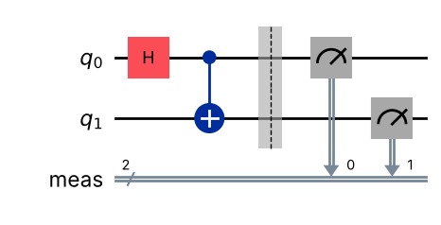
Counts: {'00': 510, '11': 514}

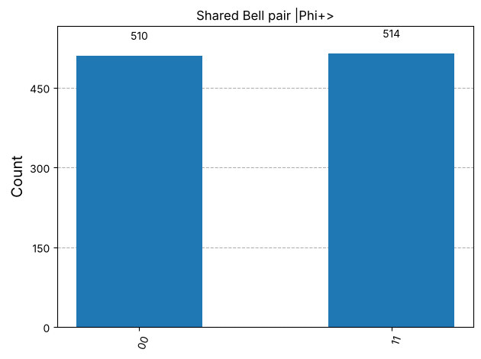
Inference: The pair is (|00>+|11>)/√2: only 00 and 11 are observed, each ≈50%. Alice's and Bob's results always agree, although each one on its own is random.
Program 2: Implement superdense coding for the message 00. Draw the complete circuit with barriers between the preparation, encoding and decoding stages, and show the measurement result.
Code:
# Program 2: superdense coding for message 00. Alice = q0, Bob = q1
qc = QuantumCircuit(2, 2)
qc.h(0); qc.cx(0, 1) # preparation (shared Bell pair)
qc.barrier()
# encoding for "00": identity (no gate)
qc.barrier()
qc.cx(0, 1); qc.h(0) # Bob's decoding
qc.barrier()
qc.measure(0, 1) # Alice's qubit -> bit b1 (left)
qc.measure(1, 0) # Bob's qubit -> bit b0 (right)
show(qc.draw("mpl"))
counts = run(qc)
print("Counts:", counts)

OUTPUT:
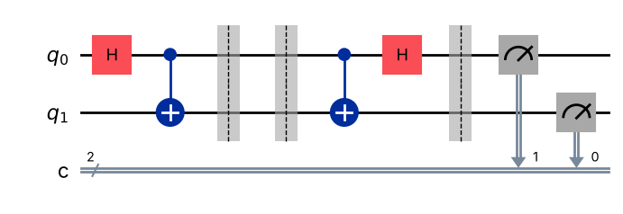
Counts: {'00': 1024}

Inference: Bob reads 00 in all 1024 shots. With no encoding gate the decoding (CNOT then H) simply undoes the Bell-pair preparation, returning |00>. The measurement is wired so that the printed string reads b1b0.
Program 3: Write a function that builds the superdense coding circuit for any two-bit message. Run it for 00, 01, 10 and 11 and tabulate the message sent against the message received.
Code:
# Program 3: superdense coding for any 2-bit message b1b0
def superdense(msg):
b1, b0 = msg[0], msg[1]
qc = QuantumCircuit(2, 2)
qc.h(0); qc.cx(0, 1); qc.barrier()
if b0 == "1": qc.x(0) # X if b0 = 1
if b1 == "1": qc.z(0) # then Z if b1 = 1
qc.barrier()
qc.cx(0, 1); qc.h(0); qc.barrier()
qc.measure(0, 1); qc.measure(1, 0)
return qc
print("Message sent | Alice's gate | Received (counts)")
gate = {"00": "I", "01": "X", "10": "Z", "11": "ZX"}
for m in ["00", "01", "10", "11"]:
c = run(superdense(m))
print(f" {m} | {gate[m]:<3} | {c} {'OK' if list(c) == [m] else 'ERR'}")
show(superdense("11").draw("mpl"))

OUTPUT:
Message sent | Alice's gate | Received (counts)
00 | I | {'00': 1024} OK
01 | X | {'01': 1024} OK
10 | Z | {'10': 1024} OK
11 | ZX | {'11': 1024} OK

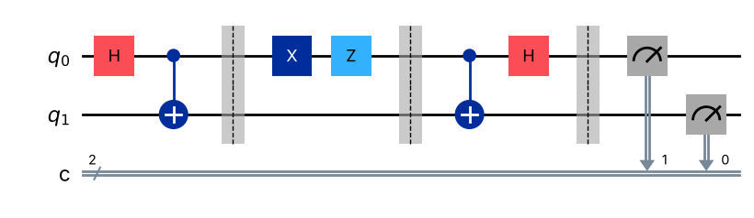
Inference: Every message 00, 01, 10, 11 is received correctly with 100% probability. Alice's four operations I, X, Z, ZX produce the four orthogonal Bell states, which Bob's Bell measurement distinguishes perfectly: two classical bits are carried by one transmitted qubit.
Program 4: For each of the four messages, measure only the qubit that Alice sends, without Bob's decoding. Show that the result is 0 or 1 with equal probability in every case, and explain what this means for an eavesdropper.
Code:
# Program 4: eavesdropper measures only the travelling qubit (Alice's q0), no decoding
print("Message | counts of Alice's qubit alone | P(0)")
for m in ["00", "01", "10", "11"]:
qc = QuantumCircuit(2, 1)
qc.h(0); qc.cx(0, 1); qc.barrier()
if m[1] == "1": qc.x(0)
if m[0] == "1": qc.z(0)
qc.barrier()
qc.measure(0, 0)
c = run(qc)
rho = partial_trace(Statevector(qc.remove_final_measurements(inplace=False)), [1])
print(f" {m} | {str(c):<29} | {c.get('0', 0)/1024:.3f} reduced state =",
np.round(rho.data.real, 2).tolist())

OUTPUT:
Message | counts of Alice's qubit alone | P(0)
00 | {'0': 508, '1': 516} | 0.496 reduced state = [[0.5, 0.0], [0.0, 0.5]]
01 | {'0': 492, '1': 532} | 0.480 reduced state = [[0.5, 0.0], [0.0, 0.5]]
10 | {'1': 522, '0': 502} | 0.490 reduced state = [[0.5, 0.0], [0.0, 0.5]]
11 | {'0': 501, '1': 523} | 0.489 reduced state = [[0.5, 0.0], [0.0, 0.5]]

Inference: For every message the intercepted qubit gives 0 or 1 with ≈50% probability; its reduced density matrix is I/2 in all four cases. An eavesdropper who holds only the travelling qubit learns nothing about the message — the information is stored in the correlation with Bob's qubit.
Program 5: Implement quantum teleportation of the state $|1⟩$ using three qubits and classically controlled corrections. Measure Bob's qubit and show that it is always 1.
Code:
# Program 5: teleport |1>. q0 = state to send, q1 = Alice's half, q2 = Bob's half
def teleport(prep, bob_basis_h=False, corrections=True):
q = QuantumRegister(3, "q")
m1 = ClassicalRegister(1, "m1") # measurement of q0
m2 = ClassicalRegister(1, "m2") # measurement of q1
b = ClassicalRegister(1, "bob")
qc = QuantumCircuit(q, m1, m2, b)
prep(qc) # prepare |psi> on q0
qc.barrier()
qc.h(1); qc.cx(1, 2) # Bell pair Alice-Bob
qc.barrier()
qc.cx(0, 1); qc.h(0) # Alice's operations
qc.measure(0, m1); qc.measure(1, m2)
qc.barrier()
if corrections:
with qc.if_test((m2, 1)):
qc.x(2)
with qc.if_test((m1, 1)):
qc.z(2)
if bob_basis_h:
qc.h(2)
qc.measure(2, b)
return qc
def bob_counts(counts):
out = {}
for k, v in counts.items():
bit = k.split()[0] # key = "bob m2 m1"
out[bit] = out.get(bit, 0) + v
return out
qc = teleport(lambda c: c.x(0))
show(qc.draw("mpl"))
counts = run(qc)
print("Full counts (bob m2 m1):", counts)
print("Bob's qubit:", bob_counts(counts))

OUTPUT:
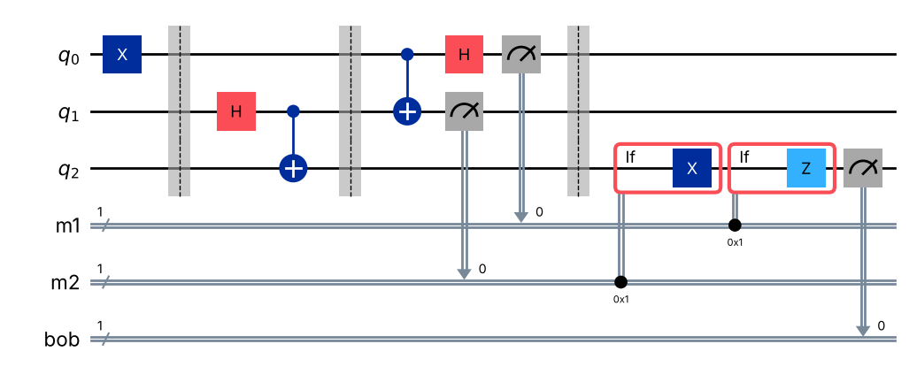
Full counts (bob m2 m1): {'1 0 1': 245, '1 0 0': 273, '1 1 0': 246, '1 1 1': 260}
Bob's qubit: {'1': 1024}

Inference: Alice's two bits are random (all four combinations ≈25%), but after the classically controlled X/Z corrections Bob's qubit measures 1 in all 1024 shots: the state |1> has been teleported.
Program 6: Teleport the state $|+⟩$. Apply a Hadamard gate to Bob's qubit before measuring it and show that the result is always 0.
Code:
# Program 6: teleport |+>; Bob applies H before measuring
qc = teleport(lambda c: c.h(0), bob_basis_h=True)
counts = run(qc)
print("Bob's qubit after H:", bob_counts(counts))
show(plot_histogram(bob_counts(counts), title="Teleported |+>, measured after H"))

OUTPUT:
Bob's qubit after H: {'0': 1024}

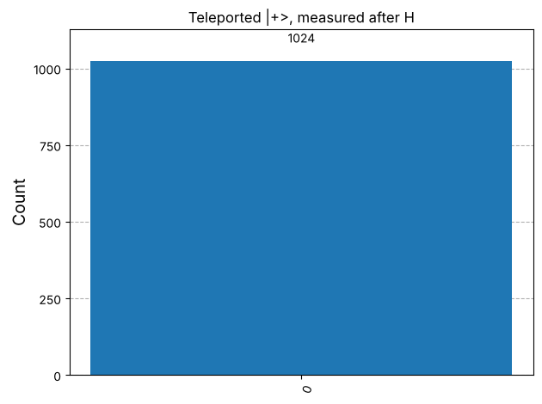
Inference: Bob always measures 0 after the H gate, so his qubit was exactly |+> (H|+> = |0>). This shows that the superposition including its relative phase is transferred, not just a classical bit.
Program 7: Teleport the state $R_{y}\left(θ\right)|0⟩$ with $θ=π/3$. Show that Bob's qubit measures 1 with probability $\sin^{2}\left(θ/2\right)=0.25$, using at least 8192 shots.
Code:
# Program 7: teleport Ry(pi/3)|0>, 8192 shots
theta = np.pi / 3
qc = teleport(lambda c: c.ry(theta, 0))
counts = bob_counts(run(qc, shots=8192))
p1 = counts.get("1", 0) / 8192
print("Bob's counts:", counts)
print(f"Measured P(1) = {p1:.4f} expected sin^2(theta/2) = {np.sin(theta/2)**2:.4f}")
show(plot_histogram(counts, title="Teleported Ry(pi/3)|0>, 8192 shots"))

OUTPUT:
Bob's counts: {'1': 2023, '0': 6169}
Measured P(1) = 0.2469 expected sin^2(theta/2) = 0.2500

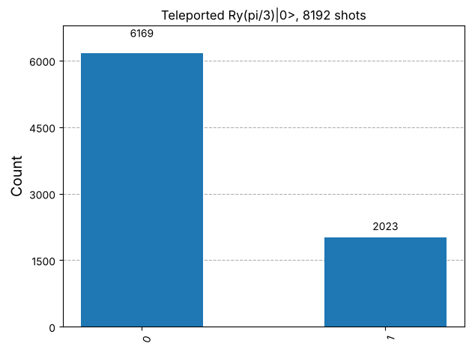
Inference: Bob's qubit measures 1 with probability close to the expected sin²(π/6) = 0.25 (the small difference is shot noise, ≈ ±0.005 for 8192 shots), confirming that an arbitrary amplitude is teleported faithfully.
Program 8: Repeat Program 7 with Bob's corrections removed. Show that Bob's qubit now measures 0 and 1 with equal probability, and explain why the classical bits are necessary.
Code:
# Program 8: same as Program 7 but WITHOUT Bob's corrections
qc = teleport(lambda c: c.ry(theta, 0), corrections=False)
counts = bob_counts(run(qc, shots=8192))
print("Bob's counts without corrections:", counts)
print(f"P(1) = {counts.get('1', 0)/8192:.4f}")
show(plot_histogram(counts, title="No corrections: Bob sees noise"))

OUTPUT:
Bob's counts without corrections: {'1': 4099, '0': 4093}
P(1) = 0.5004

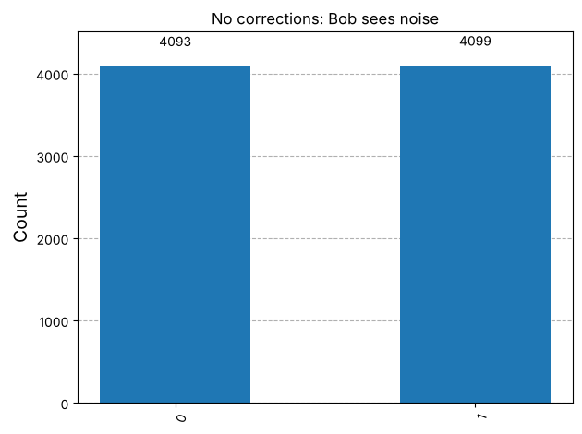
Inference: Without the corrections Bob gets 0 and 1 with ≈50% each: averaged over Alice's four random outcomes his qubit is in the maximally mixed state I/2. Only the two classical bits tell Bob which of X, Z, ZX or I to apply, so they are necessary — and since they travel no faster than light, teleportation cannot be used for faster-than-light signalling.
Program 9: Replace the classically controlled corrections with a CNOT gate and a CZ gate controlled by Alice's qubits (deferred measurement). Show that Bob's result is the same as in Program 7.
Code:
# Program 9: deferred measurement - quantum-controlled corrections
qc = QuantumCircuit(3, 1)
qc.ry(theta, 0); qc.barrier()
qc.h(1); qc.cx(1, 2); qc.barrier()
qc.cx(0, 1); qc.h(0); qc.barrier()
qc.cx(1, 2) # replaces "X if m2 = 1"
qc.cz(0, 2) # replaces "Z if m1 = 1"
# exact check: Bob's reduced state equals Ry(theta)|0>
rho_bob = partial_trace(Statevector(qc), [0, 1])
psi = QuantumCircuit(1); psi.ry(theta, 0)
target = DensityMatrix(Statevector(psi))
print("Bob's reduced density matrix:\n", np.round(rho_bob.data.real, 3))
print("Equal to |psi><psi| :", np.allclose(rho_bob.data, target.data))
qc.measure(2, 0)
show(qc.draw("mpl"))
counts = run(qc, shots=8192)
print("Bob's counts:", counts, f" P(1) = {counts.get('1', 0)/8192:.4f}")

OUTPUT:
Bob's reduced density matrix:
[[0.75 0.433]
[0.433 0.25 ]]
Equal to |psi><psi| : True

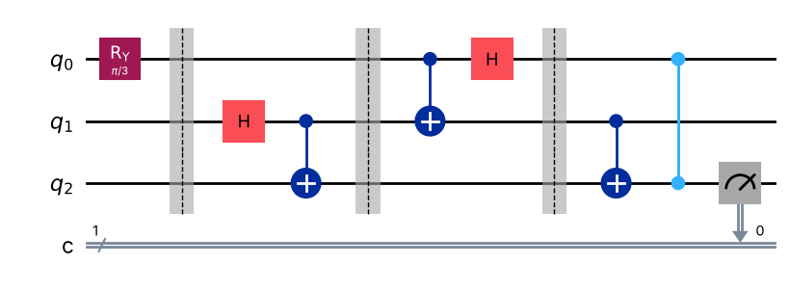
Bob's counts: {'1': 1972, '0': 6220} P(1) = 0.2407

Inference: With CNOT and CZ controlled by Alice's qubits the result is the same as Program 7: P(1) ≈ 0.25 and Bob's reduced density matrix equals |ψ><ψ| exactly. By the principle of deferred measurement, classically controlled gates after a measurement are equivalent to quantum-controlled gates before it.
VIVA Q&A:
- What is a Bell pair, and how is it prepared?
Ans: A Bell pair is a maximally entangled two-qubit state such as |Φ+> = (|00>+|11>)/√2. It is prepared from |00> with a Hadamard on the first qubit followed by a CNOT from the first to the second.
- How many classical bits does one qubit carry in superdense coding, and what must be shared in advance?
Ans: One transmitted qubit carries two classical bits, but only if Alice and Bob share one entangled Bell pair in advance (Alice holds one half, Bob the other).
- Which gate does Alice apply for each of the four messages 00, 01, 10 and 11?
Ans: 00 → I (no gate), 01 → X, 10 → Z, 11 → ZX (X followed by Z, equivalent to iY up to phase).
- How does Bob decode the message in superdense coding?
Ans: Bob performs a Bell-basis measurement: a CNOT with Alice's qubit as control and his own as target, then a Hadamard on Alice's qubit, then measures both qubits to read b1b0.
- What is transferred in quantum teleportation: the qubit itself or its state?
Ans: Only the quantum state (the amplitudes α, β) is transferred; no particle or matter travels from Alice to Bob. Bob's own qubit takes on the state.
- Why are two classical bits needed for teleportation?
Ans: Alice's measurement has four equally likely outcomes, each leaving Bob's qubit in a different version of |ψ> (I, X, Z or ZX applied). Two bits are needed to tell Bob which of the four corrections to apply.
- Why does teleportation not violate the no-cloning theorem?
Ans: Alice's measurement destroys the original state on her qubit, so at the end only Bob has |ψ>. At no time do two copies exist, so the no-cloning theorem is respected.
- Why does teleportation not allow communication faster than light?
Ans: Before the two classical bits arrive, Bob's qubit is in the maximally mixed state I/2 whatever |ψ> is, so he learns nothing. The classical bits travel at most at the speed of light, so no information arrives faster than light.
- Which correction does Bob apply for each of Alice's four measurement results?
Ans: m1m2 = 00 → I, 01 → X, 10 → Z, 11 → ZX (X first, then Z), where m1 is the measurement of the state qubit and m2 that of Alice's half of the pair.
- How are superdense coding and teleportation related to each other?
Ans: They are mirror images (dual protocols): superdense coding uses 1 Bell pair + 1 qubit sent to carry 2 classical bits, while teleportation uses 1 Bell pair + 2 classical bits sent to carry 1 qubit. Both rely on the four Bell states being perfectly distinguishable.
RESULT:
Superdense coding and quantum teleportation were implemented in Qiskit using a shared Bell pair. All four two-bit messages were transmitted with 100% accuracy using one qubit, and an intercepted qubit alone was shown to give random results. The states |1>, |+> and Ry(π/3)|0> were teleported (P(1) ≈ 0.25 for the last), the necessity of the two classical bits was demonstrated by removing the corrections, and the deferred-measurement version gave the same result. Hence the experiment was successfully completed.

EVALUATION (for faculty use):

Evaluation method | Prep | Program | Output | Inference | Viva | Timely | Total
Maximum marks | 2 | 5 | 3 | 2 | 2 | 1 | 15
Marks awarded
Faculty signature with date:

