Department of Computer Science and Engineering
2024 CSE BATCH
23CSE463 – Quantum Computing

NAME : Agneay B Nair
REG NO : CH.SC.U4CSE24102

WORKSHEET
WORKSHEET- 6
EX.NO : 6
DATE :
TITLE : Implementation of Shor's Algorithm for Integer Factorization Using Qiskit
AIM:
To implement the quantum period-finding part of Shor's algorithm in Qiskit for N = 15, and to use the measured period with classical post-processing to obtain the prime factors.
APPARATUS REQUIRED:
- Python 3.10 or above
- Qiskit 2.x and Qiskit Aer simulator (pip install qiskit qiskit-aer)
- Matplotlib and pylatexenc (for circuit diagrams and histograms)
- Jupyter Notebook / Visual Studio Code (VS Code)
- Internet Connection (for package installation and documentation access)
- Quantum Computing Reference Material or Lab Manual
THEORY:
Shor's algorithm finds the prime factors of an integer $N$. Its speed-up over the best known classical methods is superpolynomial, which is why it threatens RSA and elliptic-curve cryptography. The algorithm turns factoring into period finding. Choose an integer $a$ with $1<a<N$ that shares no factor with $N$. The period (or order) $r$ is the smallest positive integer for which
$$a^{r}≡1 \left(\text{mod }N\right)$$
If $r$ is even and $a^{r/2}$ is not equal to $−1$ modulo $N$, the factors of $N$ are
$$p=gcd\left(a^{r/2}−1, N\right), q=gcd\left(a^{r/2}+1, N\right)$$
Worked example. Take $N=15$ and $a=7$. The powers of 7 modulo 15 are 7, 4, 13, 1, so $r=4$. Then $a^{r/2}=7^{2}=49$, and $gcd\left(48,15\right)=3$ and $gcd\left(50,15\right)=5$. So $15=3×5$.
The quantum part finds $r$. It uses two registers. A counting register of $t$ qubits is put into superposition with Hadamard gates. A work register starts in the state $|1⟩$ and is multiplied by $a,a^{2},a^{4},…$ modulo $N$, each multiplication controlled by one counting qubit. An inverse QFT on the counting register then turns the hidden period into a number that can be measured. The measured value $c$ satisfies
$$\frac{c}{2^{t}}≈\frac{s}{r}, s=0,1,…,r−1$$
With $t=8$ counting qubits and $r=4$, the only outcomes are 0, 64, 128 and 192, which correspond to the phases 0, 1/4, 1/2 and 3/4.
The classical part reads $r$ as the denominator of this fraction, using the continued-fraction method (Fraction(c, 2**t).limit_denominator(N) in Python). Some runs give a denominator smaller than $r$: the outcome 128 gives 1/2. The run is therefore repeated, and each candidate is checked by confirming that $a^{r}$ leaves remainder 1 on division by $N$.
Steps of the full algorithm. First, pick $a$ and check that $gcd\left(a,N\right)=1$. Second, find the period $r$ with the quantum circuit. Third, if $r$ is odd or $a^{r/2}$ equals $−1$ modulo $N$, pick another $a$. Fourth, compute the two greatest common divisors.
For N = 15 the modular multiplication can be written directly with SWAP and X gates on four work qubits. Multiplication by 7 is swap(0, 1), swap(1, 2), swap(2, 3) followed by an X gate on each of the four qubits. This shortcut uses knowledge of the answer and does not extend to large numbers. Factoring numbers of the size used in real cryptography needs error-corrected quantum computers far larger than the noisy devices available today.
PROCEDURE:
- Install Qiskit and the Aer simulator with pip install qiskit qiskit-aer matplotlib pylatexenc, and print the installed version with qiskit.__version__.
- Open Jupyter Notebook or Visual Studio Code.
- Import QuantumCircuit and transpile from qiskit, Statevector and Operator from qiskit.quantum_info, AerSimulator from qiskit_aer and plot_histogram from qiskit.visualization. Import gcd from math and Fraction from fractions.
- Choose $a$, check that $gcd\left(a,15\right)=1$, and find the period classically first so that the expected answer is known.
- Build the four-qubit circuit that multiplies the work register by a modulo 15, and verify it on basis states with Statevector.
- Create a circuit with $t$ counting qubits, four work qubits and $t$ classical bits. Apply H to every counting qubit and X to the first work qubit to prepare $|1⟩$.
- For each counting qubit $j$, append the multiplication circuit raised to the power $2^{j}$ as a controlled gate (.power(2**j).to_gate().control()).
- Apply the inverse QFT to the counting register, measure the counting register, and draw the circuit.
- Run the circuit on AerSimulator with 1024 shots, convert each outcome to a phase and then to a candidate period with Fraction(...).limit_denominator(15).
- Check the period, compute the factors with gcd, and record the code, the circuit, the output and the inference under each program.
PROGRAM:
Common setup (imports and helper functions used by every program):
# Common setup for all programs in this worksheet
%matplotlib inline
import qiskit, numpy as np, matplotlib.pyplot as plt
from qiskit import QuantumCircuit, transpile
from qiskit.quantum_info import Statevector, Operator
from qiskit_aer import AerSimulator
from qiskit.visualization import plot_histogram
from IPython.display import display
print("Qiskit version:", qiskit.__version__)
sim = AerSimulator()
_seed = 2024 # seeds incremented per run -> reproducible counts
np.set_printoptions(precision=3, suppress=True, linewidth=110)
plt.rcParams["figure.dpi"] = 100
def show(fig):
"""display a matplotlib figure (circuit diagram / histogram) and close it"""
display(fig); plt.close(fig)
def run(qc, shots=1024):
global _seed
_seed += 1
return sim.run(transpile(qc, sim), shots=shots, seed_simulator=_seed).result().get_counts()
def amps(sv, tol=1e-9):
"""print the non-zero amplitudes of a statevector with Qiskit labels (qubit 0 rightmost)"""
n = sv.num_qubits
for i, a in enumerate(sv.data):
if abs(a) > tol:
print(f" |{i:0{n}b}> : {a.real:+.3f}{a.imag:+.3f}j P = {abs(a)**2:.3f}")
from math import gcd
from fractions import Fraction
N = 15
def period(a, N):
r, v = 1, a % N
while v != 1:
v = (v * a) % N; r += 1
return r
def qft(n):
qc = QuantumCircuit(n, name=f"QFT{n}")
for j in reversed(range(n)):
qc.h(j)
for k in reversed(range(j)):
qc.cp(np.pi / 2 ** (j - k), k, j)
for i in range(n // 2):
qc.swap(i, n - 1 - i)
return qc
def iqft(n): # reused from Experiment 5
g = qft(n).inverse(); g.name = f"IQFT{n}"
return g
def mult_mod15(a):
"""4-qubit circuit |y> -> |a*y mod 15> (shortcut valid for N = 15)"""
U = QuantumCircuit(4, name=f"x{a} mod 15")
if a == 7:
U.swap(0, 1); U.swap(1, 2); U.swap(2, 3)
U.x(range(4))
elif a == 11:
U.swap(1, 3); U.swap(0, 2)
U.x(range(4))
else:
raise ValueError("only a = 7 and a = 11 are implemented")
return U
def shor_circuit(a, t=8):
qc = QuantumCircuit(t + 4, t)
qc.h(range(t)) # counting register
qc.x(t) # work register = |1>
qc.barrier()
U = mult_mod15(a)
for j in range(t):
cU = U.power(2 ** j).to_gate(label=f"{a}^{2**j}").control()
qc.append(cU, [j] + list(range(t, t + 4)))
qc.barrier()
qc.append(iqft(t).to_gate(label="IQFT"), range(t))
qc.measure(range(t), range(t))
return qc

Qiskit version: 2.5.2

Program 1: Classically compute $7^{x}\text{ mod }15$ for $x$ = 0 to 12 and plot the values. Read the period from the plot.
Code:
# Program 1: 7^x mod 15 for x = 0..12
xs = np.arange(13)
vals = [pow(7, int(x), N) for x in xs]
print(" x :", " ".join(f"{x:>3}" for x in xs))
print("7^x:", " ".join(f"{v:>3}" for v in vals))
fig, ax = plt.subplots(figsize=(7, 3.2))
ax.plot(xs, vals, "o-")
ax.set_xlabel("x"); ax.set_ylabel("7^x mod 15"); ax.set_title("7^x mod 15 (period r = 4)")
ax.set_xticks(xs); ax.grid(alpha=.3)
show(fig)
print("Period read from the plot / table: r =", period(7, N))

OUTPUT:
x : 0 1 2 3 4 5 6 7 8 9 10 11 12
7^x: 1 7 4 13 1 7 4 13 1 7 4 13 1

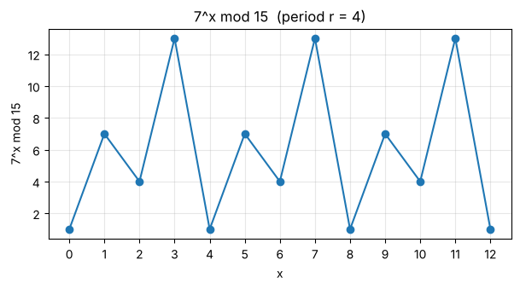
Period read from the plot / table: r = 4

Inference: The values repeat 1, 7, 4, 13, 1, 7, 4, 13, … so the sequence is periodic with period r = 4 (7⁴ = 2401 ≡ 1 mod 15).
Program 2: For every $a$ in 2, 4, 7, 8, 11, 13 and 14, compute the period $r$ classically and the two values $gcd\left(a^{r/2}±1,15\right)$. Tabulate the results, identify the value of $a$ that fails to give the factors and explain why.
Code:
# Program 2: period and factors for every a
print(" a gcd(a,15) r a^(r/2) mod 15 gcd(a^(r/2)-1,15) gcd(a^(r/2)+1,15) result")
for a in [2, 4, 7, 8, 11, 13, 14]:
r = period(a, N)
if r % 2:
print(f" {a:>2} {gcd(a,N)} {r} odd period -> fail"); continue
h = pow(a, r // 2, N)
p, q = gcd(h - 1, N), gcd(h + 1, N)
ok = {p, q} == {3, 5}
note = "factors 3 x 5" if ok else f"FAILS (a^(r/2) = {h} = -1 mod 15)"
print(f" {a:>2} {gcd(a,N)} {r} {h:>2} {p:>2} {q:>2} {note}")

OUTPUT:
a gcd(a,15) r a^(r/2) mod 15 gcd(a^(r/2)-1,15) gcd(a^(r/2)+1,15) result
2 1 4 4 3 5 factors 3 x 5
4 1 2 4 3 5 factors 3 x 5
7 1 4 4 3 5 factors 3 x 5
8 1 4 4 3 5 factors 3 x 5
11 1 2 11 5 3 factors 3 x 5
13 1 4 4 3 5 factors 3 x 5
14 1 2 14 1 15 FAILS (a^(r/2) = 14 = -1 mod 15)

Inference: Every a except 14 gives the factors 3 and 5 (periods 4 for a = 2, 7, 8, 13 and 2 for a = 4, 11). For a = 14, r = 2 and a^(r/2) = 14 ≡ −1 (mod 15), so gcd(13,15) = 1 and gcd(15,15) = 15 are trivial factors; such an a must be rejected and another chosen.
Program 3: Build the four-qubit circuit that multiplies by 7 modulo 15. Verify with Statevector that repeated application takes $|1⟩$ to $|7⟩$, $|4⟩$, $|13⟩$ and back to $|1⟩$.
Code:
# Program 3: multiply-by-7 mod 15 circuit
U7 = mult_mod15(7)
show(U7.draw("mpl"))
sv = Statevector.from_label("0001") # |1>
seq = [1]
for _ in range(4):
sv = sv.evolve(U7)
seq.append(int(np.argmax(np.abs(sv.data))))
print("Repeated application to |1>:", " -> ".join(f"|{v}>" for v in seq))
print("Check on all inputs 1..14 (y -> 7y mod 15):",
all(int(np.argmax(np.abs(Statevector.from_int(y, 16).evolve(U7).data))) == (7 * y) % 15 for y in range(1, 15)))

OUTPUT:
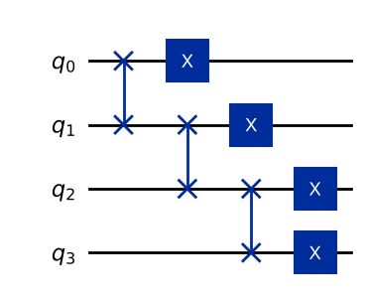
Repeated application to |1>: |1> -> |7> -> |4> -> |13> -> |1>
Check on all inputs 1..14 (y -> 7y mod 15): True

Inference: Applying the circuit repeatedly gives |1> → |7> → |4> → |13> → |1>, i.e. multiplication by 7 mod 15 with period 4; it is correct for every y = 1…14. The circuit is just a permutation of bits plus X gates, a shortcut that works only for N = 15.
Program 4: Convert the multiplication circuit into a controlled gate, and build the controlled versions of its powers $2^{j}$ for $j$ = 0 to 7.
Code:
# Program 4: controlled powers U^(2^j), j = 0..7
print(" j power 2^j U^(2^j)|1> 7^(2^j) mod 15")
cgates = []
for j in range(8):
P = U7.power(2 ** j)
cgates.append(P.to_gate(label=f"7^{2**j}").control())
out = int(np.argmax(np.abs(Statevector.from_int(1, 16).evolve(P).data)))
print(f" {j} {2**j:>4} |{out:>2}> {pow(7, 2**j, 15)}")
print("\nControlled gate for j = 0:", cgates[0].name, " qubits:", cgates[0].num_qubits)
demo = QuantumCircuit(5); demo.append(cgates[1], range(5))
show(demo.decompose().draw("mpl"))

OUTPUT:
j power 2^j U^(2^j)|1> 7^(2^j) mod 15
0 1 | 7> 7
1 2 | 4> 4
2 4 | 1> 1
3 8 | 1> 1
4 16 | 1> 1
5 32 | 1> 1
6 64 | 1> 1
7 128 | 1> 1
Controlled gate for j = 0: cx7 mod 15**1 qubits: 5

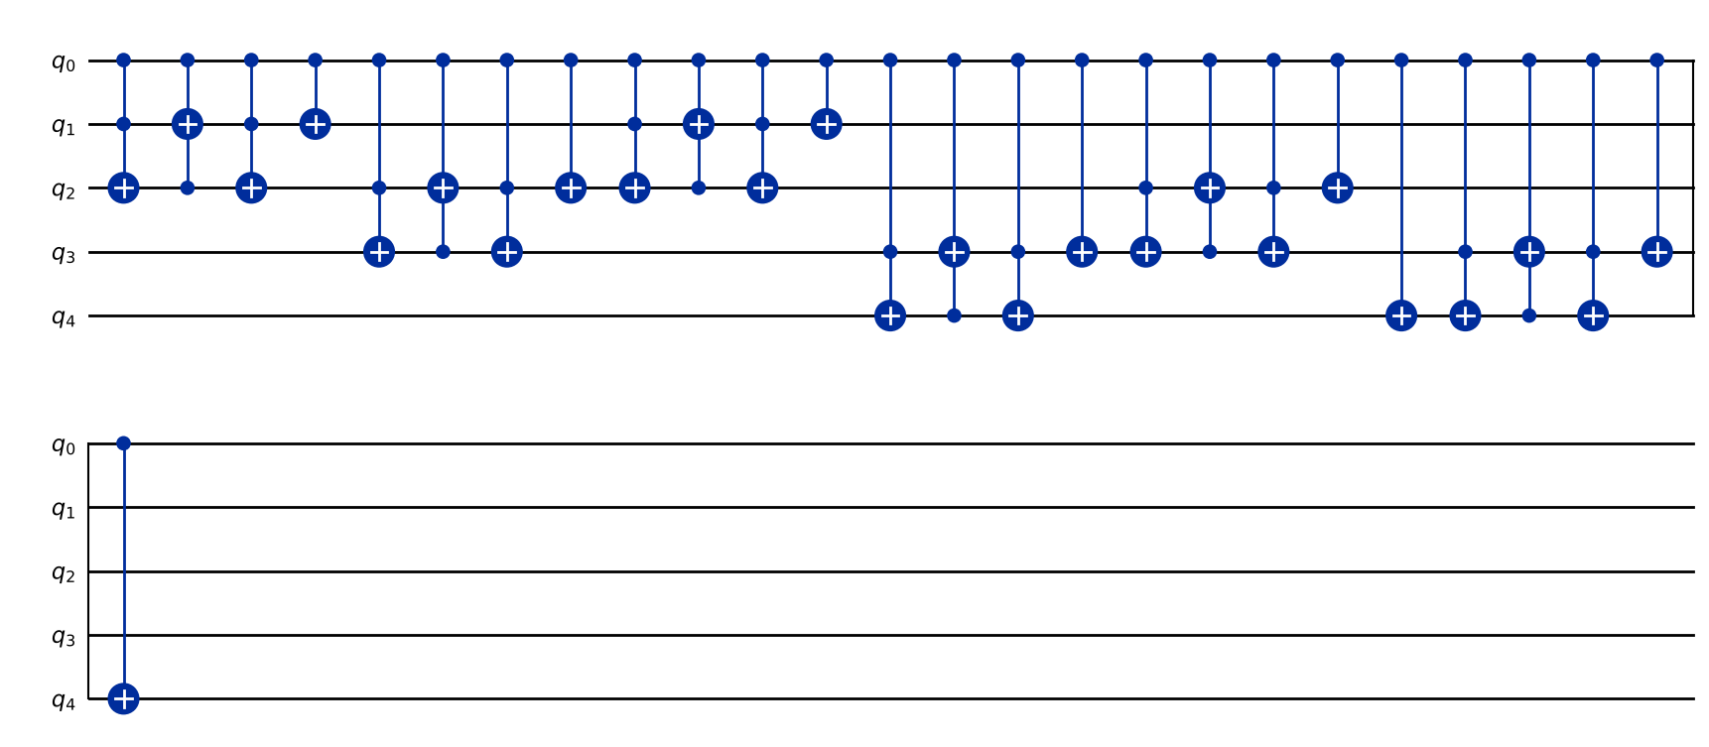
Inference: Each controlled gate acts on 1 control + 4 work qubits. U^(2^j)|1> gives 7, 4, 1, 1, … because 7^(2^j) mod 15 = 7, 4, 1 for j = 0, 1, 2 and 1 for all j ≥ 2 (since r = 4 divides 2^j), so only the first two controlled powers actually change the work register.
Program 5: Build the inverse QFT on eight qubits (reuse the function from Experiment 5) and verify it on one basis state.
Code:
# Program 5: 8-qubit inverse QFT, verified on one basis state
t = 8
c0 = 64
show(iqft(t).draw("mpl", fold=-1, scale=0.5))
sv =Statevector.from_int(c0, 2 ** t).evolve(qft(t)).evolve(iqft(t))
print(f"IQFT(QFT|{c0}>) = |{int(np.argmax(np.abs(sv.data)))}>, probability {np.max(np.abs(sv.data))**2:.6f}")
print("IQFT8 . QFT8 = identity:", Operator(qft(t).compose(iqft(t))).equiv(Operator(QuantumCircuit(t))))

OUTPUT:
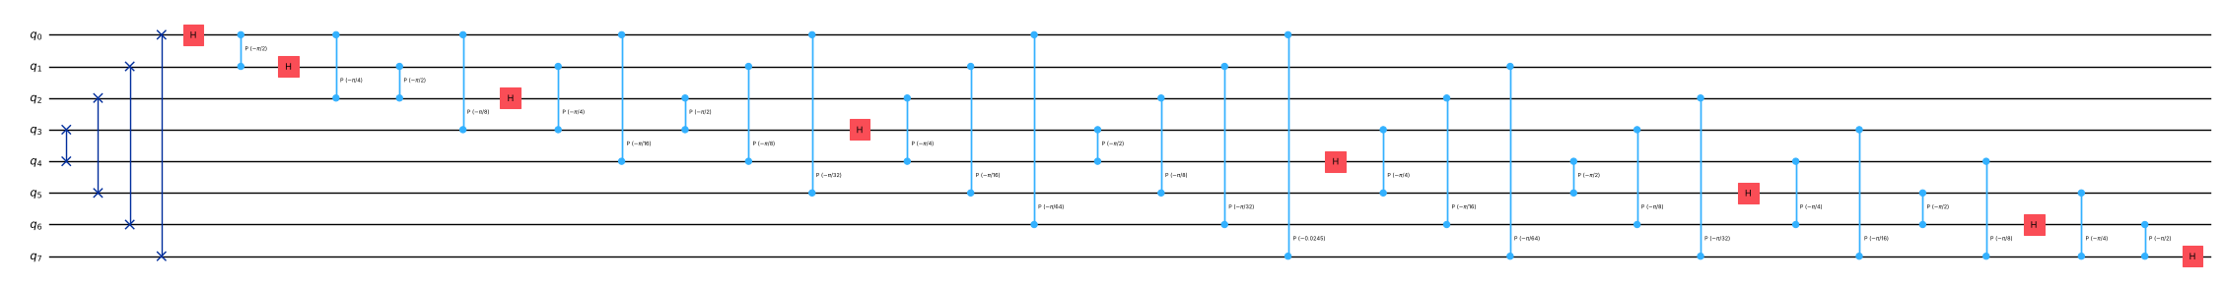
IQFT(QFT|64>) = |64>, probability 1.000000
IQFT8 . QFT8 = identity: True

Inference: The 8-qubit inverse QFT exactly undoes the QFT: QFT|64> followed by IQFT returns |64> with probability 1, and IQFT·QFT is the identity operator.
Program 6: Assemble the complete period-finding circuit for a = 7 with eight counting qubits and four work qubits. Draw the circuit and report the number of qubits and the circuit depth.
Code:
# Program 6: complete period-finding circuit for a = 7
qc7 = shor_circuit(7)
show(qc7.draw("mpl", fold=-1, scale=0.6))
tq = transpile(qc7, sim)
print("Qubits:", qc7.num_qubits, "(8 counting + 4 work) classical bits:", qc7.num_clbits)
print("Depth (high-level gates):", qc7.depth())
print("Depth after transpiling for AerSimulator:", tq.depth())
print("Gate counts after transpiling:", dict(tq.count_ops()))

OUTPUT:
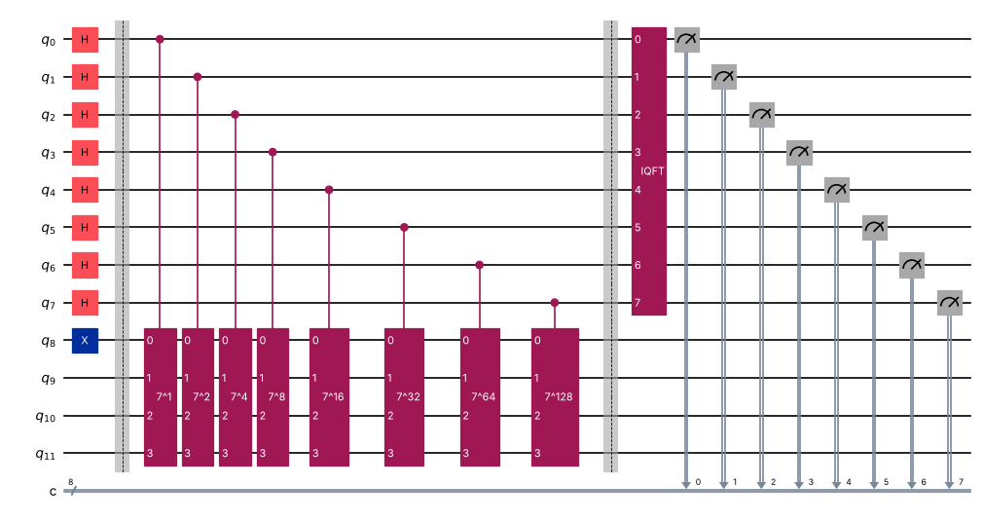
Qubits: 12 (8 counting + 4 work) classical bits: 8
Depth (high-level gates): 11
Depth after transpiling for AerSimulator: 3297
Gate counts after transpiling: {'ccx': 2295, 'cx': 1020, 'cp': 28, 'h': 16, 'measure': 8, 'barrier': 2, 'x': 1}

Inference: The circuit has 12 qubits (8 counting, 4 work): Hadamards on the counting register, X to prepare |1>, eight controlled-U^(2^j) gates and the inverse QFT. Its high-level depth is small but the transpiled depth is much larger, because each controlled modular multiplication expands into many elementary gates.
Program 7: Run the circuit with 1024 shots and plot the histogram. Tabulate each outcome as a bit string, as a decimal number c and as the phase c/256.
Code:
# Program 7: run with 1024 shots
counts7 = run(qc7, 1024)
show(plot_histogram(counts7, title="Shor period finding, a = 7, N = 15"))
print(" bitstring c phase c/256")
for b in sorted(counts7, key=lambda s: int(s, 2)):
c = int(b, 2)
print(f" {b} {c:>3} {c/256:.4f} ({counts7[b]} counts)")

OUTPUT:
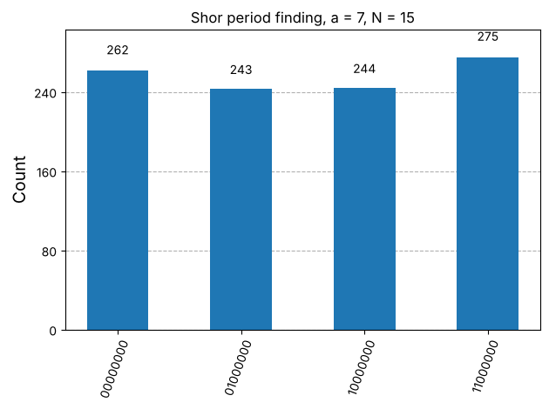
bitstring c phase c/256
00000000 0 0.0000 (262 counts)
01000000 64 0.2500 (243 counts)
10000000 128 0.5000 (244 counts)
11000000 192 0.7500 (275 counts)

Inference: Only four outcomes appear, each ≈25%: c = 0, 64, 128, 192, i.e. phases 0, 1/4, 1/2, 3/4 = s/4. With r = 4 dividing 2⁸, the inverse QFT gives exact peaks at multiples of 256/4 = 64.
Program 8: Convert each phase to a fraction with Fraction(c, 256).limit_denominator(15) and list the candidate periods. Confirm the period and compute the prime factors of 15.
Code:
# Program 8: continued fractions -> period -> factors
a = 7
print(" c phase fraction candidate r 7^r mod 15 == 1 ?")
cands = set()
for b in sorted(counts7, key=lambda s: int(s, 2)):
c = int(b, 2)
f = Fraction(c, 256).limit_denominator(N)
r = f.denominator
good = pow(a, r, N) == 1
print(f" {c:>3} {c/256:.4f} {str(f):>6} {r} {good}")
if good and r > 1:
cands.add(r)
r = min(cands)
print("\nConfirmed period r =", r)
h = pow(a, r // 2, N)
print(f"a^(r/2) mod N = {h}; gcd({h}-1, 15) = {gcd(h-1, N)}, gcd({h}+1, 15) = {gcd(h+1, N)}")
print(f"15 = {gcd(h-1, N)} x {gcd(h+1, N)}")

OUTPUT:
c phase fraction candidate r 7^r mod 15 == 1 ?
0 0.0000 0 1 False
64 0.2500 1/4 4 True
128 0.5000 1/2 2 False
192 0.7500 3/4 4 True
Confirmed period r = 4
a^(r/2) mod N = 4; gcd(4-1, 15) = 3, gcd(4+1, 15) = 5
15 = 3 x 5

Inference: c = 64 and 192 give 1/4 and 3/4 → r = 4 (and 7⁴ mod 15 = 1); c = 128 gives 1/2 → r = 2, which fails the check (7² mod 15 = 4), and c = 0 gives no information. With r = 4: 7² mod 15 = 4, gcd(3,15) = 3 and gcd(5,15) = 5, so 15 = 3 × 5.
Program 9: Repeat the experiment for a = 11, for which the multiplication is swap(1, 3), swap(0, 2) followed by an X gate on each of the four qubits. Explain why the histogram now has only two peaks, and obtain the factors.
Code:
# Program 9: repeat for a = 11
U11 = mult_mod15(11)
sv = Statevector.from_int(1, 16); seq = [1]
for _ in range(2):
sv = sv.evolve(U11); seq.append(int(np.argmax(np.abs(sv.data))))
print("Multiply-by-11 check:", " -> ".join(f"|{v}>" for v in seq))
qc11 = shor_circuit(11)
counts11 = run(qc11, 1024)
show(plot_histogram(counts11, title="Shor period finding, a = 11, N = 15"))
print("Outcomes:", {int(k, 2): v for k, v in counts11.items()})
rs = {Fraction(int(k, 2), 256).limit_denominator(N).denominator for k in counts11}
r = max(rs)
print("Candidate periods:", rs, " -> r =", r, " check 11^r mod 15 =", pow(11, r, N))
h = pow(11, r // 2, N)
print(f"gcd({h}-1, 15) = {gcd(h-1, N)}, gcd({h}+1, 15) = {gcd(h+1, N)} -> 15 = {gcd(h-1, N)} x {gcd(h+1, N)}")

OUTPUT:
Multiply-by-11 check: |1> -> |11> -> |1>

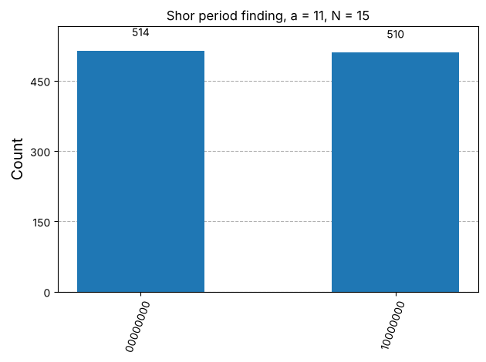
Outcomes: {128: 510, 0: 514}
Candidate periods: {1, 2} -> r = 2 check 11^r mod 15 = 1
gcd(11-1, 15) = 5, gcd(11+1, 15) = 3 -> 15 = 5 x 3

Inference: 11·1 = 11 and 11·11 = 121 ≡ 1 (mod 15), so r = 2 and the histogram has only two peaks, c = 0 and c = 128 (phases 0 and 1/2), each ≈50%: with period 2 there are only two values of s/r. Then 11^(r/2) = 11, gcd(10,15) = 5 and gcd(12,15) = 3, again giving 15 = 3 × 5.
VIVA Q&A:
- What problem does Shor's algorithm solve, and why does it matter for RSA?
Ans: It finds the prime factors of an integer N in polynomial time on a quantum computer. RSA's security rests on factoring N = pq being infeasible classically; Shor's algorithm would recover p and q (and hence the private key), breaking RSA (and, in a variant, elliptic-curve cryptography).
- What is the period (order) of a modulo N?
Ans: The period (order) r of a modulo N is the smallest positive integer such that a^r ≡ 1 (mod N), for a coprime to N. Then the sequence a^x mod N repeats every r steps.
- How are the factors of N obtained from the period r?
Ans: If r is even and a^(r/2) ≢ −1 (mod N), then (a^(r/2)−1)(a^(r/2)+1) ≡ 0 (mod N) and the factors are p = gcd(a^(r/2)−1, N) and q = gcd(a^(r/2)+1, N).
- For which choices of a does the method fail, and what is done then?
Ans: It fails if r is odd or if a^(r/2) ≡ −1 (mod N) (e.g. a = 14 for N = 15), which gives only trivial factors 1 and N. Then a new random a is chosen and the procedure is repeated; (if gcd(a,N) > 1 a factor is found immediately).
- Which part of Shor's algorithm is quantum and which part is classical?
Ans: Only period finding is quantum (superposition of the counting register, controlled modular exponentiation, inverse QFT, measurement). Choosing a, the gcd checks, the continued-fraction expansion, verifying r and computing the factors are classical.
- What is the role of the inverse QFT in the circuit?
Ans: The controlled multiplications write the phase s/r into the counting register (phase kickback of the eigenvalues e^(2πis/r)); the inverse QFT converts this phase into a binary number c ≈ 2^t·s/r that can be measured.
- Why does the measurement give multiples of $2^{t}/r$?
Ans: The work register is in a superposition of eigenstates of U with eigenvalues e^(2πis/r). Phase estimation on t qubits returns c with c/2^t ≈ s/r, so the outcomes are concentrated at c = s·2^t/r (exact multiples when r divides 2^t, like r = 4 and 2^t = 256).
- Why is the continued-fraction step needed?
Ans: The measurement gives only the fraction c/2^t ≈ s/r, possibly with rounding error and with s and r sharing a factor. The continued-fraction expansion (limit_denominator(N)) finds the best fraction with denominator < N, giving a candidate r that is then checked.
- What kind of speed-up does Shor's algorithm give over the best known classical methods?
Ans: A superpolynomial (roughly exponential) speed-up: about O((log N)³) operations versus the general number field sieve's sub-exponential exp(O((log N)^(1/3)(log log N)^(2/3))).
- Why can present-day quantum computers not factor the numbers used in real cryptography?
Ans: Factoring a 2048-bit RSA number needs thousands of error-corrected logical qubits (millions of physical qubits) and billions of gates. Today's devices are small and noisy (NISQ) without full error correction, so only toy cases like 15 or 21 — often using compiled shortcuts such as here — have been demonstrated.
RESULT:
The quantum period-finding part of Shor's algorithm was implemented in Qiskit for N = 15 with 8 counting qubits and 4 work qubits, using controlled powers of the modular-multiplication circuit and an 8-qubit inverse QFT. For a = 7 the outcomes 0, 64, 128, 192 gave the period r = 4, and for a = 11 the outcomes 0, 128 gave r = 2. Continued fractions and gcd post-processing gave the prime factors 15 = 3 × 5 in both cases, and a = 14 was identified as a failing choice. Hence the experiment was successfully completed.

EVALUATION (for faculty use):

Evaluation method | Prep | Program | Output | Inference | Viva | Timely | Total
Maximum marks | 2 | 5 | 3 | 2 | 2 | 1 | 15
Marks awarded
Faculty signature with date:

