Department of Computer Science and Engineering
2024 CSE BATCH
23CSE463 – Quantum Computing

NAME : Agneay B Nair
REG NO : CH.SC.U4CSE24102

WORKSHEET
WORKSHEET- 7
EX.NO : 7
DATE :
TITLE : Implementation of Grover's Search Algorithm Using Qiskit
AIM:
To implement Grover's search algorithm in Qiskit for two and three qubits, to construct the oracle and the diffusion operator, and to study how the probability of finding the marked item changes with the number of iterations.
APPARATUS REQUIRED:
- Python 3.10 or above
- Qiskit 2.x and Qiskit Aer simulator (pip install qiskit qiskit-aer)
- Matplotlib and pylatexenc (for circuit diagrams and histograms)
- Jupyter Notebook / Visual Studio Code (VS Code)
- Internet Connection (for package installation and documentation access)
- Quantum Computing Reference Material or Lab Manual
THEORY:
Grover's algorithm searches an unsorted list. Suppose one of $N=2^{n}$ items is marked. Checking the items one at a time takes about $N/2$ tries on average. Grover's algorithm needs about $\frac{π}{4}\sqrt{N}$ steps. This is a quadratic speed-up, not an exponential one.
The computer holds one number, called an amplitude, for each item, and the probability of finding an item is the square of its amplitude. The algorithm has three parts.
1. Superposition. Hadamard gates on all the qubits give every item the same amplitude $1/\sqrt{N}$. This state is called $|s⟩$.
2. Oracle. The oracle multiplies the amplitude of the marked item $|w⟩$ by $−1$ and leaves the others unchanged. The probabilities do not change at this step, because a sign disappears when the amplitude is squared.
3. Diffuser. The diffuser reflects every amplitude about the average of all the amplitudes: new amplitude = 2 × average − old amplitude. The marked item is far below the average because of its minus sign, so it ends far above it.
$$U_{w}=I−2|w⟩⟨w|, D=2|s⟩⟨s|−I$$
Worked example with four items, marked item 11. After the Hadamard gates the four amplitudes are (1/2, 1/2, 1/2, 1/2). After the oracle they are (1/2, 1/2, 1/2, −1/2), with average 1/4. After the diffuser, each unmarked item has 2 × 1/4 − 1/2 = 0 and the marked item has 2 × 1/4 + 1/2 = 1. One step finds the marked item with certainty.
More than one step. With $sinθ=1/\sqrt{N}$, the probability of success after $k$ repetitions of the oracle and the diffuser is
$$P_{k}=\sin^{2}\left(\left(2k+1\right)θ\right), k_{opt}≈\frac{π}{4}\sqrt{N}$$
For $N=8$, $θ={20.7}^{∘}$ and the probability of success is 78.1% after one step, 94.5% after two and 33.0% after three. Repeating too many times lowers the probability again; this is called over-rotation. With $M$ marked items, $sinθ=\sqrt{M/N}$ and fewer steps are needed.
In Qiskit, the two-qubit oracle for 11 is a CZ gate. Other marked items are obtained by placing X gates before and after it on the qubits that should be 0. The diffuser is H on all qubits, X on all qubits, a multi-controlled Z gate, X on all qubits and H on all qubits. This circuit equals $−D$, so the simulator may show $−1$ where the formula gives $+1$. A sign on the whole state (a global phase) never affects a measurement. Qiskit prints qubit 0 as the rightmost bit.
PROCEDURE:
- Install Qiskit and the Aer simulator with pip install qiskit qiskit-aer matplotlib pylatexenc, and print the installed version with qiskit.__version__.
- Open Jupyter Notebook or Visual Studio Code.
- Import QuantumCircuit and transpile from qiskit, Statevector and Operator from qiskit.quantum_info, AerSimulator from qiskit_aer and plot_histogram from qiskit.visualization. Import NumPy as well.
- Create a circuit with $n$ qubits and apply H to every qubit to prepare the equal superposition.
- Build the oracle: a CZ gate (two qubits) or a multi-controlled Z gate (H, mcx, H on the last qubit), with X gates before and after it on the qubits that should be 0 in the marked item.
- Build the diffuser: H on all qubits, X on all qubits, the multi-controlled Z gate, X on all qubits and H on all qubits.
- Repeat the oracle and the diffuser the required number of times, and draw the circuit with barriers between the stages.
- Display the amplitudes after each stage with Statevector(qc) and compare them with the hand calculation.
- Add measurements and run the circuit on AerSimulator with 1024 shots: sim.run(transpile(qc, sim), shots=1024).result().get_counts(). Plot the counts with plot_histogram.
- Compare the result with the hand calculation. Remember that Qiskit prints qubit 0 as the rightmost bit. Record the code, the circuit diagram, the output and a one-line inference under each program.
PROGRAM:
Common setup (imports and helper functions used by every program):
# Common setup for all programs in this worksheet
%matplotlib inline
import qiskit, numpy as np, matplotlib.pyplot as plt
from qiskit import QuantumCircuit, transpile
from qiskit.quantum_info import Statevector, Operator
from qiskit_aer import AerSimulator
from qiskit.visualization import plot_histogram
from IPython.display import display
print("Qiskit version:", qiskit.__version__)
sim = AerSimulator()
_seed = 2024 # seeds incremented per run -> reproducible counts
np.set_printoptions(precision=3, suppress=True, linewidth=110)
plt.rcParams["figure.dpi"] = 100
def show(fig):
"""display a matplotlib figure (circuit diagram / histogram) and close it"""
display(fig); plt.close(fig)
def run(qc, shots=1024):
global _seed
_seed += 1
return sim.run(transpile(qc, sim), shots=shots, seed_simulator=_seed).result().get_counts()
def amps(sv, tol=1e-9):
"""print the non-zero amplitudes of a statevector with Qiskit labels (qubit 0 rightmost)"""
n = sv.num_qubits
for i, a in enumerate(sv.data):
if abs(a) > tol:
print(f" |{i:0{n}b}> : {a.real:+.3f}{a.imag:+.3f}j P = {abs(a)**2:.3f}")
REG_NO = "CH.SC.U4CSE24102"
def mcz(qc, n):
"""multi-controlled Z on all n qubits (CZ for n = 2)"""
if n == 2:
qc.cz(0, 1)
else:
qc.h(n - 1); qc.mcx(list(range(n - 1)), n - 1); qc.h(n - 1)
def oracle(marked, n):
"""phase oracle: -1 on each marked bit string (rightmost character = qubit 0)"""
if isinstance(marked, str):
marked = [marked]
o = QuantumCircuit(n, name="Oracle")
for w in marked:
zeros = [i for i, b in enumerate(reversed(w)) if b == "0"]
if zeros: o.x(zeros)
mcz(o, n)
if zeros: o.x(zeros)
return o
def diffuser(n):
d = QuantumCircuit(n, name="Diffuser")
d.h(range(n)); d.x(range(n))
mcz(d, n)
d.x(range(n)); d.h(range(n))
return d
def grover(marked, n, k, measure=True):
qc = QuantumCircuit(n)
qc.h(range(n))
for _ in range(k):
qc.barrier(); qc.compose(oracle(marked, n), inplace=True)
qc.barrier(); qc.compose(diffuser(n), inplace=True)
if measure:
qc.measure_all()
return qc
def p_success(marked, n, k):
if isinstance(marked, str): marked = [marked]
probs = Statevector(grover(marked, n, k, measure=False)).probabilities_dict()
return sum(probs.get(w, 0) for w in marked)

Qiskit version: 2.5.2

Program 1: Create the equal superposition of two qubits. Display the four amplitudes and probabilities.
Code:
# Program 1: equal superposition of two qubits
qc = QuantumCircuit(2)
qc.h([0, 1])
show(qc.draw("mpl"))
amps(Statevector(qc))

OUTPUT:
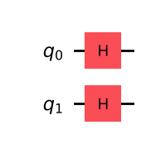
|00> : +0.500+0.000j P = 0.250
|01> : +0.500+0.000j P = 0.250
|10> : +0.500+0.000j P = 0.250
|11> : +0.500+0.000j P = 0.250

Inference: H on both qubits gives |s> = ½(|00>+|01>+|10>+|11>): all four amplitudes are 1/√4 = 0.5 and every item has probability 0.25.
Program 2: Add the oracle that marks 11 (a CZ gate). Display the statevector and show that the sign of the marked item has changed while the probabilities have not.
Code:
# Program 2: oracle marking 11 (CZ)
qc = QuantumCircuit(2)
qc.h([0, 1]); qc.barrier()
qc.cz(0, 1)
show(qc.draw("mpl"))
sv2 = Statevector(qc)
amps(sv2)
print("Probabilities unchanged:", np.allclose(sv2.probabilities(), [0.25] * 4))

OUTPUT:
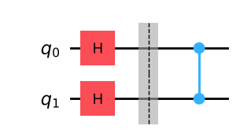
|00> : +0.500+0.000j P = 0.250
|01> : +0.500+0.000j P = 0.250
|10> : +0.500+0.000j P = 0.250
|11> : -0.500+0.000j P = 0.250
Probabilities unchanged: True

Inference: After the CZ oracle the amplitude of |11> becomes −0.5 while the others stay +0.5. The probabilities are still all 0.25, because the sign disappears when the amplitude is squared — the oracle only marks the item in the phase.
Program 3: Build the oracles that mark 00, 01 and 10 using X gates before and after the CZ gate. Verify each by displaying the diagonal of its operator.
Code:
# Program 3: oracles for 00, 01, 10 (X before and after CZ)
for w in ["00", "01", "10", "11"]:
o = oracle(w, 2)
diag = np.real(np.diag(Operator(o).data))
print(f"Oracle for {w}: diagonal", {f"{i:02b}": int(d) for i, d in enumerate(diag)})
show(oracle("01", 2).draw("mpl"))

OUTPUT:
Oracle for 00: diagonal {'00': -1, '01': 1, '10': 1, '11': 1}
Oracle for 01: diagonal {'00': 1, '01': -1, '10': 1, '11': 1}
Oracle for 10: diagonal {'00': 1, '01': 1, '10': -1, '11': 1}
Oracle for 11: diagonal {'00': 1, '01': 1, '10': 1, '11': -1}

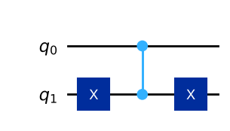
Inference: Each oracle is diagonal with −1 exactly at its marked item and +1 elsewhere: the X gates map the marked string to 11, the CZ flips its sign, and the second X gates undo the mapping. (Diagonal index labels use Qiskit order q1q0.)
Program 4: Build the two-qubit diffuser from H, X and CZ gates. Apply it to the state from Program 2 and display the amplitudes after it.
Code:
# Program 4: two-qubit diffuser applied to the state from Program 2
d = diffuser(2)
show(d.draw("mpl"))
qc = QuantumCircuit(2); qc.h([0, 1]); qc.cz(0, 1)
qc.compose(d, inplace=True)
amps(Statevector(qc))

OUTPUT:
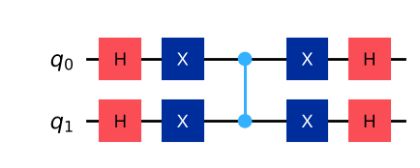
|11> : -1.000+0.000j P = 1.000

Inference: After the diffuser the state is −|11>: amplitudes 0, 0, 0 and −1. The mean of (½, ½, ½, −½) is ¼, so the unmarked amplitudes become 2·¼ − ½ = 0 and the marked one 2·¼ + ½ = 1. The overall −1 is the global phase of the H-X-CZ-X-H circuit (= −D) and does not affect measurement.
Program 5: Assemble the complete two-qubit Grover circuit for the marked item 11. Run it with 1024 shots and plot the histogram.
Code:
# Program 5: complete two-qubit Grover search for 11
qc = grover("11", 2, 1)
show(qc.draw("mpl"))
counts = run(qc)
print("Counts:", counts)
show(plot_histogram(counts, title="Grover, N = 4, marked 11"))

OUTPUT:
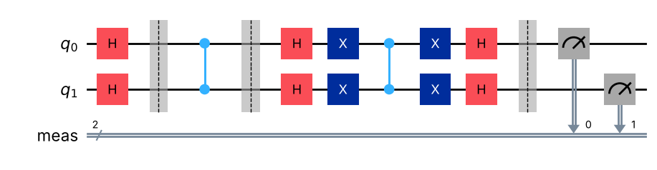
Counts: {'11': 1024}

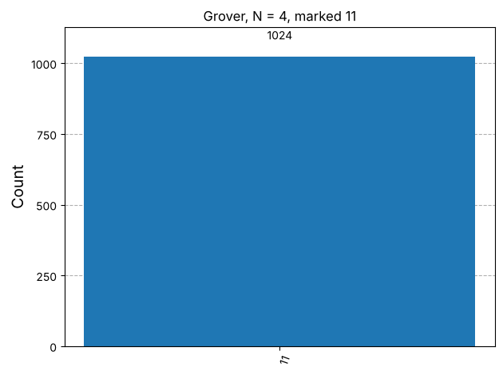
Inference: All 1024 shots return 11: for N = 4 a single oracle + diffuser iteration finds the marked item with certainty, versus 2.25 queries on average classically.
Program 6: Run the two-qubit Grover circuit for each of the four possible marked items and tabulate the marked item against the measured result.
Code:
# Program 6: every marked item, N = 4
print("Marked item | Measured (1024 shots)")
for w in ["00", "01", "10", "11"]:
c = run(grover(w, 2, 1))
print(f" {w} | {c} {'OK' if list(c) == [w] else ''}")

OUTPUT:
Marked item | Measured (1024 shots)
00 | {'00': 1024} OK
01 | {'01': 1024} OK
10 | {'10': 1024} OK
11 | {'11': 1024} OK

Inference: For each of the four possible marked items the measured result equals the marked item in 100% of the shots, confirming that one Grover iteration solves any N = 4 search.
Program 7: Implement three-qubit Grover search for the marked item 101. Record the probability of success after one and after two iterations and compare it with the formula in the theory.
Code:
# Program 7: three-qubit Grover for 101, 1 and 2 iterations
theta = np.arcsin(1 / np.sqrt(8))
print(f"theta = {np.degrees(theta):.2f} deg")
for k in [1, 2]:
qc = grover("101", 3, k)
c = run(qc)
p_exact = p_success("101", 3, k)
print(f"k = {k}: P(101) simulated = {c.get('101',0)/1024:.3f}, exact = {p_exact:.4f}, "
f"formula sin^2((2k+1)theta) = {np.sin((2*k+1)*theta)**2:.4f}")
if k == 2:
show(qc.draw("mpl", fold=-1, scale=0.6))
show(plot_histogram(c, title="Grover, N = 8, marked 101, 2 iterations"))

OUTPUT:
theta = 20.70 deg
k = 1: P(101) simulated = 0.820, exact = 0.7812, formula sin^2((2k+1)theta) = 0.7812
k = 2: P(101) simulated = 0.952, exact = 0.9453, formula sin^2((2k+1)theta) = 0.9453

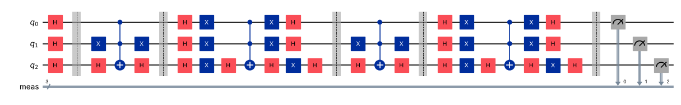
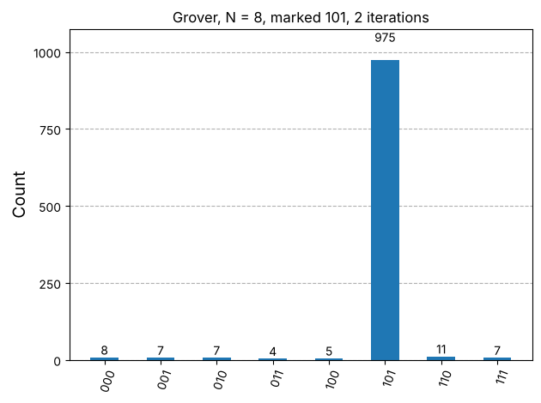
Inference: With θ = 20.7°, the success probability is 78.1% after one iteration and 94.5% after two, both from the statevector and the formula sin²((2k+1)θ); the 1024-shot results agree closely (small differences come from the finite number of shots). Two iterations ≈ (π/4)√8 = 2.2 is the best choice for N = 8.
Program 8: For the three-qubit search, vary the number of iterations from 0 to 6 and plot the probability of success against the number of iterations. Identify the best number of iterations and explain the drop that follows it.
Code:
# Program 8: success probability vs number of iterations (k = 0..6)
ks = range(7)
p_sim = [run(grover("101", 3, k)).get("101", 0) / 1024 for k in ks]
p_th = [np.sin((2 * k + 1) * theta) ** 2 for k in ks]
for k in ks:
print(f"k = {k}: simulated {p_sim[k]:.3f} formula {p_th[k]:.3f}")
fig, ax = plt.subplots(figsize=(6.5, 3.6))
ax.plot(ks, p_th, "o-", label="formula sin²((2k+1)θ)")
ax.plot(ks, p_sim, "s--", label="simulated (1024 shots)")
ax.set_xlabel("iterations k"); ax.set_ylabel("P(success)"); ax.set_title("Grover, N = 8: over-rotation")
ax.grid(alpha=.3); ax.legend(); show(fig)
first_peak = next(k for k in ks if p_th[k + 1] < p_th[k])
print("Best number of iterations (first maximum, fewest oracle calls):", first_peak)

OUTPUT:
k = 0: simulated 0.121 formula 0.125
k = 1: simulated 0.792 formula 0.781
k = 2: simulated 0.932 formula 0.945
k = 3: simulated 0.353 formula 0.330
k = 4: simulated 0.012 formula 0.012
k = 5: simulated 0.536 formula 0.548
k = 6: simulated 1.000 formula 1.000

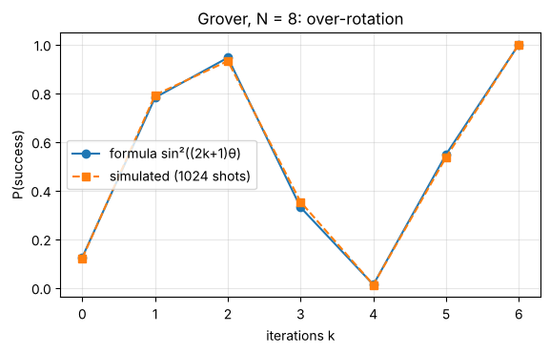
Best number of iterations (first maximum, fewest oracle calls): 2

Inference: The probability rises 0.125 → 0.781 → 0.945 for k = 0, 1, 2, then falls to 0.330 at k = 3 and 0.012 at k = 4, before rising again (0.548 at k = 5, ≈1.0 at k = 6, since P_k is periodic in k). The best choice is k = 2: it is the first maximum and needs the fewest oracle calls (k = 6 costs three times as many queries for almost no gain). Each iteration rotates the state by 2θ ≈ 41° towards |w>; after passing it the state rotates away again (over-rotation).
Program 9: Mark two items (101 and 110) in the three-qubit search. Show that one iteration is enough, and explain the result using the formula for M marked items.
Code:
# Program 9: two marked items 101 and 110, N = 8
M, Nn = 2, 8
th2 = np.arcsin(np.sqrt(M / Nn))
qc = grover(["101", "110"], 3, 1)
show(qc.draw("mpl", fold=-1, scale=0.6))
c = run(qc)
print("Counts after 1 iteration:", c)
print(f"theta = {np.degrees(th2):.1f} deg; P after 1 iteration = sin^2(3 theta) = {np.sin(3*th2)**2:.3f}")
print("Exact success probability:", round(p_success(["101", "110"], 3, 1), 4))
show(plot_histogram(c, title="Grover, two marked items (101, 110), 1 iteration"))

OUTPUT:
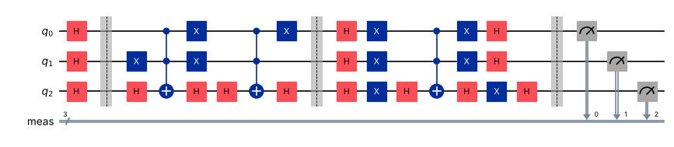
Counts after 1 iteration: {'101': 513, '110': 511}
theta = 30.0 deg; P after 1 iteration = sin^2(3 theta) = 1.000
Exact success probability: 1.0

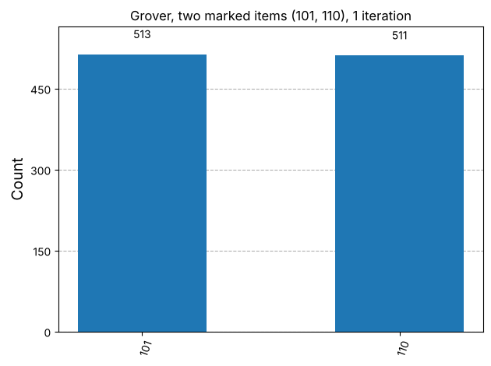
Inference: After one iteration only 101 and 110 appear (≈50% each, 100% in total). With M = 2, sinθ = √(2/8) = ½, θ = 30°, so P₁ = sin²(3·30°) = sin²(90°) = 1: more marked items mean a larger θ and fewer iterations (k_opt ≈ (π/4)√(N/M)).
Program 10: Take the last digit of your register number, find the remainder on division by 8 and write it as a three-bit string. Use it as the marked item in the three-qubit search and report the histogram for the best number of iterations.
Code:
# Program 10: marked item from the register number
last = int(REG_NO[-1])
w = format(last % 8, "03b")
print(f"Register number {REG_NO}: last digit = {last}, {last} mod 8 = {last % 8} -> marked item {w}")
k_best = int(np.floor(np.pi / 4 * np.sqrt(8)))
print("Best number of iterations:", k_best)
qc = grover(w, 3, k_best)
c = run(qc)
print("Counts:", c, f" P({w}) = {c.get(w,0)/1024:.3f}")
show(plot_histogram(c, title=f"Grover, marked {w}, {k_best} iterations"))

OUTPUT:
Register number CH.SC.U4CSE24102: last digit = 2, 2 mod 8 = 2 -> marked item 010
Best number of iterations: 2
Counts: {'001': 6, '110': 11, '011': 1, '111': 7, '100': 10, '101': 6, '000': 8, '010': 975} P(010) = 0.952

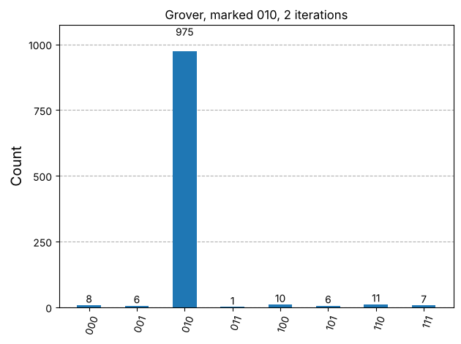
Inference: For CH.SC.U4CSE24102 the last digit is 2, 2 mod 8 = 2, so the marked item is 010. With the best k = 2 iterations, 010 is measured in about 95% of the shots (theory 94.5%), far above every other outcome (≈1% each).
VIVA Q&A:
- What problem does Grover's algorithm solve?
Ans: It searches an unstructured (unsorted) database of N = 2ⁿ items for an item marked by an oracle, i.e. finds w with f(w) = 1, using about (π/4)√N oracle queries.
- How many steps does a classical search need for N items, and how many does Grover's algorithm need?
Ans: Classically about N/2 queries on average (N in the worst case); Grover's algorithm needs about (π/4)√N iterations, e.g. 2 instead of ~4 for N = 8.
- What does the oracle do to the marked item?
Ans: It multiplies the amplitude of the marked item by −1 (U_w = I − 2|w><w|) and leaves every other amplitude unchanged.
- Why do the measurement probabilities not change immediately after the oracle?
Ans: The oracle only changes the sign (phase) of the marked amplitude; the probability is the squared magnitude, which does not depend on the sign. The diffuser is needed to turn this phase difference into an amplitude difference.
- What does the diffuser do? What is meant by inversion about the mean?
Ans: The diffuser D = 2|s><s| − I reflects every amplitude about the average: new = 2·mean − old. Because the marked amplitude is negative it lies far below the mean, so after the inversion it ends up far above it, while the others shrink — this is inversion about the mean.
- What is the best number of iterations for N = 4 and for N = 8?
Ans: For N = 4, k = 1 (success probability 100%). For N = 8, k = 2 (≈94.5%), from k_opt ≈ (π/4)√N.
- What happens if the oracle and the diffuser are repeated too many times?
Ans: The state rotates past the marked state (over-rotation), so the success probability decreases again (e.g. 94.5% → 33% → 1% for N = 8). P_k = sin²((2k+1)θ) is periodic in k.
- Is the speed-up of Grover's algorithm quadratic or exponential?
Ans: Quadratic: O(√N) versus O(N). It is provably optimal for unstructured search, so no exponential speed-up is possible for this problem.
- How does the number of marked items change the number of iterations needed?
Ans: With M marked items, sinθ = √(M/N), so θ is larger and the optimal number of iterations k ≈ (π/4)√(N/M) is smaller; e.g. M = 2, N = 8 needs only one iteration.
- What is the effect of Grover's algorithm on symmetric-key cryptography?
Ans: Grover's search reduces brute-force key search from 2ⁿ to about 2^(n/2) operations, effectively halving the key length (AES-128 → 64-bit security). The countermeasure is to double the key length (e.g. use AES-256).
RESULT:
Grover's search algorithm was implemented in Qiskit for two and three qubits with phase oracles (CZ / multi-controlled Z with X gates) and the H-X-MCZ-X-H diffuser. For N = 4 one iteration found every marked item with 100% probability. For N = 8 (marked 101) the success probability was 78.1% after one and 94.5% after two iterations, matching sin²((2k+1)θ), and over-rotation was observed beyond k = 2. With two marked items one iteration sufficed, and the register-number item 010 was found with ≈94.5% probability. Hence the experiment was successfully completed.

EVALUATION (for faculty use):

Evaluation method | Prep | Program | Output | Inference | Viva | Timely | Total
Maximum marks | 2 | 5 | 3 | 2 | 2 | 1 | 15
Marks awarded
Faculty signature with date:

