Figure 1: This is a Test Caption for Figures

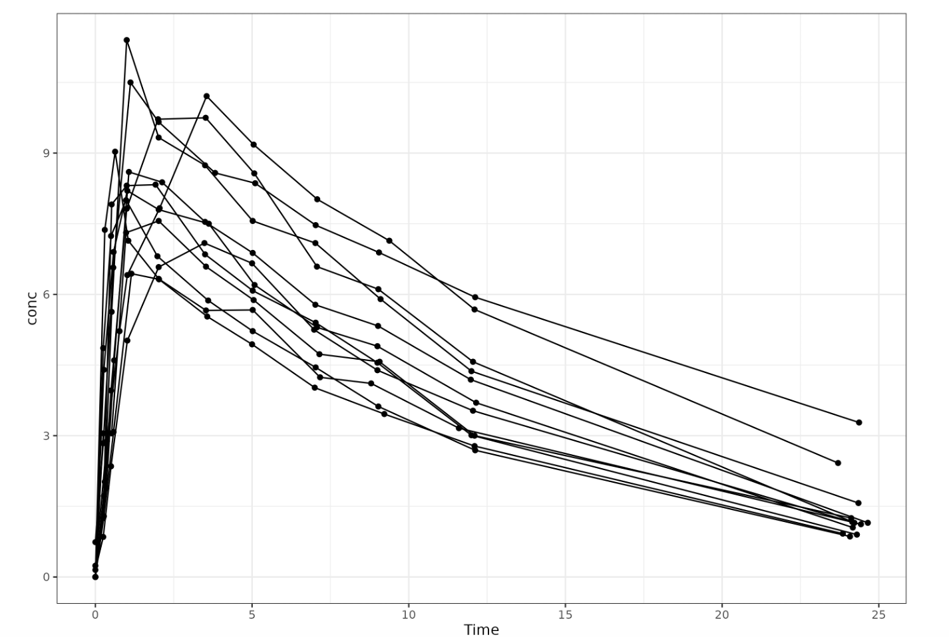  
Source: images/image1.png

Text between images

  
Source: images/image2.png