# This is a Test Heading

Table 1: This is a Test Caption for Tables

| **Subject** | **Wt** | **Dose** | **Time** | **conc** |
| --- | --- | --- | --- | --- |
| 1 | 79.6 | 4.02 | 0.00 | 0.74 |
| 1 | 79.6 | 4.02 | 0.25 | 2.84 |
| 1 | 79.6 | 4.02 | 0.57 | 6.57 |
| 1 | 79.6 | 4.02 | 1.12 | 10.50 |
| 1 | 79.6 | 4.02 | 2.02 | 9.66 |
| 1 | 79.6 | 4.02 | 3.82 | 8.58 |
| 1 | 79.6 | 4.02 | 5.10 | 8.36 |
| 1 | 79.6 | 4.02 | 7.03 | 7.47 |
| 1 | 79.6 | 4.02 | 9.05 | 6.89 |
| 1 | 79.6 | 4.02 | 12.12 | 5.94 |
| 1 | 79.6 | 4.02 | 24.37 | 3.28 |
| 2 | 72.4 | 4.40 | 0.00 | 0.00 |
| 2 | 72.4 | 4.40 | 0.27 | 1.72 |
| 2 | 72.4 | 4.40 | 0.52 | 7.91 |
| 2 | 72.4 | 4.40 | 1.00 | 8.31 |
| 2 | 72.4 | 4.40 | 1.92 | 8.33 |
| 2 | 72.4 | 4.40 | 3.50 | 6.85 |
| 2 | 72.4 | 4.40 | 5.02 | 6.08 |
| 2 | 72.4 | 4.40 | 7.03 | 5.40 |
| 2 | 72.4 | 4.40 | 9.00 | 4.55 |
| 2 | 72.4 | 4.40 | 12.00 | 3.01 |
| 2 | 72.4 | 4.40 | 24.30 | 0.90 |
| 3 | 70.5 | 4.53 | 0.00 | 0.00 |
| 3 | 70.5 | 4.53 | 0.27 | 4.40 |
| 3 | 70.5 | 4.53 | 0.58 | 6.90 |
| 3 | 70.5 | 4.53 | 1.02 | 8.20 |
| 3 | 70.5 | 4.53 | 2.02 | 7.80 |
| 3 | 70.5 | 4.53 | 3.62 | 7.50 |
| 3 | 70.5 | 4.53 | 5.08 | 6.20 |
| 3 | 70.5 | 4.53 | 7.07 | 5.30 |
| 3 | 70.5 | 4.53 | 9.00 | 4.90 |
| 3 | 70.5 | 4.53 | 12.15 | 3.70 |
| 3 | 70.5 | 4.53 | 24.17 | 1.05 |
| 4 | 72.7 | 4.40 | 0.00 | 0.00 |
| 4 | 72.7 | 4.40 | 0.35 | 1.89 |
| 4 | 72.7 | 4.40 | 0.60 | 4.60 |
| 4 | 72.7 | 4.40 | 1.07 | 8.60 |
| 4 | 72.7 | 4.40 | 2.13 | 8.38 |
| 4 | 72.7 | 4.40 | 3.50 | 7.54 |
| 4 | 72.7 | 4.40 | 5.02 | 6.88 |
| 4 | 72.7 | 4.40 | 7.02 | 5.78 |
| 4 | 72.7 | 4.40 | 9.02 | 5.33 |
| 4 | 72.7 | 4.40 | 11.98 | 4.19 |
| 4 | 72.7 | 4.40 | 24.65 | 1.15 |
| 5 | 54.6 | 5.86 | 0.00 | 0.00 |
| 5 | 54.6 | 5.86 | 0.30 | 2.02 |
| 5 | 54.6 | 5.86 | 0.52 | 5.63 |
| 5 | 54.6 | 5.86 | 1.00 | 11.40 |
| 5 | 54.6 | 5.86 | 2.02 | 9.33 |
| 5 | 54.6 | 5.86 | 3.50 | 8.74 |
| 5 | 54.6 | 5.86 | 5.02 | 7.56 |
| 5 | 54.6 | 5.86 | 7.02 | 7.09 |
| 5 | 54.6 | 5.86 | 9.10 | 5.90 |
| 5 | 54.6 | 5.86 | 12.00 | 4.37 |
| 5 | 54.6 | 5.86 | 24.35 | 1.57 |
| 6 | 80.0 | 4.00 | 0.00 | 0.00 |
| 6 | 80.0 | 4.00 | 0.27 | 1.29 |
| 6 | 80.0 | 4.00 | 0.58 | 3.08 |
| 6 | 80.0 | 4.00 | 1.15 | 6.44 |
| 6 | 80.0 | 4.00 | 2.03 | 6.32 |
| 6 | 80.0 | 4.00 | 3.57 | 5.53 |
| 6 | 80.0 | 4.00 | 5.00 | 4.94 |
| 6 | 80.0 | 4.00 | 7.00 | 4.02 |
| 6 | 80.0 | 4.00 | 9.22 | 3.46 |
| 6 | 80.0 | 4.00 | 12.10 | 2.78 |
| 6 | 80.0 | 4.00 | 23.85 | 0.92 |
| 7 | 64.6 | 4.95 | 0.00 | 0.15 |
| 7 | 64.6 | 4.95 | 0.25 | 0.85 |
| 7 | 64.6 | 4.95 | 0.50 | 2.35 |
| 7 | 64.6 | 4.95 | 1.02 | 5.02 |
| 7 | 64.6 | 4.95 | 2.02 | 6.58 |
| 7 | 64.6 | 4.95 | 3.48 | 7.09 |
| 7 | 64.6 | 4.95 | 5.00 | 6.66 |
| 7 | 64.6 | 4.95 | 6.98 | 5.25 |
| 7 | 64.6 | 4.95 | 9.00 | 4.39 |
| 7 | 64.6 | 4.95 | 12.05 | 3.53 |
| 7 | 64.6 | 4.95 | 24.22 | 1.15 |
| 8 | 70.5 | 4.53 | 0.00 | 0.00 |
| 8 | 70.5 | 4.53 | 0.25 | 3.05 |
| 8 | 70.5 | 4.53 | 0.52 | 3.05 |
| 8 | 70.5 | 4.53 | 0.98 | 7.31 |
| 8 | 70.5 | 4.53 | 2.02 | 7.56 |
| 8 | 70.5 | 4.53 | 3.53 | 6.59 |
| 8 | 70.5 | 4.53 | 5.05 | 5.88 |
| 8 | 70.5 | 4.53 | 7.15 | 4.73 |
| 8 | 70.5 | 4.53 | 9.07 | 4.57 |
| 8 | 70.5 | 4.53 | 12.10 | 3.00 |
| 8 | 70.5 | 4.53 | 24.12 | 1.25 |
| 9 | 86.4 | 3.10 | 0.00 | 0.00 |
| 9 | 86.4 | 3.10 | 0.30 | 7.37 |
| 9 | 86.4 | 3.10 | 0.63 | 9.03 |
| 9 | 86.4 | 3.10 | 1.05 | 7.14 |
| 9 | 86.4 | 3.10 | 2.02 | 6.33 |
| 9 | 86.4 | 3.10 | 3.53 | 5.66 |
| 9 | 86.4 | 3.10 | 5.02 | 5.67 |
| 9 | 86.4 | 3.10 | 7.17 | 4.24 |
| 9 | 86.4 | 3.10 | 8.80 | 4.11 |
| 9 | 86.4 | 3.10 | 11.60 | 3.16 |
| 9 | 86.4 | 3.10 | 24.43 | 1.12 |
| 10 | 58.2 | 5.50 | 0.00 | 0.24 |
| 10 | 58.2 | 5.50 | 0.37 | 2.89 |
| 10 | 58.2 | 5.50 | 0.77 | 5.22 |
| 10 | 58.2 | 5.50 | 1.02 | 6.41 |
| 10 | 58.2 | 5.50 | 2.05 | 7.83 |
| 10 | 58.2 | 5.50 | 3.55 | 10.21 |
| 10 | 58.2 | 5.50 | 5.05 | 9.18 |
| 10 | 58.2 | 5.50 | 7.08 | 8.02 |
| 10 | 58.2 | 5.50 | 9.38 | 7.14 |
| 10 | 58.2 | 5.50 | 12.10 | 5.68 |
| 10 | 58.2 | 5.50 | 23.70 | 2.42 |
| 11 | 65.0 | 4.92 | 0.00 | 0.00 |
| 11 | 65.0 | 4.92 | 0.25 | 4.86 |
| 11 | 65.0 | 4.92 | 0.50 | 7.24 |
| 11 | 65.0 | 4.92 | 0.98 | 8.00 |
| 11 | 65.0 | 4.92 | 1.98 | 6.81 |
| 11 | 65.0 | 4.92 | 3.60 | 5.87 |
| 11 | 65.0 | 4.92 | 5.02 | 5.22 |
| 11 | 65.0 | 4.92 | 7.03 | 4.45 |
| 11 | 65.0 | 4.92 | 9.03 | 3.62 |
| 11 | 65.0 | 4.92 | 12.12 | 2.69 |
| 11 | 65.0 | 4.92 | 24.08 | 0.86 |
| 12 | 60.5 | 5.30 | 0.00 | 0.00 |
| 12 | 60.5 | 5.30 | 0.25 | 1.25 |
| 12 | 60.5 | 5.30 | 0.50 | 3.96 |
| 12 | 60.5 | 5.30 | 1.00 | 7.82 |
| 12 | 60.5 | 5.30 | 2.00 | 9.72 |
| 12 | 60.5 | 5.30 | 3.52 | 9.75 |
| 12 | 60.5 | 5.30 | 5.07 | 8.57 |
| 12 | 60.5 | 5.30 | 7.07 | 6.59 |
| 12 | 60.5 | 5.30 | 9.03 | 6.11 |
| 12 | 60.5 | 5.30 | 12.05 | 4.57 |
| 12 | 60.5 | 5.30 | 24.15 | 1.17 |
| Source: OUTPUTS/tables/01-12345-pk-theoph.csv    Abbreviations: N/A | | | | |

Figure 1: This is a Test Caption for Figures

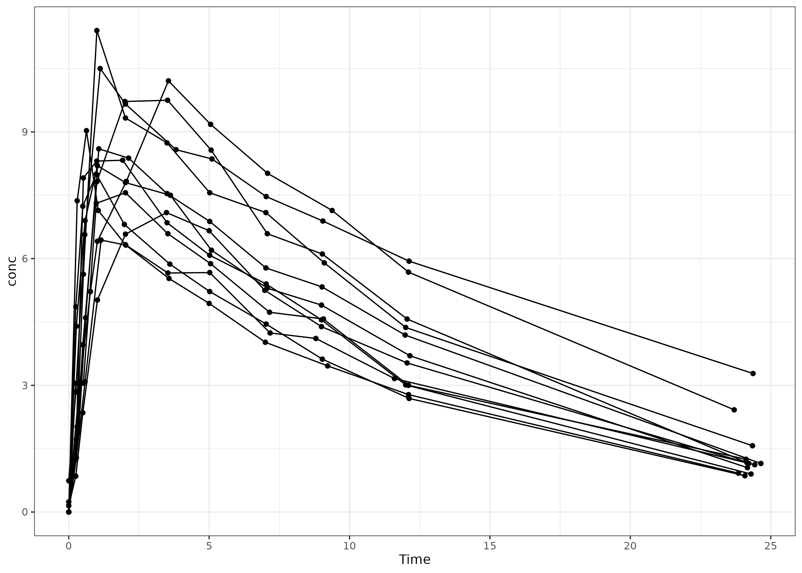

Source: OUTPUTS/figures/01-12345-pk-timecourse.png

Notes: N/A

Abbreviations: N/A