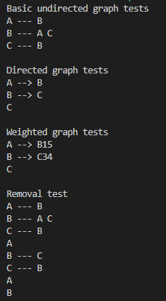
Task 1

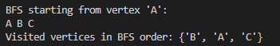
Task 2
Discuss BFS properties (level-by-level exploration).
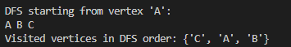
Task 3
There is some comparing to do as well need to check the lab sheet
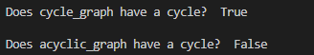
Task 4
There might be discussion
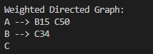
Task 5

There might be discussion

Task 6
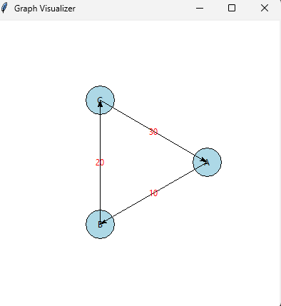
Discuss performance implications of graph size and structure.

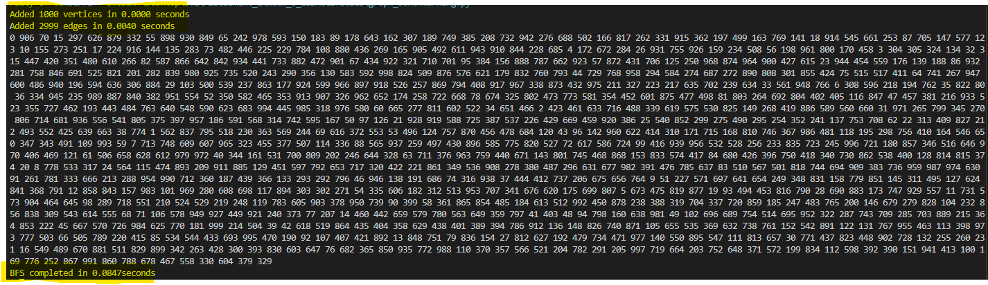
Task 7
Discuss performance implications of graph size and structure.
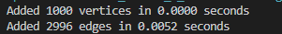

Task 8

