ICT ACADEMY OF KERALA
Summer Internship Report

Reunite

Campus Lost and Found



Agnes Joy
Sahrdaya College of Engineering and Technology
24 October 2026

EXECUTIVE SUMMARY
Reunite is a MERN application for campus lost and found. Students post reports, search the board and submit private ownership evidence. Campus administrators review claims, approve one claimant and record the return after handover. The implementation separates shared item descriptions from private claim records.
The production build and 26 database integration tests passed. A local browser walkthrough verified the student-to-help-desk process and a downloaded CSV summary. Demonstration items and identities are fictional. Application source is public and hosting verification remains pending; no institutional adoption or measured recovery improvement is claimed.

INTRODUCTION
Lost-item notices and informal messages can leave owners uncertain about where to look and staff without a consistent record of ownership checks. Reunite explores one application for posting an item, reviewing a private claim and retaining the final return decision.
The project is prepared for Agnes Joy at Sahrdaya College of Engineering and Technology in the full stack course context of ICT Academy of Kerala. It is a student demonstration, separate from the institution's operational systems.

OBJECTIVES
The objectives are to implement a complete report-to-return workflow, keep evidence private, prevent conflicting approvals under simultaneous requests, and provide source, tests and documentation that can be understood and demonstrated.
- Provide one board for lost and found reports with clear lifecycle rules.
- Keep ownership evidence private and make staff decisions consistent.
- Verify the main process and prepare reproducible documentation.

SCOPE AND DELIVERABLES
The release includes student registration and sign-in, Lost/Found reports, eligible reporter editing/deletion, literal search, category/type/status filters, pagination, private claims, withdrawal, staff review notes, approval/rejection, return recording, closure, counts and CSV summaries.
Deliverables include the React frontend, Express API, MongoDB models, this report, an SRS, setup/API notes, integration tests, a learning guide, eight screenshots and a source archive. Publication and hosting use Agnes's own accounts after access is configured.
Photo uploads, automated matching, college-email verification, password recovery, email notifications, QR handover and multi-campus tenancy are excluded. A reference supports tracking and does not establish ownership. Staff must verify evidence and carry out the physical handover.

METHODOLOGY
Work proceeded through requirements definition, role and lifecycle modelling, API implementation, interface construction, integration testing, browser verification and documentation. Coding assistance was used to prepare the source and report; the learning guide supports student review and explanation.
React and TypeScript manage controlled forms, session state and responsive views. A shared API client handles cookies, timeouts and readable errors. Express middleware verifies sessions and current roles, Zod validates inputs, and Mongoose models persist User and Item documents.
Claims are embedded in an Item document and capped at 100. A conditional update checks claim eligibility and duplicates atomically. The approval pipeline changes the selected claim, competing Pending claims and item status together, avoiding a race that could approve two owners.

PROJECT ACTIVITIES
Requirements and data design: defined Student and Administrator responsibilities, Open/Claimed/Returned/Closed report rules, Pending/Approved/Rejected/Withdrawn claims, private evidence boundaries and bounded arrays.
Backend implementation: added authentication, reports, claims, review, status, statistics and export endpoints. Strict validation, bcrypt hashes, cookie sessions, ownership/role checks, origin protection, rate limits and safe projections protect the workflow.
Frontend implementation: created the item board, report form, private claim panel, My reports, My claims and help-desk review screens. Native dialogs, labels, confirmation steps and busy/error/empty states support predictable interaction.
Integration and browser review: checked registration, empty search, private claim submission, refresh persistence, report creation and correction, reporter recovery, admin review, competing-claim rejection, final return visibility and CSV download.
Packaging: documented commands, production environment variables, API access, domain limits and demonstration steps. Generated credentials remain ignored and private. Public application source is available at https://github.com/agnesjoyjacob15-byte/reunite-campus. Hosting configuration is pending.

RESULTS AND FINDINGS
The production build and all 26 real-MongoDB integration tests passed. Tests exercise authentication, role escalation, safe profiles, strict inputs, owner CRUD, search, pagination, eligibility, privacy, duplicate claims, capacity, concurrent decisions, review auditing, return/closure rules, withdrawal, export escaping, origin/rate limits, health, logout and SPA fallback.
The local browser walkthrough confirmed a student claim reaching the help desk, approval of one claimant, rejection of a competing Pending claim and a returned update visible to the claimant. A second fictional lost report was created, edited and recorded as recovered. The CSV download excludes private evidence.
Desktop views used 1440 by 1000. A 390 by 844 iframe checked the mobile board and private claim dialog. The board measured 375 CSS pixels for both client and scroll width. No physical-device test was performed.
The application and local verification are complete. Application source is publicly accessible. Hosting verification is pending. Public repository: https://github.com/agnesjoyjacob15-byte/reunite-campus. No hosted project URL is available yet. These checks do not establish real ownership, physical handover, institutional effectiveness, sustained uptime, load capacity or independent security certification.

CONCLUSION
Reunite connects campus item reports to private ownership review and recorded returns. Server checks enforce who may see evidence and change state, while single-document updates keep competing claim decisions consistent.
Before final submission, Agnes should review the learning guide, practise explaining a request through the source, complete hosting verification and confirm any institution-specific details. Future work could add verified campus membership, image storage, notifications, retention tooling and a separate Claim collection for larger scale.

APPENDIX
Public repository: https://github.com/agnesjoyjacob15-byte/reunite-campus. Hosted project link: pending. Local development: http://127.0.0.1:5175. The localhost address is not a public hosted submission link.
Supporting SRS, API notes, test results and learning guide are in docs/. Tests are in server/test/. Figures show fictional local views from different stages of the walkthrough.
Figure 1 Student sign in and registration
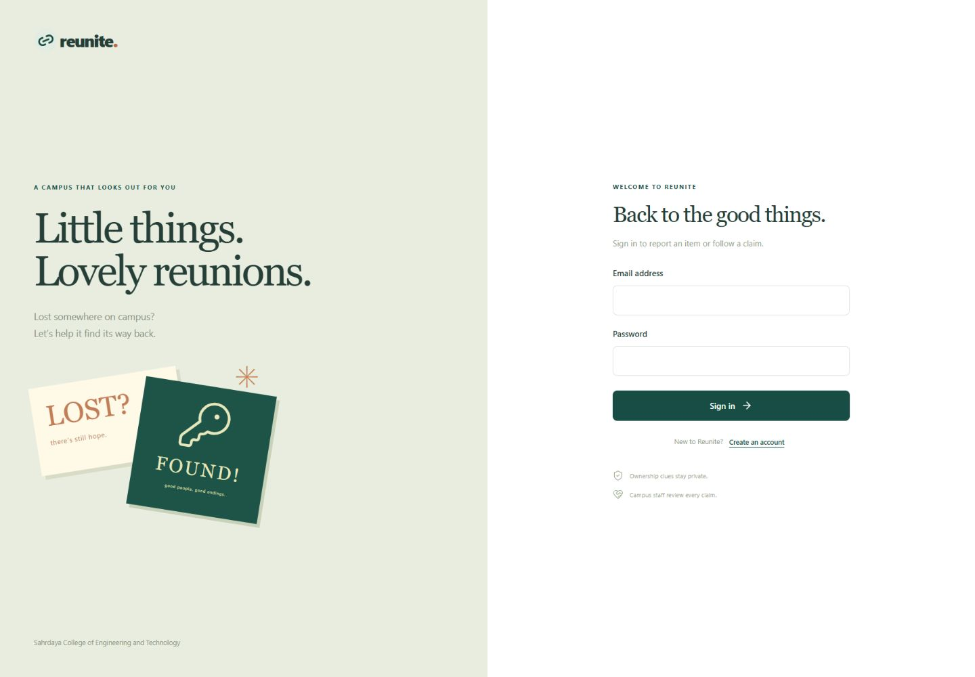
Figure 2 Campus item board and search filters
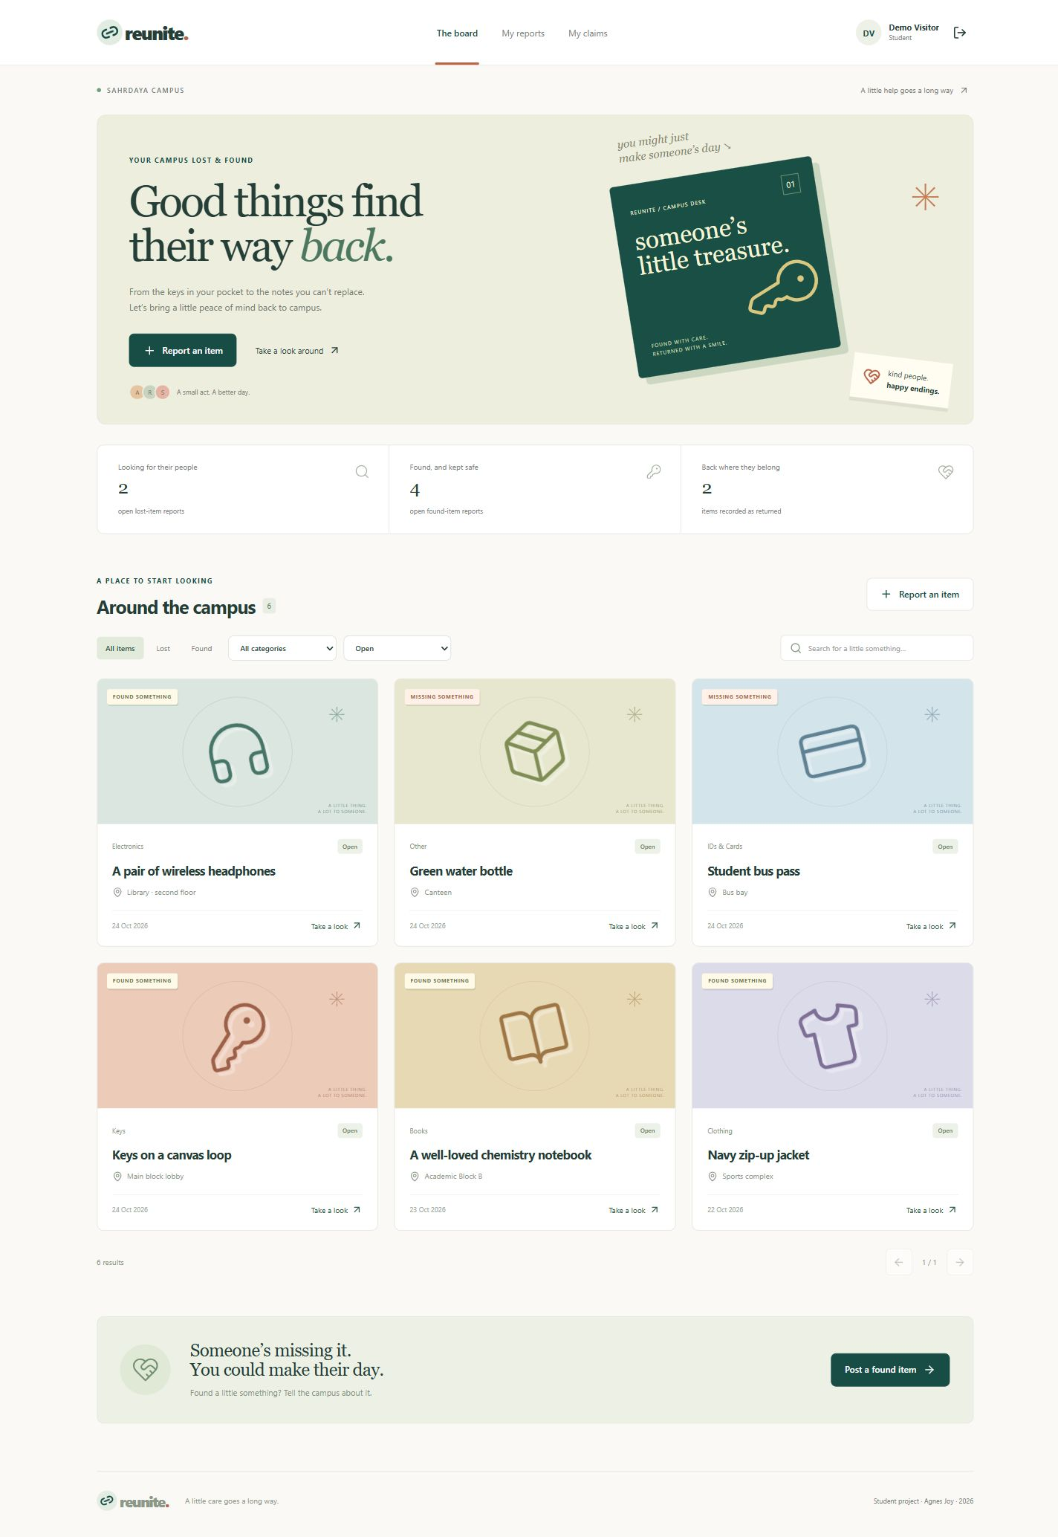
Figure 3 Private ownership evidence form
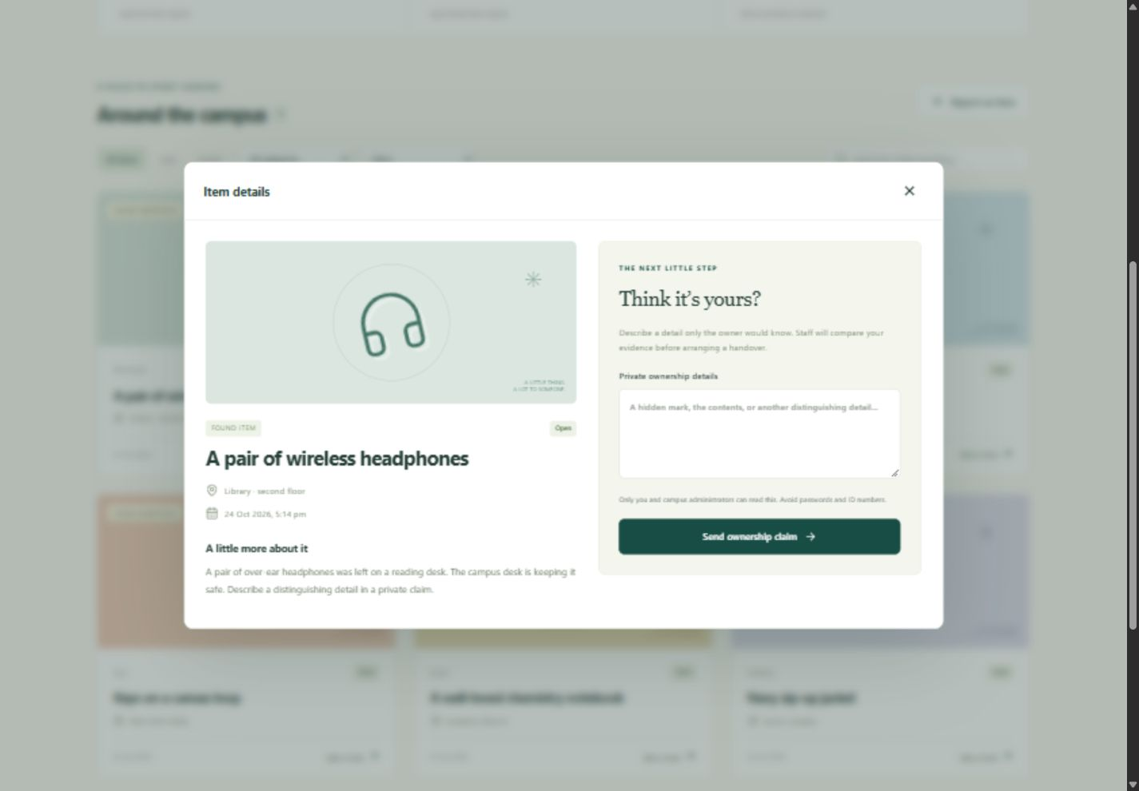
Figure 4 Student claim history
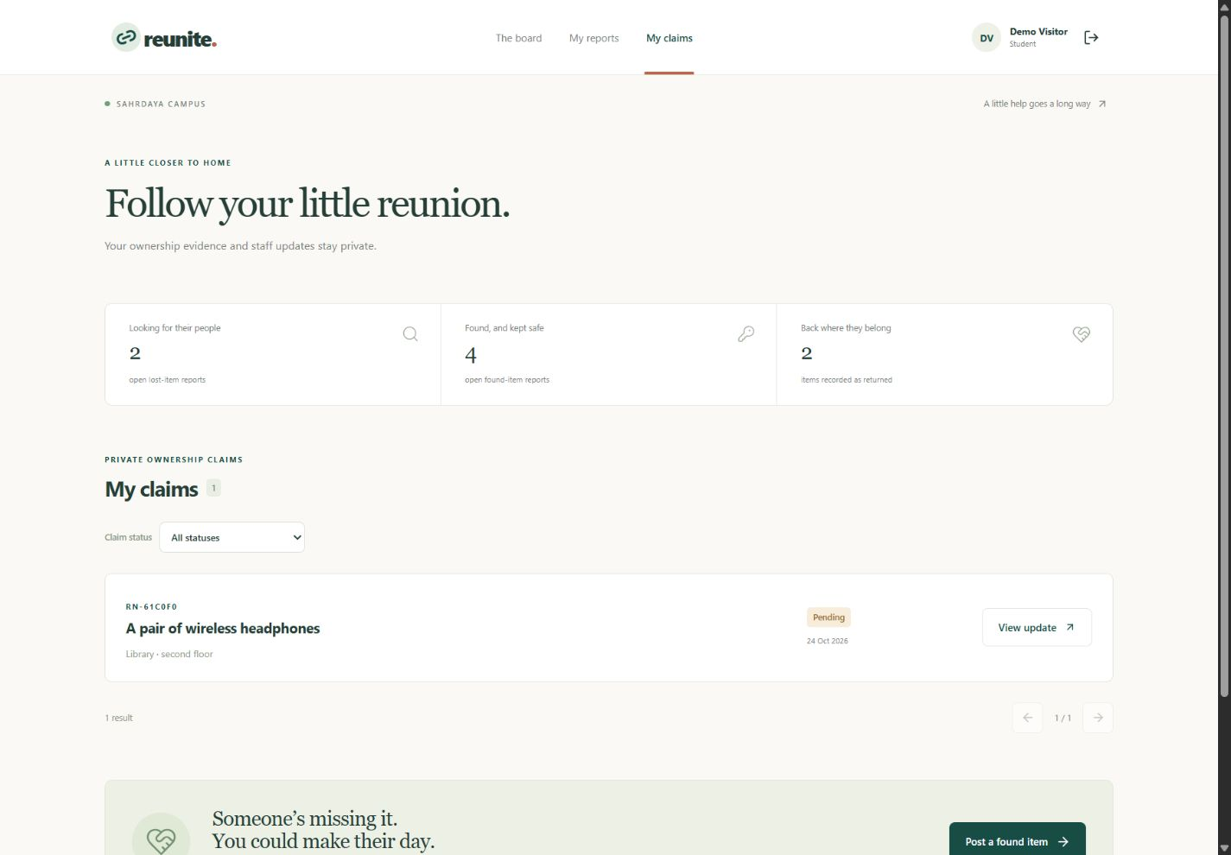
Figure 5 Lost item report form
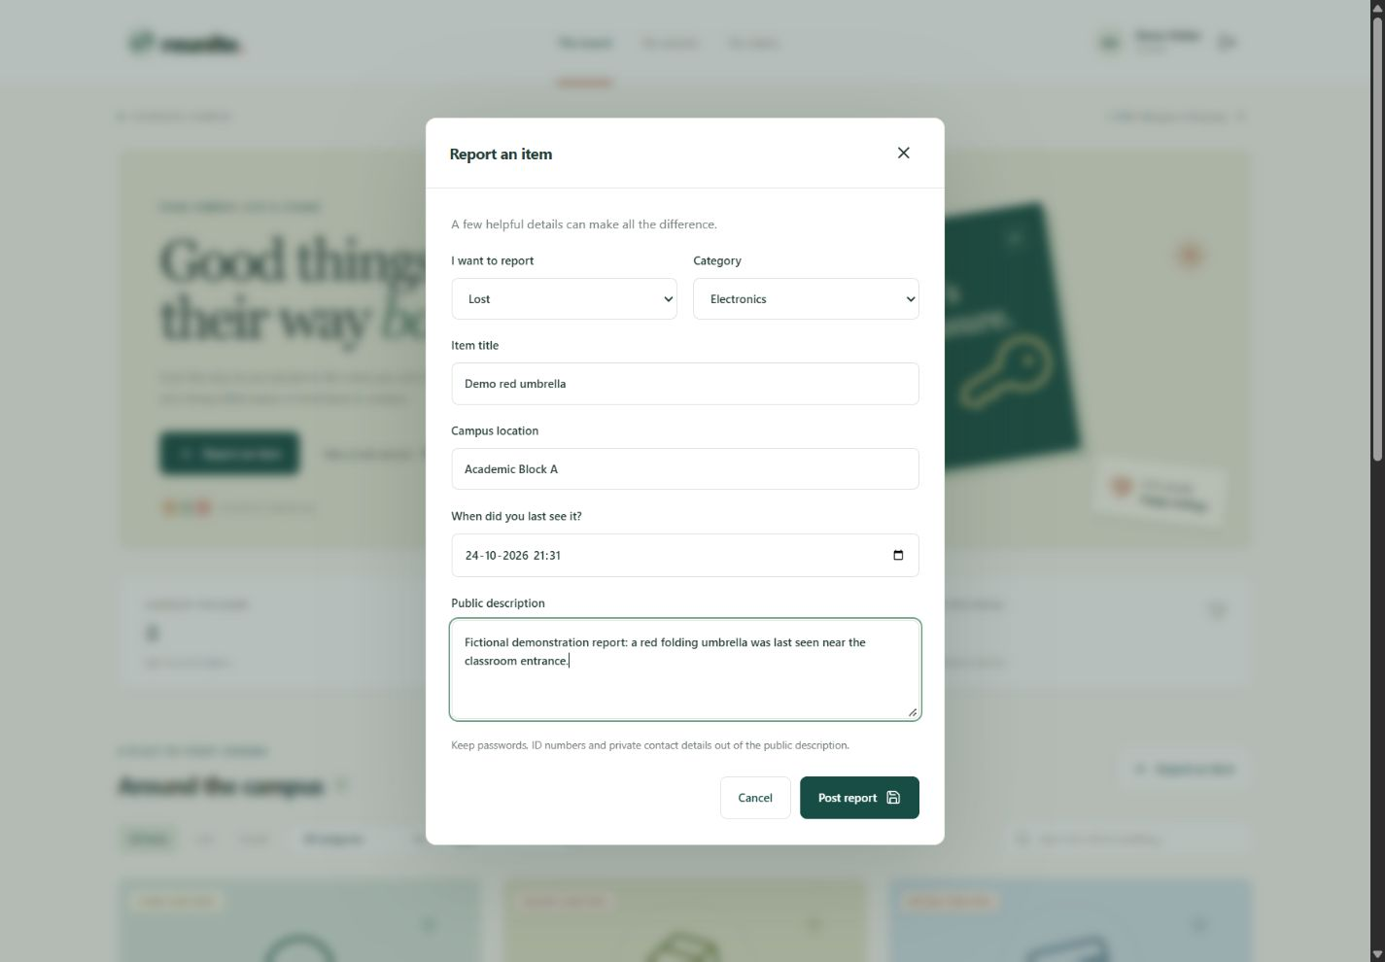
Figure 6 Administrator evidence review
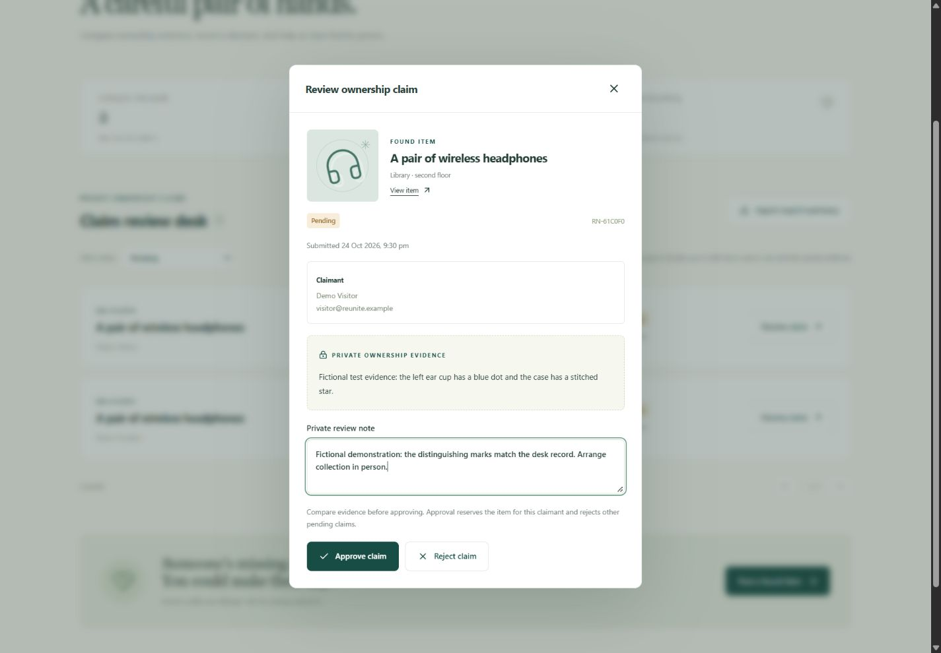
Figure 7 Approved claimant return update
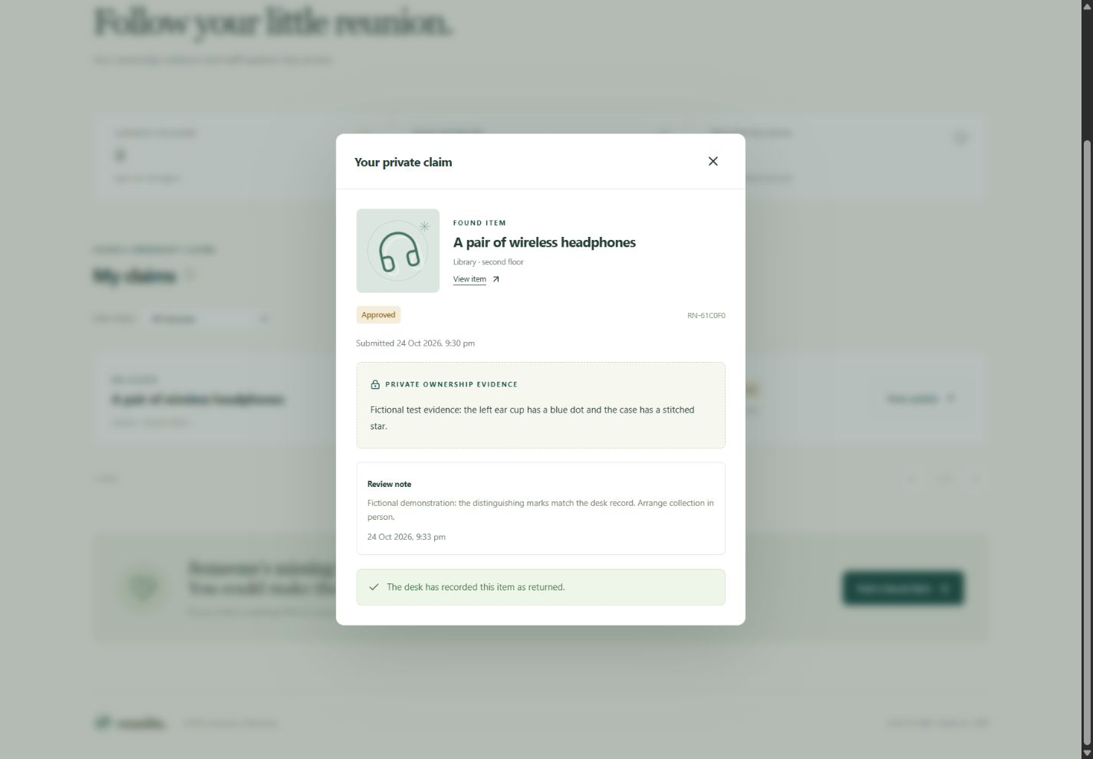
Figure 8 Private claim in a 390 pixel frame
