

**Agnès CARDIN**

**- Scala & PHP Developer -**

| EDUCATION |
| --- |

| **2015** | Security, Cryptography and Information Coding Master **- Université Joseph Fourier** |
| --- | --- |

| SKILLS |
| --- |

**TECHNICAL**

| **OS** | LINUX, ANDROID |
| --- | --- |
| **Langages** | **SCALA, JAVA-EE, PHP**, REACT, JAVASCRIPT, PYTHON, HTML/CSS |
| **Frameworks** | PLAY, AKKA HTTP, API PLATFORM |
| **SGBD** | POSTGRESQL, MYSQL, REDIS, CASSANDRA, ELASTIC |
| **Outils** | **INTELLIJ**, GIT, MAVEN, TERRAFORM |
| **Versioning** | GIT (GITHUB, GITLAB) |
| **Packet Manager** | NPM, MAVEN |
| **Serveurs** | DOCKER |
| **Pratiques** | **SOFTWARE CRAFTSMANSHIP, PAIR PROGRAMMING,** PAIR REVIEW, AGILE PRACTICES, TDD, KANBAN |

**ROLES/MISSIONS**

* Back-end / Front-end Development
* Technical lead
* Refactoring
* Technical architecture
* Legacy maintenance / evolutions

**BOOKS**

* ENI 2022: “Scala - Prise en main du langage”

**TALKS**

* Camping des Speakers 2023: “Ivre et au chômage, elle décide d’écrire un livre sur le Scala en plein Covid”
* Codeurs en Seine 2020: “Épanoui au travail: Yes, No, Maybe, I don't know”

**COMMUNITY INVOLVEMENT**

* Software Crafters Nantes - from 2020
* Duchesses - from 2020
* Volunteer for Ma Petite Planète - from 2023
* Volunteer for 1000 Moustaches - from 2023

**INTERESTS**

* Video games (JPRG)
* Pastry

| EXPERIENCE |
| --- |



September 2023 - March 2024 **- MICHELIN**

**Clojure Developer**

*Michelin is a French multinational tyre manufacturing company based in Clermont-Ferrand in the Auvergne-Rhône-Alpes region of France. It is the second largest tyre manufacturer in the world behind Bridgestone and larger than both Goodyear and Continental.*

**This mission aims to consolidate all data concerning tire manufacturing for all factories in order to create a unified platform that could be used as a common referential.**

* Clojure back-end development
* Functional leader support
* Needs definition and prioritization

**CLOJURE, DATASCRIPT, JAVA, POSTGRESQL**

**GIT, DOCKER**



December 2022 to July 2023 **- IADVIZE**

**Scala Developer**

*iAdvize is a conversational platform that humanizes digital experience for more than 2 000 brands in 100 countries worldwide.*

**As a member of a 7 person team, I was responsible for maintaining the visitor experience features (conversations, profiles, etc). It implies continuous evolutions and fixing with Agile methods.**

* Scala back-end development of the conversations API
* Legacy php back-end evolutions
* PostgreSQL and MySQL evolutions
* Php 5 to php 8 migration analysis
* Functional and unit testing
* Continuous delivery

**SCALA, PLAY, PHP, POSTGRESQL, MYSQL**

**GIT, DOCKER**



November 2021 to November 2022 **- LIBERTY & CO**

**Php Developer**

*Liberty & Co, Incentive Marketing agency from 2007, offers accessible and efficient motivation solutions and digital animations.*

**The aim was to rebuild an entire new product from the 10 year legacy one in order to obtain a more up-to-date one. This leads to the creation of Joozy, a brand new application, totally different from the original, technically and functionally, with a very new client target.**

* Php back-end development of a monolithic API
* React front-end development for the back-office and front-office applications
* UX/UI designer support to improve both websites design
* Database evolutions
* Technical and function architecture
* Management of a 3 person technical team
* Project management as a proxy Product Owner
* Unit and functional testing

**PHP, API PLATFORM, REACT, HTML/CSS, MUI, POSTGRESQL, REDIS, POSTMAN**

**GIT, GITHUB ACTIONS, DOCKER**

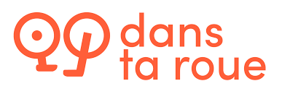

July 2021 to Septembre 2021 **- DANS TA ROUE**

**Full-stack Developer**

*Dans ta roue is a platform created to facilitate exchanges between bikers and professional repairers in Nantes, Paris and Lyon.*

**Dans ta roue was an early start-up with a low budget that wanted a low-cost back-office for bicycle repairers, a front-office for the bikers and an API to manage appointments between the two parts.**

* Front-end development for the back-office and front-office applications
* Back-end development of a monolithic API
* Repairers calendar management
* Customer experience management with Tripetto
* Clever Cloud administration

**REACT, REACT ADMIN, NODE JS**

**GIT, CLEVER CLOUD**

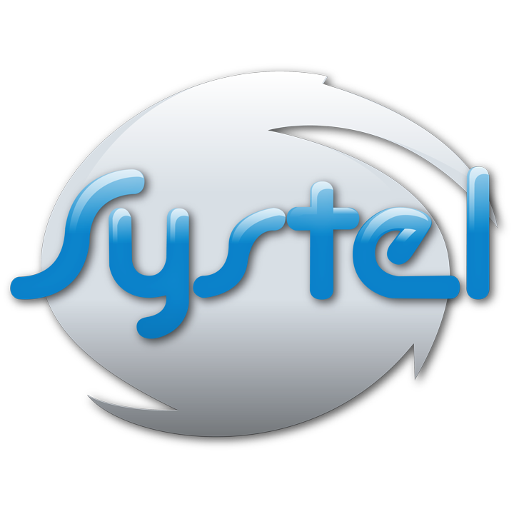

September 2020 to June 2021 **- SYSTEL**

**Java Developer**

*SYSTEL is a cutting-edge company focusing on national and regional services related to alert processing, decision support tools, 3D mapping & emergency calls handling.*

**In this mission, I was included in the current team to help them deliver client expected developments.**

* Back-end Development

**JAVA, GIT**

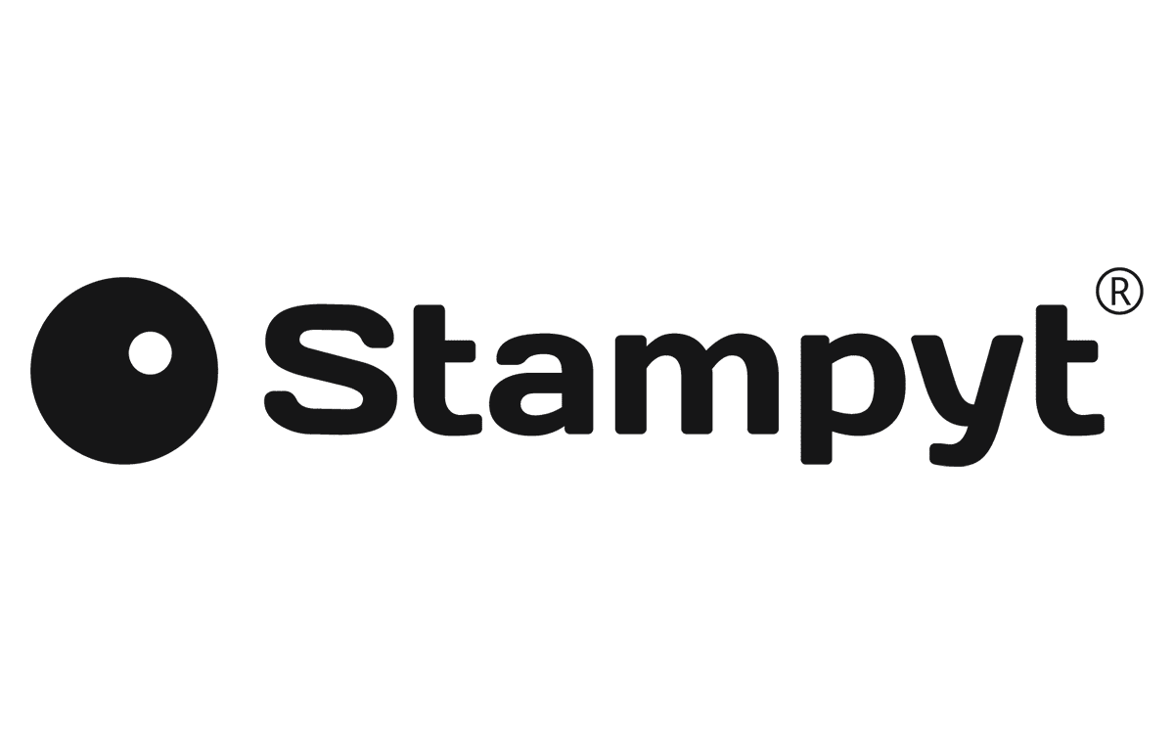

Avril 2018 à Septembre 2020 **- STAMPYT**

**Scala Developer**

*Stampyt offers technological applications for photography in the new professions of automotive.*

**As the sole back-end developer, my goal was to evolve and maintain the current product. Since Stampty was a start-up, I had to help wherever I was needed – team management, functional needs, etc.**

* Scala API Development
* Technical issues drafting
* Clients needs drafting (some in English)
* Technical and functional documentation drafting
* Installation of a new queue system to manager asynchronously some flows
* Integration of photo processes in Deep Learning APIs
* Securing of some applications with OpenID (Keycloak)
* Unit and functional testing
* Relational database creation with Neo4J
* PostgreSQL and MySQL databases management

**SCALA, PLAY, PYTHON, POSTGRESQL, MYSQL, NEO4J**

**JIRA, KEYCLOAK, JENKINS, AWS, CLEVER CLOUD**



January 2017 to November 2017 **- COMPTE NICKEL**

**Scala Developer**

*Nickel is an alternative bank account model without overdraft one can open in 5 minutes in a certified tobacconist. This account allows money deposit and withdrawal, credit transfers and automatic debiting, thanks to a GNI available right at the creation.*

**My job was to conceive and develop the SEPA module, meaning credit transfers and automatic debiting, with a binome.**

* Kafka installation to manage bank flows
* Real-time database management (Cassandra)
* Specs drafting
* Technical studies
* Unit and functional testing

**SCALA, CASSANDRA**

**GIT, GATLING, KAFKA**



October 2015 to September 2016 **- PSA**

**Java Developer**

*PSA Group is a French car manufacturer that groups car brands as Peugeot, Citroën, DS, as well as Opel and Vauxhall.*

**Maintenance and evolution of a Java application responsible for vehicle schematics verification.**

* Maintenance and evolution of Java 5 application
* Migration to Java 8
* Unit and functional testing

**JAVA, HTML, VBA**

**GIT, SVN**