Simulating a Satellite Pass

Overview
Over the next five weeks, you'll build a Python simulation of a real satellite passing over a ground station, then present what you did and how you did it. Your simulation will produce the satellite's path in 3D, the Doppler shift on its CW beacon, and a waterfall plot of the pass like the ones on SatNOGS. By the end, it will generate whole datasets of passes for training a model.
What you'll simulate: a real satellite, located using its TLE, passing over a station at a latitude, longitude and altitude you choose. The signal is exact: no noise and no frequency errors.
What comes later: next semester adds noise and frequency errors, trains a machine learning model on the results, and compares against real SatNOGS recordings. This semester ends with a tool that generates training data, and those projects start from it.
Tool | What you'll use it for
Your Python editor (VS Code works well) | Writing and running your code, in notebooks or scripts
skyfield (uses sgp4 underneath) | Fetching the TLE, predicting the orbit, placing the station, finding passes, computing range-rate
numpy | Vector math and arrays
matplotlib | 2D plots: elevation, Doppler curve, sky plot, waterfall
plotly | An interactive 3D view of Earth, the orbit and the station
SatNOGS DB and Network websites | Choosing a satellite with an active CW beacon, and looking at real waterfalls
Each week ends with a checkpoint you can use to confirm your work is right before moving on.
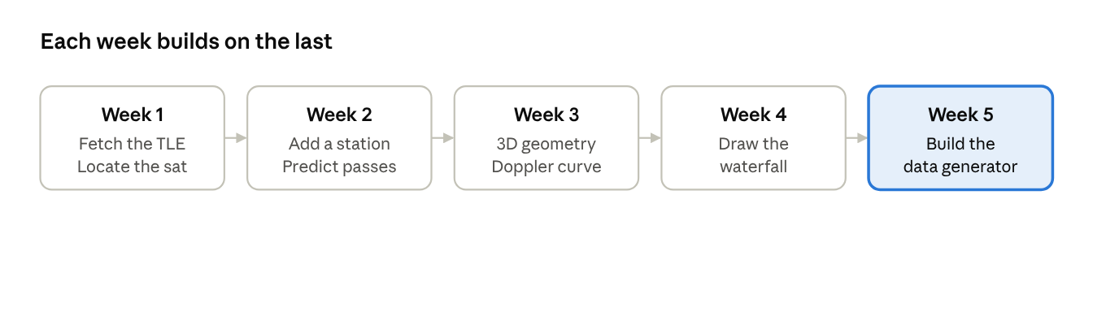
five weeks · one pipeline

Week 1: Pick a satellite and find it
By the end of this week, you'll be able to print where your satellite is right now.
Ideas to understand first
- Doppler shift: a car horn sounds higher as it approaches and lower as it drives away. Radio signals from satellites do the same thing.
- An orbit: a satellite in low Earth orbit circles the planet in about 90 minutes.
- A TLE (two-line element set): two lines of numbers that describe a satellite's orbit at one moment, called the epoch. A model called SGP4 uses them to predict where the satellite goes next.
Tasks
- Set up a Python project in your editor and install skyfield, numpy, matplotlib and plotly. In VS Code, the Python and Jupyter extensions let you run notebooks.
- Choose your satellite on the SatNOGS DB website. Look for one with a transmitter listed as mode CW and marked active, and with recent good observations on SatNOGS Network. Write down its NORAD catalog number and beacon frequency.
- Fetch its TLE from CelesTrak with skyfield's load.tle_file(), using https://celestrak.org/NORAD/elements/gp.php?CATNR=<number>&FORMAT=TLE with your catalog number filled in.
- Print the TLE's epoch and how many days old it is.
- Find where the satellite is right now, and print its latitude, longitude and altitude using wgs84.subpoint().
Checkpoint: the altitude is somewhere between about 300 and 1,000 km, and the latitude never strays further from the equator than the orbit's inclination (or 180° minus it, for orbits tilted past 90°).
Stretch: plot the satellite's ground track for one full orbit on a latitude–longitude plot.

Week 2: Put down a ground station and predict passes
By the end of this week, you'll have a table of upcoming passes over your station and a plot of one pass across the sky.
Ideas to understand first
- Latitude, longitude and altitude, and why the station moves with the rotating Earth.
- Elevation (height above the horizon) and azimuth (compass direction).
- A pass: the satellite rises, reaches its highest point (culminates), and sets.
Tasks
- Define the station with wgs84.latlon(lat, lon, elevation_m=alt). Use the location of a real SatNOGS station, listed on the SatNOGS Network site, so later projects can compare your simulation against its recordings. Pick one that has observed your satellite recently.
- Find every pass in the next 7 days with satellite.find_events(station, t0, t1, altitude_degrees=10). Events come back as codes: 0 rise, 1 culminate, 2 set.
- Build a table with each pass's rise time, culmination time, set time and peak elevation.
- Pick the highest pass. Sample it every second with (satellite - station).at(t).altaz().
- Plot elevation against time, and a sky plot (polar axes, azimuth around, 90° minus elevation outward).
Checkpoint: a pass lasts roughly 5 to 15 minutes, and the elevation plot rises, peaks once and falls.
Stretch: compare the predicted passes against the satellite's pass list on the SatNOGS Network site or another pass predictor. They should agree to within a minute.

Week 3: Work in 3D and compute the Doppler shift
By the end of this week, you'll have an interactive 3D view of the pass and the Doppler curve your station would hear.
Ideas to understand first
- Position and velocity as 3D vectors in a frame that doesn't rotate with Earth.
- The line-of-sight vector from station to satellite, and range (its length).
- Range-rate: how fast the range is changing. Positive means the satellite is moving away.
- The dot product as "how much of one vector points along another."
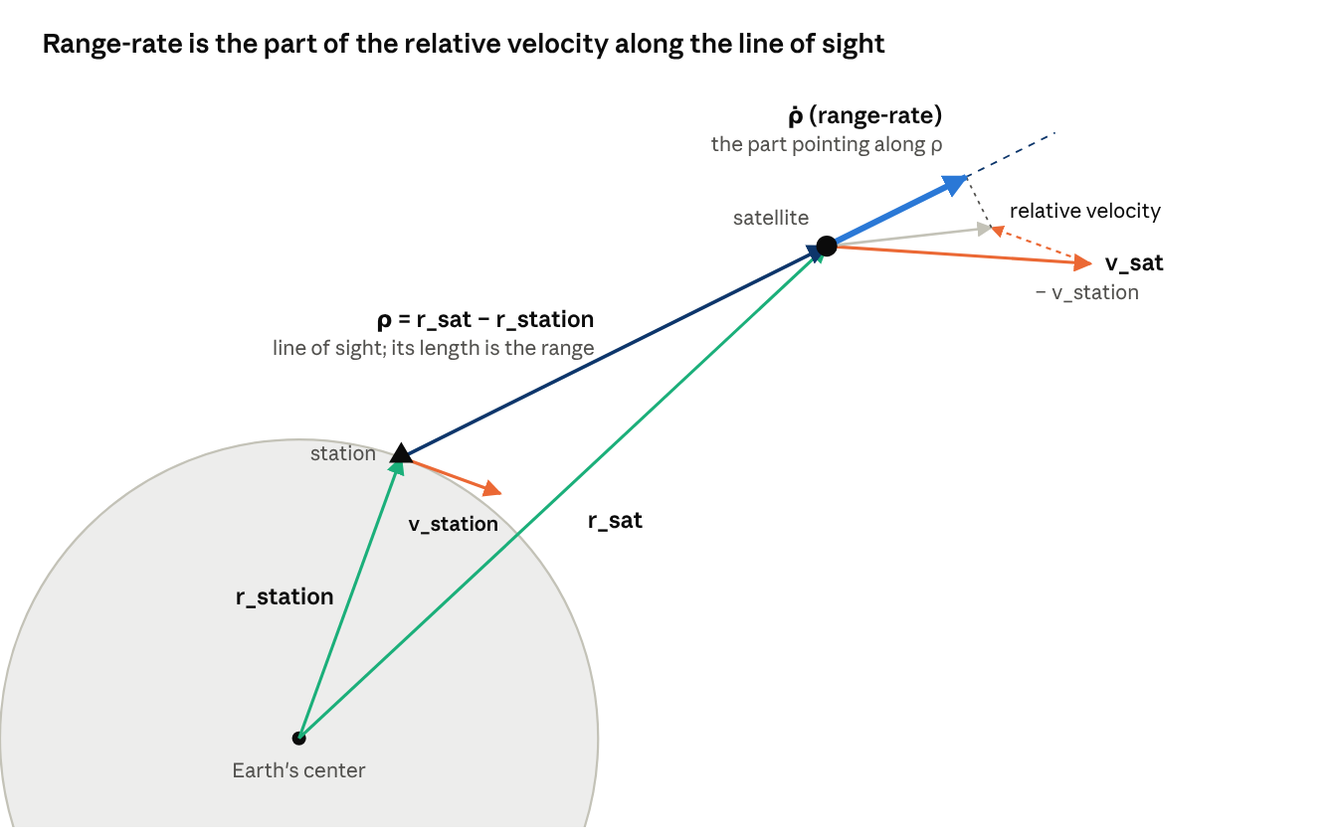
the vectors in the formulas below · not to scale, station speed drawn larger
Positions r are measured from Earth's center. Subtracting them gives ρ, the arrow from you to the satellite. Subtracting velocities gives the relative velocity, and the thick arrow is the part of it that points along ρ: that's ρ̇. In reality the station moves about 20 times slower than the satellite.
The two formulas you need, with ρ the station-to-satellite vector and v the velocities:
ρ̇ = (ρ / |ρ|) · (v_sat − v_station) f_r = f_0 (1 − ρ̇ / c)
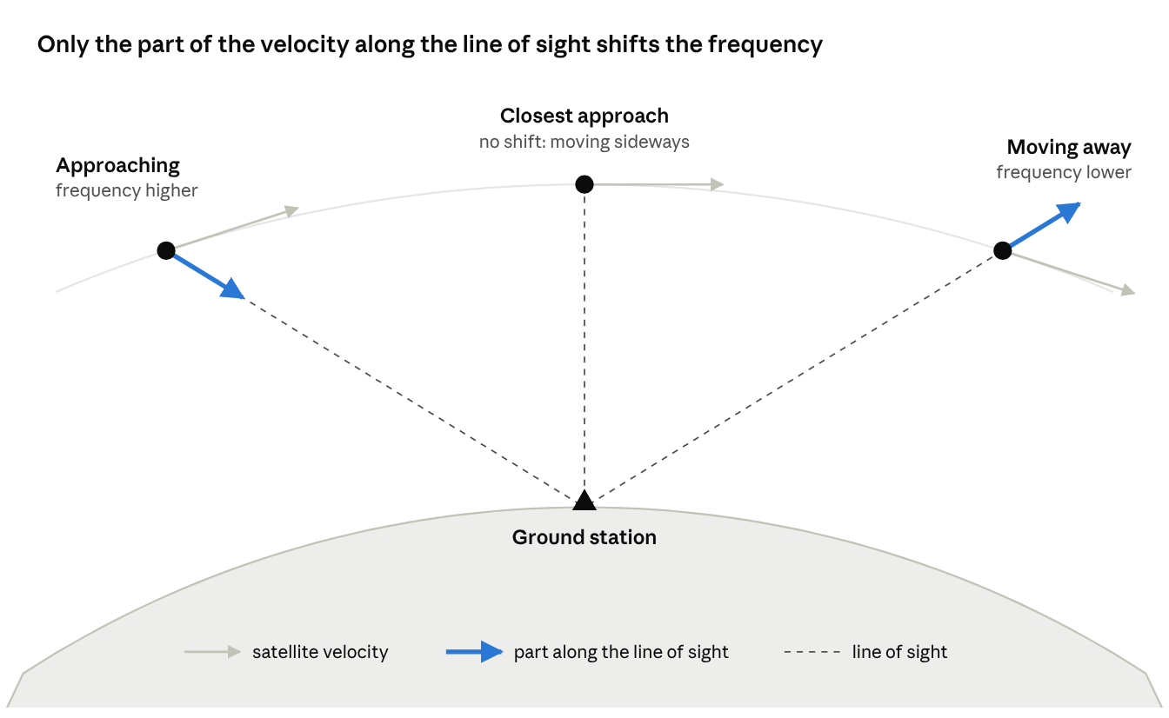
one pass seen from the side · not to scale
The dot product in the first formula picks out the thick colored arrow: how much of the satellite's velocity points toward or away from you. At closest approach the satellite moves sideways, so that part is zero and so is the shift.
Tasks
- Over the chosen pass, get satellite and station positions and velocities as arrays: satellite.at(t) and station.at(t), then .position.km and .velocity.km_per_s.
- Plot in 3D with plotly: a sphere for Earth, one full orbit of the satellite, the station, and the line of sight drawn at a few moments during the pass.
- Compute range-rate three ways and plot them together:
  - By hand with the dot product formula.
  - By finite difference: the change in range between samples, divided by the time step.
  - With skyfield's (satellite - station).at(t).frame_latlon_and_rates(station). The sixth value it returns is range-rate.
- Convert range-rate to received frequency with the Doppler formula, and plot the Doppler shift f_r − f_0 against time.
Checkpoint:
- The three range-rate curves agree to within about 1 m/s.
- The Doppler curve crosses zero at the moment of minimum range.
- The peak shift is close to f_0 × 7.5 km/s ÷ c: about ±10 kHz at 437 MHz, or ±3.5 kHz at 145 MHz.
Stretch: plot Doppler curves for a high pass and a low pass on the same axes, and explain why the high pass flips faster.

Week 4: Draw the pass as a waterfall
By the end of this week, you'll have a waterfall plot of your simulated pass that looks like the ones on SatNOGS Network.
Ideas to understand first
- A waterfall is a picture of a radio signal over time. One axis is time, the other is frequency, and brightness shows how strong the signal is at each frequency and moment.
- A radio tuned to the beacon frequency f_0 sees the satellite's signal at an offset of f_r − f_0. That offset is your Doppler shift from Week 3. A CW beacon is a single pure tone, so it shows up as one thin bright line.
- SatNOGS stations correct for Doppler while they record: they keep retuning the radio to follow the predicted shift. If the prediction were perfect, the line would be perfectly straight.
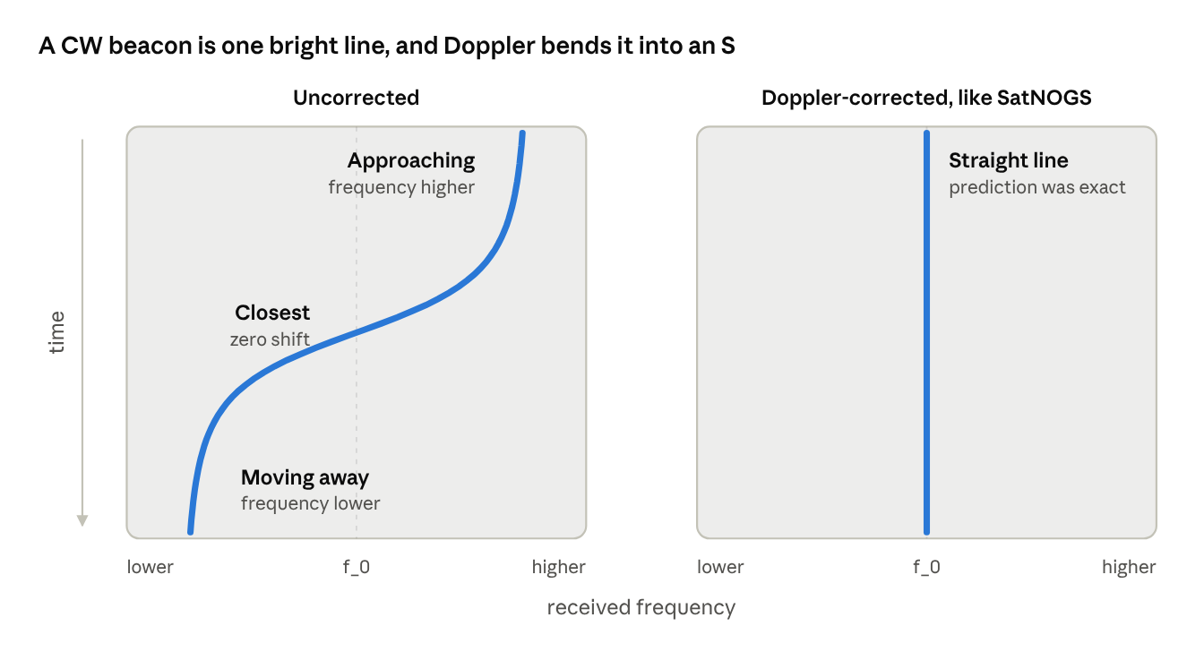
how to read your two waterfalls · sketch, not to scale
Read each picture top to bottom: the line's sideways position at each moment is the frequency you'd hear then. Your real plots should have these same shapes.
Tasks
- Choose your axes. Time: one row per second across the pass. Frequency: from −12 kHz to +12 kHz around f_0 in 50 Hz steps (use about ±5 kHz for a 145 MHz beacon). Widen the range if your Doppler curve runs off the edge.
- Make a 2D numpy array of zeros, with one row per time and one column per frequency step.
- Fill each row with a bright line at that second's Doppler shift. A smooth bump works well: np.exp(-((freqs - shift) / 100)**2), where 100 Hz sets the line's width.
- Plot it with plt.pcolormesh, frequency across and time down the side, using a dark colormap such as viridis and a colorbar. Label both axes with units. Open a real waterfall for your satellite on SatNOGS Network and match its orientation.
- Make a second, Doppler-corrected waterfall the way a SatNOGS station would see it. Each row's offset is (actual Doppler) − (predicted Doppler). Because your simulation is exact, this should be a straight line down the middle.
- Put your two waterfalls side by side with a real SatNOGS waterfall of the same satellite.
Checkpoint:
- The uncorrected line traces an S-curve that crosses zero at the moment of closest approach.
- Its far edges reach the same peak shift you found in Week 3.
- The corrected line is perfectly straight.
Stretch: draw your Week 3 Doppler curve as a dashed line on top of the waterfall. It should sit exactly on the bright line.

Week 5: Build a training-data generator
By the end of this week, you'll have code that simulates hundreds of passes and saves each one with its true answer attached. Next semester's machine learning model will train on this data.
Ideas to understand first
- Training data is pairs of inputs and labels. Here the input is a waterfall, and the label is the true Doppler curve that made it.
- Real recordings never come with the true answer. Simulated ones always do, which is why we build a simulator first.
- Every example should carry enough information (satellite, TLE, station, frequency, times) to regenerate it exactly. Next semester's students will need that to add noise and errors to the same passes.
Tasks
- Wrap your Weeks 1 to 4 code in one function, simulate_pass(norad_id, f0, lat, lon, alt_m, start, end), that returns the times, 3D positions, elevation, range-rate, Doppler curve and waterfall for one pass.
- Add two arguments, noise_level and freq_offset_hz, both defaulting to 0. Leave them unused for now; next semester will fill them in. This keeps the function ready for them without changing how it's called.
- Test simulate_pass on three new cases: a different station, a low pass, and a second satellite on another frequency band. Each should still pass the Week 3 and Week 4 checks.
- Put every pass on the same grid so the examples line up: time from −400 s to +400 s around closest approach in 1-second steps, and frequency from −12 kHz to +12 kHz in 50 Hz steps. Where the satellite is below 10° elevation, leave that row of the waterfall at zero.
- Write generate_dataset(norad_ids, stations, start, end, out_name). It finds every pass of each satellite over each station in the date range, simulates it, and saves the results. Use at least 20 real SatNOGS stations spread across different latitudes.
- Save each batch as two files:
  - <out_name>.npz, written with np.savez_compressed, holding waterfalls (passes × times × frequencies), doppler_hz and elevation_deg (passes × times), and the shared times_s and freqs_hz axes.
  - <out_name>.csv, with one row per pass: its index in the arrays, NORAD ID, both TLE lines, station ID, latitude, longitude, altitude, beacon frequency, rise, closest-approach and set times in UTC, and peak elevation.
- Write a short README.md that describes every array and column, with units.
- In a separate script that only reads the saved files, plot nine random waterfalls with their doppler_hz label drawn on top, and a histogram of peak elevations across the dataset.
Checkpoint:
- The dataset holds at least 500 passes.
- In the gallery, every label curve sits exactly on its bright line.
- Picking any row of the CSV and running simulate_pass with its values reproduces that pass's waterfall exactly.
- Someone who has never seen your code can load the data using only the README.

Common mistakes
- Mixed units. skyfield gives distances in km and speeds in km/s, while the speed of light is usually written in m/s. Convert everything to meters once, at the top of your notebook.
- Flipped sign. Positive range-rate means the satellite is moving away, so its frequency is lower. If your Doppler curve starts low and ends high, the sign is backwards.
- Old TLEs. A TLE that's several weeks old can be off by minutes. Fetch a fresh one at the start of each session and print its epoch.
- Time zones. skyfield works in UTC. Convert pass times to local time on purpose, not by accident.
- A line that vanishes on the waterfall. If the bright line is narrower than one frequency step, it can fall between steps and disappear. Make the line wider or the steps smaller.

What comes after this
Next semester picks up from your dataset, so keep your code and files tidy:
- Noise and frequency errors: fill in noise_level and freq_offset_hz so the simulated waterfalls look like real ones.
- A machine learning model: train it to find the Doppler curve in a noisy waterfall, a job where simple peak-finding struggles once the signal is faint.
- Real recordings: run that model on real SatNOGS waterfalls of the same satellites and stations, and compare against your simulations.
- Later ideas: turning a pass into audio, estimating how far off a TLE is, or working out a station's location from its recordings.

