# File Used

1. AGV set 1.csv

**Generated: manually**

Positioning AGV in the field.

Example:

|  |  |  |
| --- | --- | --- |
| Coordinate X | Coordinate Y | Orientation |
| 6 | 24 | Right |
| 9 | 10 | left |

Coordinate-X = Placed the agv to the coordinate x in the world

Coordinate-Y = Placed the agv to the coordinate y in the world

Orientation = Determine the direction faced on the world

1. layout set 2.csv

**Generated: manually**

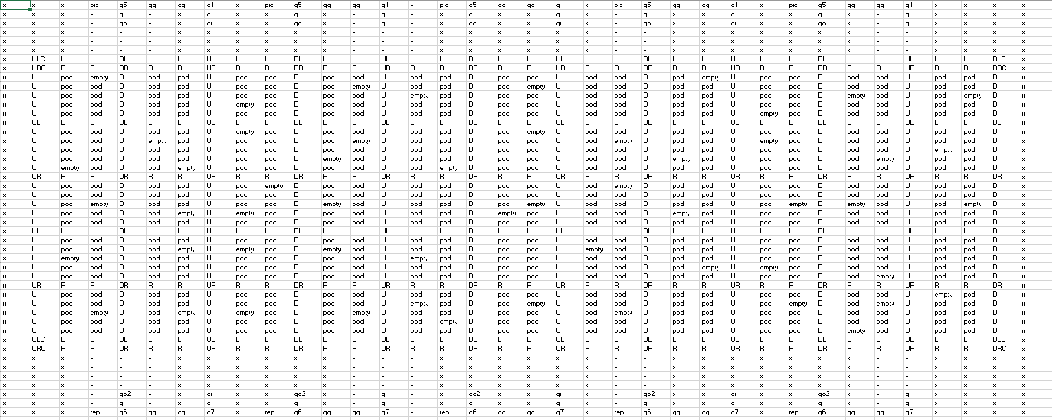

Equal to

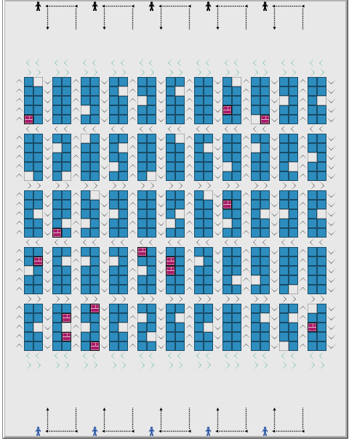

Every Cells represents types of object on the World. Several types included in system are:

1. x = white space
2. pic = picker picture
3. rep = replenishment picture
4. q5 = Second queue turning place
5. q = queue line
6. qq = queue going left only
7. qo = queue out line in picking station
8. q1 = First queue turning place in picking station
9. qi = queue in line
10. qo2 = queue out for replenishment
11. q7 = First turning place in replenishment station
12. q6 = Second turning place in replenishment station
13. U = can going up
14. L = can going left
15. R = can going right
16. D = can going down
17. C = Corner
18. pod = occupied place for pod
19. empty = unoccupied place for pod
20. Assigned_order_to_pod.csv

**Generated by assignmentOP.py**

**Used: assignmenOP.py, FinnishOrder.py, countingThrougput.py, reduceQty.py, ManageItemInPod.py**

Note: Pod ID and WHO in the turtle is different properties.

Assigned order to pod is a list of ordered items that should be deliver to the picking station.

|  |  |  |  |  |
| --- | --- | --- | --- | --- |
| Pod ID | Due_date | quantity | time | Finnish time |
| 466 | 1 | 1 | -61 | 0 |
| 297 | 1 | 2 | -61 | 0 |
| 57 | 1 | 2 | -61 | 0 |

Pod ID = Identifier for each of the POD

Due_date = Set the due date of the ordered item inside the pod

Quantity = total item ordered

Time = start time initiated

Finnish time = ending time initiated

1. Deliver_to_pick_station.csv

**Generated by NetLogo**

Calculating picking service time

|  |  |
| --- | --- |
| Pod ID | Quantity delivered |
| 412 | 2 |
| 268 | 2 |
| 389 | 3 |
| 41 | 1 |
| 260 | 3 |

Pod ID = Identifier of the Pod

Quantity delivered = total quantity delivered to picking station

1. Item in pod.csv

**Generated by assignmentOP.py**

**Used: assignmentOP.py, virtualRep.py, replenishIndicator.py, reduceQty.py, duplicatepoddata.py**

Contain list of total items in each of the pods. (Main data to control pod items). This list is sorted by shortest due date.

|  |  |  |  |  |
| --- | --- | --- | --- | --- |
| Pod ID | Item ID | Quantity | Due Date | Max Quantity |
| 268 | 68 | 12 | 1 | 14 |
| 75 | 646 | 10 | 1 | 13 |
| 215 | 374 | 10 | 1 | 11 |
| 323 | 237 | 10 | 1 | 13 |
| 17 | 497 | 13 | 1 | 14 |

Pod ID = Identifier of the Pod

Item ID = Identifier of the item

Quantity = total quantity available in the pod

Due date = Due date should be delivered to the picking station (if the value is 999 means not ordered yet)

Max Quantity = Max capacity of the SKU’s in each of the pods

1. Orders.csv

**Generated by assignmentOP.py**

**Used: assignmentOP.py**

List of orders generated to be processed by the simulation

Note: if it debugged via python only it will appear empty cell because this file used to generate incoming orders.

|  |  |  |  |
| --- | --- | --- | --- |
| Item ID | Quantity | Due date | |
| 341 | 2 | 2 |
| 729 | 2 | 1 |
| 215 | 2 | 2 |
| 134 | 1 | 1 |
| 460 | 2 | 2 |
| 288 | 2 | 1 |

Item ID = Identifier of the item

Quantity = Total quantity available in the pod

Due date = Due date should be delivered to the picking station

1. Replicate pod data.csv

**Generated by ManageItemPod.py**

**Used: manageItemPod.py**

Used for generating the result of the simulation at fixed amount of time. If the time reaching 43200 it will restart simulation.

|  |  |  |  |  |
| --- | --- | --- | --- | --- |
| Pod ID | Item | Quantity | Due Date | Max Quantity |

Pod ID = ….

Item = ….

Quantity = ….

Due Date = ….

Max Quantity = ….

# Objects

1. AGV

Robot which bring pods to the destination

|  |
| --- |
| AGV |
| +who: int  +color: int  +heading: int  +xcor: int  +ycor: int  +shape: string  +label  +label-color: float  +breed: string  +hidden: Boolean  +size: float  +pen-size: float  +pen-mode: string  +countdown: int  +status: string  +path-status: arrive  +agv-id: int  +destination: int  +xstart: int  +ystart: int  +xend: int  +yend: int  +uturn: int  +straight-first:  +availability:  +carrying-pod-id: int  +next-empty-id: int  +previous-x: int  +previous-y: int  +start-time: int  +r-cycyle-time:  +pick-time: int  +bring-qty: int |
| Methods |

1. Pods

Carrying SKU to store several items. It will be placed on predetermined place which can be carried by AGV and placing on the Emptys

|  |
| --- |
| Pods |
| +who: int  +color: int  +heading: int  +xcor: int  +ycor: int  +shape: string  +label  +label-color: float  +breed: string  +hidden: Boolean  +size: float  +pen-size: float  +pen-mode: string  +items: array  +pod-id: int  +status:  +replenish:  +rep-lead-time: |
| Methods |

1. Jobs
2. Emptys

Empty is an empty place to place the pods

|  |
| --- |
| Pods |
| +who: int  +color: int  +heading: int  +xcor: int  +ycor: int  +shape: string  +label  +label-color: float  +breed: string  +hidden: Boolean  +size: float  +pen-size: float  +pen-mode: string  +order-status:  +status  +empty-id: int |
| Methods |

1. Pick-stations

Place for pods to be picked by the picker.

|  |
| --- |
| Pick station |
| +who: int  +color: int  +heading: int  +xcor: int  +ycor: int  +shape: string  +label  +label-color: float  +breed: string  +hidden: Boolean  +size: float  +pen-size: float  +pen-mode: string  +order: int |
| Methods |

# Data flow in To Setup

1. Replication-read

Read the replication data

1. fefweafwef