Agnia Vibriani

2023-10-02

# Task 4

## Using R example datasets

**Describe briefly the content of the CO2 dataset using the help function**

#load the data  
data("CO2")  
?CO2

The experiment is analyzing the cold tolerance of the grass species *Echinochola cruss-galli* by measuring the CO2 response curve for photosynthesis. The data contain the CO2 uptake at several levels of CO2 concentration in the chilled and non-chilled plants.

**What is the average and median CO2 uptake of the plants from Quebec and Missisipi?**

library(tidyverse)

## ── Attaching core tidyverse packages ──────────────────────── tidyverse 2.0.0 ──  
## ✔ dplyr 1.1.3 ✔ readr 2.1.4  
## ✔ forcats 1.0.0 ✔ stringr 1.5.0  
## ✔ ggplot2 3.4.3 ✔ tibble 3.2.1  
## ✔ lubridate 1.9.3 ✔ tidyr 1.3.0  
## ✔ purrr 1.0.2   
## ── Conflicts ────────────────────────────────────────── tidyverse_conflicts() ──  
## ✖ dplyr::filter() masks stats::filter()  
## ✖ dplyr::lag() masks stats::lag()  
## ℹ Use the conflicted package (<http://conflicted.r-lib.org/>) to force all conflicts to become errors

library(dplyr)

data(CO2)  
#select the plant originated from quebec only  
Quebec <-filter(CO2, Type=="Quebec")  
summary(Quebec)

## Plant Type Treatment conc uptake   
## Qn1 :7 Quebec :42 nonchilled:21 Min. : 95 Min. : 9.30   
## Qn2 :7 Mississippi: 0 chilled :21 1st Qu.: 175 1st Qu.:30.32   
## Qn3 :7 Median : 350 Median :37.15   
## Qc1 :7 Mean : 435 Mean :33.54   
## Qc3 :7 3rd Qu.: 675 3rd Qu.:40.15   
## Qc2 :7 Max. :1000 Max. :45.50   
## (Other):0

#select the plant originated from Mississippi only  
Mississippi<-filter(CO2, Type=="Mississippi")  
summary(Mississippi)

## Plant Type Treatment conc uptake   
## Mn3 :7 Quebec : 0 nonchilled:21 Min. : 95 Min. : 7.70   
## Mn2 :7 Mississippi:42 chilled :21 1st Qu.: 175 1st Qu.:13.88   
## Mn1 :7 Median : 350 Median :19.30   
## Mc2 :7 Mean : 435 Mean :20.88   
## Mc3 :7 3rd Qu.: 675 3rd Qu.:28.05   
## Mc1 :7 Max. :1000 Max. :35.50   
## (Other):0

#generate the table  
data <-data_frame(  
 Plant_Origin = c("Quebec", "Mississippi"),  
 Mean = c(33.54, 20.88),  
 Median = c(37.15, 19.30))

## Warning: `data_frame()` was deprecated in tibble 1.1.0.  
## ℹ Please use `tibble()` instead.  
## This warning is displayed once every 8 hours.  
## Call `lifecycle::last_lifecycle_warnings()` to see where this warning was  
## generated.

knitr::kable(data, caption = "CO2 uptake based on plant origin")

CO2 uptake based on plant origin

| Plant_Origin | Mean | Median |
| --- | --- | --- |
| Quebec | 33.54 | 37.15 |
| Mississippi | 20.88 | 19.30 |

**[OPTIONAL]In the airway example data from Bioconductor, how many genes are expressed in each sample? How many genes are ot expressed in any sample?**

## R Markdown

This is an R Markdown document. Markdown is a simple formatting syntax for authoring HTML, PDF, and MS Word documents. For more details on using R Markdown see <http://rmarkdown.rstudio.com>.

When you click the **Knit** button a document will be generated that includes both content as well as the output of any embedded R code chunks within the document. You can embed an R code chunk like this:

summary(cars)

## speed dist   
## Min. : 4.0 Min. : 2.00   
## 1st Qu.:12.0 1st Qu.: 26.00   
## Median :15.0 Median : 36.00   
## Mean :15.4 Mean : 42.98   
## 3rd Qu.:19.0 3rd Qu.: 56.00   
## Max. :25.0 Max. :120.00

## Including Plots

You can also embed plots, for example:

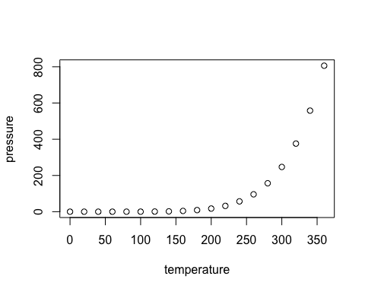

Note that the echo = FALSE parameter was added to the code chunk to prevent printing of the R code that generated the plot.