**iBrgy: A MOBILE APP FOR BARANGAY CONCERNS AND EMERGENCIES**

Luigi M. Dimagnaong

BSIT  
Banate, Malungon,   
Sarangani Province  
+639072762137

wcluigi1999@gmail.com

Geraldin P. Cayode

BSIT  
Kibuaya, Hagonoy  
Davao del Sur  
+6399076515433

dindin17mee@gmail.com

John Lloyd O. Casia

BSIT  
Colorado, Digos City  
Davao del Sur  
+639100912550

lloydcasia@gmail.com

Cyvil Dave T. Dasargo, MIT

Adviser  
UM Digos College

cyvildavedasargo@gmail.com

# 1. INTRODUCTION

Barangay is one of the basic units of government in the Philippines. There are currently a little over 42,000 barangays all over the country. On the average, there is a barangay for every 2,500 Filipinos [1]. And one of them had already a mobile or smartphone that can be used through communication. According to Philippine Statistics Authority (PSA) based on 2015 census, barangay Aplaya has the highest population of all the barangay [16].

There are some cases that needed the urgency to take action like the earthquake incident that recently happened makes the people of Digos City crumbles, especially in Barangay Aplaya. Struggling to quell panic over fake news about a tsunami and another powerful earthquake that have continued to circulate in social media following the magnitude 6.3 tremor that struck parts of Mindanao [16]. Another case is a decomposing body of a bank messenger, was found near a lodging house in Barangay Aplaya, A. Young said the victim’s body – which was covered with coconut leaves – was discovered when a child playing near it complained of foul odor [17].

Thus, barangays’ have many problems: brawls everywhere, drinking sessions on the street, minors roaming at night, gossipers proliferating the concerns of the streets [3]. The case study on “Barangay Government Disaster Preparedness: The case of typhoon Sendong affected Iligan Communities” reveals that most of barangays are not prepared for disasters [4]. Even on late nights, there are some emergencies that particularly those residents that lived on rural areas which need urgent response. Hence, necessity to develop this project to help personnel of the barangay to manage the concerns of residents and minimize the delays of responses on emergencies.

The proposed system by the researchers aims to provide functions that can respond to emergencies in just a tip of the finger as long as the user’s account has the approval of the admin in the desktop application. This is designed to help the respondents lessen the hassle of asking the victim on where the incident happened as the location of the victim will be shown in the system's GPS, Time in emergency is always ticking where every second counts. Those reported incidents will be recorded in the system and will display the number of incidents that may happen in the following months of the year represented by a graph.

## Purpose and Description

The application enables the users to choose what concern they’re going to raise and which type of emergency they’re experiencing and which rescue agency they need to contact and allows an immediate contact with the needed rescue agency and also the barangay tanod, providing an instant details of the exact location of the victim is sent to the admin represented by a map and viewed by the rescuers and also via text message. The system will record the reported incidents such as reported incidents, accidents, respondents, location, and how the situation was handled that will be generated as a report. These reports shall include number of incidents that may happen in the following months of the year. Therefore, the main purpose of this project is to develop an application that enables the user choose a menu of emergency and get the needed help accessible to every android user to further ease or at least minimize vulnerability to hazards and cope with accidents.

The proposed emergency response system will help the rescuers as they don't need to search where the incident happened and also, they don't need to verify it if the incidents is valid once the users register and approved by the admin in the system, to reduce the chance of getting prank calls. The application will also help the users as they don't need to search for numbers and the needed agency to call that will reduce the hassle of where, how, and who to contact.

## Objectives of the Study

**1.2.1 General Objectives**

The main objective of this proposal is to develop a web based and android application for barangay emergencies and concerns of to respond accidents promptly. Specifically, it aims to:

**1.2.2 Specific Objectives**

* To develop an android application with a menu of emergencies that will send the users' location to the system of the android user through the help of desktop Application and Android Studio for the android app.
* To locate and show the location to which the emergency occurred to the user’s longitude and latitude who sends the information with the help of GPS.
* To notify the residents and tanods about the announcements through news feed in the android application
* To generate report of incidents or concerns and determine number of accidents represented by a graph using linear regression algorithm.
* To provide a request form that can lessen the time of requesting a document by just sending a request letter thru the android app.

## Scope and Limitation

The system’s main role is to receive a concern and locate emergency reports. The accident which fall within the scope of the application are only incidents related to concerns like public disturbance, fire, drowning, vehicular accident, robbery, rape and illegal gambling. When it comes to requesting an emergency, the android application will locate and display the location of the emergency to the longitude and latitude of the user who sends the information with the help of the GPS. Using the Google Map API to produce incident or concern reporting and determine the amount of accidents represented by a graph.

The android application will also handle the requesting of documents like cedula, certificates, clearance.

If there are any announcement within the barangay, the administrator will also handle the announcement.

The system will not cope the availability of the respondents and barangay tanod.

# Review of Related Literature and System

This portion of the document gives all the references and works on the scheme being created that have been reviewed. Previous theses, publications, and works linked to this article will be used in this section of the study to offer the reader a clearer knowledge of what the proponents is attempting to do, and for the study that places importance on why this research work is being undertaken.

## Review of Related Literature

The review of related literature conducted by certain authors, journalists, and undergraduate thesis writers on systems related to the study, previous dissertations, journals, and works related to this paper will be used to give the reader a better understanding on what the researchers are trying to develop and for the study that place significance why this research work is conducted and this will also justify the fact that the proposed system is possible to develop.

Android is right now the most popular mobile platform available in the market. With over 85% market share worldwide, Android Operating System dominates the mobile platform market [6]. In the Philippines, Smart Phones are getting within everyone’s reach due to the growing affordability [2]. Information and Communications Technology (ICT) have been used by different Governments organizations to promote participation with its citizens. Through M-government or Mobile-Government, citizens can make urban incident reports in their neighborhood to the local administration. In this context, citizens can use incident reporting tools that permit communication with the local administration. Although most M-government applications concern an urban environment such as traffic jams, parking availability in town among others, applications have been used even in rural areas [7].

Similar android applications that offers emergency responses have been created to other countries but only some have made an application that have been implemented as a National Emergency Hotline. In Australia, there is an emergency hotline called Triple 0 (000) just like the 911 that the Philippines has. An application was created for Triple Zero that can run in different mobile application platforms. It 1.) Provides the caller with information about when to call Triple Zero, 2.) Provides the caller with information about who to call in various non-emergency situations, 3.) Displays the GPS coordinates of the phone's location that the caller can read out to the emergency operator [5]. While in iBrgy, the registered user will be provided types of emergencies to choose without making a phone call but if the said emergency is urgent, they can simply tap the SOS button that will make a call to 911. Another difference between the two applications is that the Triple Zero Application gives the user his/her coordinates and has to be read out to the emergency operator.

In the case of the proposed system, the request will be automatically labeled as a legitimate emergency as the only users of this said system are the ones who’s registered in their designated barangay and will be forwarded to the admin that will contact the needed rescue agencies and if it’s an emergency that needs a barangay tanod’s help, the system will send them a text message from the system if they don’t have a smartphone.

Most of the common target of these studies is to focus on improving the ability to understand the common problems of the respondents on the accident site using new system designed to track incidents on the allotted time frames. Therefore, developing such systems need guiding design principles and concepts.

Using mobile technologies to add another emergency reaction option and medium. The suggested technique used present trends in mobile and web technology to deliver emergency units quickly and efficiently. They maximize the use of smartphones as a medium and assist individuals save their life in an emergency situation. Command centers will also benefit from readily detecting and plotting the user's place on a map [8].

The mobile application in Bangladesh offers 911 emergency advantages. Users efficiently use it to access emergency services that imply such facilities need and usefulness. BES ' main highlights include fast access to vital phone numbers (police, fire, hospitals); mechanized discovery of and access to the nearest crisis specialist organizations using interactive maps; and area-based information customization. One of the major disadvantages of these frameworks is that they depend to a large extent on predefined contacts from customers, which are unlikely to be able to assist in the midst of emergencies due to physical separation or inaccessibility. BES decreases these problems by providing access to the nearest emergency service organizations, taking into account the current place of the user. By expecting users to enter a pin within 10 seconds of pressing a button, the application prevents inadvertent emergency call [10].

## Review of Related System

**SakunAPP: A Framework for Mobile Application Development in Disaster Awareness, Preparedness and Response:**

The system is focusing on the preparedness of its constituents while having also a report about the latest incident. The system’s platform is a web application and android application that focuses on disaster preparedness and response. Let the user send a complaint or report, thru mobile app and verify by the admin. The application also has a “News Feed” that can manipulate the events recently happened, and they also use Mapping System to ensure the safety of their residents [11].

In case of emergencies, the system is very helpful. The preparedness plan is the primary arrangement on that. With the users’ choice, they can send a complaint to the system and tagging them into the map. The proponents’ system will not verify the user unless he is not a resident of the barangay.

**The Emergency Direct Mobile App: Safety Message Dissemination over Multi-Group Network of Smartphones using Wi-Fi Direct**

The application provides a service of Instantaneous Messaging (IM) during emergency and critical situations. The users must insert their generalities and select the profile. Data are stored on the local device, and loaded at future usages of the Emergency Direct App. The user can also send an emergency message [12].

The similarities of both applications are that they have a messaging system that can send to a group but the difference is the EDM App uses Wifi-Direct while in the proponent’s system is using Textblast.

Table 1 shows the main components of the proponents’ system compared to the features of the related system. The system we’re the same in structure but uses other forms of notifying; however, the development that would be done by the proponents would be different.

**Table 1**. *Review of Related System Matrix*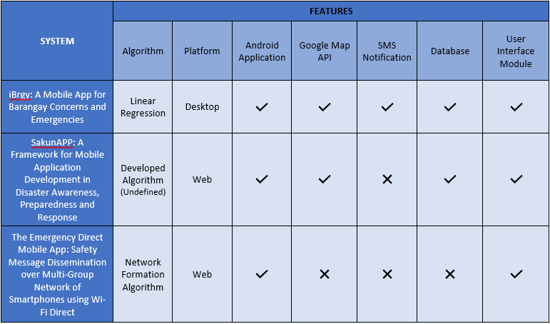

# Technical Background

This section deals with the details of the proposed framework, the tools will be use on how to utilize the framework. This chapter will also describe the individuals going to involve in this operation.

## Conceptual Framework

***Figure 1****. Conceptual Framework (Input-Process-Output)*

In the figure 1, From the incident area, concern citizens or even the victims will send the report of the incident to the barangay. Upon receiving the report, the location of the concern citizen or the victim will be plotted on the map using Google Map API. Then the admin notifies the needed rescue agency, barangay tanod, or even the police to go to the victims, then the admin asks the rescue agency if the incident is already solved after the operation. The identified location and the list of the victims will be recorded in the database. The recorded information will be used in another function of the system to which is to graph and to predict how many incidents might happen in the following months of the year and will be plotted on a map using Google Map API.

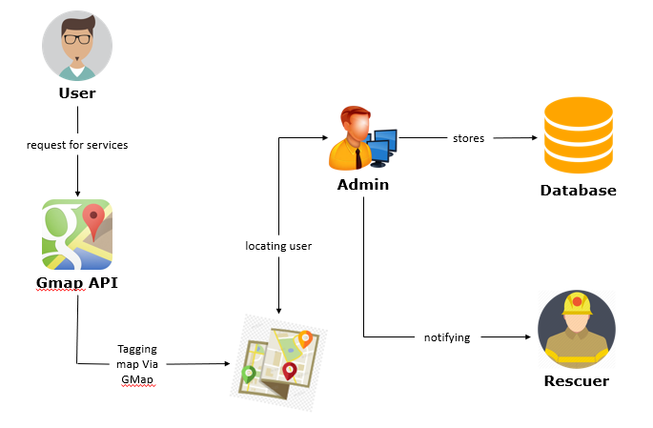

***Figure 2****. Conceptual Framework*

In the figure 2, the user will use the application to choose which type of emergency they need and will request location with the help of Google Map API. The user’s information and its location will be sent to the admin which allows the admin to send information about the victim, if the respondent doesn’t have a smartphone then a text message will be sent instead and the system will store all the information gathered which will be used in another function of the system to graph and to predict how many incidents might happen in the following months of the year and will be plotted in the map with the help of Google Map API.

The interface will be developed using C# for Desktop application and Android Studio for the mobile application. The proponents will use C# tool to provide a platform that one barangay can only access the application. All of these made up the system and will use FireBase Database that will acting as a hosting to connect the android application to desktop application.

**3.5 Development Tools**

**3.5.1FireBase**

The proponents will use the FireBase Database as the tool for database to make it easy to test the database structure and queries without worrying about the underlying file structure, and also to act as a host to connect both android and web application.

**3.*5*.2 C#**

The proponents will use this as a tool for development of the desktop application because it supports the Firebase database and can also uses the rest of API for android application.

### **3.5.3 Android Studio**

### The proponents will use android studio to connect the process of the system and make it easier to use as the users’ compatibility.

## 3.5.4 Google Map API

The proponents will use Gmap API as the tool for mapping to show the location of the victim, and tagging them into admins’ access on web application.

# Methodology

Methodology refers to a series of distinct phases or processes that have endured the entire development of software. It is used to develop project development and project management. In this chapter, further discuss the methodology that will be used to plan, structure and complete the software development process.

## Development Approach

The researchers will use Agile Development Method in software development specifically, Extreme Programming methodology. The reason for using this type of development approach is that it has principles to embrace changes, more user engagement in terms of feedback to create a much-wanted output, and continuous integration to qualify user satisfaction. Changing requirements from customers or users is constant and inevitable while developing the software, as they were encouraged to give feedback or suggestion. That is why the researchers will use a methodological approach that is flexible to certain changes, to improve the quality of the final product and to ensure customer satisfaction from continuous integration of the changes made into the system.

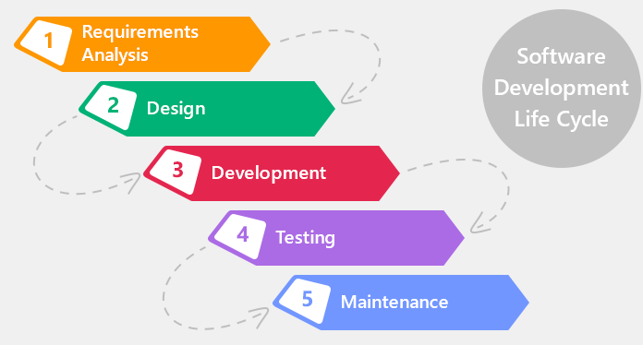

**Figure 3.** *SDLC*

## Planning

The researcher will conduct an interview at the Barangay Aplaya to learn about the barangay operation. Because of this fact all the information was gathered by researchers. It includes the algorithm and what would be the platform to use in the planning process, and finally how to achieve the goals within the system. It includes the project's probability when it will be completed based on the scheduled time limits and the data allocated to make this system as a whole process.

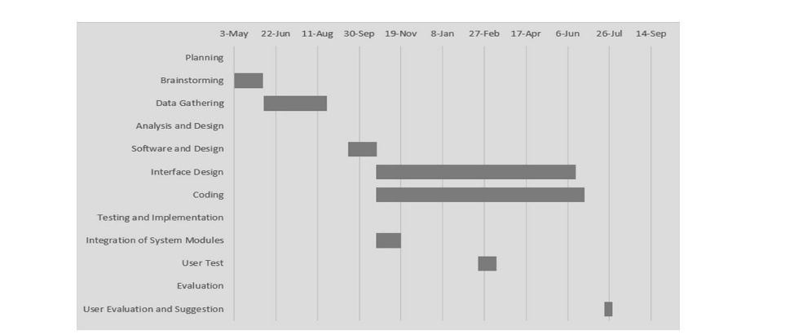F**igure 4.** *Gantt Chart*

## Context Diagram

The Context diagram gives a broad overview in the entire system. It specifies where data goes and stored. The manual process is being discussed in existing process flow and to identify the difference between the proposed system flows.

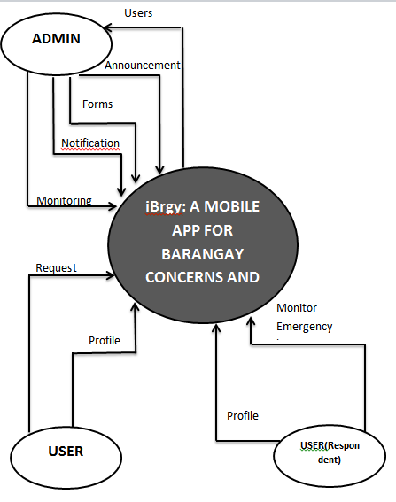

**Figure 5.** *Context Diagram*

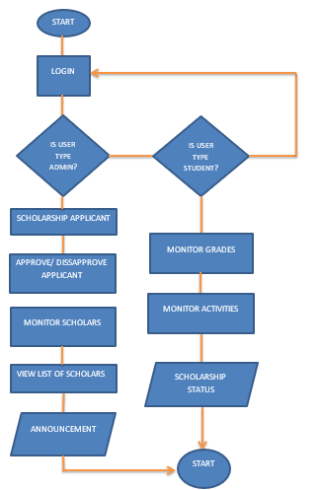

**Figure 6.** *Process Flow Diagram*

The Figure 6 shows the proposed process flow of the system. It is composed of an Administrator, constituents and respondents with its corresponding actions and different processes. There are three users, which is the admin, respondents and constituents. The constituents can receive announcements and can view the announcements online. The residents will be able to view request forms and request for an emergency.

## Entity Relationship Diagram

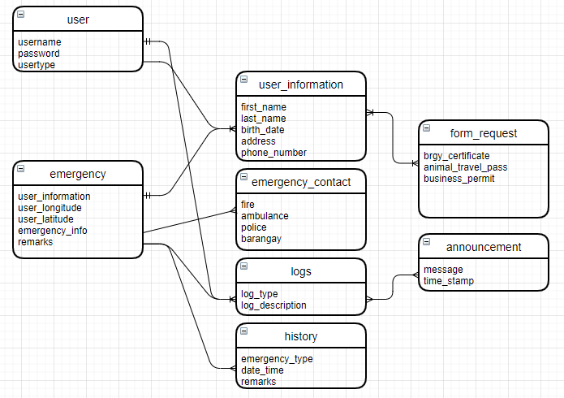

**Figure 7.** *ERD*

## Use Case Diagram

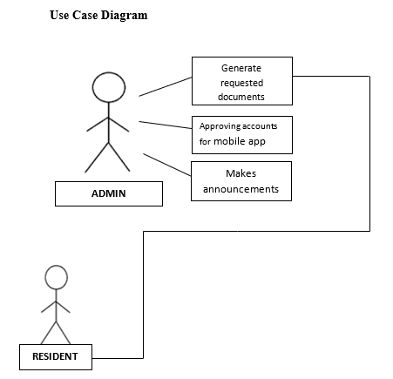

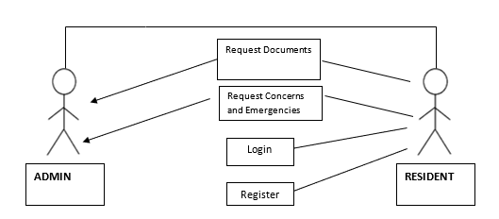

**Figure 8.** *Use Case Diagram*

The Figure 8 shows the use case diagram as a representation of the user’s interaction in the system that shows the relationship between the user and different use cases in which the user is involved. It has an administrator that can view and generate requested documents, approve accounts for mobile app, make announcements. And it has an resident request documents, request concerns and emergencies.

## Infrastructure Diagram

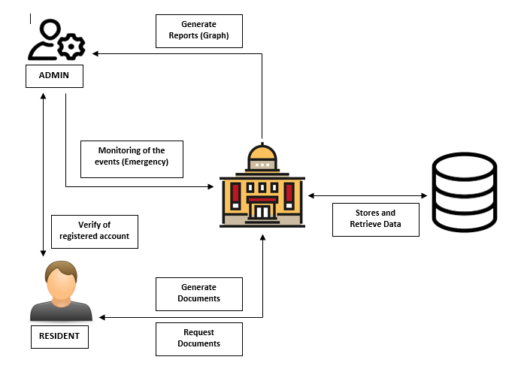

***Figure 9****. Infrastructure Diagram*

## Software Requirement Specification

This type of requirement refers to the system's specific process and purpose. These processes and functionalities are described in another module which the system has:

### Functional Requirements

**Login Module**: In this module, the admin will log-in his/her account.

**Register Module**: In this module, the residents will create an account with personal information.

### Non- Functional Requirements

This is where the requirements are illustrated wherein the system can perform and process it without any errors.

### Security Requirements

This is where the requirements are illustrated wherein the system can perform and process it without any errors.

### Usability & Compatibility

The program can be accessed with the Internet Connection via Web Browser and mobile Application it is accessible by the barangay Admin and residents of Aplaya.

### Research Locale

The program can be accessed with the Internet Connection via Web Browser and mobile Application it is accessible by the barangay Admin and residents of Aplaya.

]

### Population of Study

The program can be accessed with the Internet Connection via Web Browser and mobile Application it is accessible by the barangay Admin and residents of Aplaya.

## Coding

The development of the system is important for implementation. So that the researchers used some development tools for the success of the system. The proponents used C# as a software editor desktop application in which it creates the administrator interface of the system and .Net for the backend programming development for building the application, it also makes procedures like read and write into the database, modify and update data and display data on the interface of the system. Firebase for the database. The researchers also used Linear Regression Model for analytics in which it will show the statistics of the crime rates, blotter reports, rape reports.

## Implementation

The development of the system is important for implementation. So that the researchers used some development tools for the success of the system. The proponents used C# as a software editor desktop application in which it creates the administrator interface of the system and .Net for the backend programming development for building the application, it also makes procedures like read and write into the database, modify and update data and display data on the interface of the system. Firebase for the database. The researchers also used Linear Regression Model for analytics in which it will show the statistics of the crime rates, blotter reports, rape reports.

## Testing

In testing phase, it is a procedure that should be done during the development process. Testing was one of the important stages on the project in which it can determine the accuracy of the system and it can detect bugs. The Barangay Aplaya was the selected partner of the proponents to conduct a testing with regards of understanding the risks of software implementation. The proponents will be conducting a testing which is the unit testing and user acceptance testing. The proponents also will be conducting the alpha test and beta testing to the company Barangay Aplaya. These tests are the process of evaluation of a system if the software meets the user requirements.

## Unit Testing

This was performed by the development team. Unit tests includes testing individual components or unit. It typically written and run by the proponents to ensure that code meets its design and behaves as intended.

# RESULTS AND DISCUSSION

This chapter discusses the result or the final output of the study. Deliberation on how the researchers accomplished the objectives after going through several phases of system development will also be presented in this chapter.

Request an emergency through the mobile application which uses Android Studio. C# as for the desktop application for the admin and FireBase as the storing of the data online.

When all the data and resources available, it’s been accumulated during the development of the system, the researchers developed a mobile application for the constituents of the barangay to enable them to request for emergency purposes. The development of the mobile application compromises of Android Studio and APIs, C# for the desktop application, and FireBase as the data storage.

As presented in Figure 10 below using the developed mobile application, in the Request Emergency Form wherein the resident can request an emergency into the admin’s desktop application.

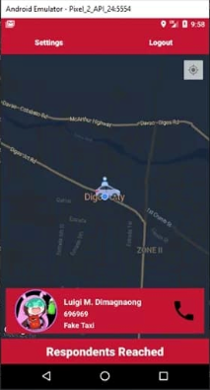

**Figure10**. Request Emergency Form

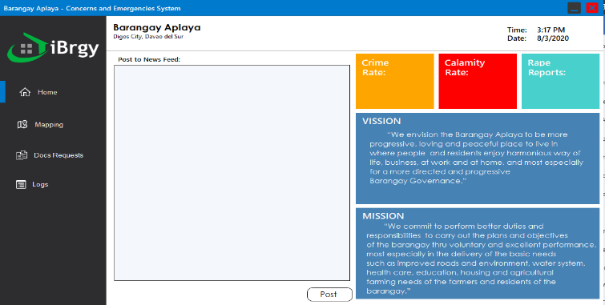

**Figure 11**. Admin Home Page

Figure 11 shows the admin homepage where the statistics report will be shown, and a text area where announcement will be sent to the mobile application.

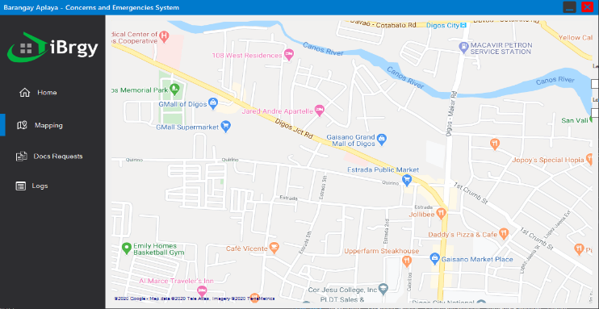

**Figure 12**. Admin Mapping Page

As presented by Figure 12 above, the administrator will be monitoring the situation if the resident requested an emergency.

# CONCLUSION AND RECOMMENDATION

# 6.1 Conclusion

From the findings of the study, it was concluded that the functionality of iBrgy: has gained effectiveness in terms of the functionality, reliability and usability. Moreover, residents encountered in manipulating transactions.

It is also concluded that the management and monitoring system as rated by the administrators has gained effectiveness in terms of the functionality, reliability and usability.

**6.2 Recommendation**

* Needs to be use without internet connection
* Functionality that store the all information of the residents
* Functions that notify if there are important documents requested

REFERENCES

1. Punongbayan B. 2018. The Barangay System. https://www.bworldonline.com/the-barangay-system/
2. Tamayo R. 2016. Philippine Daily Inquirer. The Value of Barangay Assemblies. https://www.pressreader.com/philippines/philippine-daily-inquirer-1109/20161013/281887297824400
3. Balmas R. 2018. Qoura. What are some Barangay problems?   
   https://www.quora.com/What-are-some-Barangay-problems
4. Gonzales D. et al. 2016. Research Gate. Barangay Disaster Preparedness Monitoring Web Application System. https://www.researchgate.net/publication/308186353_BaraBara_Disaster_Preparedness_Monitoring_Web_ApplicatioA_System
5. Mehta H. 2017. Emergency service call 000 (Triple Zero). Here is key information on 000 including when and how to call. https://www.sbs.com.au/language/english/audio/everything-you-need-to-know-about-australia-s-emergency-number-000
6. Vignesh Vicky, Entrepreneur 2019. What are the importance of Android app development? https://www.quora.com/What-are-the-importance-of-Android-app-development
7. G. Novio et al,. 2016. Empowering consumers in selected Public Markets in Metro Manila: A framework for the development of AgriWatchPH.  
   https://ieeexplore.ieee.org/document/7848426
8. Raut D. et al. 2015. Semantic Scholar. TECHNOLOGY ENHANCED FUNCTIONALITY EMERGENCY CALL APPLICATION FOR ANDROID. https://www.semanticscholar.org/paper/TECHNOLOGY-ENHANCED-FUNCTIONALITY-EMERGENCY-CALL-Raut-Patil/9498e9563a92501e62f6d6b734305f76f68f17e2
9. Aazam, M., Hung P ., & Eui-Nam, H. 2015. M2M Emergency Help Alert Mobile CLous Architecture.
10. Hossan, M., Sharmin, M., & Ahmed, S. 2018. Bangladesh Emergency Services: A Mobile Application to Provide 911-Like Service in Bangladesh.
11. Toledo M. et al. 2017. SakunAPP: A Framework for Mobile Application Development in Disaster Awareness, Preparedness and Response
12. Bononi L. 2016. Research Gate. The Emergency Direct Mobile App: Safety Message Dissemination over a Multi-Group Network of Smartphones using Wi-Fi Direct
13. Walter Ang. 2018. Barangay to Broadway: Filipino American Theater History. P. 1-2. https://books.google.com.sg/books?id=KsptDwAAQBAJ&pg=PT7&dq=barangay&hl=en&sa=X&ved=0ahUKEwirl4ewtc3kAhUBl48KHdebBe8Q6AEIKDAA#v=onepage&q=barangay&f=false
14. Sun Star Manila. October 2019. Davao struggles to quell panic over fake quake news. https://www.sunstar.com.ph/article/1827977
15. E. Aguirre. February 2016. Bank messenger found dead in Digos City. https://newsinfo.inquirer.net/767442/bank-messenger-found-dead-in-digos-city
16. PhilAtlas. Aplaya, City of Digos, Province of Davao del Sur. https://www.philatlas.com/mindanao/r11/davao-del-sur/digos/aplaya.html