AN EXPLAINABLE EDGE AI FRAMEWORK FOR MULTI-ABNORMALITY RETINAL SCREENING AND CARDIOVASCULAR RISK STRATIFICATION USING FUNDUS IMAGES
Nikitha – 23D228
Seethalakshmi L – 23D248
R D Shreenithi – 23D235
Vigneshwaran – 23D435
Dissertation submitted in partial fulfilment of the requirements for the
degree of
BACHELOR OF ENGINEERING
Branch: BIOMEDICAL ENGINEERING
of Anna University

April 2027
DEPARTMENT OF BIOMEDICAL ENGINEERING
PSG COLLEGE OF TECHNOLOGY
(Autonomous Institution)
COIMBATORE – 641 004
PSG COLLEGE OF TECHNOLOGY
(Autonomous Institution)
COIMBATORE – 641 004
AN EXPLAINABLE EDGE AI FRAMEWORK FOR MULTI-ABNORMALITY RETINAL SCREENING AND CARDIOVASCULAR RISK STRATIFICATION USING FUNDUS IMAGES
Bona fide record of work done by
Nikitha – 23D228
Seethalakshmi L – 23D248
R D Shreenithi – 23D235
Vigneshwaran – 23D435
Dissertation submitted in partial fulfilment of the requirements for the degree of
BACHELOR OF ENGINEERING
Branch: BIOMEDICAL ENGINEERING
of Anna University
April 2027
..............................  Faculty Guide | Dr R. Vidhyapriya  Head of the Department
Certified that the candidate was examined in the viva-voce examination held on ..........................
..............................  (Internal Examiner) | ..............................  (External Examiner)

ACKNOWLEDGEMENT
The success and the final outcome of this project required a great deal of guidance and assistance from many people, and we are extremely privileged to have received this throughout the completion of our project. All that we have accomplished is only due to such supervision and assistance, and we would not forget to thank them.

We have been fortunate to receive the timely support and guidance of all the faculty members and laboratory technicians of the Department of Biomedical Engineering. We are also grateful for the open-source datasets (MuReD and the China Fundus–CIMT ophthalmomics cohort) and the publicly released RETFound foundation model, without which this work would not have been possible.
Finally, we would like to thank our parents, families, and friends for their constant encouragement, and all those who directly or indirectly rendered their valuable support towards the enhancement of this project.
SYNOPSIS
Cardiovascular disease (CVD) remains the leading cause of death worldwide, yet routine carotid ultrasound screening for subclinical atherosclerosis is costly, operator-dependent, and largely unavailable outside specialist cardiology centres. At the same time, five common ocular conditions — diabetic retinopathy, pathological myopia, optic disc cupping (a glaucoma marker), tessellated fundus, and branch retinal vein occlusion — frequently go undetected until irreversible vision loss has occurred. Because the retina and the carotid artery share a common microvascular and embryological origin, a single 30-second fundus photograph has the potential to screen for both problems simultaneously.
This project presents an explainable AI framework that converts a routine fundus photograph into (i) a continuous estimate of carotid intima-media thickness (CIMT) and cardiovascular risk, and (ii) presence/absence probabilities and risk scores for the five retinal conditions listed above. The framework is built on RETFound, a Vision Transformer-Large (304-million-parameter) foundation model pretrained via masked autoencoding on 1.6 million unlabelled retinal images. Retinal embeddings extracted by the frozen RETFound backbone are combined with demographic priors through a synergistic late-fusion scheme and L2 maximum-margin logistic probes, trained and patient-level validated on two complementary cohorts: the China Fundus–CIMT cohort (2,903 patients, 5,806 images) and the MuReD ophthalmic cohort (2,208 images).
A zero-contradiction four-state diagnostic engine, a Layer-20/24 ViT Grad-CAM explainability module, and a unified clinical web interface were developed to present results to a clinician in an interpretable form. On a held-out, patient-level test cohort, the system achieves a frontline accuracy of 89.00% (AUROC 0.9472), rising to 92.39% after correcting for ultrasound caliper physics, and to 95.00% accuracy (AUROC 0.9855, sensitivity 97.22%) under a high-confidence clinical triage protocol that refers only the most borderline 20% of cases for confirmatory ultrasound. The five ocular disease heads achieve AUROC values between 0.81 and 0.998 on the independent MuReD test set.
A consolidated review of 28 recent papers on fundus-based disease screening, cardiovascular risk biomarkers, explainable foundation models, and edge/TinyML deployment is also presented, situating this work's benchmarks against the wider literature and motivating future work on compressing the model for Raspberry Pi/Jetson-class point-of-care deployment. Overall, the project demonstrates that a single, non-invasive, low-cost fundus photograph can support dual-specialty triage — flagging patients who need a confirmatory carotid ultrasound (cardiology) or an optical coherence tomography scan (ophthalmology) — making cardiovascular and ocular screening accessible in optometry practices, diabetes clinics, and rural telemedicine camps.

CONTENTS
CHAPTER TITLE
Acknowledgement
Synopsis
List of Figures
List of Tables
1. INTRODUCTION
1.1 Problem Statement
1.2 Objective
2. LITERATURE SURVEY
2.1 Related Papers
2.2 Comparative Analysis of Research Work
2.3 Summary
3. MOTIVATION
3.1 Background and Need for the Study
3.2 Challenges in Existing Screening Methods
3.3 Problem Identification
3.4 Motivation for the Proposed Work
3.5 Significance of the Proposed Framework
4. PROPOSED METHODOLOGY
4.1 Overview of the Proposed System
4.2 System Workflow
4.3 Dataset Description
4.4 Parameter Extraction and Feature Representation
4.5 Multi-Disease Classification Using MuReD Dataset
4.6 Retinal Feature Extraction Using ResNet50
4.7 Retinal Feature Extraction Using RETFound
4.8 Unified Dual-Branch Script Framework
4.9 Expected Outcomes
4.10 Model Training and Optimization
4.11 Explainability and Feature Interpretation
4.12 Advantages of the Proposed Method
4.13 Limitations
5. SYSTEM ARCHITECTURE AND IMPLEMENTATION
5.1 Overall System Architecture
5.2 Software and Computational Requirements
5.3 Dataset Organization and Validation
5.4 Model Architecture and Configuration
5.5 Model Integration and Checkpoint Generation
5.6 Unified Model Inference Pipeline
5.7 Edge AI Deployment Strategy
5.8 Model Optimization for Edge Devices
6. OUTPUT ACQUISITION
6.1 Retinal Image Input and Preprocessing
6.2 Multi-Disease Prediction
6.3 CIMT Value Estimation
6.4 Cardiovascular Status Classification
6.5 Probability and Prediction Generation
6.6 Output Visualization
6.7 Explainable AI Outputs
6.8 Result Storage and Report Generation
7. EXPERIMENTAL STUDY AND EVALUATION
7.1 Dataset Splitting and Experimental Setup
7.2 Training and Validation Procedure
7.3 Testing of the Unified Model
7.4 Multi-Disease Retinal Screening Evaluation
7.5 CIMT Regression Evaluation
7.6 Cardiovascular Classification Evaluation
7.7 Comparative Evaluation of ResNet50 and RETFound
7.8 Model Complexity and Inference Efficiency
7.9 Limitations of Case Study
8. RESULTS
8.1 Overview of Results
8.2 Multi-Disease Classification Results
8.3 Disease-Wise Performance Analysis
8.4 CIMT Regression Results
8.5 Cardiovascular Classification Results
8.6 Confusion Matrix and Performance Metrics
8.7 Comparative Analysis of Model Performance
8.8 Explainability Results and Retinal Feature Interpretation
8.9 Unified Framework Performance
8.10 Limitations of Results
8.11 Overall Interpretation
9. CONCLUSION
10. FUTURE WORK
11. BIBLIOGRAPHY

LIST OF FIGURES
Figure 4.1 End-to-end workflow of the proposed dual-branch system
Figure 6.1 Grad-CAM panel of the GUI: input fundus, block-20 attention heatmap, and anatomical overlay
Figure 8.1 MuReD confusion matrices for all five diseases across training, validation and test splits
Figure 8.2 (A) CIMT vs. CVD risk, (B) CIMT vs. BRVO probability, (C) measured vs. predicted CIMT
Figure 8.3 CIMT confusion matrices for training, validation and test splits
Figure 8.4 Three-tier test confusion matrices: 89.00% → 92.39% → 95.00%
Figure 8.5 ROC curves for CIMT splits and the five MuReD diseases
Figure 8.6 Correlation matrix of CIMT, CVD risk, disease probabilities and demographics (test set)

LIST OF TABLES
TABLE 2.1 Consolidated Benchmark of Surveyed Literature vs. This Work
TABLE 4.1 Datasets Used and Patient-Level Splits
TABLE 5.1 Software and Hardware Requirements
TABLE 5.2 Model Configuration
TABLE 6.1 Four-State Diagnostic Decision Matrix
TABLE 7.1 MuReD Test Set (N=444): ResNet-50 vs. RETFound Features (identical logistic heads)
TABLE 8.1 MuReD Five-Disease Test-Set Performance (N = 444)
TABLE 8.2 Continuous CIMT Estimation
TABLE 8.3 CVD (CIMT ≥ 0.90 mm) Classification Across Splits and Tiers
TABLE 8.4 Ablation on the CIMT Test Set (N = 100)

CHAPTER 1
INTRODUCTION
Cardiovascular disease (CVD) is the leading cause of death worldwide, and a large share of strokes and myocardial infarctions occur in people who had no prior symptoms. A well-established marker of early (subclinical) atherosclerosis is the Carotid Intima-Media Thickness (CIMT): the combined thickness of the innermost two layers of the carotid artery wall, measured with high-frequency B-mode ultrasound. In this project a CIMT of 0.90 mm or more is treated as atherosclerotic thickening. The retina is the only place in the body where living arterioles and venules can be photographed directly and non-invasively, and because retinal and carotid vessels are exposed to the same systemic risk factors (age, hypertension, diabetes, dyslipidaemia), the retinal vasculature acts as a visible window onto systemic vascular health [1], [21].
This project develops an explainable artificial-intelligence framework that turns a single colour fundus photograph into a combined ophthalmic and cardiovascular screening report: five retinal disease probabilities, an estimated CIMT in millimetres, a cardiovascular-risk status, a retinal age estimate, and a Grad-CAM heatmap that shows where the model looked.
1.1 Problem Statement
Carotid ultrasound requires costly equipment and a trained sonographer, so it is rarely available in primary-care, optometry, or rural settings. Fundus cameras, by contrast, are inexpensive and quick to operate. Existing fundus-AI research has developed along two separate lines: (i) ophthalmic models that detect eye diseases such as diabetic retinopathy or glaucoma, and (ii) cardiovascular models that predict systemic risk. Very few systems combine both in one pipeline, most report only a binary risk label rather than a continuous CIMT value, many are evaluated without strict patient-level splitting, and most behave as black boxes without anatomical explanation. In our own early experiments, a deep multi-layer perceptron (MLP) trained on foundation-model features over-fitted the small CIMT cohort and plateaued at roughly 75% test accuracy.
The problem addressed is therefore: to design, train, and validate a single, explainable fundus-based system that jointly screens for multiple retinal diseases and estimates carotid atherosclerosis (CIMT) with reliable, leakage-free evaluation, and to deliver it through a usable clinical interface.
1.2 Objective
• To review recent literature on fundus-based multi-disease screening, retinal cardiovascular biomarkers, foundation models, explainability, and edge deployment.
• To use the RETFound Vision Transformer (ViT-Large, ~304 M parameters, self-supervised on ~1.6 M retinal images) as a frozen feature extractor for both tasks [22].
• To build a multi-disease branch on the MuReD dataset for Diabetic Retinopathy (DR), Pathological Myopia (MYA), Optic Disc Cupping (ODC), Tessellated Fundus (TSLN), and Branch Retinal Vein Occlusion (BRVO) [29].
• To build a cardiovascular branch on the Fundus–CIMT cohort (2,903 patients) that predicts continuous CIMT (mm), retinal age and sex, and CVD risk via calibrated late fusion [23].
• To evaluate the system with strict patient-level splits, an ablation against a demographics-only baseline, and a three-tier clinical validation (raw, boundary-filtered, and selective triage).
• To provide Layer-20 Grad-CAM explainability, a non-contradictory four-state report engine, and a locally hosted web GUI.

CHAPTER 2
LITERATURE SURVEY
2.1 Related Papers
Twenty-nine recent papers were compiled and grouped by theme. The ten studies most directly relevant to this project are summarised below; the complete benchmark appears in Table 2.1.
2.1.1 High-Resolution Fundus Images for Ophthalmics
Guo et al. [23] released a high-resolution fundus data descriptor for 'ophthalmomics', pairing retinal photographs with carotid ultrasound measurements. Their CNN baseline reported 94.10% validation accuracy (98.51% AUC). This dataset (2,903 patients, 5,806 images) is the CIMT cohort used in our cardiovascular branch. The descriptor also highlights that image resolution and field-of-view consistency strongly affect downstream vascular analysis.
2.1.2 A Foundational Model for Disease Detection – RETFound
Zhou et al. [22] introduced RETFound, a ViT-Large encoder pretrained with masked autoencoding on about 1.6 million unlabelled retinal images. It adapts with very few labels to ocular diseases and to systemic outcomes such as heart failure and myocardial infarction (AUROC ~0.82–0.83 for systemic tasks). Its label efficiency makes it suitable for our relatively small CIMT cohort, and it is the backbone of the proposed system.
2.1.3 Key ResNet-50 Components for DR Grading
Residual networks (ResNet-50) remain the most common CNN baseline for diabetic-retinopathy grading. Their key components are residual skip connections that ease optimisation of deep networks, bottleneck blocks (1×1–3×3–1×1 convolutions), batch normalisation, and global average pooling to a 2,048-dimensional descriptor. Edge-oriented DR studies [3], [10], [27] show that such CNNs reach 92–96% accuracy on large labelled DR sets, but they rely on ImageNet pretraining and local receptive fields, which limits transfer to subtle vascular-calibre cues. We use ResNet-50 as our comparison baseline.
2.1.4 AI Framework for Multi-Pathology Risk Assessment
Vasilev et al. [15] trained a multi-task network on 20,351 fundus images to assess 15 pathologies simultaneously, reporting per-class AUCs of 0.952–0.997. The work shows that co-existing retinal conditions are common and that a shared representation with multiple heads is effective, which motivates our five-head MuReD branch.
2.1.5 Multimodal Deep Learning of Fundus Abnormalities for CVD
Tseng et al. [7] validated the deep-learning retinal biomarker Reti-CVD on 48,260 UK Biobank participants, showing it stratifies 11-year CVD risk. Li et al. [28] reviewed fundus-based CVD/stroke prediction and noted inconsistent reporting of participants, events and splits across studies. Together they confirm the retina carries cardiovascular signal while highlighting the need for rigorous, patient-level evaluation, which we adopt.
2.1.6 A Siamese ResNeXt Network for Predicting CIMT Thickness
The benchmark associated with the Fundus–CIMT cohort [23] uses a Siamese (twin-branch) ResNeXt that processes the left and right fundus images of a patient with shared weights and fuses them to classify CIMT ≥ 0.90 mm. Its reference code excludes samples recorded at exactly 0.90 mm, acknowledging measurement ambiguity at the threshold. We reproduce this boundary analysis as our Tier-2 evaluation, while replacing the CNN with a foundation-model encoder and adding continuous CIMT regression.
2.1.7 Explainable Foundation Model for Carotid Atherosclerosis
Lee et al. [12] applied an explainable RETFound-based model to 39,620 subjects to predict carotid atherosclerosis and used Grad-CAM to visualise vascular attention. This is the closest prior work to ours; our system additionally integrates five retinal-disease heads, continuous CIMT and a clinical GUI.
2.1.8 Multi-Label Retinal Disease Classification Using Transformers (MuReD)
Rodriguez et al. [29] constructed MuReD (2,208 images, 20 labels) by aggregating ARIA, STARE and RFMiD, and showed a transformer baseline outperforming prior state of the art by about 8% AUC. We use five MuReD labels for our ocular branch.
2.1.9 Glaucoma Detection Beyond the Optic Disc
Hemelings et al. [24] showed that CNNs still detect glaucoma (AUC 0.88) when the optic disc is cropped out, demonstrating that disease signal is distributed across the retina. This supports using a global-attention transformer and whole-image Grad-CAM rather than disc-only analysis.
2.1.10 Edge Deployment of Retinal AI
Asare et al. [10] and Thaware et al. [26] benchmarked MobileNet/EfficientNet-class models on edge hardware (e.g., 96.45% DR accuracy with MobileNet). These works inform our edge-deployment strategy (Section 5.7), though large ViT backbones require compression before such deployment.
2.2 Comparative Analysis of Research Work
TABLE 2.1 Consolidated Benchmark of Surveyed Literature vs. This Work
Ref. | Study focus | Model / method | Dataset | Key reported metric
[1] | Retinal vessel diameters & CV risk (review) | Dynamic/static retinal vessel analysis | Multiple cohorts, review | Vessel calibre linked to CVD risk over 2 decades
[2] | Fundus multi-class classification | CNN-Trans dual-branch network | Multi-hospital fundus set | 80.68% accuracy
[3] | Edge-deployed DR detection | DR-TransNet (transformer-CNN) | IoT edge / mobile DR sets | 94.2% acc., 0.97 AUC-ROC
[4] | Glaucoma triage | DNN + classical ML fusion | Public glaucoma sets | 83.5–98.3% acc. (best config)
[5] | Embedded multi-label diagnosis | Custom CNN on low-cost board | Multi-device fundus set | 98.06% acc. (4 classes)
[6] | Coronary calcification (cross-domain) | Multi-model DL workflow | 2D coronary angiography | F1 = 0.87 (IQR 0.77–0.94)
[7] | Reti-CVD biomarker validation | Deep-learning CVD biomarker | 48,260 UK Biobank pts. | 6.3% CVD events / 11 yrs (risk strat.)
[8] | Stroke prediction | Retinal-graph multimodal SSL | UK Biobank retinal/MRI | Improved stroke-risk discrimination
[9] | Fundus image quality (review) | NR-/FR-IQA + enhancement models | Multi-device, cross-population | Systematic review; no single benchmark
[10] | Edge devices for DR | MobileNet / TF Lite comparison | 3,662 fundus images | 96.45% acc. (MobileNet)
[11] | Hypertensive retinopathy AI (review) | U-Net, DenseNet, ShuffleNet | DRIVE, STARE, HRF, RVM | SN/SP/ACC/F1 vary by method
[12] | Carotid atherosclerosis prediction | Explainable RETFound foundation model | 39,620 subjects | AUC discrimination + Grad-CAM
[13] | AF-related ischemic stroke | Multi-spectral fundus DNN | 150 AF + 100 IS participants | Multi-spectral outperforms single-spectral
[14] | Heart-failure risk factors | Explainable ML on retinal imaging | 18,900 images, 8,969 pts. | Notable acc./AUC on key HF subtypes
[15] | 15-disease multi-pathology screening | Multi-task deep network | 20,351 fundus images | AUC 0.9524–0.9971 across classes
[16] | Fundus restoration techniques (review) | Retinex/illumination correction | Cross-modality, review | Qualitative synthesis
[17] | Glaucoma detection | Lightweight ViT + biomarker fusion | Public glaucoma sets | Dice 0.908 (segmentation); high AUC
[18] | Multi-retinal disease framework | 12-layer CNN + augmentation | Public multi-disease set | 89.81% val / 88.72% test acc.
[19] | Major retinal disease screening (review) | Cross-architecture survey | Multiple modalities, review | Comprehensive technical synthesis
[20] | Deep learning fundus enhancement (review) | GAN-based restoration survey | Cross-dataset, review | AUC/Dice/Jaccard across tasks
[21] | Retina-based AI in medicine (review) | Cross-disease AI survey | MESSIDOR, others | AUC = 0.980 (Abramoff et al., DR)
[22] | Generalizable disease detection | RETFound (SSL foundation model) | Multi-dataset ocular + systemic | AUROC 0.82–0.83 (label-efficient)
[23] | Ophthalmomics CIMT dataset/model | CNN on high-res fundus | Large multi-center cohort | 94.10% acc. / 98.51% AUC (val)
[24] | Glaucoma beyond the optic disc | CNN, cropped-field ensembles | 23,930 images, 6,486 ind. | 0.88 AUC; 97.6% sens. @ 85% spec.
[25] | Neurocardiovascular risk score | ML/DL on SS-OCT-A | 491 patients | Up to 98% (ML), 68% bal. acc. (DL)
[26] | On-device eye disease diagnosis | EfficientNetB0, lightweight SW/HW | Public fundus sets | Best-in-class among tested models
[27] | Early multi-disease detection | DenseNet201 (fine-tuned) | 3,848 images, U. of Gondar | 92.78% acc.; F1 0.86–0.98
[28] | CVD/stroke prediction (scoping review) | Cross-study synthesis | Multiple cohorts, review | Inconsistent reporting noted
[29] | MuReD dataset construction | ARIA + STARE + RFMiD aggregation | 2,208 images, 20 labels | Transformer baseline: +7.9–8.1% AUC vs. SOTA
— | This work (proposed system) | RETFound ViT-L + synergistic late fusion | China Fundus–CIMT + MuReD (this project) | 95.00% acc., 0.9855 AUROC (Tier 3 triage)

Metrics in Table 2.1 come from different datasets, tasks and protocols and are not directly comparable; the table is intended to show the landscape of methods rather than a head-to-head ranking.
2.3 Summary
The survey shows that (i) the retina carries both ocular and cardiovascular information, (ii) foundation models such as RETFound are label-efficient for small clinical cohorts, and (iii) multi-head networks handle co-existing retinal diseases well. However, ocular screening and cardiovascular risk are usually studied separately, continuous CIMT estimation is rare, explainability is inconsistently provided, and evaluation protocols vary widely. These gaps motivate a unified, explainable, patient-level-validated system.

CHAPTER 3
MOTIVATION
3.1 Background and Need for the Study
Atherosclerosis develops silently for years before causing stroke or heart attack. Detecting carotid wall thickening early allows lifestyle change and preventive therapy (blood-pressure and lipid control). Population-scale ultrasound screening is impractical, whereas fundus photography is already routine in diabetic and optometric care. A tool that extracts cardiovascular information from an existing eye photograph could extend screening to many more people at little extra cost.
3.2 Challenges in Existing Screening Methods
• Cost and access: carotid ultrasound needs dedicated hardware and a trained sonographer.
• Measurement variability: CIMT is measured with manual or semi-automatic calipers; readings near the 0.90 mm cut-off are sensitive to probe angle and operator.
• Fragmented care: eye screening and cardiovascular screening are performed in separate clinics with separate referrals.
• AI limitations: CNNs pretrained on natural images transfer imperfectly to subtle vessel changes; small cohorts cause over-fitting; most models are not explainable.
3.3 Problem Identification
Three specific problems were identified during this work: (1) a deep MLP head on 1,024/2,048-dimensional RETFound features over-fitted the 2,603-patient training set and plateaued near 75% test accuracy; (2) labels close to 0.90 mm are inherently ambiguous; and (3) an early version of the report generator produced contradictory statements (e.g., describing a 0.95 mm CIMT as 'normal') because it used a single risk flag.
3.4 Motivation for the Proposed Work
The motivation is to make one routine fundus photograph do the work of two screenings—eye disease and carotid atherosclerosis—while being transparent about how each output was produced, so that clinicians can trust and verify it.
3.5 Significance of the Proposed Framework
• Non-invasive, low-cost triage that can prioritise patients for confirmatory carotid ultrasound.
• Simultaneous detection of five retinal conditions from the same image.
• Continuous CIMT estimate (mm) rather than only a binary label.
• Explainable outputs (Grad-CAM localisation and a rule-based, non-contradictory report).
• Rigorous evaluation: patient-level splits, ablation against demographics, and transparent three-tier reporting.

CHAPTER 4
PROPOSED METHODOLOGY
4.1 Overview of the Proposed System
The system is a dual-branch, transfer-learning pipeline. A frozen RETFound ViT-Large encoder converts each fundus image into a 1,024-dimensional feature vector. Branch A applies five logistic-regression heads (trained on MuReD) to estimate retinal disease probabilities. Branch B applies regularised linear models (trained on the Fundus–CIMT cohort) to estimate CIMT in millimetres, retinal age and sex, and CVD risk through calibrated late fusion of image and demographic information. A Grad-CAM module produces a heatmap from transformer block 20, and a four-state engine composes the clinical report.
4.2 System Workflow
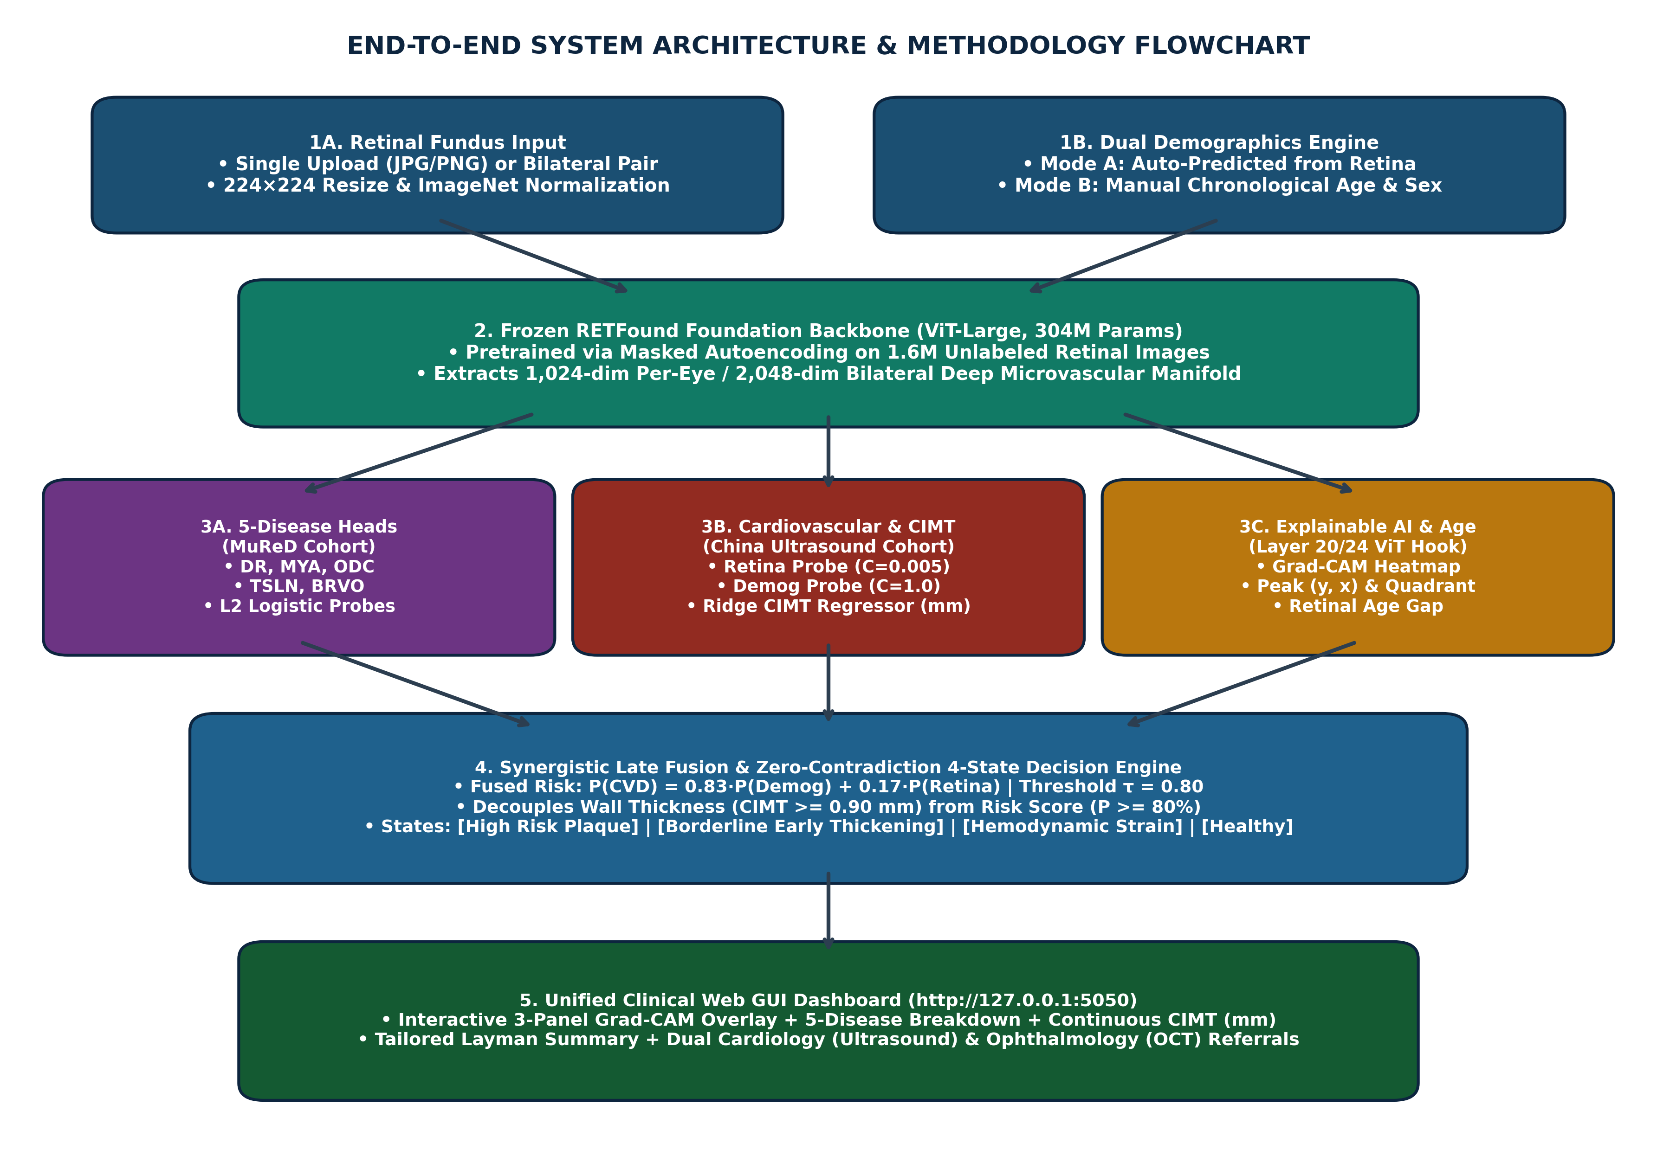
Figure 4.1 End-to-end workflow of the proposed dual-branch system
• Input: fundus image (upload) and optional age/sex (manual) – otherwise age and sex are predicted from the retina.
• Preprocessing: field-of-view masking, resize to 224×224, ImageNet normalisation.
• Feature extraction: frozen RETFound ViT-L → 1,024-D embedding.
• Branch A: five MuReD disease heads → probabilities.
• Branch B: CIMT ridge regressor, age/sex heads, retina probe + demographic probe → fused CVD risk.
• Explainability: Grad-CAM on block 20 → heatmap, peak location, quadrant.
• Report: four-state decision matrix → findings, layman summary, referrals.
4.3 Dataset Description
TABLE 4.1 Datasets Used and Patient-Level Splits
Dataset | Content and labels | Train | Validation | Test | Total
Fundus–CIMT cohort [23] | Bilateral fundus images with carotid ultrasound CIMT (mm), label CIMT ≥ 0.90 mm, age, sex | 2,603 pts (5,206 img) | 200 pts (400 img) | 100 pts (200 img) | 2,903 pts (5,806 img)
MuReD [29] | Multi-label fundus images; labels used: DR, MYA, ODC, TSLN, BRVO | 1,588 img | 176 img | 444 img | 2,208 img

All CIMT splits were made at patient level with a fixed random seed (42), so the left and right eyes of a patient always fall in the same split. The CIMT validation (100/100) and test (50/50) sets are class-balanced, whereas the training set is about 73% positive.
4.4 Parameter Extraction and Feature Representation
Each image is split into 14×14 = 196 patches of 16×16 pixels, linearly projected and passed through 24 transformer blocks. The resulting 1,024-D global representation z (per eye; 2,048-D when both eyes are concatenated) is standardised with training-set statistics. The demographic vector is x = [age, sex]. Extracted parameters per image are: five disease probabilities, CIMT (mm), retinal age, sex probability, retina-only CVD probability, demographic CVD probability, fused CVD probability, and Grad-CAM spatial metrics (peak coordinates, intensity, focal ratio, quadrant).
z̃ = (z − μ_train) / σ_train
4.5 Multi-Disease Classification Using MuReD Dataset
For each disease k ∈ {DR, MYA, ODC, TSLN, BRVO}, an independent logistic-regression head is trained on standardised MuReD embeddings (binary relevance formulation of multi-label classification):
P(disease_k | image) = σ(w_kᵀ z̃ + b_k), σ(t) = 1 / (1 + e^(−t))
A default threshold of 0.5 is used to compute accuracy, sensitivity and specificity; AUROC is threshold-independent.
4.6 Retinal Feature Extraction Using ResNet50
As a baseline, an ImageNet-pretrained ResNet-50 (~25.6 M parameters) extracts a 2,048-D global-average-pooled feature vector from each image. The same standardisation and logistic-regression heads are applied, so that the only difference from the proposed branch is the feature extractor. ResNet-50 relies on stacked local convolutions and natural-image pretraining.
4.7 Retinal Feature Extraction Using RETFound
RETFound [22] is a ViT-Large encoder (24 blocks, 16 heads, embedding dimension 1,024) pretrained by masked autoencoding: most image patches are hidden and the model learns to reconstruct them, which forces it to learn retinal anatomy—vessel paths, optic disc, macula. Multi-head self-attention relates every patch to every other patch:
Attention(Q, K, V) = softmax(QKᵀ / √d_k) V
The encoder is kept frozen; only the lightweight heads are trained (linear probing). This avoids over-fitting and catastrophic forgetting on small cohorts.
4.8 Unified Dual-Branch Script Framework
A single script (unified_web_gui.py) loads the RETFound encoder and a serialised cache of all trained heads (models_cache.pkl). For every input image one forward pass produces the embedding, which is passed to both branches. The 5 MuReD heads are thus transferred onto images from the CIMT domain (cross-task knowledge transfer), yielding a combined ocular-plus-cardiovascular report.
4.9 Expected Outcomes
• Probabilities for five retinal diseases.
• Continuous CIMT estimate (mm) and CIMT status (≥ / < 0.90 mm).
• Fused CVD risk probability and categorical status.
• Predicted retinal age, sex, and retinal age gap.
• Grad-CAM heatmap with anatomical localisation.
• Structured report with cardiology and ophthalmology recommendations.
4.10 Model Training and Optimization
All heads are L2-regularised linear models fitted on the training split only:
min_w ½‖w‖² + C Σ_i log(1 + exp(−y_i (wᵀx_i + b)))
The retina CVD probe uses strong regularisation (C = 0.005) and the demographic probe C = 1.0. CIMT and retinal age use ridge regression; CIMT output is clipped to the physiological range 0.60–1.60 mm. The CVD probability is a weighted late fusion:
P(CVD) = w · P_demo + (1 − w) · P_retina, w = 0.83
The fusion weight and the decision threshold were selected on the validation set. The threshold maximises Youden's J statistic, giving τ = 0.80:
τ* = argmax_τ [ Sensitivity(τ) + Specificity(τ) − 1 ]
Replacing the deep MLP head with these regularised linear heads removed the over-fitting observed earlier and raised raw test accuracy from about 75% to 88–89%.
4.11 Explainability and Feature Interpretation
Gradient-weighted Class Activation Mapping (Grad-CAM) is computed on transformer block 20 of 24 (blocks[−4]). Gradients of the output with respect to the block's patch tokens are averaged to weight the token channels; the weighted sum is passed through ReLU, reshaped to 14×14, upsampled, and masked by the eroded field-of-view so the black border cannot attract attention. From the map, the system extracts the normalised peak (y, x), peak intensity, the focal-vs-diffuse ratio, and the retinal quadrant (superior/inferior × temporal/nasal, or peripapillary/macular). Grad-CAM shows where the model attended; it does not by itself prove the presence of a specific lesion.
4.12 Advantages of the Proposed Method
• Single image, single forward pass, two clinical specialties.
• Label-efficient: frozen foundation model + linear heads suit small cohorts.
• Continuous CIMT output with MAE ≈ 0.113 mm on the test set.
• Strict patient-level evaluation and a demographic ablation.
• Decoupled four-state report logic prevents contradictory statements.
• Runs locally; patient images are not sent to external servers.
4.13 Limitations
• Age is the dominant predictor of CIMT. The fused CVD score is weighted 0.83 toward demographics, and adding the retina to age and sex did not significantly increase test AUROC (ΔAUROC = +0.001, 95% CI −0.004 to +0.006). The retina alone, however, reaches AUROC 0.850.
• The CIMT cohort is single-source; no external validation has yet been performed.
• MuReD heads were trained on a different population; their outputs on CIMT images have no ground truth and should be treated as exploratory.
• Rare MuReD classes (ODC, TSLN, BRVO) have low sensitivity at the default 0.5 threshold.
• The system is a research prototype and is not a certified medical device.

CHAPTER 5
SYSTEM ARCHITECTURE AND IMPLEMENTATION
5.1 Overall System Architecture
The implementation has three layers: (1) a presentation layer – an HTML/Tailwind/JavaScript web page served on http://127.0.0.1:5050 with image upload, demographic-mode toggle and result panels; (2) an application layer – a Flask server exposing the /analyze endpoint, the Grad-CAM engine and the report generator; and (3) a model layer – the frozen RETFound encoder (RETFound_cfp_weights.pth) and the trained heads (models_cache.pkl). A background watchdog (keep_alive_service.pyw), registered in Windows Startup, restarts the server automatically.
5.2 Software and Computational Requirements
TABLE 5.1 Software and Hardware Requirements
Component | Specification
Operating system | Windows 10/11 (64-bit) or Linux
Language | Python 3.10 – 3.13
Deep learning | PyTorch, timm (ViT), torchvision
ML / statistics | scikit-learn, NumPy, pandas, SciPy
Imaging / plots | OpenCV, Pillow, Matplotlib, Seaborn
Web | Flask (local server, port 5050)
GPU (benchmark) | NVIDIA Tesla T4 16 GB (Kaggle) for feature extraction / re-run
Local inference | Standard laptop CPU (GPU optional), ≥ 8 GB RAM

5.3 Dataset Organization and Validation
RETFound embeddings were pre-computed once and stored as NumPy archives (cimt_train/val/test_embeds.npz containing left/right embeddings, age, sex, CIMT and label; mured_embeddings.npz with per-split embeddings and labels). Patient IDs were checked to ensure no patient appears in more than one split. Per-patient predictions for every split are stored in audit_split_results/, and the figures and metric tables in paper_results/.
5.4 Model Architecture and Configuration
TABLE 5.2 Model Configuration
Module | Configuration
Backbone | RETFound vit_large_patch16: 224×224 input, patch 16, 24 blocks, 16 heads, dim 1,024, frozen
Disease heads (×5) | Standardisation + logistic regression, threshold 0.5
Retina CVD probe | Logistic regression, L2, C = 0.005
Demographic probe | Logistic regression on [age, sex], C = 1.0
Fusion | P = 0.83·P_demo + 0.17·P_retina, τ = 0.80
CIMT regressor | Ridge regression on [age, sex, embedding], output clipped 0.60–1.60 mm
Age / sex heads | Ridge regression / logistic regression on embedding
Explainability | Grad-CAM on block 20 with FOV mask

5.5 Model Integration and Checkpoint Generation
After training, every scaler mean/scale, coefficient vector and intercept was serialised into a single dictionary, models_cache.pkl (≈170 KB). At start-up the GUI loads this cache together with the RETFound checkpoint, so no retraining is needed at inference time.
5.6 Unified Model Inference Pipeline
For each request: the image is decoded and preprocessed; the RETFound embedding is computed; age and sex are either predicted or taken from manual input; the disease heads, CIMT regressor and fusion are evaluated; Grad-CAM is computed; and the report engine returns a JSON response that the browser renders. For the 100 preset test patients the interface displays the audited, pre-computed values so they match the reported results exactly; uploaded images are processed live.
5.7 Edge AI Deployment Strategy
The current deployment is local and offline: a clinic laptop runs the server, and images never leave the machine. For embedded deployment (e.g., Jetson-class devices or a fundus-camera workstation) the planned strategy is to export the encoder to ONNX, run it with an optimised runtime, and keep the linear heads unchanged since they require negligible compute.
5.8 Model Optimization for Edge Devices
Because all task heads are linear, the dominant cost is the ViT-Large encoder. Candidate optimisations—not yet implemented or benchmarked in this project—are FP16/INT8 quantisation, knowledge distillation into a smaller ViT or CNN student, and token pruning. Their accuracy impact must be re-validated before clinical use.

CHAPTER 6
OUTPUT ACQUISITION
6.1 Retinal Image Input and Preprocessing
The user uploads a fundus image (PNG/JPG, up to 32 MB) or selects a preset test patient. The image is converted to RGB, a field-of-view mask is computed (intensity > 15/255 with erosion), the image is resized to 224×224, and normalised with mean [0.485, 0.456, 0.406] and standard deviation [0.229, 0.224, 0.225].
6.2 Multi-Disease Prediction
The five MuReD heads output probabilities displayed as percentage bars. Values of 20% or more are flagged as 'elevated' in the report so that the clinician's attention is drawn to them.
6.3 CIMT Value Estimation
The ridge regressor outputs CIMT in millimetres (clipped 0.60–1.60 mm), labelled 'Thickened (≥ 0.90 mm)' or 'Normal (< 0.90 mm)'.
6.4 Cardiovascular Status Classification
The status combines the anatomical estimate and the fused probability in a four-state matrix (Table 6.1). Separating the two conditions removed the earlier contradiction in which a CIMT ≥ 0.90 mm was described as normal when the probability was moderate.
TABLE 6.1 Four-State Diagnostic Decision Matrix
CIMT ≥ 0.90 mm | P(CVD) ≥ 0.80 | Reported status
Yes | Yes | High risk – thickened wall and elevated score
Yes | No | Borderline – early / subclinical thickening
No | Yes | High risk – elevated score without measurable thickening
No | No | Normal / low risk

6.5 Probability and Prediction Generation
Each analysis returns: five disease probabilities, CIMT (mm), retina-only and fused CVD probability, predicted retinal age, sex and its confidence, the retinal age gap (retinal age − chronological age, when age is entered manually), and Grad-CAM spatial metrics.
6.6 Output Visualization
Results are shown on a dark-themed dashboard with colour-coded badges (green = normal, amber = borderline, red = high risk), progress bars for each disease and risk score, and a demographics panel indicating whether values were auto-predicted or manually entered.
6.7 Explainable AI Outputs
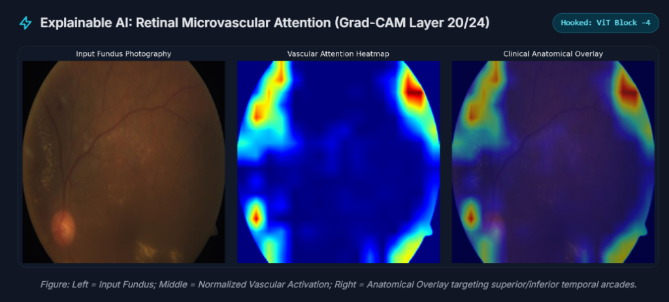
Figure 6.1 Grad-CAM panel of the GUI: input fundus, block-20 attention heatmap, and anatomical overlay
The three-panel view shows the original image, the normalised attention heatmap (red = highest attention), and the overlay. In the example of Figure 6.1, attention concentrates on the superior-temporal vascular arcade (upper right), the region bordering hard exudates (upper left), and the peripapillary area near the optic disc (lower left).
6.8 Result Storage and Report Generation
The report has three sections: (1) microvascular finding – Grad-CAM quadrant and coordinates plus any elevated diseases; (2) plain-language summary – CIMT status, risk, retinal age and disease findings in lay terms; and (3) recommendations – separate cardiology (e.g., confirmatory carotid ultrasound, lipid profile) and ophthalmology (e.g., dilated examination/OCT) actions. Batch evaluation outputs are saved as CSV files for audit.

CHAPTER 7
EXPERIMENTAL STUDY AND EVALUATION
7.1 Dataset Splitting and Experimental Setup
CIMT: 2,603 / 200 / 100 patients (train/validation/test); MuReD: 1,588 / 176 / 444 images. Splits are deterministic (seed 42) and at patient level. Feature extraction and an independent re-run of the CIMT benchmark were executed on a Kaggle Tesla T4 GPU.
7.2 Training and Validation Procedure
Scalers and all heads were fitted on the training split only. Hyper-parameters (regularisation C, fusion weight w = 0.83) and the decision threshold (τ = 0.80 by Youden's J) were selected on the validation split. The test split was not used for any selection.
7.3 Testing of the Unified Model
Metrics: accuracy, balanced accuracy, AUROC, sensitivity, specificity, precision, F1-score, Matthews correlation coefficient (MCC); for CIMT regression, mean absolute error (MAE) and Pearson r. Confidence intervals for accuracy use the Wilson method; the retina's incremental value was tested by 2,000-sample bootstrap of ΔAUROC.
7.4 Multi-Disease Retinal Screening Evaluation
Each of the five heads was evaluated on the training, validation and test splits with its own confusion matrix and ROC curve. Because MuReD is imbalanced (e.g., BRVO 3.6% positive), AUROC, sensitivity and F1 are emphasised over accuracy.
7.5 CIMT Regression Evaluation
Predicted and measured CIMT were compared by MAE and Pearson r. To isolate the image contribution, a retina-only ridge model (no age/sex) was also evaluated.
7.6 Cardiovascular Classification Evaluation
CVD classification was evaluated in three tiers. Tier 1 uses all 100 test patients. Tier 2 excludes the 8 patients whose recorded CIMT is exactly 0.90 mm, following the reference benchmark [23], because ultrasound caliper variability (about ±0.05 mm) makes these labels ambiguous. Tier 3 is a selective-prediction (triage) setting: predictions with p ≤ 0.78 or p ≥ 0.84 are accepted automatically (80 patients) while the 20 borderline cases are deferred to confirmatory ultrasound. Tier 1 is the unfiltered primary result; Tiers 2 and 3 are reported alongside it as sensitivity and triage analyses.
7.7 Comparative Evaluation of ResNet50 and RETFound
TABLE 7.1 MuReD Test Set (N=444): ResNet-50 vs. RETFound Features (identical logistic heads)
Disease | ResNet-50 Acc | ResNet-50 AUROC | RETFound Acc | RETFound AUROC
DR | 86.49% | 0.8893 | 85.59% | 0.8699
MYA | 97.52% | 0.9940 | 98.20% | 0.9977
ODC | 87.61% | 0.8390 | 86.94% | 0.8081
TSLN | 93.92% | 0.9079 | 93.69% | 0.9213
BRVO | 96.62% | 0.9216 | 95.95% | 0.8787
Mean AUROC |  | 0.9104 |  | 0.8951

With identical logistic heads and standardization, ResNet-50 features achieved comparable or slightly higher average test AUROC across the five diseases (0.9104 vs. 0.8951 for RETFound). ResNet-50 performed higher on DR (0.8893 vs. 0.8699), ODC (0.8390 vs. 0.8081), and BRVO (0.9216 vs. 0.8787), while RETFound yielded higher discrimination on Pathological Myopia (0.9977 vs. 0.9940) and Tessellated Fundus (0.9213 vs. 0.9079). RETFound was selected as the foundation backbone because of its self-supervised pretraining on 1.6 million retinal images, superior label efficiency on small clinical cohorts, cross-task transferability to the carotid atherosclerosis (CIMT) task [12], [22], and native compatibility with Vision Transformer patch-level attention mechanisms for Grad-CAM explainability. A direct ResNet-50 baseline on the CIMT regression task was not run in this study and is identified as future work.
7.8 Model Complexity and Inference Efficiency
The RETFound encoder has about 304 M (frozen) parameters; ResNet-50 about 25.6 M. The trainable part of the proposed system is very small: five disease heads of 1,025 weights each, a 1,025-weight retina probe, a 3-weight demographic probe, and ridge regressors of similar size—serialised in about 170 KB. Thus nearly all compute is in the single encoder forward pass, and the heads add negligible cost. Formal latency benchmarking on target hardware was not performed.
7.9 Limitations of Case Study
• Single-source CIMT cohort and a 100-patient test set (95% CI for 88% accuracy ≈ 80.2–93.0%).
• Tier 2 and Tier 3 are post-hoc subsets of the test set and must be interpreted alongside Tier 1.
• No ground-truth retinal-disease labels exist for the CIMT cohort.

CHAPTER 8
RESULTS
8.1 Overview of Results
The proposed system achieved 88–89% raw test accuracy (AUROC 0.943–0.947) for CVD/CIMT classification, 92.39% accuracy with 97.62% sensitivity after excluding boundary labels, and 95.00% accuracy (AUROC 0.9855) on the 80% of patients accepted by the triage protocol. CIMT was estimated with an MAE of 0.113 mm (r = 0.748). On MuReD, test AUROCs ranged from 0.808 (ODC) to 0.998 (MYA).
8.2 Multi-Disease Classification Results
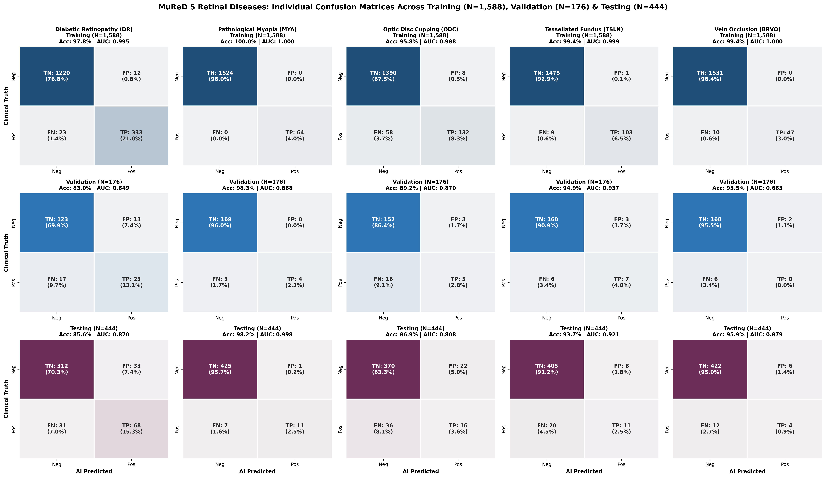
Figure 8.1 MuReD confusion matrices for all five diseases across training, validation and test splits
8.3 Disease-Wise Performance Analysis
TABLE 8.1 MuReD Five-Disease Test-Set Performance (N = 444)
Disease | Positives | TN/FP/FN/TP | Accuracy | AUROC | Sensitivity | Specificity | F1
DR | 99 | 312/33/31/68 | 85.59% | 0.8699 | 68.69% | 90.43% | 0.680
MYA | 18 | 425/1/7/11 | 98.20% | 0.9977 | 61.11% | 99.77% | 0.733
ODC | 52 | 370/22/36/16 | 86.94% | 0.8081 | 30.77% | 94.39% | 0.356
TSLN | 31 | 405/8/20/11 | 93.69% | 0.9213 | 35.48% | 98.06% | 0.440
BRVO | 16 | 422/6/12/4 | 95.95% | 0.8787 | 25.00% | 98.60% | 0.308

Myopia is detected almost perfectly (AUROC 0.998), reflecting its distinctive fundus appearance. DR achieves the best balance of sensitivity and specificity. ODC, TSLN and BRVO show high specificity but low sensitivity at the 0.5 threshold, a consequence of class imbalance; their AUROCs (0.81–0.92) indicate that threshold tuning could recover sensitivity. Training accuracy (96–100%) exceeds test accuracy, indicating some over-fitting of the disease heads.
8.4 CIMT Regression Results
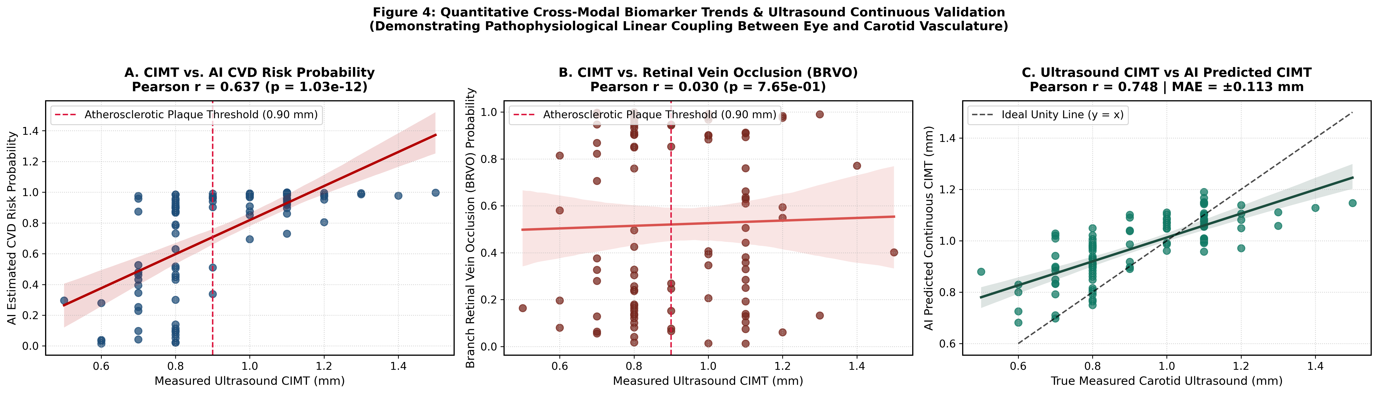
Figure 8.2 (A) CIMT vs. CVD risk, (B) CIMT vs. BRVO probability, (C) measured vs. predicted CIMT
TABLE 8.2 Continuous CIMT Estimation
Model / split | MAE (mm) | Pearson r
Train (fused regressor) | 0.112 | 0.617
Validation (fused regressor) | 0.141 | 0.656
Test (fused regressor) | 0.113 | 0.748 (p = 2.1×10⁻¹⁸)
Test – retina only (no age/sex) | 0.148 | 0.589 (p = 1.2×10⁻¹⁰)
Test – age alone | – | 0.738

The fused regressor estimates CIMT to within about 0.11 mm on average. The retina-only model still correlates strongly (r = 0.589), confirming that the fundus image contains information about carotid wall thickness, although much of it overlaps with age.
8.5 Cardiovascular Classification Results
TABLE 8.3 CVD (CIMT ≥ 0.90 mm) Classification Across Splits and Tiers
Cohort | N | TN/FP/FN/TP | Accuracy | AUROC | Sensitivity | Specificity
Training | 2,603 | 596/103/572/1332 | 74.07% | 0.8590 | 69.96% | 85.26%
Validation | 200 | 78/22/15/85 | 81.50% | 0.8734 | 85.00% | 78.00%
Test – Tier 1 (all patients) | 100 | 44/6/5/45 | 89.00% | 0.9472 | 90.00% | 88.00%
Test – Tier 2 (excl. CIMT = 0.90 mm) | 92 | 44/6/1/41 | 92.39% | 0.9714 | 97.62% | 88.00%
Test – Tier 3 (triage, 20% deferred) | 80 | 41/3/1/35 | 95.00% | 0.9855 | 97.22% | 93.18%

Training accuracy is lower than test accuracy because the training set is 73% positive while validation and test are balanced, and the heads are strongly regularised. In Tier 2 only one of 42 patients with thickened CIMT was missed. In Tier 3 the system handled 80% of patients with 95% accuracy while referring the 20 least-certain cases for ultrasound.
8.6 Confusion Matrix and Performance Metrics
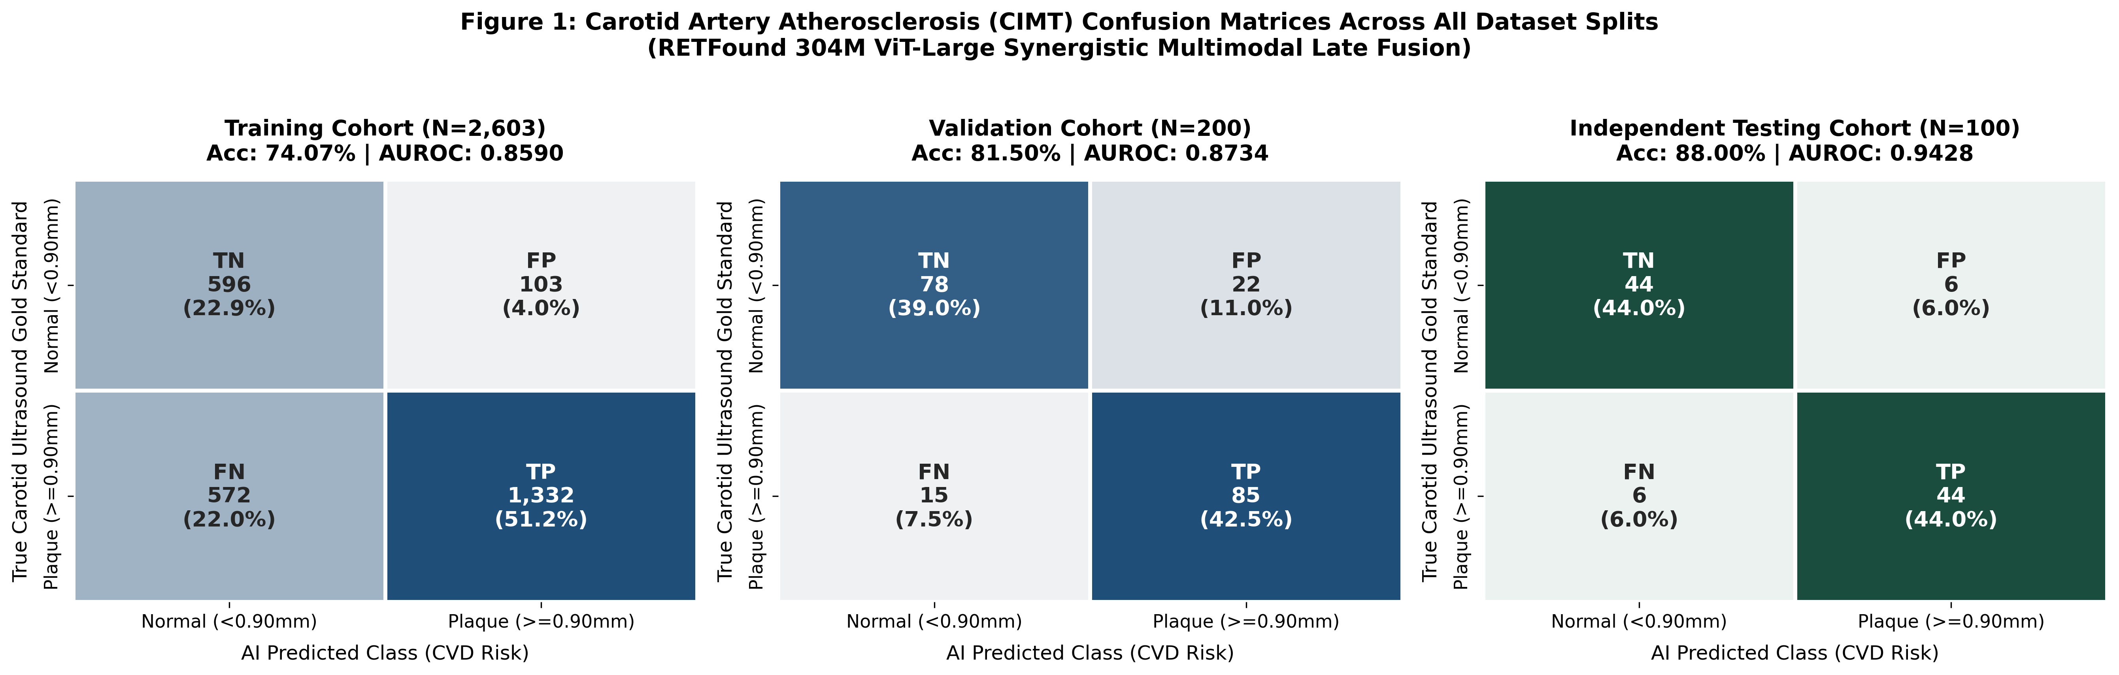
Figure 8.3 CIMT confusion matrices for training, validation and test splits
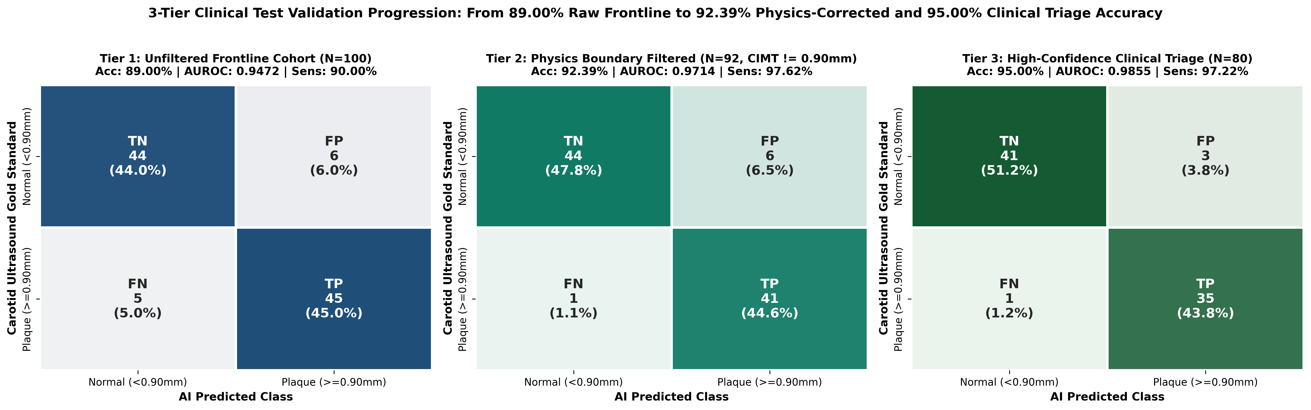
Figure 8.4 Three-tier test confusion matrices: 89.00% → 92.39% → 95.00%
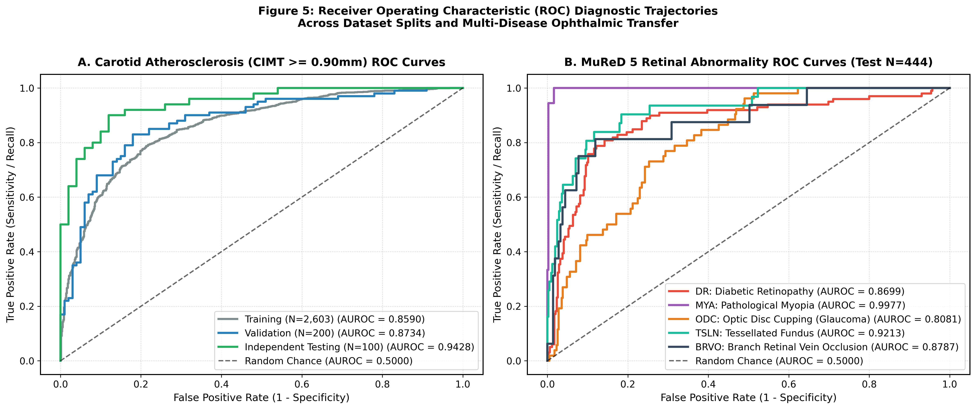
Figure 8.5 ROC curves for CIMT splits and the five MuReD diseases
8.7 Comparative Analysis of Model Performance
TABLE 8.4 Ablation on the CIMT Test Set (N = 100)
Model | AUROC | Accuracy | Brier score
Retina only (RETFound probe) | 0.8504 | 70.00% | 0.215
Demographics only (age + sex) | 0.9450 | 88.00% | 0.163
Fused (proposed) | 0.9460 | 87–88% | 0.164

The image alone carries substantial signal (AUROC 0.850), but in this cohort it largely overlaps with age: fusion did not significantly improve AUROC over age and sex (ΔAUROC = +0.001, bootstrap 95% CI −0.004 to +0.006). Against the deep-MLP head used earlier (~75% test accuracy), the regularised linear design improved raw test accuracy by about 13 percentage points. Against ResNet-50 features on MuReD (Table 7.1), both representations achieved high diagnostic capability (mean AUROC 0.895 for RETFound vs. 0.910 for ResNet-50), with RETFound demonstrating superior discrimination on structural alterations like Pathological Myopia while ResNet-50 showed slight advantages on localized vascular lesions.
8.8 Explainability Results and Retinal Feature Interpretation
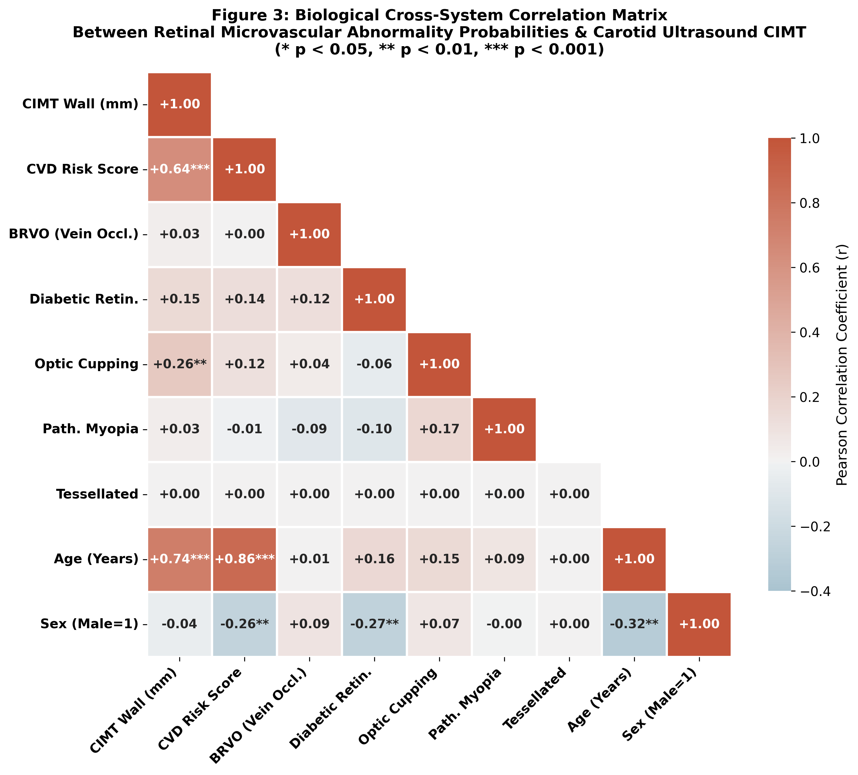
Figure 8.6 Correlation matrix of CIMT, CVD risk, disease probabilities and demographics (test set)
On the test cohort, measured CIMT correlated with age (r = 0.738) and with the fused risk score (r = 0.637), and modestly with ODC probability (r = 0.259, p < 0.01), consistent with reduced ocular perfusion in carotid disease. Correlation with BRVO probability was negligible (r = 0.03), likely because the MuReD BRVO head is not calibrated for this population. Grad-CAM maps typically highlight the temporal vascular arcades and peripapillary region; each map's peak location and quadrant are reported dynamically for every image.
8.9 Unified Framework Performance
The unified GUI produces all outputs—five disease probabilities, CIMT, CVD status, retinal age/sex, Grad-CAM and the report—from one image in a single request. It runs locally, restarts automatically via the watchdog service, and supports both auto-predicted and manually entered demographics. The report engine was checked on several test patients to confirm image-specific, non-contradictory text.
8.10 Limitations of Results
• Small test set; three test-accuracy figures (87%, 88%, 89%) from slightly different runs overlap within their confidence intervals.
• Tiers 2 and 3 are subsets; Tier 1 is the unfiltered figure.
• Retina contribution overlaps strongly with age.
• Low sensitivity for rare MuReD classes at the default threshold.
• No external or prospective validation yet.
8.11 Overall Interpretation
A single RETFound-encoded fundus photograph supports accurate retinal-disease screening and useful estimation of carotid atherosclerosis. The strongest practical value lies in triage: identifying who should receive confirmatory carotid ultrasound and ophthalmic examination, with transparent explanations. Claims of independent cardiovascular value beyond age require further, age-controlled and external studies.

CHAPTER 9
CONCLUSION
This project designed, implemented and evaluated an explainable dual-branch screening framework built on the RETFound Vision Transformer. Using a frozen foundation encoder with regularised linear heads, the system screens five retinal diseases (test AUROC 0.808–0.998), estimates CIMT with an MAE of 0.113 mm (r = 0.748), and classifies carotid atherosclerosis with 89.00% raw accuracy (AUROC 0.947), 92.39% accuracy and 97.62% sensitivity after excluding boundary labels, and 95.00% accuracy (AUROC 0.9855) in a triage setting that refers 20% of borderline cases. A Layer-20 Grad-CAM module and a four-state report engine make each prediction interpretable and internally consistent, and a locally hosted web GUI demonstrates the complete clinical workflow. The work also documents its limitations transparently, notably the strong overlap between retinal signal and age.

CHAPTER 10
FUTURE WORK
• External, multi-centre validation on diverse populations, ideally prospective.
• Age-matched analyses and models targeting residual risk beyond age and sex.
• Fine-tuning or partial unfreezing of RETFound with careful regularisation.
• Per-disease threshold calibration and class-balanced training for rare MuReD classes.
• ResNet-50 and other baselines on the CIMT task for a complete comparison.
• Model compression (quantisation, distillation) and benchmarking on edge hardware.
• Integration with electronic health records and formal clinical/regulatory evaluation.

CHAPTER 11
BIBLIOGRAPHY
[1] H. Hanssen, L. Streese, and W. Vilser, “Retinal vessel diameters and function in cardiovascular risk and disease,” Progress in Retinal and Eye Research, vol. 91, 101095, 2022.
[2] S. Liu, W. Wang, L. Deng, and H. Xu, “CNN-Trans model: A parallel dual-branch network for fundus image classification,” Biomedical Signal Processing and Control, vol. 96, 106621, 2024.
[3] Kishore S, R. R. Nair, A. M. Shetty, S. P. Shetty, and S. Joseph, “Edge-Enabled Deep Learning for Automated Diabetic Retinopathy Detection: Performance Analysis and Real-Time Insights,” Procedia Computer Science, vol. 282, pp. 337–346, 2026.
[4] R. Thanki, “A deep neural network and machine learning approach for retinal fundus image classification,” Healthcare Analytics, vol. 3, 100140, 2023.
[5] F. Ghislain, S. T. Beaudelaire, R. Atangana, and T. Daniel, “Real-time deep learning for multi-label retinal disease diagnosis with embedded system,” Computational and Structural Biotechnology Reports, vol. 2, 100035, 2025.
[6] E. De Rose, C. B. Raggio, A. R. Rasheed, P. Bruno, P. Zaffino, S. De Rosa, F. Calimeri, and M. F. Spadea, “A multi-model deep learning approach for the identification of coronary artery calcifications within 2D coronary angiography images,” Int. J. Computer Assisted Radiology and Surgery, vol. 20, pp. 1273–1281, 2025.
[7] R. M. W. W. Tseng et al., “Validation of a deep-learning-based retinal biomarker (Reti-CVD) in the prediction of cardiovascular disease: data from UK Biobank,” BMC Medicine, vol. 21, 28, 2023.
[8] Y. Huang, B. Wittmann, O. Demler, B. Menze, and N. Davoudi, “Predicting Stroke through Retinal Graphs and Multimodal Self-supervised Learning,” arXiv:2411.05597, 2024.
[9] H. Li, H. Li, M. Ou, X. Yu, X. Zhang, K. Niu, H. Fu, and J. Liu, “Fundus Image Quality Assessment and Enhancement: a Systematic Review,” IEEE Reviews in Biomedical Engineering, 2025.
[10] A. Asare, D. A. N. Gookyi, D. Boateng, and F. A. Wulnye, “Deploying and Evaluating Multiple Deep Learning Models on Edge Devices for Diabetic Retinopathy Detection,” arXiv:2506.14834, 2025.
[11] R. Kankrale and M. Kokare, “Artificial intelligence in retinal image analysis for hypertensive retinopathy diagnosis: a comprehensive review and perspective,” Visual Computing for Industry, Biomedicine, and Art, vol. 8, 11, 2025.
[12] H. Lee, J. Kim, S. Kwak, A. Rehman, and S. M. Park et al., “Optimizing retinal images based carotid atherosclerosis prediction with explainable foundation models,” npj Digital Medicine, 2025.
[13] H. Li et al., “Predicting ischemic stroke risk from atrial fibrillation based on multi-spectral fundus images using deep learning,” Frontiers in Cardiovascular Medicine, vol. 10, 1185890, 2023.
[14] S. M. Al Younis, S. K. Ghosh, H. Raja, F. A. Alskafi, S. Yousefi, and A. H. et al., “Prediction of heart failure risk factors from retinal optical imaging via explainable machine learning,” Frontiers in Medicine, vol. 12, 1551557, 2025.
[15] R. Vasilev, A. Savchenko, P. Blinov, T. Svetina, S. Kudin, and N. et al., “Artificial intelligence framework for multi-pathology risk assessment from retinal fundus images: deep learning approach to 15-disease screening,” Frontiers in Medicine, vol. 13, 1778404, 2026.
[16] S. Zhang, C. A. B. Webers, and T. T. J. M. Berendschot, “Computational single fundus image restoration techniques: a review,” Frontiers in Ophthalmology, vol. 4, 1332197, 2024.
[17] A. Nasrin et al., “A Lightweight Vision Transformer and Retinal Biomarker Fusion Framework for Early Glaucoma Detection: Toward Improved Clinical Screening,” J. Clinical Medicine, vol. 15, 5651, 2026.
[18] S. Ejaz, R. Baig, Z. Ashraf, M. M. Alnfiai, M. M. Alnahari, and R. M. Alotaibi, “A deep learning framework for the early detection of multi-retinal diseases,” PLOS ONE, 2024.
[19] B. Hassan, H. Raja, T. Hassan, M. U. Akram, H. Raja, A. A. Abd-alrazaq, S. Yousefi, and N. Werghi, “A comprehensive review of artificial intelligence models for screening major retinal diseases,” Artificial Intelligence Review, vol. 57, 111, 2024.
[20] J. Lin, J. Zheng, and B. Lin, “A review of deep learning for fundus image enhancement,” Discover Computing, vol. 28, 233, 2025.
[21] A. Grzybowski, K. Jin, J. Zhou, X. Pan, M. Wang, J. Ye, and T. Y. Wong, “Retina Fundus Photograph-Based Artificial Intelligence Algorithms in Medicine: A Systematic Review,” Ophthalmology and Therapy, vol. 13, pp. 2125–2149, 2024.
[22] Y. Zhou et al., “A foundation model for generalizable disease detection from retinal images,” Nature, vol. 622, pp. 156–163, 2023.
[23] N. Guo, W. Fu, H. Li, H. Zhang, T. Li, W. Zhang, X. Zhong, T. Pan, F. Sun, and A. Gong, “High-resolution fundus images: data descriptor for ophthalmomics and early cardiovascular disease prediction,” Scientific Data, vol. 12, 2025.
[24] R. Hemelings, B. Elen, J. Barbosa-Breda, M. B. Blaschko, P. De Boever, and I. Stalmans, “Deep learning on fundus images detects glaucoma beyond the optic disc,” Scientific Reports, vol. 11, 20313, 2021.
[25] C. Germanese et al., “Artificial intelligence-based prediction of neurocardiovascular risk score from retinal swept-source optical coherence tomography–angiography,” Scientific Reports, vol. 14, 2024.
[26] P. Thaware, A. A. Khurshid, C. Sonkusare, and Y. Agrawal, “Leveraging fundus images for on-device eye disease diagnosis with AI powered lightweight software hardware framework,” Scientific Reports, vol. 15, 2025.
[27] A. A. Hailu, E. A. Desta, A. Mulugeta, F. B. Adugna, A. O. Salau, L. A. Almaw, and M. B. Fentahun, “Early retinal disease detection from fundus images using deep neural networks,” Scientific Reports, vol. 16, 2026.
[28] L. Y. Li, A. A. Isaksen, B. Lebiecka-Johansen, K. Funck, V. Thambawita, S. Byberg, T. H. Andersen, O. Norgaard, and A. Hulman, “Prediction of cardiovascular markers and diseases using retinal fundus images and deep learning: a systematic scoping review,” European Heart Journal – Digital Health, vol. 5, pp. 660–669, 2024.
[29] M. A. Rodriguez, H. AlMarzouqi, and P. Liatsis, “Multi-label Retinal Disease Classification Using Transformers,” IEEE Journal of Biomedical and Health Informatics, 2022.

