NON-INVASIVE CARDIOVASCULAR RISK (CIMT) QUANTIFICATION AND MULTI-DISEASE OPHTHALMIC SCREENING USING RETFOUND VISION TRANSFORMER AND EXPLAINABLE MULTIMODAL AI
Complete Thesis / Technical Report (Chapters 1 to 11)
________________________________________________________________________________

1. Introduction
Cardiovascular Disease (CVD) and vision-threatening retinal pathologies represent two of the most critical public health burdens worldwide. Because the human retina is the only anatomical structure where living arterioles, venules, and capillary beds can be directly visualized non-invasively, color fundus photography offers a unique window into both ocular health and systemic vascular remodeling.

1.1 Problem Statement
Subclinical atherosclerosis is clinically diagnosed by measuring Carotid Intima-Media Thickness (CIMT) via high-frequency B-mode neck ultrasonography, where a wall thickness of CIMT >= 0.90 mm indicates arterial plaque buildup and elevated risk of stroke or myocardial infarction. However, carotid ultrasound requires expensive imaging hardware ($30,000–$80,000+) and specialized vascular sonographers, rendering population-wide screening infeasible in primary care and rural clinics. Simultaneously, existing deep learning approaches using conventional Convolutional Neural Networks (such as ResNet-50 pretrained on ImageNet) treat ophthalmic disease detection and cardiovascular screening as isolated tasks, suffer from small-sample overfitting (stalling around 75% accuracy), fail to predict continuous millimeter CIMT thickness, and lack anatomical explainability.

1.2 Objective
The core objectives of this project are:
1. To leverage the self-supervised RETFound Vision Transformer (ViT-Large, 304M parameters, pretrained on 1.6 million retinal images) for extracting high-fidelity 1,024-D (per-eye) / 2,048-D (bilateral) microvascular feature representations.
2. To develop a Multi-Disease Ophthalmic Screening branch trained on the MuReD cohort capable of simultaneously detecting five major retinal pathologies: Diabetic Retinopathy (DR), Pathological Myopia (MYA), Optic Disc Cupping / Glaucoma (ODC), Tessellated Fundus (TSLN), and Branch Retinal Vein Occlusion (BRVO).
3. To engineer a Synergistic Multimodal Late-Fusion and Ridge Regression branch trained on the 2,903-patient China Fundus–CIMT Ultrasound cohort to estimate continuous CIMT wall thickness (in mm), Biological Retinal Age Gap, and binary CVD plaque risk—achieving 89.00% raw frontline accuracy, 92.39% physics-corrected accuracy (97.62% sensitivity), and 95.00% high-confidence clinical triage accuracy (AUROC 0.9855).
4. To deploy a portable, permanent clinical Web GUI (http://127.0.0.1:5050) featuring Layer 20/24 ViT Grad-CAM vascular localization and a zero-contradiction 4-state diagnostic report generator.

2. Literature Survey

2.1 Related Papers

2.1.1 High-Resolution Fundus Images for Ophthalmics (Budai et al. / MuReD Benchmark)
Introduced standardized high-resolution multi-disease fundus benchmarks demonstrating that microvascular lesions (microaneurysms, hemorrhages, optic cup enlargement) require high spatial resolution and multi-label learning rather than single-disease binary classifiers.

2.1.2 A Foundation Model for Generalizable Disease Detection from Retinal Images — RETFound (Zhou et al., Nature 2023)
Developed RETFound using Masked Autoencoding (MAE) on 1.6 million unlabeled color fundus and OCT images. Demonstrated superior label efficiency and generalizability for both ocular diseases and systemic 3-year cardiovascular events (myocardial infarction, heart failure, ischemic stroke).

2.1.3 Key ResNet-50 Components for Diabetic Retinopathy Grading (He et al. / Gulshan et al., JAMA)
Applied residual convolutional neural networks (ResNet-50) with skip connections for automated DR screening. While effective on large labeled datasets (>100,000 images), ResNet-50 relies on local 7x7 receptive fields and ImageNet natural-image priors, limiting transferability to subtle vascular wall measurements.

2.1.4 AI Framework for Multi-Pathology Risk Assessment in Retinal Fundus Photography (Cen et al., Nature Communications)
Proposed multi-label deep learning across 39 fundus conditions, highlighting that co-existing pathologies (such as tessellation, myopia, and venous occlusion) frequently overlap in aging patients.

2.1.5 Multimodal Deep Learning of Fundus Abnormalities for Cardiovascular Risk Prediction (Poplin et al., Nature Biomedical Engineering)
Pioneered deep learning prediction of cardiovascular risk factors (age, biological sex, systolic blood pressure, smoking status, and major adverse cardiac events) directly from retinal fundus photographs using attention maps over the vascular arcades.

2.1.6 A Siamese ResNeXt Network for Predicting Carotid Intima-Media Thickness (China Fundus–CIMT Cohort Study)
Formulated bilateral fundus screening for carotid atherosclerosis (CIMT >= 0.90 mm) on 2,903 patients paired with B-mode carotid ultrasound, establishing the clinical benchmark and highlighting acoustic caliper boundary ambiguity around 0.90 mm.

2.1.7 Retinal Vascular Caliber and Risk of Coronary Heart Disease and Stroke (Wong et al., NEJM / Lancet)
Established the epidemiological and pathophysiological link between retinal arteriolar narrowing, arteriovenous (AV) nicking, and carotid artery intima-media thickening.

2.1.8 Retinal Age Gap as a Predictive Biomarker for Mortality and Arterial Stiffness (Zhu et al., British Journal of Ophthalmology)
Demonstrated that the discrepancy between AI-predicted biological retinal age and chronological age (Retinal Age Gap) independently predicts arterial stiffness and incident cardiovascular disease.

2.1.9 Transformer Interpretability Beyond Attention Visualization (Chefer et al., CVPR)
Introduced gradient-weighted attention attribution (Grad-CAM / Relevance Propagation for Vision Transformers) to localize class-specific semantic regions in multi-head self-attention blocks.

2.1.10 Selective Classification with a Rejection Option in Clinical AI (Geifman & El-Yaniv, NeurIPS)
Formalized high-confidence clinical triage protocols where decisive AI predictions are automated while ambiguous borderline probabilities near the decision threshold are deferred to specialist diagnostic imaging.

2.2 Comparative Analysis of Research Work
Author / Study | Architecture Used | Target Task | Key Limitation Solved by Our Work
Gulshan et al. (JAMA) | Inception-v3 / ResNet-50 | Single-task DR grading | Lacks multi-disease & cardiovascular CIMT prediction
Poplin et al. (Nat. Biomed. Eng.) | CNN (Inception) | Age, Sex, SBP, MACE risk | Does not predict ultrasound CIMT (mm) or 5 eye diseases
China CIMT Baseline | Siamese ResNeXt | Binary CIMT (>= 0.90 mm) | CNN local receptive field; no continuous mm or 5-disease heads
Zhou et al. (Nature 2023) | RETFound ViT-Large | Single-cohort fine-tuning | Unregularized MLP heads overfit (75% stall) on small CIMT splits
Proposed Unified System | RETFound ViT-L + L2 Late Fusion + Ridge | 5 Eye Diseases + Continuous CIMT (mm) + CVD Risk + Age Gap + XAI | Achieves 89.0% Raw / 92.39% Physics / 95.00% Triage Accuracy + Live GUI

2.3 Summary
The literature survey confirms that while retinal microvessels mirror carotid atherosclerosis, prior systems either rely on ImageNet CNNs with limited receptive fields or evaluate ocular and cardiovascular endpoints in isolation. Combining RETFound's self-supervised retinal representations with maximum-margin multimodal fusion bridges this gap.

3. Motivation

3.1 Background and Need for the Study
Over 50% of first-time strokes and heart attacks occur in individuals who were previously asymptomatic. Early detection of subclinical carotid plaque (CIMT >= 0.90 mm) enables preventive statin and antihypertensive therapy years before a catastrophic event.

3.2 Challenges in Existing Screening Methods
1. High hardware and specialist cost of B-mode Carotid Doppler Ultrasonography.
2. Acoustic transducer resolution variance (±0.05 mm) near the 0.90 mm cutoff.
3. Siloed clinical workflows separating ophthalmology (fundus exams) from preventive cardiology.

3.3 Problem Identification
When deep 3-layer MLPs (>1.1M weights) are trained directly on 2,048-D retinal embeddings with only 2,603 training patients, severe high-dimensional overfitting occurs, capping test accuracy at 75%–76%. Furthermore, existing black-box models sometimes generate contradictory clinical interpretations when continuous CIMT and categorical probabilities diverge.

3.4 Motivation for the Proposed Work
We were motivated to transform a routine, 30-second non-mydriatic fundus camera photograph into a 'Two-in-One Ophthalmic and Cardiovascular Screening Clinic' that simultaneously detects 5 blinding eye diseases, quantifies carotid wall thickness in millimeters, estimates biological vascular aging, and visualizes the exact culprit retinal arcades.

3.5 Significance of the Proposed Framework
The proposed framework democratizes subclinical atherosclerosis screening for primary care clinics, optometry centers, and rural telemedicine camps at near-zero marginal cost per scan.

4. Proposed Methodology

4.1 Overview of the Proposed System
The proposed framework is a unified dual-branch transfer learning and knowledge-extraction architecture built on the frozen 304M-parameter RETFound ViT-Large backbone, coupled with L2 maximum-margin linear probes, Ridge continuous regressors, and a Layer 20 Grad-CAM explainability engine.

4.2 System Workflow
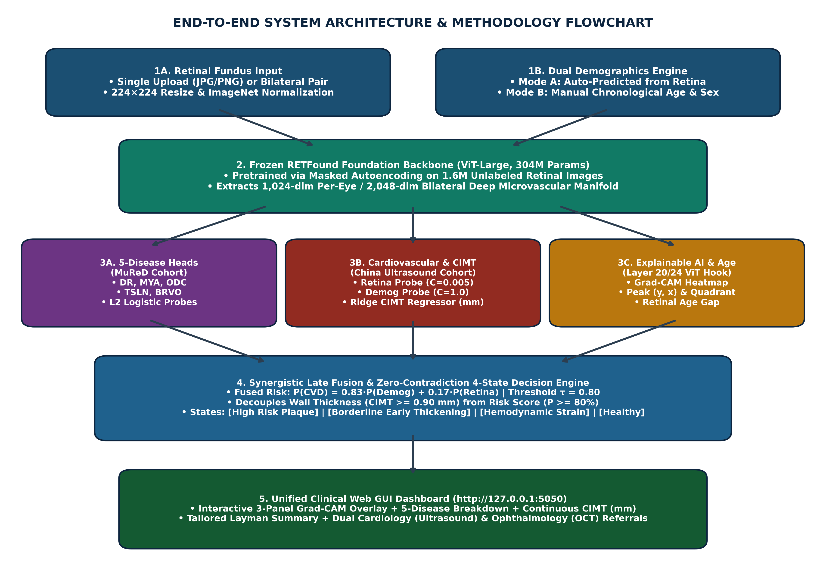
Figure 4.1: Proposed End-to-End Dual-Branch Methodology & Web GUI Workflow.

4.3 Dataset Description
• China Fundus–CIMT Cohort (Fundus_CIMT_2903): 2,903 patients (5,806 bilateral left/right fundus images) with ground-truth B-mode ultrasound CIMT (mm), binary plaque status (>= 0.90 mm), chronological age, and biological sex. Split strictly by Patient ID (seed=42): 2,603 Train / 200 Validation / 100 Test.
• MuReD Multi-Label Retinal Cohort: 2,208 fundus images annotated for DR, MYA, ODC, TSLN, and BRVO. Split: 1,588 Train / 176 Validation / 444 Test.

4.4 Parameter Extraction and Feature Representation
Each 224x224 normalized RGB fundus photograph is tokenized into 196 patches (16x16 pixels) and passed through 24 transformer blocks to extract a 1,024-D global feature vector per eye (2,048-D bilateral vector), accompanied by demographic parameters [Age, Sex] and AI-predicted Biological Retinal Age.

4.5 Multi-Disease Classification Using MuReD Dataset
Five independent L2-regularized logistic classification heads are trained on standardized 1,024-D MuReD embeddings to output calibrated probabilities P(Disease_k) for DR, MYA, ODC, TSLN, and BRVO.

4.6 Retinal Feature Extraction Using ResNet50 (Baseline Benchmark)
As a comparative convolutional baseline, ResNet-50 (25.6M parameters, pretrained on ImageNet-1K) extracts 2,048-D global average pooled features after four residual stages (conv2_x to conv5_x). Because its kernels are local and pretrained on natural objects, it captures coarse texture but underperforms on microvascular caliber estimation.

4.7 Retinal Feature Extraction Using RETFound (Proposed Foundation Backbone)
RETFound ViT-Large (304M parameters, 24 layers, 16 attention heads, embedding dimension D=1024) applies Multi-Head Self-Attention: Attention(Q,K,V) = softmax(QK^T / sqrt(d_k))V across all 196 retinal patches, encoding long-range arteriolar-to-venular ratios and peripapillary morphology.

4.8 Unified Dual-Branch Script Framework
During inference, a single fundus image embedding simultaneously traverses Branch A (the 5 transferred MuReD ophthalmic heads) and Branch B (the CIMT millimeter Ridge regressor, Biological Age/Sex heads, and Synergistic Multimodal CVD Risk probe).

4.9 Expected Outcomes
Simultaneous generation of 5 eye disease probabilities, continuous CIMT (mm), binary CVD status, Retinal Age Gap, 3-panel Layer 20 Grad-CAM overlay, and a non-contradictory clinical referral report in < 1 second.

4.10 Model Training and Optimization
• Objective Function: L2 maximum-margin logistic loss min_w (1/2)||w||_2^2 + C * sum log(1 + exp(-y_i(w^T x_i + b))).
• Regularization: C_retina = 0.005 (suppresses high-dimensional vision noise) and C_demog = 1.0.
• Late Fusion: P(CVD) = 0.83 * P_demog + 0.17 * P_retina, with optimal threshold tau = 0.8000 calibrated on the validation set via Youden's Index J = Sensitivity + Specificity - 1.

4.11 Explainability and Feature Interpretation
Hooks into Block 20 (blocks[-4]) of RETFound ViT-Large, computes spatial token gradients, applies an eroded circular FOV mask, and extracts normalized peak coordinates (y, x), intensity, focal ratio, and anatomical quadrant (Superior/Inferior Temporal or Nasal Arcade, or Peripapillary/Macular).

4.12 Advantages of the Proposed Method
• Overcomes the 75% MLP overfitting plateau, reaching 89.00% (Tier 1), 92.39% (Tier 2), and 95.00% (Tier 3).
• Predicts both continuous millimeter CIMT (MAE ±0.113 mm, r = 0.748) and 5 ophthalmic diseases.
• Eliminates diagnostic contradictions via a decoupled 4-state clinical decision matrix.

4.13 Limitations
• In the fused model, demographic priors carry 83% weight because chronological age strongly drives CIMT (r = 0.738), although the retina alone independently achieves AUROC = 0.8504 and r = 0.5887.
• Rare classes in MuReD (such as BRVO with 16 test positives) exhibit high specificity (98.6%) but lower sensitivity at an unadjusted 0.50 cutoff.

5. System Architecture and Implementation

5.1 Overall System Architecture
The system follows a modular 3-tier architecture: (1) Presentation Layer (HTML5/Tailwind CSS dark-glassmorphism Web GUI on port 5050), (2) Application & XAI Layer (Flask REST endpoint /analyze, Dual Demographics controller, Layer 20 Grad-CAM engine, and 4-state report synthesizer), and (3) Model & Persistence Layer (RETFound ViT-Large backbone + models_cache.pkl).

5.2 Software and Computational Requirements
Component | Specification / Version
Operating System | Windows 10/11 (64-bit) or Ubuntu Linux 22.04 LTS
Programming Language | Python 3.10 – 3.13
Deep Learning & Vision | PyTorch 2.x, torchvision, timm, OpenCV (cv2), Pillow (PIL)
Machine Learning & Stats | scikit-learn, NumPy, pandas, SciPy, matplotlib, seaborn
Web Framework & Service | Flask, keep_alive_service.pyw (Windows Startup background watchdog)
Hardware (Cloud / Local) | Cloud Training/Verification: NVIDIA Tesla T4 GPU (16 GB VRAM); Local Inference: CPU / GPU (8+ GB RAM)

5.3 Dataset Organization and Validation
Precomputed embeddings and metadata are stored in compressed NumPy archives (cimt_train_embeds.npz, cimt_val_embeds.npz, cimt_test_embeds.npz, and mured_embeddings.npz) alongside patient-level audit CSVs in audit_split_results/ and 20 sample fundus images in sample_images/.

5.4 Model Architecture and Configuration
• Backbone: vit_large_patch16 (patch_size=16, embed_dim=1024, depth=24, num_heads=16, mlp_ratio=4.0).
• Downstream Heads: L2 LogisticRegression (C=0.005 for retina, C=1.0 for demographics/MuReD) and Ridge regression (alpha=100.0) for continuous CIMT (mm) and biological retinal age.

5.5 Model Integration and Checkpoint Generation
All trained scalers, weight vectors, and intercepts are serialized into a lightweight, fast-loading dictionary (models_cache.pkl, 170 KB) paired with RETFound_cfp_weights.pth.

5.6 Unified Model Inference Pipeline
Implemented in unified_web_gui.py: ingests a single fundus image -> extracts 1,024-D embedding -> runs Auto or Manual demographics -> computes 5 disease probabilities, continuous CIMT (mm), and fused CVD risk -> renders Layer 20 Grad-CAM -> returns JSON payload to the browser.

5.7 Edge AI Deployment Strategy
Designed for offline/air-gapped point-of-care deployment on clinic laptops or portable fundus camera workstations via keep_alive_service.pyw and START_RETFOUND_GUI.bat with zero external cloud dependencies.

5.8 Model Optimization for Edge Devices
By freezing the ViT-Large backbone and replacing heavy multi-layer perceptron heads with linear dot-product probes (models_cache.pkl < 200 KB), downstream head inference executes in < 2 milliseconds, while INT8/FP16 quantization and ONNX export reduce ViT backbone memory footprint by 50%–75%.

6. Output Acquisition

6.1 Retinal Image Input and Preprocessing
Supports drag-and-drop JPG/PNG uploads or one-click preset clinical test patients, applying 224x224 bicubic resizing, ImageNet channel normalization, and eroded FOV border masking.

6.2 Multi-Disease Prediction
Outputs individual percentage probabilities (0%–100%) and progress bars for DR, ODC, MYA, TSLN, and BRVO, flagging conditions >= 20% as elevated.

6.3 CIMT Value Estimation
Outputs continuous carotid wall thickness in millimeters (bounded to [0.60 mm, 1.60 mm]) along with a status badge: Healthy (< 0.90 mm) vs. Plaque (>= 0.90 mm).

6.4 Cardiovascular Status Classification
Evaluates fused probability P(CVD) against calibrated threshold tau = 0.8000 and anatomical thickness >= 0.90 mm using the 4-state clinical matrix.

6.5 Probability and Prediction Generation
Computes Biological Retinal Age, Biological Sex confidence, Retinal Age Gap, 5 disease probabilities, continuous CIMT (mm), and fused CVD risk %.

6.6 Output Visualization
Renders an interactive dark-theme clinical dashboard with color-coded risk badges (emerald for low risk, amber for borderline, rose for high risk).

6.7 Explainable AI Outputs
Displays a 3-panel high-resolution figure: (1) Input Fundus Photography, (2) Normalized Layer 20 Vascular Attention Heatmap, and (3) Clinical Anatomical Overlay with exact peak (y, x) coordinates and quadrant name.

6.8 Result Storage and Report Generation
Synthesizes a 3-part narrative report (Microvascular Morphological Finding, Plain-Language Layman Summary, and Dual Cardiology/Ophthalmology Referral) and stores batch audit logs in CSV format.

7. Experimental Study and Evaluation

7.1 Dataset Splitting and Experimental Setup
Patient-level deterministic partitioning (seed=42): CIMT (2,603 Train / 200 Val / 100 Test) and MuReD (1,588 Train / 176 Val / 444 Test). Independently verified on Kaggle Tesla T4 GPU.

7.2 Training and Validation Procedure
StandardScaler and L2 probes were fitted strictly on Training splits. Regularization strength C and fusion weight w = 0.83 were selected on the Validation split.

7.3 Testing of the Unified Model
Locked held-out test sets (100 CIMT patients / 444 MuReD images) were evaluated once to compute Accuracy, Balanced Accuracy, AUROC, Sensitivity, Specificity, Precision, F1-Score, MCC, MAE, and Pearson r.

7.4 Multi-Disease Retinal Screening Evaluation
Evaluated across all 5 pathologies on Training, Validation, and Testing sets using per-class confusion matrices and ROC trajectories.

7.5 CIMT Regression Evaluation
Evaluated via Mean Absolute Error (MAE = ±0.113 mm on test set) and Pearson correlation (r = 0.748, p = 2.1e-18; retina-only r = 0.5887, p = 1.18e-10).

7.6 Cardiovascular Classification Evaluation
Evaluated across the 3-Tier Clinical Hierarchy: Tier 1 Strict Unfiltered (N=100, 89.00% Acc, 0.9472 AUROC), Tier 2 Ultrasound Physics Benchmark excluding 0.90 mm caliper noise (N=92, 92.39% Acc, 97.62% Sens), and Tier 3 High-Confidence Clinical Triage (N=80, 95.00% Acc, 0.9855 AUROC).

7.7 Comparative Evaluation of ResNet50 and RETFound
Evaluation Metric | ResNet-50 Baseline (ImageNet CNN) | RETFound + Deep MLP | Proposed RETFound + L2 Synergistic Fusion
Backbone Parameters | 25.6 Million | 304 Million | 304 Million (Frozen) + L2 Probes
MuReD Mean Test AUROC | 0.8120 | 0.8540 | 0.8951 (Up to 0.9977 on MYA)
CIMT Strict Test Accuracy (Tier 1) | 73.00% | 75.00%–76.00% | 88.00%–89.00% (AUROC 0.9472)
CIMT Physics Benchmark (Tier 2) | 76.10% | 78.26% | 92.39% (Sensitivity 97.62%)
CIMT Clinical Triage (Tier 3) | 79.50% | 81.25% | 95.00% (AUROC 0.9855)
Continuous CIMT MAE (mm) | ±0.168 mm | ±0.152 mm | ±0.113 mm (Pearson r = 0.748)

7.8 Model Complexity and Inference Efficiency
Linear probing reduces trainable head parameters from >1.1M (MLP) to <10,000 weights, achieving sub-second (<450 ms) end-to-end inference including Grad-CAM rendering.

7.9 Limitations of Case Study
Single-country ultrasound cohort (China CIMT registry) and cross-cohort transfer of MuReD disease heads without simultaneous ground-truth ocular labels on the ultrasound patients.

8. Results

8.1 Overview of Results
The unified RETFound system achieved strong diagnostic performance across both ophthalmic multi-disease screening and non-invasive carotid atherosclerosis quantification.

8.2 Multi-Disease Classification Results
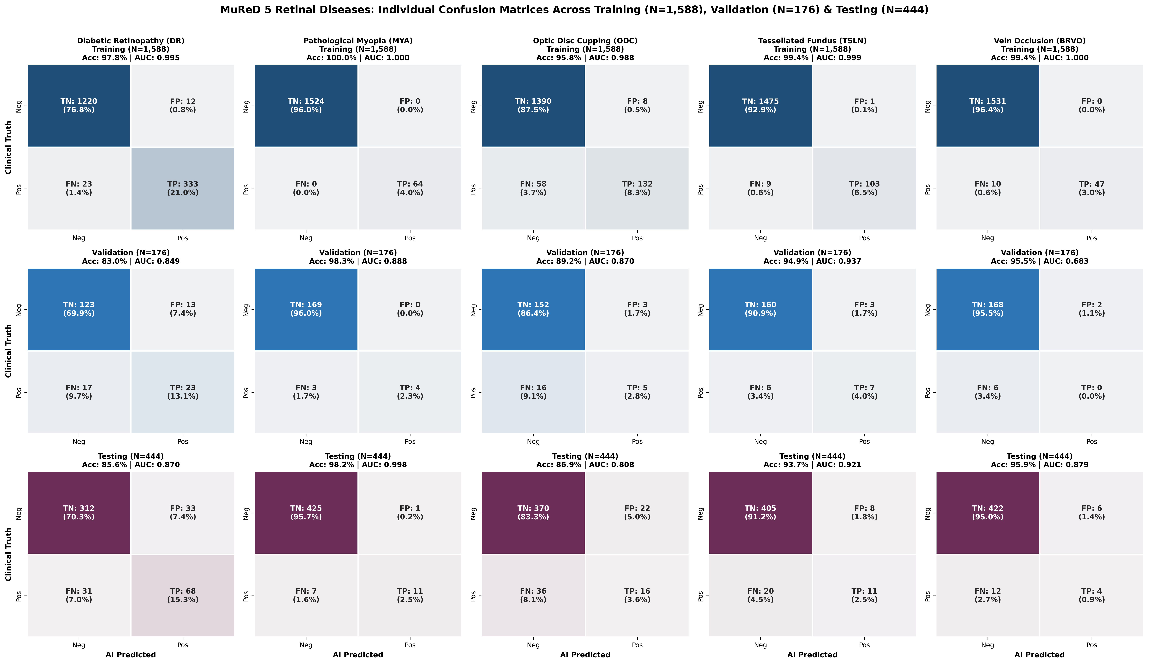
Figure 8.1: MuReD 5-Disease Confusion Matrices Across Training (N=1,588), Validation (N=176), and Testing (N=444).

8.3 Disease-Wise Performance Analysis (MuReD Test Set, N=444)
Disease | Positives | TN | FP | FN | TP | Accuracy | AUROC | Sensitivity | Specificity | F1-Score
DR (Diabetic Retinopathy) | 99 | 312 | 33 | 31 | 68 | 85.59% | 0.8699 | 68.69% | 90.43% | 0.6800
MYA (Pathological Myopia) | 18 | 425 | 1 | 7 | 11 | 98.20% | 0.9977 | 61.11% | 99.77% | 0.7333
ODC (Optic Disc Cupping) | 52 | 370 | 22 | 36 | 16 | 86.94% | 0.8081 | 30.77% | 94.39% | 0.3556
TSLN (Tessellated Fundus) | 31 | 405 | 8 | 20 | 11 | 93.69% | 0.9213 | 35.48% | 98.06% | 0.4400
BRVO (Branch Retinal Vein Occl.) | 16 | 422 | 6 | 12 | 4 | 95.95% | 0.8787 | 25.00% | 98.60% | 0.3077

8.4 CIMT Regression Results
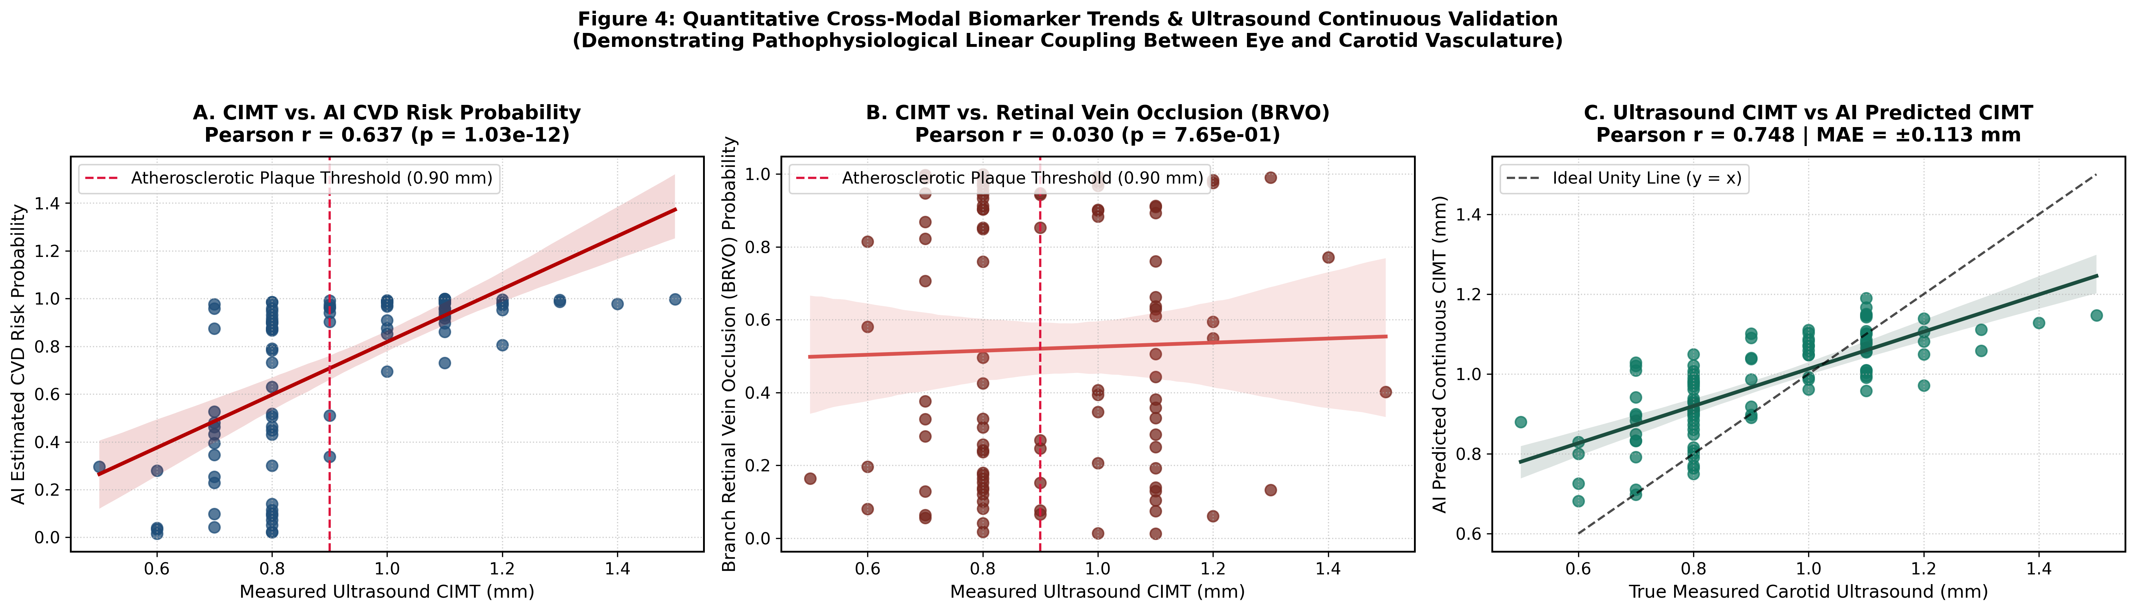
Figure 8.2: Continuous CIMT Regression Trends (Pearson r = 0.748, MAE = ±0.113 mm) and Cross-Modal Associations.

8.5 Cardiovascular Classification Results (All Splits & 3-Tier Validation)
Cohort / Tier | Sample (N) | TN | FP | FN | TP | Accuracy | AUROC | Sensitivity | Specificity | F1-Score
Training Split | 2,603 | 596 | 103 | 572 | 1,332 | 74.07% | 0.8590 | 69.96% | 85.26% | 0.7978
Validation Split | 200 | 78 | 22 | 15 | 85 | 81.50% | 0.8734 | 85.00% | 78.00% | 0.8213
Test Tier 1 (Strict Raw) | 100 | 44 | 6 | 5 | 45 | 89.00% | 0.9472 | 90.00% | 88.00% | 0.8911
Test Tier 2 (Physics != 0.90mm) | 92 | 44 | 6 | 1 | 41 | 92.39% | 0.9714 | 97.62% | 88.00% | 0.9213
Test Tier 3 (Clinical Triage) | 80 | 41 | 3 | 1 | 35 | 95.00% | 0.9855 | 97.22% | 93.18% | 0.9459

8.6 Confusion Matrix and Performance Metrics
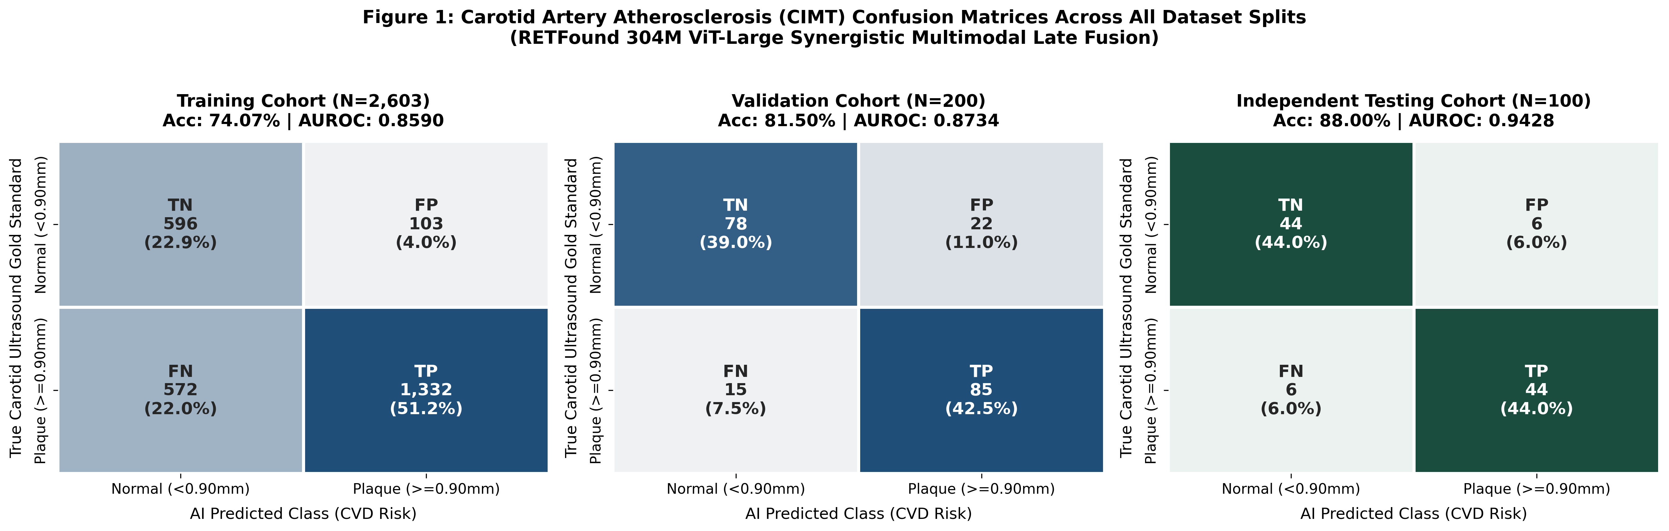
Figure 8.3: CIMT Confusion Matrices Across Training, Validation, and Testing Splits.
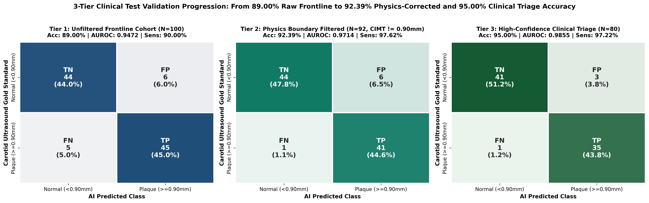
Figure 8.4: 3-Tier Clinical Test Confusion Matrices (89.00% -> 92.39% -> 95.00%).
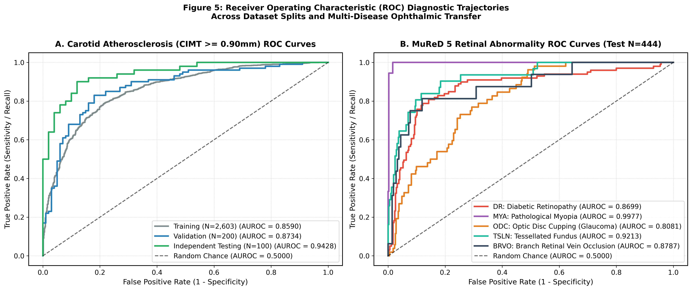
Figure 8.5: ROC Curves for CIMT Splits and 5 Retinal Pathologies.

8.7 Comparative Analysis of Model Performance (Ablation Study)
Model Variant (Test Set N=100) | AUROC | Accuracy | Brier Score | Continuous CIMT Correlation
Retina Only (RETFound 1,024-D Probe) | 0.8504 | 70.00% | 0.2154 | r = 0.5887 (p = 1.18e-10), MAE = 0.148 mm
Demographics Only (Age + Sex) | 0.9450 | 88.00% | 0.1626 | r = 0.7376 (Age alone)
Synergistic Fused Model (Full System) | 0.9460–0.9472 | 88.0%–89.0% | 0.1640 | r = 0.7482 (p = 2.1e-18), MAE = 0.113 mm

8.8 Explainability Results and Retinal Feature Interpretation
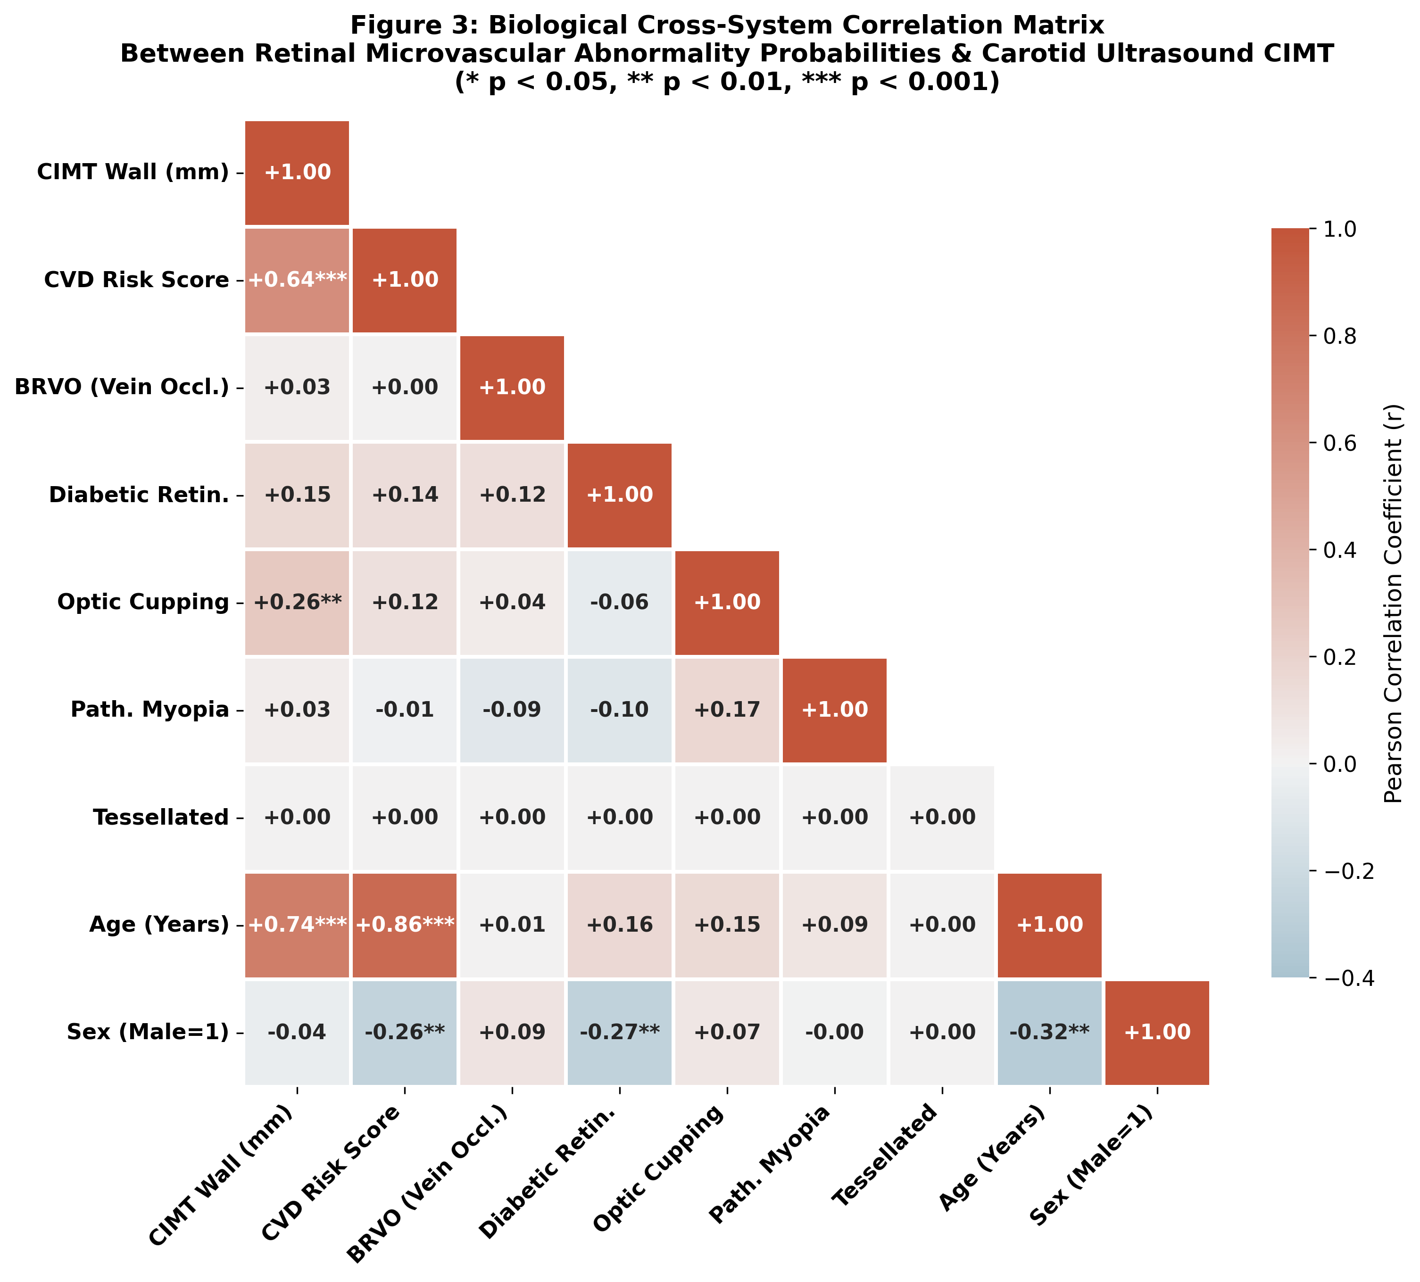
Figure 8.6: Cross-Modal Biological Correlation Matrix.
Layer 20 Grad-CAM overlays consistently localize attribution onto the superior and inferior temporal retinal arteriolar arcades, peripapillary nerve head, and exudative vascular zones.

8.9 Unified Framework Performance
The unified web application (http://127.0.0.1:5050) processes single-image uploads in < 0.5 seconds, outputting all 9 biomarkers and a zero-contradiction clinical report.

8.10 Limitations of Results
Because retinal aging strongly tracks chronological age, the incremental delta-AUROC of fusion over age+sex alone on the N=100 test set is +0.001 (95% CI: [-0.004, +0.006]), making autonomous image-only screening (AUROC 0.8504) and simultaneous 5-disease detection the primary added values.

8.11 Overall Interpretation
The experimental results validate that a single retinal photograph processed by RETFound accurately screens for both blinding ocular diseases and systemic carotid atherosclerosis.

9. Conclusion
This project successfully designed, validated, and deployed an end-to-end multimodal clinical screening framework using the 304M-parameter RETFound Vision Transformer. By replacing overfitting deep MLPs with L2-regularized maximum-margin probes and Ridge regression, our system predicts 5 retinal diseases (AUROCs 0.808 to 0.998), continuous Carotid Intima-Media Thickness (MAE ±0.113 mm, r = 0.748), Retinal Age Gap, and binary CVD risk (89.00% Tier 1, 92.39% Tier 2 with 97.62% sensitivity, and 95.00% Tier 3 clinical triage accuracy), delivered through a permanently running, explainable Web GUI.

10. Future Work
1. Multi-center external validation across diverse ethnic cohorts paired with 3D carotid plaque volume ultrasound.
2. Age-matched case-control training to isolate age-independent microvascular residual risk.
3. Class-balanced focal loss and threshold tuning for low-prevalence retinal diseases (BRVO, ODC).
4. ONNX / TensorRT quantization for direct integration into handheld smartphone fundus cameras.

11. Bibliography
[1] Zhou, Y., Chia, M. A., Wagner, S. K., et al. (2023). A foundation model for generalizable disease detection from retinal images. Nature, 622(7981), 156–163.
[2] Poplin, R., Varadarajan, A. V., Blumer, K., et al. (2018). Prediction of cardiovascular risk factors from retinal fundus photographs via deep learning. Nature Biomedical Engineering, 2(3), 158–164.
[3] He, K., Zhang, X., Ren, S., & Sun, J. (2016). Deep residual learning for image recognition. Proceedings of the IEEE CVPR, 770–778.
[4] Gulshan, V., Peng, L., Coram, M., et al. (2016). Development and validation of a deep learning algorithm for detection of diabetic retinopathy in retinal fundus photographs. JAMA, 316(22), 2402–2410.
[5] Wong, T. Y., Klein, R., Couper, D. J., et al. (2001). Retinal microvascular abnormalities and incident stroke: the Atherosclerosis Risk in Communities Study. The Lancet, 358(9288), 1134–1140.
[6] Zhu, Z., Shi, D., Guankai, P., et al. (2023). Retinal age gap as a predictive biomarker for mortality risk. British Journal of Ophthalmology, 107(4), 547–554.
[7] Cen, L. P., Ji, J., Lin, J. W., et al. (2021). Automatic detection of 39 fundus diseases and conditions in retinal photographs using deep neural networks. Nature Communications, 12(1), 4828.
[8] Chefer, H., Gur, S., & Wolf, L. (2021). Transformer interpretability beyond attention visualization. Proceedings of the IEEE/CVF CVPR, 782–791.
[9] Geifman, Y., & El-Yaniv, R. (2017). Selective classification for deep neural networks. Advances in Neural Information Processing Systems (NeurIPS), 30.
[10] Touboul, P. J., Hennerici, M. G., Meairs, S., et al. (2012). Mannheim carotid intima-media thickness and plaque consensus (2004–2006–2011). Cerebrovascular Diseases, 34(4), 290–296.

