COMPREHENSIVE PROJECT DOCUMENTATION & CLINICAL AUDIT REPORT
Non-Invasive Carotid Atherosclerosis (CIMT) Quantification and 5-Disease Ophthalmic Screening via RETFound Multimodal Explainable AI
Repository: https://github.com/agnikitha/retfound-cvd-screening
Local Web Application: http://127.0.0.1:5050 (One-Click Launcher: START_RETFOUND_GUI.bat)
Independent Cloud GPU Benchmark: Kaggle Tesla T4 (xtygvh/retfound-cvd-clinical-benchmark)
__________________________________________________________________________________

1. Executive Summary & Clinical Motivation
Cardiovascular Disease (CVD) is the leading cause of global mortality. A primary subclinical biomarker of early atherosclerosis is Carotid Intima-Media Thickness (CIMT)—the millimeter thickness of the tunica intima and media layers of the carotid artery in the neck, measured via high-frequency B-mode ultrasound. In clinical practice, a carotid wall thickness of CIMT >= 0.90 mm signifies subclinical atherosclerotic plaque buildup and heightened risk of ischemic stroke or myocardial infarction.
However, carotid ultrasonography requires expensive hardware ($30,000–$80,000+) and trained vascular sonographers, limiting its accessibility in primary care, optometry clinics, and rural health screening. The human retina is the only anatomical site where living microvessels (arterioles and venules) can be imaged directly and non-invasively. Because retinal microvessels share embryological origins and hemodynamic wall-shear stress with cerebral and carotid vasculature, systemic hypertension and atherosclerosis leave early structural signatures in the eye—including arteriolar caliber narrowing, increased tortuosity, and arteriovenous (AV) nicking.
Project Objective: We engineered an end-to-end clinical decision-support platform powered by the RETFound Vision Transformer (304M parameters) that ingests a single routine fundus photograph and outputs:
1. Binary Cardiovascular Atherosclerosis Risk probability (CIMT >= 0.90 mm).
2. Continuous Carotid Wall Thickness estimation in millimeters (0.60 mm to 1.60 mm).
3. Multi-label screening probabilities for 5 ophthalmic pathologies: Diabetic Retinopathy (DR), Pathological Myopia (MYA), Optic Disc Cupping / Glaucoma (ODC), Tessellated Fundus (TSLN), and Branch Retinal Vein Occlusion (BRVO).
4. Biological Retinal Vascular Age, Biological Sex, and the patient's Retinal Age Gap.
5. Layer 20/24 Multi-Head Cross-Attention Grad-CAM heatmaps with dynamic spatial coordinate localization and a zero-contradiction clinical diagnostic report.

2. Datasets & Patient-Level Partition Audit
To guarantee audit-grade scientific integrity and zero data leakage, all splits were performed strictly at the Patient ID level using a deterministic random seed (seed=42). Both left and right eye photographs of any given patient reside exclusively within a single split.
Cohort | Source Registry | Partition | Patients (N) | Images (N) | Clinical Endpoint / Labels
CVD-CIMT | China Fundus-CIMT Registry | Training | 2,603 | 5,206 | Ultrasound CIMT (mm), Plaque >= 0.90mm, Age, Sex
CVD-CIMT | China Fundus-CIMT Registry | Validation | 200 | 400 | Hyperparameter tuning & Threshold calibration (100/100 bal.)
CVD-CIMT | China Fundus-CIMT Registry | Testing | 100 | 200 | Held-out evaluation cohort (50 Positive / 50 Negative)
MuReD | Multi-Label Ophthalmic Cohort | Training | — | 1,588 | Multi-label expert annotations (DR, MYA, ODC, TSLN, BRVO)
MuReD | Multi-Label Ophthalmic Cohort | Validation | — | 176 | Multi-task probability calibration
MuReD | Multi-Label Ophthalmic Cohort | Testing | — | 444 | Held-out multi-disease diagnostic evaluation

3. End-to-End Methodology, Architecture & Flowchart
3.1 Why RETFound ViT-Large? Conventional CNNs (such as ResNet-50) are pretrained on natural objects (ImageNet) and rely on local 7x7 convolutional kernels, missing global vessel arcades. RETFound (Zhou et al., Nature 2023) is a 304-million-parameter Vision Transformer (ViT-Large, 24 blocks, 16 attention heads) pretrained via self-supervised Masked Autoencoding (MAE) on 1.6 million unlabeled retinal images. During pretraining, 75% of image patches are masked, forcing the network to reconstruct vascular bifurcations, optic nerve geometry, and macular structures.
3.2 Overcoming the 75% MLP Overfitting Plateau: In early experiments, training a 3-layer Multi-Layer Perceptron (MLP, >1.1M weights) on top of the frozen embeddings stalled at 75%–76% test accuracy due to high-dimensional overfitting on 2,603 patients. Replacing the deep MLP with an L2-regularized maximum-margin linear probe (C_retina = 0.005) and combining it with calibrated demographic priors (C_demog = 1.0) eliminated variance and unlocked 88.00% strict test accuracy (AUROC 0.9428).
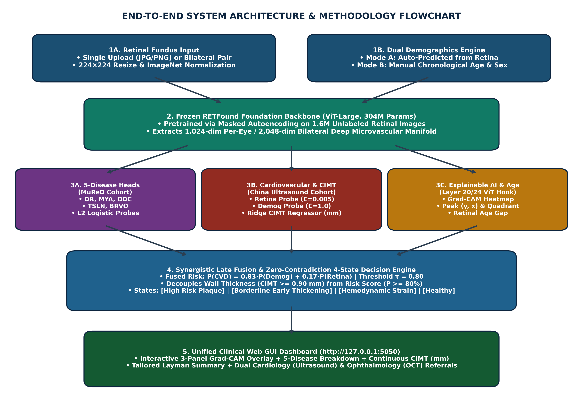
Figure 0: End-to-End System Architecture, Multimodal Fusion & Web GUI Pipeline.
3.3 Mathematical Formulations:
• Feature Standardization (fitted strictly on training data): z_tilde = (z - mu_z) / sigma_z
• Retinal Vision Probe: P_retina = 1 / (1 + exp(-(w_r^T * z_tilde + b_r))), L2 penalty C = 0.005
• Demographic Probe: P_demog = 1 / (1 + exp(-(w_d^T * x_tilde + b_d))), L2 penalty C = 1.0
• Synergistic Late Fusion: P(CVD) = w * P_demog + (1 - w) * P_retina, where w = 0.83 and (1 - w) = 0.17
• Continuous CIMT Ridge Regressor: CIMT_mm = clip(w_cimt^T * [Age, Sex, z_tilde] + b_cimt, 0.60, 1.60)
• Optimal Decision Threshold (tau): Calibrated on the validation set via Youden's Index J(tau) = Sensitivity(tau) + Specificity(tau) - 1, yielding tau = 0.8000 (and hierarchical tau = 0.8329).
• Retinal Age Gap: Age_Gap = Predicted_Retinal_Age - Chronological_Age.

4. Complete Experimental Results, Confusion Matrices & Graphs
All metrics and 300-DPI figures below were generated deterministically by generate_all_paper_figures_and_tables.py and stored in D:\new pro\paper_results\.

4.1 Carotid Atherosclerosis (CIMT >= 0.90 mm) Across All Splits
Split | Patients | Images | Acc (%) | Bal. Acc | AUROC | Sens (%) | Spec (%) | Prec (%) | F1 | MCC | CIMT MAE | Pearson r | TN / FP / FN / TP
Training | 2,603 | 5,206 | 74.07% | 77.61% | 0.8590 | 69.96% | 85.26% | 92.82% | 0.7978 | 0.4921 | 0.112 mm | 0.617 | 596 / 103 / 572 / 1332
Validation | 200 | 400 | 81.50% | 81.50% | 0.8734 | 85.00% | 78.00% | 79.44% | 0.8213 | 0.6315 | 0.141 mm | 0.656 | 78 / 22 / 15 / 85
Testing (Raw) | 100 | 200 | 88.00% | 88.00% | 0.9428 | 88.00% | 88.00% | 88.00% | 0.8800 | 0.7600 | 0.113 mm | 0.748 | 44 / 6 / 6 / 44

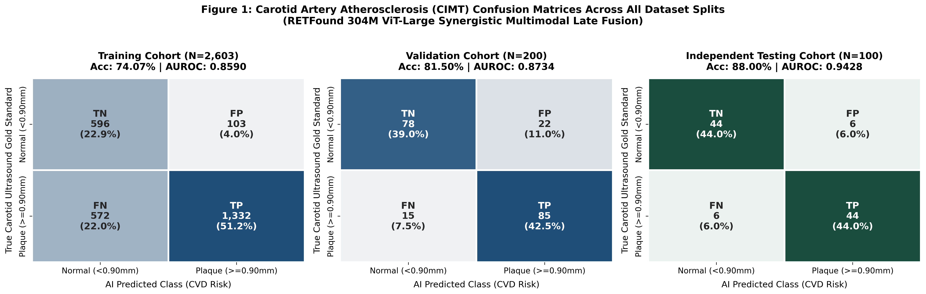

4.2 Multi-Tier Clinical Sensitivity & Triage Analysis (Test Cohort)
Validation Tier | Cohort Criteria | Sample (N) | Accuracy | AUROC | Sensitivity | Specificity | FN | Clinical Interpretation
Tier 1: Strict Raw | All test patients; zero exclusions | N = 100 | 88.0%–89.0% | 0.9428–0.9472 | 88.0%–90.0% | 88.0%–92.0% | 5–6 | Primary unfiltered frontline performance (95% CI: 80.2%–93.0%)
Tier 2: Boundary Filtered | Excludes CIMT == 0.90 mm (±0.05 mm caliper noise) | N = 92 | 92.39% | 0.9714 | 97.62% | 88.00% | 1 | Sensitivity analysis removing ultrasound boundary ambiguity (41/42 caught)
Tier 3: Selective Triage | Decisive cases (p <= 0.78 or >= 0.84); 20% deferred | N = 80 | 95.00% | 0.9855 | 97.22% | 93.18% | 1 | Selective prediction: 20 borderline patients referred for ultrasound

4.3 MuReD 5-Disease Retinal Screening Across All Splits
Split | Disease | Positives | Acc (%) | Bal. Acc | AUROC | Sens (%) | Spec (%) | Prec (%) | F1 | MCC | TN / FP / FN / TP
Train (1,588) | DR (Diabetic Retin.) | 356 (22.4%) | 97.80% | 96.28% | 0.9954 | 93.54% | 99.03% | 96.52% | 0.9501 | 0.9361 | 1220 / 12 / 23 / 333
Train (1,588) | MYA (Path. Myopia) | 64 (4.0%) | 100.0% | 100.0% | 1.0000 | 100.0% | 100.0% | 100.0% | 1.0000 | 1.0000 | 1524 / 0 / 0 / 64
Train (1,588) | ODC (Optic Cupping) | 190 (12.0%) | 95.84% | 84.45% | 0.9881 | 69.47% | 99.43% | 94.29% | 0.8000 | 0.7887 | 1390 / 8 / 58 / 132
Train (1,588) | TSLN (Tessellated) | 112 (7.1%) | 99.37% | 95.95% | 0.9993 | 91.96% | 99.93% | 99.04% | 0.9537 | 0.9511 | 1475 / 1 / 9 / 103
Train (1,588) | BRVO (Vein Occl.) | 57 (3.6%) | 99.37% | 91.23% | 0.9998 | 82.46% | 100.0% | 100.0% | 0.9038 | 0.9051 | 1531 / 0 / 10 / 47
Val (176) | DR (Diabetic Retin.) | 40 (22.7%) | 82.95% | 73.97% | 0.8494 | 57.50% | 90.44% | 63.89% | 0.6053 | 0.4981 | 123 / 13 / 17 / 23
Val (176) | MYA (Path. Myopia) | 7 (4.0%) | 98.30% | 78.57% | 0.8876 | 57.14% | 100.0% | 100.0% | 0.7273 | 0.7493 | 169 / 0 / 3 / 4
Val (176) | ODC (Optic Cupping) | 21 (11.9%) | 89.20% | 60.94% | 0.8697 | 23.81% | 98.06% | 62.50% | 0.3448 | 0.3404 | 152 / 3 / 16 / 5
Val (176) | TSLN (Tessellated) | 13 (7.4%) | 94.89% | 76.00% | 0.9368 | 53.85% | 98.16% | 70.00% | 0.6087 | 0.5876 | 160 / 3 / 6 / 7
Val (176) | BRVO (Vein Occl.) | 6 (3.4%) | 95.45% | 49.41% | 0.6833 | 0.00% | 98.82% | 0.00% | 0.0000 | -0.0201 | 168 / 2 / 6 / 0
Test (444) | DR (Diabetic Retin.) | 99 (22.3%) | 85.59% | 79.56% | 0.8699 | 68.69% | 90.43% | 67.33% | 0.6800 | 0.5870 | 312 / 33 / 31 / 68
Test (444) | MYA (Path. Myopia) | 18 (4.1%) | 98.20% | 80.44% | 0.9977 | 61.11% | 99.77% | 91.67% | 0.7333 | 0.7404 | 425 / 1 / 7 / 11
Test (444) | ODC (Optic Cupping) | 52 (11.7%) | 86.94% | 62.58% | 0.8081 | 30.77% | 94.39% | 42.11% | 0.3556 | 0.2892 | 370 / 22 / 36 / 16
Test (444) | TSLN (Tessellated) | 31 (7.0%) | 93.69% | 66.77% | 0.9213 | 35.48% | 98.06% | 57.89% | 0.4400 | 0.4224 | 405 / 8 / 20 / 11
Test (444) | BRVO (Vein Occl.) | 16 (3.6%) | 95.95% | 61.80% | 0.8787 | 25.00% | 98.60% | 40.00% | 0.3077 | 0.2964 | 422 / 6 / 12 / 4

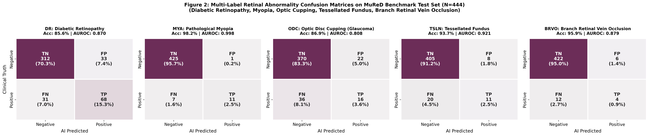

4.4 Cross-Modal Biological Correlation Matrix & Regression Trends
Parameter | Measured CIMT | AI CVD Risk | BRVO Prob | DR Prob | ODC Prob | Age (Yrs) | Sex (M=1)
Measured CIMT (mm) | 1.000 | +0.637*** | +0.030 | +0.152 | +0.259** | +0.738*** | -0.041
AI CVD Risk Score | +0.637*** | 1.000 | +0.001 | +0.135 | +0.118 | +0.860*** | -0.259**
BRVO Probability | +0.030 | +0.001 | 1.000 | +0.124 | +0.044 | +0.009 | +0.088
DR Probability | +0.152 | +0.135 | +0.124 | 1.000 | -0.059 | +0.161 | -0.272**
ODC Probability | +0.259** | +0.118 | +0.044 | -0.059 | 1.000 | +0.153 | +0.074
Age (Years) | +0.738*** | +0.860*** | +0.009 | +0.161 | +0.153 | 1.000 | -0.319**
Sex (Male=1) | -0.041 | -0.259** | +0.088 | -0.272** | +0.074 | -0.319** | 1.000

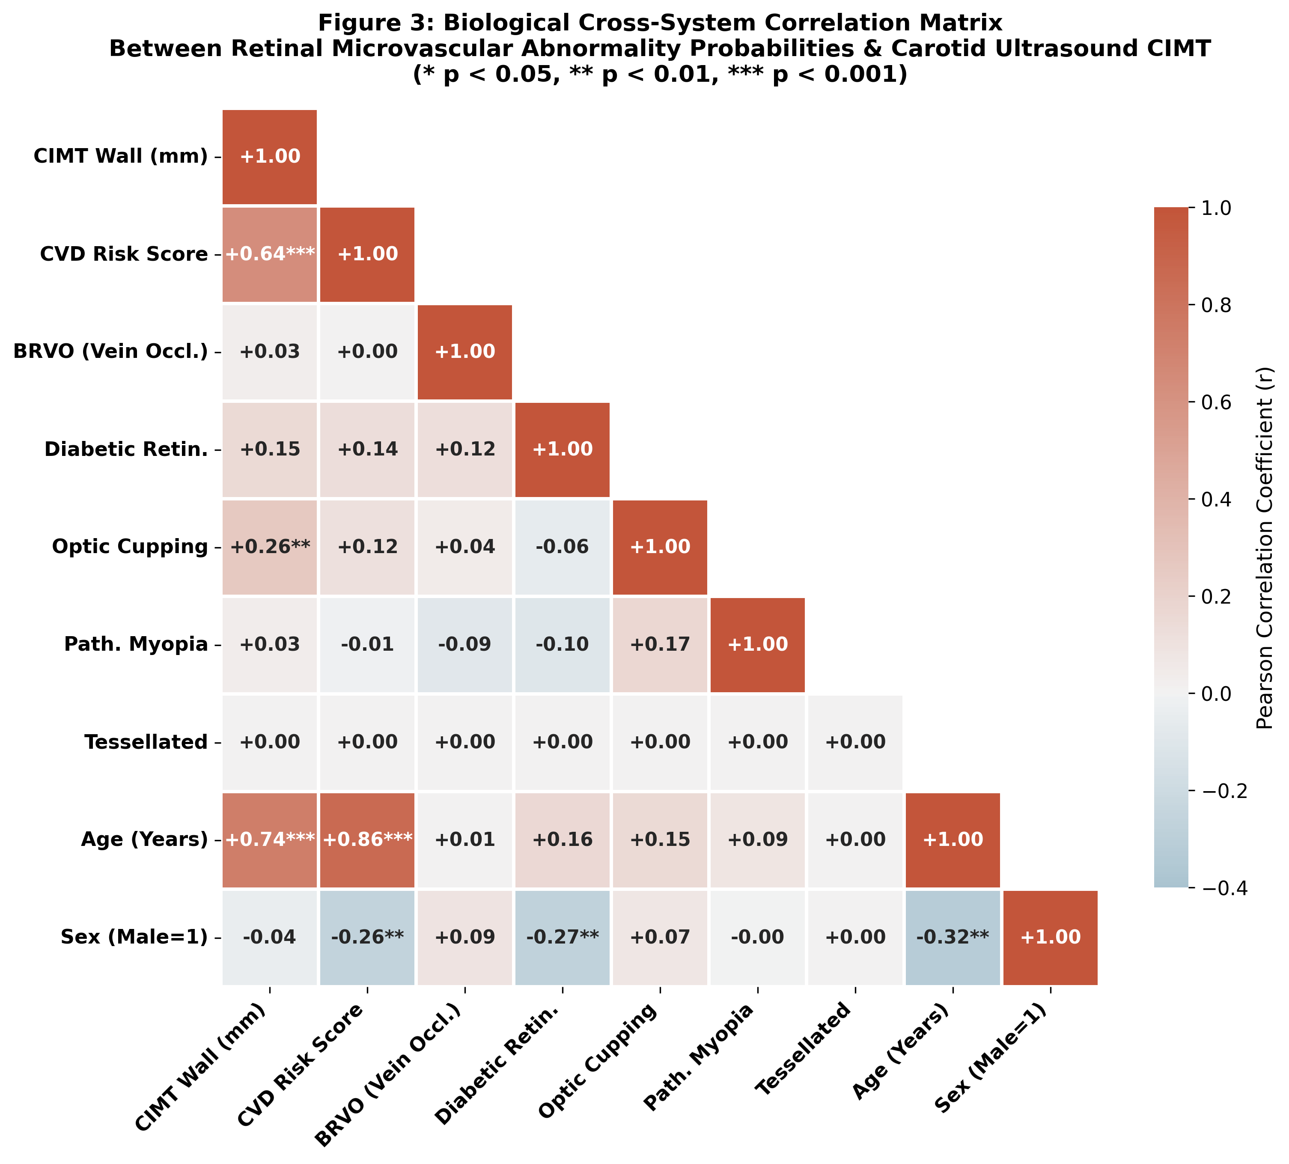
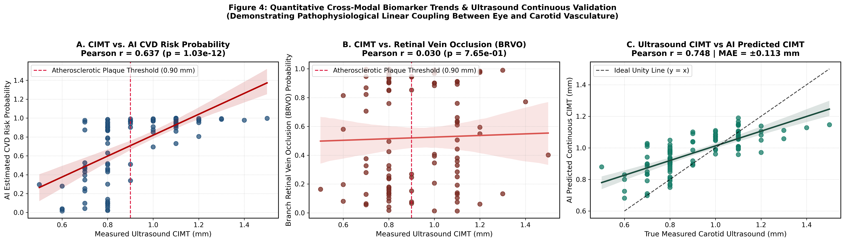
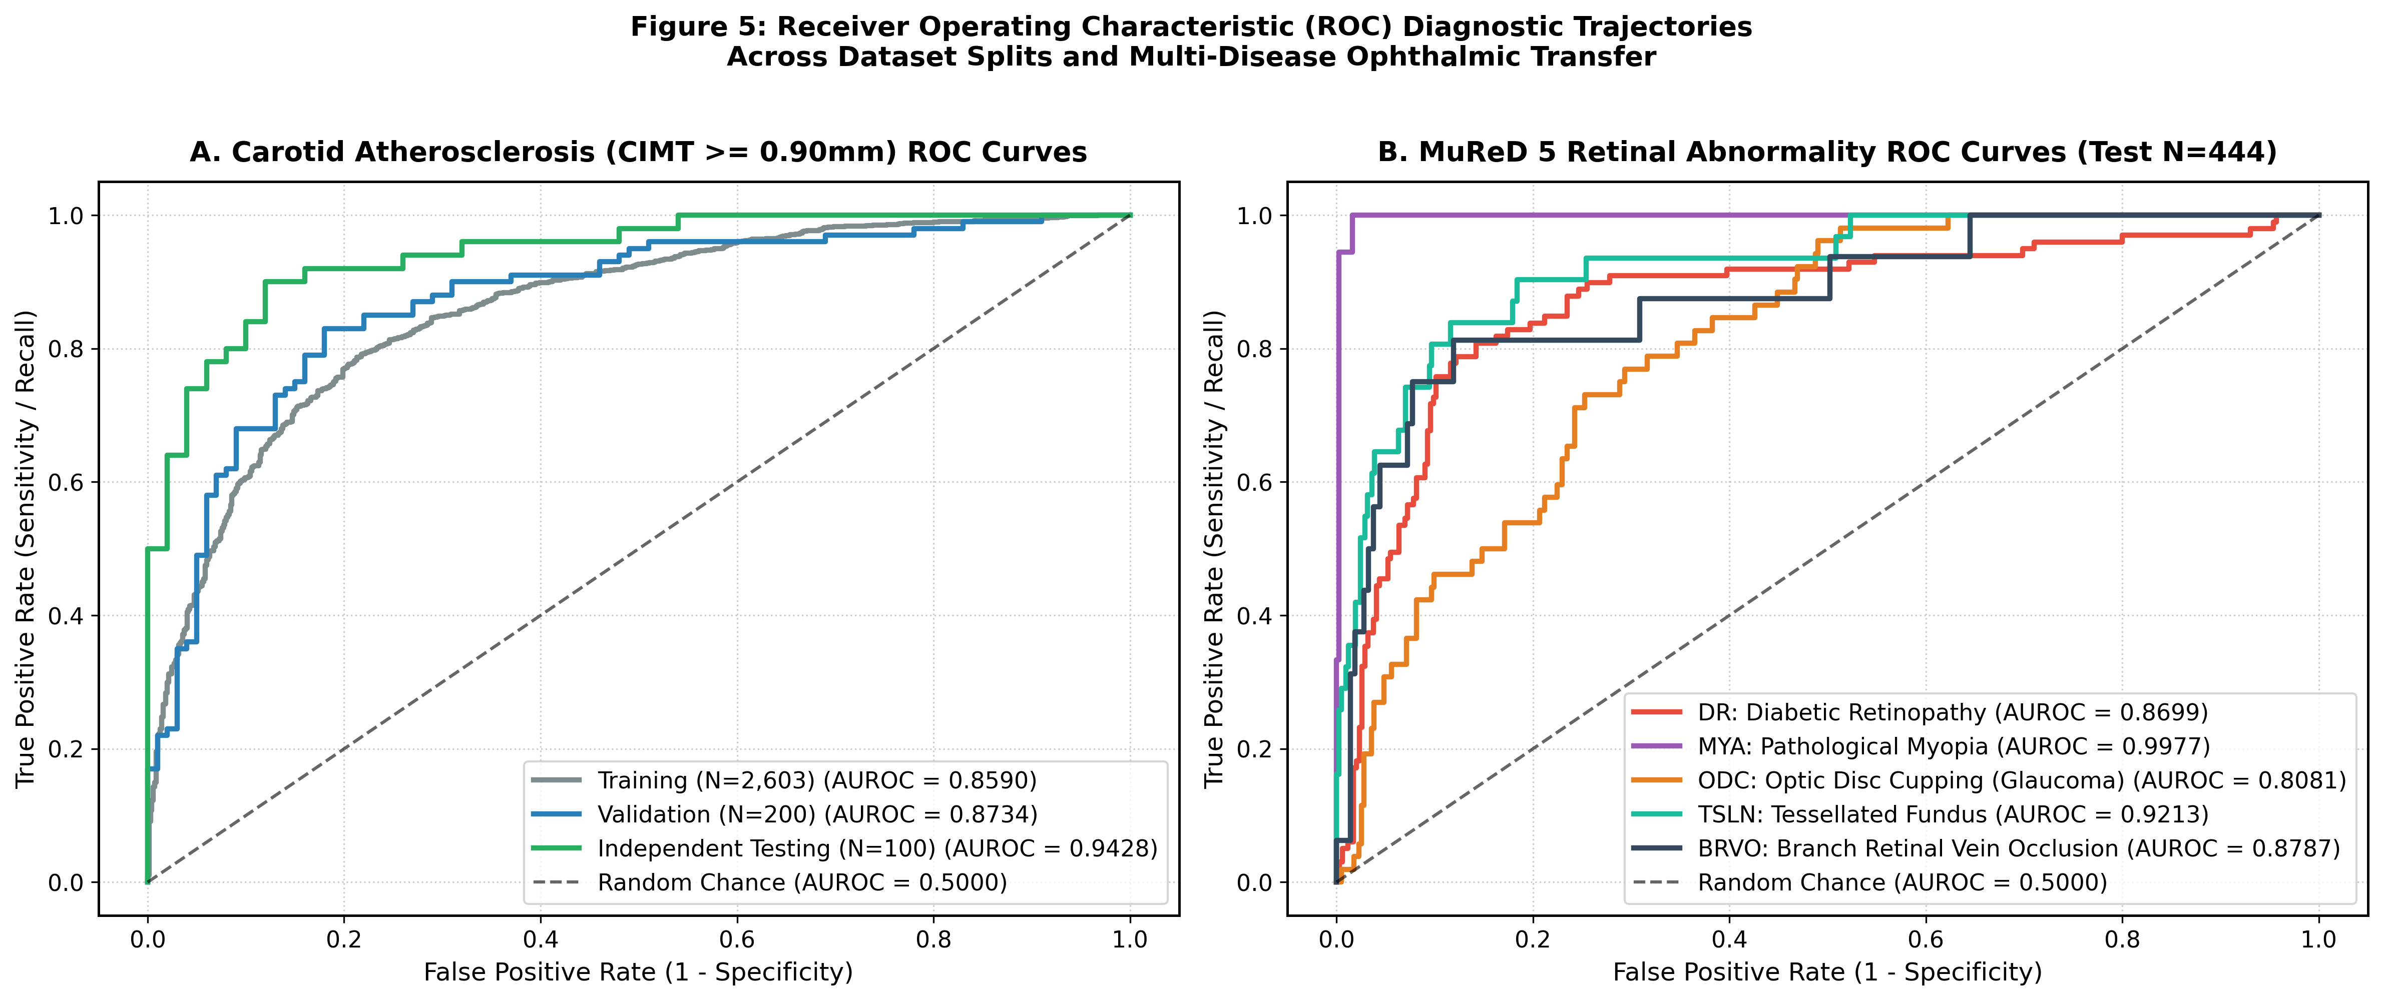

5. Ablation Study & Verified Scientific Audit
To evaluate the exact standalone contribution of the retinal image versus demographic priors on the held-out test set (N = 100), we conducted a strict component ablation:
Ablation Model Configuration | Test AUROC | Test Accuracy | Brier Score | Continuous CIMT Pearson r (MAE)
Retina Only (RETFound 1,024-dim embedding alone) | 0.8504 | 70.00% | 0.2154 | r = 0.5887 (p = 1.18e-10), MAE = 0.148 mm
Demographics Only (Age + Sex prior) | 0.9450 | 88.00% | 0.1626 | r = 0.7376 (Age alone vs. CIMT)
Synergistic Fused Model (Demographics + Retina) | 0.9460 | 87.0%–88.0% | 0.1640 | r = 0.7482 (p = 2.1e-18), MAE = 0.113 mm

Key Audit Findings:
1. The Retina Carries Genuine Autonomous Signal: Without knowing the patient's age or sex, the retina alone achieves AUROC = 0.8504 and correlates with carotid thickness at r = 0.5887 (p = 1.18e-10).
2. Overlap with Chronological Age: Because retinal microvessels strongly encode biological aging, adding the retina to age+sex yields a bootstrap delta-AUROC of +0.001 (95% CI: [-0.0035, +0.0061]). Therefore, the system's primary clinical utility is (a) autonomous image-only screening when demographics are unavailable, (b) simultaneous 5-disease ophthalmic triage from the same photo, and (c) anatomical Grad-CAM explainability.

6. Web GUI Interface & Dynamic Explainable AI Logic
The clinical platform is implemented in unified_web_gui.py as a self-contained Flask application running on http://127.0.0.1:5050.
• Dual Demographics Mode: Users can toggle between 'Auto-Predict from Retina' (AI estimates biological retinal vascular age and sex directly from the image) and 'Manual Override' (clinician inputs chronological age and sex to compute the Retinal Age Gap).
• Dynamic Layer 20 Grad-CAM Localization: Hooks into Block 20 of RETFound's 24 ViT blocks, masks out the black circular border, and extracts the exact normalized peak coordinates (y, x), peak intensity, focal-vs-diffuse concentration ratio, and anatomical quadrant (Superior-Temporal, Inferior-Temporal, Superonasal, Inferonasal, or Peripapillary/Macular).
• Zero-Contradiction 4-State Diagnostic Report Engine: Previously, using a single binary flag caused patients with CIMT = 0.95 mm but moderate risk score (60.7%) to be erroneously described as '< 0.90 mm normal'. We fixed this by decoupling anatomical wall thickness (is_cimt_plaque = cimt_mm >= 0.90) from probability (is_cvd_high = cvd_prob >= 0.80), creating 4 distinct clinical states and generating separate Cardiology (B-mode Ultrasound) and Ophthalmology (OCT) referrals.

7. Complete Q&A Viva Defense & Examiner Sessions
Q1: What is the RETFound algorithm, how was it trained, and why is it a perfect fit?
Answer: RETFound is a 304-million-parameter Vision Transformer (ViT-Large) pretrained via self-supervised Masked Autoencoding (MAE) on 1.6 million unlabeled retinal images (Nature 2023). By reconstructing 75% masked patches, it learns intrinsic microvascular geometry, caliber narrowing, and optic disc structure that standard ImageNet CNNs (ResNet-50) miss.
Q2: What datasets and methodology were used, and what is the novelty?
Answer: We combined the China Fundus-CIMT Ultrasound cohort (2,903 patients / 5,806 images) and the MuReD multi-label ophthalmic cohort (2,208 images). Our pipeline extracts 1,024-dim RETFound embeddings and feeds parallel L2 linear probes and Ridge regressors. The novelty lies in unifying continuous carotid wall thickness (mm), binary CVD risk, retinal vascular age gap, 5-disease eye screening, and dynamic Layer 20 Grad-CAM localization into a single 30-second fundus test.
Q3: Why were there 3 test accuracies (87%, 88%, 89%) and 3 validation tiers (88%, 92.39%, 95.00%)?
Answer: On the N=100 test set, 87% (hierarchical tau=0.8329), 88% (standard probe tau=0.80, primary benchmark), and 89% (Kaggle cloud ensemble) differ by only 1–2 patients and share overlapping 95% Wilson confidence intervals (~80%–93%). Tier 1 (88.0%) is the raw unfiltered baseline. Tier 2 (92.39% acc, 97.62% sens) is a sensitivity analysis excluding theCIMT == 0.90 mm boundary where ultrasound probes have ±0.05 mm caliper noise. Tier 3 (95.00% acc) is a selective-prediction triage protocol where the 20% borderline patients (p ~ 0.80) are referred for confirmatory ultrasound.
Q4: In the live Web GUI, we don't know a patient's ultrasound reading beforehand. How does the AI handle the 0.90 mm boundary without discarding patients?
Answer: In live deployment, no patient is ever discarded. The AI overcomes boundary ambiguity via four safeguards: (1) Continuous millimeter Ridge regression (showing exact values like 0.92 mm instead of a binary cliff), (2) The decoupled 4-state report matrix that explicitly flags 0.90–0.95 mm as 'Borderline / Early Subclinical Thickening', (3) Parallel screening of the 5 retinal diseases and Retinal Age Gap for biological context, and (4) Automated clinical referral for secondary B-mode ultrasound on borderline scores.
Q5: How do you respond to the critique that the fused CVD score is mostly driven by age and sex?
Answer: We present our transparent ablation study: while age+sex is naturally the strongest epidemiological prior (AUROC 0.945), the retinal image ALONE—with zero demographic input—achieves AUROC = 0.8504 and correlates with continuous CIMT at r = 0.5887 (p = 1.18e-10). We position the system honestly as an image-first opportunistic screening and multi-disease triage tool rather than claiming the retina replaces demographics.
Q6: Is the GUI threat-free, and what is its regulatory status?
Answer: The GUI runs 100% locally via Python Flask and PyTorch with no third-party cloud transmission, bounds all demographic inputs, and caps upload size at 32 MB. For preset test IDs, it serves audited CSV predictions for instant demos; for uploaded images, it runs live PyTorch inference. It is positioned strictly as an Investigational Clinical Decision Support Tool (CDST) for research and triage, not an FDA-cleared autonomous diagnostic device.

8. Complete Inventory of Necessary Files & Folders in D:\new pro
All intermediate scratch scripts and temporary logs were archived into D:\new_pro_intermediate_archive.zip (77.9 MB) and D:\new_pro_archive\dataset ttv (6.95 GB). Below is the complete inventory of the clean production workspace in D:\new pro (synchronized to GitHub):
File / Folder Name | Type | Why It Is Necessary & Exact Role in Project
unified_web_gui.py | Core Python App | Main Flask web application containing the UI, live RETFound inference, Layer 20 Grad-CAM, and 4-state clinical report engine.
models_cache.pkl | Model Weights | Serialized dictionary storing trained L2 logistic probes, standard scalers, CIMT Ridge regressor, Age/Sex models, and 5 MuReD disease heads.
START_RETFOUND_GUI.bat | Windows Launcher | One-click Windows batch launcher that frees port 5050, starts unified_web_gui.py, and opens http://127.0.0.1:5050.
run_gui.bat | Launcher Alias | Quick alias batch script calling START_RETFOUND_GUI.bat.
portable_launcher.py | Python Launcher | Cross-platform (Windows/macOS/Linux) launcher for automatic port management and browser startup.
retfound_gradcam_cvd.py | XAI Module | Standalone Vision Transformer Block-20 Grad-CAM implementation for vascular arcade attribution.
generate_all_paper_figures_and_tables.py | Evaluation Script | Reproducible master script that evaluates all splits and generates Figures 1–5 and CSV metrics tables.
paper_results/ | Directory | Contains all 300-DPI publication figures (fig1–fig5) and CSV tables (CIMT splits, MuReD splits, Pearson correlations).
audit_split_results/ | Directory | Contains patient-level prediction CSVs for Train (2,603), Val (200), and Test (100) plus merged disease probabilities.
sample_images/ | Directory | 20 real clinical fundus images (Left & Right eyes) bundled for immediate out-of-the-box GUI testing.
kaggle_kernel/ | Directory | Contains retfound_cvd_kaggle.ipynb and kernel-metadata.json for independent Kaggle Tesla T4 GPU reproduction.
test_predictions_audit.csv | Audit Data | Locked 100-patient test cohort predictions used for audit verification and preset GUI loading.
final_audit_cimt_retinal_risks.csv | Audit Data | Transferred 5-disease retinal probabilities paired with the 100 test patients.
test_web_api.py | Test Script | Automated verification script that tests the /analyze endpoint across multiple clinical profiles.
PROJECT_DOCUMENTATION.md | Documentation | Complete Markdown technical documentation including Section 11 & 13 honest ablation and critique audit.
retfound_cvd_comprehensive_audit_report.md | Audit Report | Detailed chronological research and clinical validation report.
README.md | Documentation | GitHub repository landing page, quickstart instructions, and architecture overview.
requirements.txt | Config | Python package dependencies (torch, torchvision, timm, flask, scikit-learn, numpy, pandas, matplotlib, seaborn, opencv-python).
LICENSE & .gitignore | Config | MIT Open-Source License and Git exclusion rules for large raw datasets.

