**A Project Progress Report On Face Recognition**

**Submitted By**

**Agnip Karmakar**

Project Title

THE COMPARATIVE STUDY OF HOG FEATURES AND LBP METHOD IN FACE RECOGNITION SYSTEM



Jalpaiguri Govt. Engg. College

Dept: Computer Science And Engineering

Group No-9

Team Details :

1. Sagar Halder(Group Leader) [12101104033]
2. Agnip Karmakar [12101104001]
3. Arabinda Roy [12101104006]
4. Sayantan Bain [12101104036]
5. Ishan Ghosh [12101104016]

Project Guide :

Prof. Srinibas Rana

**Certificate**

Jalpaiguri Govt. Engg. College

Dept: Computer Science And Engineering

Group No-9

This is to certify that ​***Agnip Karmakar*** of B.Tech Computer Science and engineering have successfully submitted project progress report on **“Face Recognition using LBP and HOG method”** in partial fulfilment of the degree of Bachelor of Technology in Computer Science and Engineering under the guidance of **Prof. Srinibas Rana** from Jalpaiguri Government Engineering College, Jalpaiguri - 735102, West Bengal in the year 2015-16

Signature

**Index:**

1.Problem Definition

2.Objectives

3.Flow Diagram

4.Description Of The proposed Plan

5.Current Status Of The Project

6.Conclusion

7.Bibliography

1. Problem Definition:

1. Many a times different facial expressions can not be determined by the tool properly

2. Sometimes total portion of the face can not be determined by the tool at a time . So as a result, although being the same person sometimes the tool fails to perform in the correct manner.

3. The facial appearance can be categorized into two groups: intrinsic factors and extrinsic ones .

A) Intrinsic factors are due purely to the physical nature of the face and are independent of the observer. These factors can be further divided into two classes: intrapersonal and interpersonal. Intrapersonal factors are responsible for varying the facial appearance of the same person, some examples being age, facial expression and facial paraphernalia (facial hair,glasses, cosmetics, etc.).

B) Extrinsic factors cause the appearance of the face to alter via the interaction of light with the face and the observer. These factors include illumination, pose, scale and imaging parameters (e.g., resolution,focus,imaging,noise etc).

2. Objectives:

1. We want to implement Histogram of oriented Gradients and heterogeneous face recognition method in our system and try to extract face from the HOG method.

2 . We want to make security of any database system more strong with our face recognition system.

3.We want to implement local and global binary pattern to determine different pixel of an image.

3. Flow Diagram:

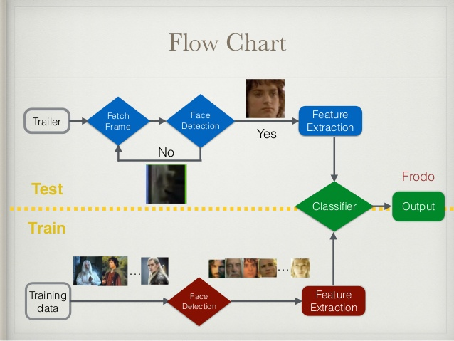

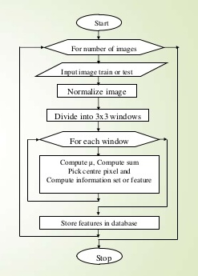

4. Description:

In the beginning of the 1970's, face recognition was treated as a 2D pattern recognition problem [2]. The distances between important points where used to recognize known faces, e.g. measuring the distance between the eyes or other important points or measuring different angles of facial components. But it is necessary that the face recognition systems to be fully automatic. Face recognition is such a challenging yet interesting problem that it has attracted researchers who have different backgrounds: psychology, pattern recognition, neural networks, computer vision, and computer graphics. The following methods are used to face recognition.

1. Holistic Matching Methods

2. Feature-based (structural) Methods

3. Hybrid Methods

1. **Holistic Matching Methods**:

In holistic approach, the complete face region is taken into account input data into face catching system. One of the best example of holistic methods are Eigenfaces [8] (most widely used method for face recognition), Principal Component Analysis, Linear Discriminant Analysis [7] and independent component analysis etc.

2. **Feature-based (structural) Methods**:

In this methodslocal features such as eyes, nose and mouth are first of allextracted and their locations and local statistics (geometric and/or appearance) are fed into a structural classifier. A big challenge for feature extraction methods is feature"restoration", this is when the system tries to retrieve features that are invisible due to large variations, e.g. head Pose when we are matching' a frontal image with a profile image.[5]Distinguishes between three different extraction methods:

I. Generic methods based on edges, lines, and curves

II. Feature-template-based methods

III. Structural matching methods that take into

consideration geometrical Constraints on the features.

3. **Hybrid Methods**:

Hybrid face recognition systems use combination of both holistic and feature extraction methods.Generally 3D Images are used in hybrid methods. The image of a person's face is caught in 3D, allowing the system to note the curves of the eye sockets, for example, or the shapes of the chin or forehead. Even a face in profile would serve because the system uses depth, and an axis of measurement, which gives it enough information to construct a full face. The 3D system usually proceeds thus: Detection, Position,Measurement, Representation and Matching. Detection -Capturing a face either a scanning a photograph or photographing a person's face in real time. Position -Determining the location, size and angle of the head.Measurement - Assigning measurements to each curve of the face to make a template with specific focus on the outside of the eye, the inside of the eye and the angle of the nose.Representation - Converting the template into a code – a numerical representation of the face and Matching -Comparing the received data with faces in the existing database.In Case the 3D image is to be compared with an existing 3D image, it needs to have no alterations. Typically, however,photos that are put in 2D, and in that case, the 3D image need a few changes. This is tricky, and is one of the biggest challenges in the field today

5: Current Status of Project Work :

Currently working on LBP Method and HOG Method.

1. LBP METHOD :

Local binary patterns were introduced by Ojala et al as a fine scale texture descriptor. In its simplest form, an LBP description of a pixel is created by thresholding the values of the 3X3 neighborhood of the pixel against the central pixel and interpreting the result as a binary number[7]. In the LBP operator is generalized by allowing larger

neighborhood radii r and different number of sampling points s. These parameters are indicated by the notation LBP s;r. For example, the original LBP operator with radius of 1 pixel and 8 sampling points is LBP[8].

.

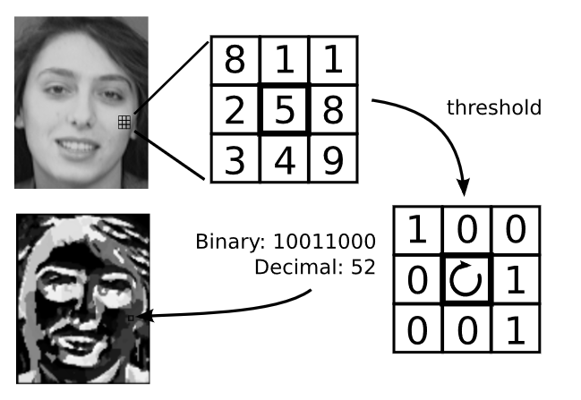

The LBP operator thresholds each pixel against its neighboring

pixels and interprets the result as a binary number

2. HOG Feature Extraction:

1. Compute control horizontal & vertical gradients with no smoothing.

2.Compute gradient orientation and magnitudes.

3.For a 60*128 image.

4.Divide the image 16*16 blocks.

5.Each block should consist of 2*2 with size 8*8.

6.Quantize the gradient orientation into 9 bins/direction.

*The vote is gradient magnitude

*Interpolate votes bi-linearly between neighbouring bin center.

*The vote can also be weighted by Gaussian to downweight the pixels near the edges of the block.

*Concatenate histogram.(feature dimension:105*4*9=3780)

Centered: f $'$ (x)= $\lim_{h→0}{\frac{f\left(x+h\right)-f(x-h)}{2h}}$ filter mask in x and y direction[5].

Centered:

|  |
| --- |
| -1 0 1 |

Gradient: Magnitude: s= (sx2 + sy2)

Orientation: = arctan(sy/sx).

6. Conclusion:

* **Future Plan Of Project:** A world filled with mobile devices capable of instantly recognizing anyone's face can seem both empowering and scary. It's empowering because ordinary consumers can expect to eventually wield such power in their handheld and wearable devices; it's scary because the government, corporations and strangers on the street could use the same devices[3].
* **Now you see me**:

Facial recognition can already identify people with 99 percent accuracy under the best circumstances, Schuepp said. "Best" circumstances for facial-recognition technology mean having an ideal "probe" image and a database of similarly ideal images for comparison[8].

* **Facing problems different way:**

Sunglasses or a profile shot with just one eye visible can frustrate even the best facial-recognition software, but a badly angled photo or video-camera image does not mean all is lost[5]. Schuepp's company, Animetrics, has developed one possible solution while selling facial-recognition technology to U.S. law enforcement and the military for almost a decade[1].

* **Making facial recognition mobile:**

Facial-recognition software can do its work almost instantly in some cases the Animetricsalgorithm takes just 1 second to do the 2D-to-3D image conversion and less than 1 second to search for a particular face among 1 million faces when running on a higher-end laptop[6] .

Bibliography:

[1] DC. He and L. Wang (1990), "Texture Unit, Texture Spectrum, And Texture Analysis", Geoscience and Remote Sensing, IEEE Transactions on, vol. 28, pp. 509 - 512.

[2] L. Wang and DC. He (1990), "Texture Classification Using Texture Spectrum", Pattern Recognition, Vol. 23, No. 8, pp. 905 - 910.

[3] T. Ojala, M. Pietikäinen, and D. Harwood (1994), "Performance evaluation of texture measures with classification based on Kullback discrimination of distributions", Proceedings of the 12th IAPR International Conference on Pattern Recognition (ICPR 1994), vol. 1, pp. 582 - 585.

[4] "An HOG-LBP Human Detector with Partial Occlusion Handling", Xiao Wang, Tony X. Han, Shuicheng Yan, ICCV 2009

[5] Trefný, Jirí, and Jirí Matas."Extended set of local binary patterns for rapid object detection." Proceedings of the Computer Vision Winter Workshop. Vol. 2010. 2010.

[6] Zha, Guoyingo, and Matti Pietikainen. "Dynamic texture recognition using local binary patterns with an application to facial expressions." Pattern Analysis and Machine Intelligence, IEEE Transactions on 29.6 (2007): 915-928.

[7] M. Heikkilä, M. Pietikäinen, "A texture-based method for modeling the background and detecting moving objects", IEEE Transactions on Pattern Analysis and Machine Intelligence, 28(4):657-662, 2006.

[8] C., Kertész: Texture-Based Foreground Detection, International Journal of Signal Processing, Image Processing and Pattern Recognition (IJSIP), Vol. 4, No. 4, 2011.