**README for Code 777**

*Created By Nithin Anand Gangadharan*

Introduction

The game is created using PhoneGap. The game uses JQuery Mobile framework for the User Interface along with a jQuery Mobile Simple Dialog Plugin ([link](http://forum.jquery.com/topic/jquery-mobile-dialog)).

Prerequisites:

**For Development:**

1. A Device with Android 2.2 or above OR an iOS Device.
2. PhoneGap ([link](http://phonegap.com/))
3. jQuery Mobile ([link](http://jquerymobile.com))
4. Simple Dialog Plugin for jQuery Mobile ([link](http://forum.jquery.com/topic/jquery-mobile-dialog)).

**Using jsdoc:**

1. Navigate to the directory containing the jsdoc jar

2. Use

Use java -jar jsrun.jar app\run.js -a -t=templates\jsdoc path\Grid.js

Use java -jar jsrun.jar app\run.js -a -t=templates\jsdoc path\Puzzle.js

where path is the path of the .js files to create jsdoc

Icon image source : <http://www.flickr.com/photos/gccommunication/5266412328/>

Instructions

**Android:**

1. Open Eclipse

2. navigate to .proj

3. Build the project

**iOS:**

1. Open Xcode

2. navigate to TileGame.xcodeproj

3. Build Project and run on simulator

Playing the game

**Game Menu:**

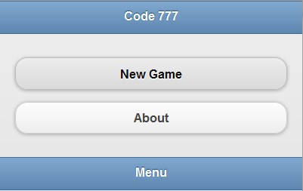

In this page you have 2 buttons

1. Start game: takes you to start game settings.
2. About: displays the information about the author.

**Game Settings Page:**

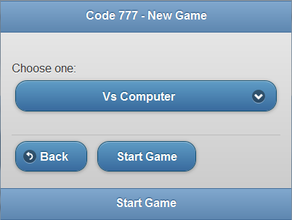

In this page the user has the option to choose the following 3:

1.Single player: starts the single player game. In this mode the player does not have to answer questions.

2.Host a game(Not implemented): The game contacts the webservice and creates a new game.

3.Join game(Not Implemented): The player is presented with a list of games that he can choose to join.

**Main Game Page:**

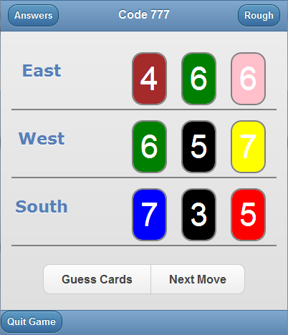

The player is presented with the main board of the game which shows the cards of the other 3 players.

There are 2 buttons on the top:

1. Answers: Takes you to the answers page that displays the questions answered by the players.

2 .Rough Page: Takes you to a Rough page where the player can select or cross out particular cards.

The player can also swipe left or right to navigate to answers or rough page respectively.

There is a button in the footer that takes you back to the new game page.

There are 2 buttons in the bottom of the page:

1. Guess Card: takes you to a page where you can guess your cards

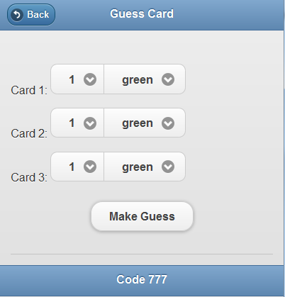

1. Next Move: Moves the game by one step. Usually means one of the opponent player answers a question.

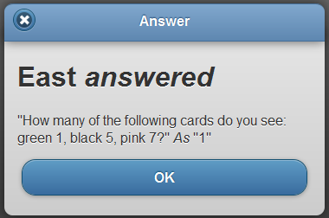

**Answers Page:**

This page displays the questions answered by the players:

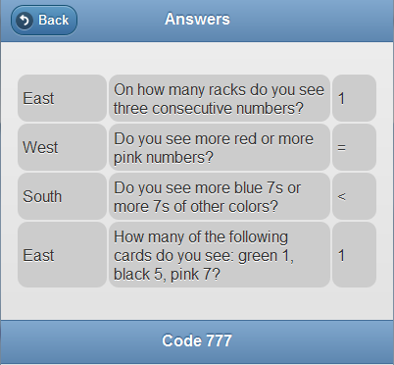

The back button takes you back to main game page.

The player also has the option to swipe left to go back to game page.

**Rough Page:**

Here the player can select or cross out particular cards.

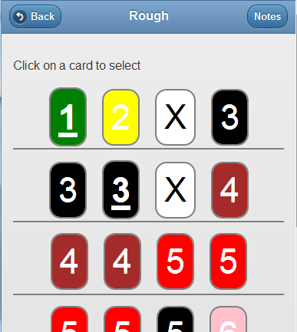

On top of the page there is back button that takes you to game page and a Notes that takes you to the Notes page.

The user can also swipe left or swipe right to go to Notes or game pages respectively

Clicking any card brings up a menu

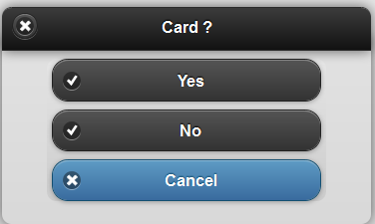

If the player clicks yes, the card is selected and underlined. If the user selects no, the card is crossed out.

Cancel escapes this dialog.

**Notes Page**

A page where the player can take down notes

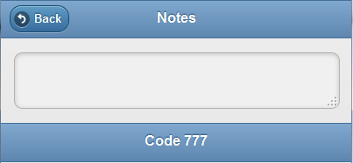

Clicking on the back button takes the user back to rough page.

The player can also swipe right to go back.

Project Files

The project consists of the following files:

Assets/www: root folder for all the phonegap files of the application.

Note: jQuery mobile divides an HTML file into several pages.

HTML

**Index.html :** first page that is loaded. This page displays the game menu with options about the game.

Contains the following pages:

1. Game Menu Page
2. Game Settings Page

**Game.html:** Contains the main game elements. Consists of the following pages.

1. Main game page
2. Answers list page
3. Rough Page
4. Notes page

Javascript

/js/ phonegap-1.2.0.js: PhoneGap library

gameoptions.js: functions used by the main game options page

ajax.js : (not complete) will contain all the ajax calls for multiplayer

/Model folder contains all the models of the game

/Model/card.js: card model

/Model/player.js: player model

/Model/game.js: game model

/Model/question.js question model

/Model/aquestion.js: answered question model

/Model/data.js: all hardcoded data

/Model/deck.js: deck model

/view Folder contains all the js that interacts with the DOM

/view/answerview.js : displays a list of answers

/view/deckview.js : creates a deck for the rough page

/view/dialog.js : function to create a dialog prompt

/view/gameview.js : main view for the game

/Controller Folder contains all the controllers in the game

/controller/main.js : main controller for the game

/jquery Folder contains the jquery library and the Simple dialog plugin

CSS

/css/ folder contains all the style sheets of the game

/css/card.css : css for card

/css/main.css : css for rest of the game

JSDOC

Jsdoc Folder contains all the jsdoc documentation