agniyaakun@gmail.com
+6289603787643 | 
linkedin.com/in/agniyaain | 
Malang, Jawa Timur,Indonesia
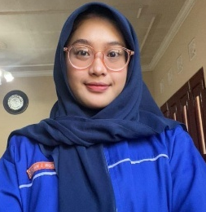
Vocational high school student majoring in Software Engineering with interest in web development. Experienced in building websites using HTML, CSS, JavaScript, PHP, and Bootstrap. Participant of JHIC 2024 as UI/UX Designer and developer of Cluezy e-learning project.
Agniya Rahmah Qurril Ain
Full Stack Web Developer

:: PROFILE ::

Full Name | : Agniya Rahmah Qurril Ain
Place, Date Birth (Ages) | : Batu, 9 July 2008 (17)
Gender | : Female
Religion | : Muslim
Status | : Student
Address | : Malang, Jawa Timur, Indonesia
Phone / WA | : 089603787643

:: EDUCATION ::

PGRI 3 Malang (2024 – Now) – Majoring Software Engineering (RPL)

:: SKILLS ::

Back End | : PHP, Laravel
Front End | : CSS, Javascript, Bootstrap, Ajax
Database | : MySQL
Repository / Versioning | : GitHub
Project Management | : Trello
Design System | : Figma

:: PROJECT EXPERIENCE ::

JHIC Competition 2025
As UI/UX Designer (July 2025 – Now)
- Designed user interface prototypes and improved user experience for a competition project.
- Collaborated with team members to create intuitive and visually appealing layouts.
- Tools : Figma, Canva
E-Learning ‘Cluezy’
Full Stack Web Developer (Aug 2025 – Now )
- Developed a web-based e-learning platform as a final school project.
- Built core features including CRUD Note, Quiz, To-Do List, and Timer.
- Contributed to both frontend and backend development.
- Tech Stack : HTML, CSS/Bootstrap, JavaScript, PHP, MySQL, and AJAX.

:: ADDITIONAL INFORMATION::

:: PREVIEW PROJECT ::

JHIC Competition 2025
As UI/UX Designer (July 2025 – Now)
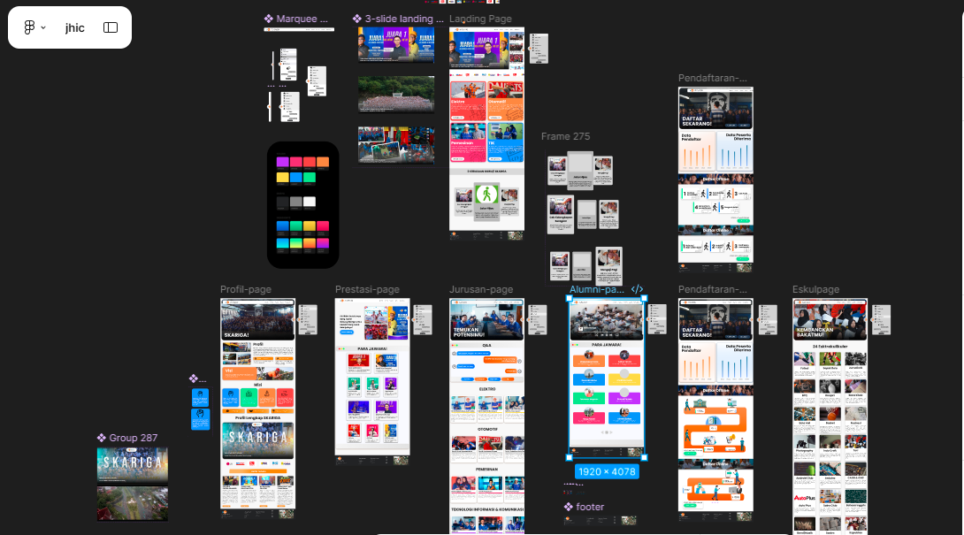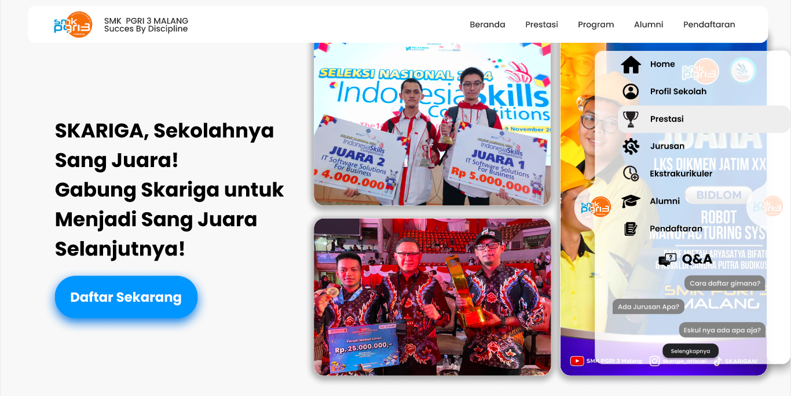

http://bit.ly/timCtrlV

E-Learning ‘Cluezy’
Full Stack Web Developer (Aug 2025 – Now )
