SQL> create table author(author_id number(3),name varchar(25),email varchar(15),phone_no number(15),status varchar(15),primary key(author_id));

Table created.

SQL> describe author;

Name Null? Type

-------------------------------- --------------- ----------------------------

AUTHOR_ID NOT NULL NUMBER(3)

NAME VARCHAR2(25)

EMAIL VARCHAR2(15)

PHONE_NO NUMBER(15)

STATUS VARCHAR2(15)

SQL> create table publisher(publisher_id number(3),name varchar(20),address varchar(50),

primary key(publisher_id));

Table created.

SQL> describe publisher;

Name Null? Type

---------------------------------- -------------- ------------------------

PUBLISHER_ID NOT NULL NUMBER(3)

NAME VARCHAR2(20)

ADDRESS VARCHAR2(50)

SQL> create table member(member_id number(5),name varchar(20),branch_code number(10),roll_no number(5),phone_no number(15),email_id varchar(20),date_of_join varchar(10),status varchar(15),primary key(member_id));

Table created.

SQL> describe member;

Name Null? Type

-------------------------------- --------------- ----------------------------

MEMBER_ID NOT NULL NUMBER(5)

NAME VARCHAR2(20)

BRANCH_CODE NUMBER(10)

ROLL_NO NUMBER(5)

PHONE_NO NUMBER(15)

EMAIL_ID VARCHAR2(20)

DATE_OF_JOIN VARCHAR2(10)

STATUS VARCHAR2(15)

SQL> create table language(language_id number(5),name varchar(20),primary key(language_id));

Table created.

SQL> describe language;

Name Null? Type

----------------------------- ----------------- ----------------------------

LANGUAGE_ID NOT NULL NUMBER(5)

NAME VARCHAR2(20)

SQL> create table book(book_id number(5),title varchar(30),language_id number(5),mrp number(8),publisher_id number(3),published_date varchar(10),volume number(3),status varchar(15),primary key(book_id),foreign key(language_id) references language(language_id),foreign key(publisher_id) references publisher(publisher_id));

Table created.

SQL> describe book;

Name Null? Type

-------------------------------- --------------- ----------------------------

BOOK_ID NOT NULL NUMBER(5)

TITLE VARCHAR2(30)

LANGUAGE_ID NUMBER(5)

MRP NUMBER(8)

PUBLISHER_ID NUMBER(3)

PUBLISHED_DATE VARCHAR2(10)

VOLUME NUMBER(3)

STATUS VARCHAR2(15)

SQL> create table book_author(book_id number(5),author_id number(3),foreign key(book_id) references book(book_id),foreign key(author_id) references author(author_id),primary key(book_id,author_id));

Table created.

SQL> describe book_author;

Name Null? Type

-------------------------------- -------------- -------------------------

BOOK_ID NOT NULL NUMBER(5)

AUTHOR_ID NOT NULL NUMBER(3)

SQL> create table book_issue(issue_id number(5),date_of_issue varchar(15),book_id number(5),member_id number(5),expected_date_of_return varchar(15),foreign key(book_id) references book(book_id),foreign key(member_id) references member(member_id));

Table created.

SQL> describe book_issue;

Name Null? Type

--------------------------------- -------------- ----------------------------

ISSUE_ID NUMBER(5)

DATE_OF_ISSUE VARCHAR2(15)

BOOK_ID NUMBER(5)

MEMBER_ID NUMBER(5)

EXPECTED_DATE_OF_RETURN VARCHAR2(15)

SQL> create table book_return(issue_id number(5),actual_date_of_return varchar(15),

late_days number(4),late_fee number(5),primary key(issue_id),foreign key(issue_id)

references book_return(issue_id));

Table created.

SQL> describe book_return;

Name Null? Type

--------------------------------------- -------------- ---------------------------

ISSUE_ID NOT NULL NUMBER(5)

ACTUAL_DATE_OF_RETURN VARCHAR2(15)

LATE_DAYS NUMBER(4)

LATE_FEE NUMBER(5)

SQL> create table late_fee_rule(from_days number(2),to_days number(4),amount number(8),primary key(to_days,from_days));

Table created.

SQL> describe late_fee_rule;

Name Null? Type

-------------------------------- ---------------- ----------------------------

FROM_DAYS NUMBER(2)

TO_DAYS NUMBER(4)

AMOUNT NUMBER(8)

alter table book add(number_of_pages number(3));

table BOOK altered.

desc book;

Name Null Type

--------------------------- ------------ --------------

BOOK_ID NOT NULL NUMBER(5)

TITLE VARCHAR2(30)

LANGUAGE_ID NUMBER(5)

MRP NUMBER(8)

PUBLISHER_ID NUMBER(3)

PUBLISHED_DATE VARCHAR2(10)

VOLUME NUMBER(3)

STATUS VARCHAR2(15)

NUMBER_OF_PAGES NUMBER(3)

alter table member modify (branch_code varchar(6));

table MEMBER altered.

desc member;

Name Null Type

--------------------- ---------------- ---------------

MEMBER_ID NOT NULL NUMBER(5)

NAME VARCHAR2(20)

BRANCH_CODE VARCHAR2(6)

ROLL_NO NUMBER(5)

PHONE_NO NUMBER(15)

EMAIL_ID VARCHAR2(20)

DATE_OF_JOIN VARCHAR2(10)

STATUS VARCHAR2(15)

insert into language values(01,'English');

1 rows inserted.

insert into language values(02,'Malayalam');

1 rows inserted.

insert into language values(03,'Hindi');

1 rows inserted.

select * from language;

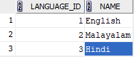

insert into publisher values(01,'DC books','Trivandrum');

1 rows inserted.

insert into publisher values(02,'MP books','Kollam');

1 rows inserted.

insert into publisher values(03,'TK books','Kottayam');

1 rows inserted.

SELECT * FROM publisher;

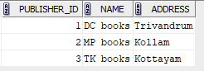

insert into book values(01,'NoteBook',01,120,02,'20-04-2001',1,'active',160);

1 rows inserted.

insert into book values(02,'Aadujeevitham',02,140,03,'11-06-2015',1,'active',180);

1 rows inserted.

insert into book values(03,'Textbook',03,90,01,'01-08-2020',2,'active',90);

1 rows inserted.

select * from book;

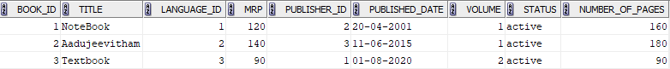

insert into member values(1,'Advait','C05',4,9876098346,'advait@gmail.com','21-06-2020','active');

1 rows inserted.

insert into member values(2,'Ria','C11',36,9676808340,'ria@gmail.com','19-07-2019','in-active');

1 rows inserted.

insert into member values(3,'Chris','A05',4,7876058341,'chris@gmail.com','01-11-2021','active');

1 rows inserted.

select * from member;

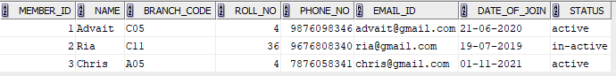

SELECT * FROM USER_CONSTRAINTS WHERE TABLE_NAME ='PUBLISHER';



SELECT * FROM USER_CONSTRAINTS WHERE TABLE_NAME ='BOOK';



ALTER TABLE BOOK DISABLE CONSTRAINT SYS_C0059446;

table BOOK altered.

TRUNCATE TABLE PUBLISHER;

table PUBLISHER truncated.

Select * from publisher;

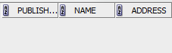

insert into author values(1,'Benchamin','benc@gmail.com',7364920451,'active');

1 rows inserted.

insert into author values(2,'Benyamin','beny@gmail.com',9364520453,'active');

1 rows inserted.

insert into author values(3,'Tom','tom@gmail.com',7335920443,'in-active');

1 rows inserted.

select * from author;

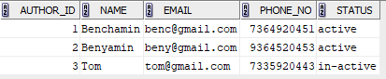

insert into book_author values(1,2);

1 rows inserted.

insert into book_author values(2,3);

1 rows inserted.

insert into book_author values(3,1);\

1 rows inserted.

select * from book_author;

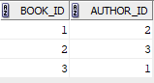

drop table author;

table author dropped;

select * from author;

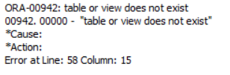

insert into late_fee_rule values('0','15',20);

insert into late_fee_rule values('15','30',50);

insert into late_fee_rule values('30','100',100);

select * from late_fee_rule;

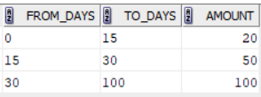

alter table late_fee_rule rename to fine;

table late_fee_rule altered.

select * from fine;

