create table employee(emp_id number(3) primary key,emp_name varchar(50),dept varchar(20),salary number(10));

Table created.

insert into employee values(1,'David Smith','HR',7000);

insert into employee values(2,'Arif','Marketing',9000);

insert into employee values(3,'Charles Brown','Sales',4000);

insert into employee values(4,'Anita','Production',8000);

insert into employee values(5,'Omar','Marketing',3000);

insert into employee values(7,'Daisy','HR',6000);

insert into employee values(8,'Christina','Production',9500);

select * from employee;

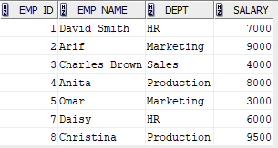

select * from employee where salary>7000;

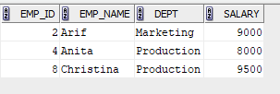

update employee set salary=8200 where emp_name='David Smith';

select * from employee;

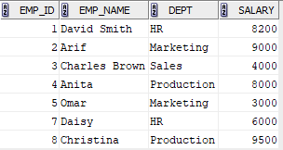

insert into employee values(6,'Daniel Harrris','Production',6700);

select * from employee;

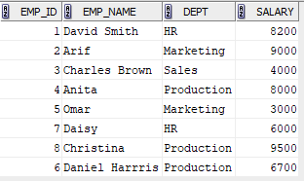

delete from employee where emp_id=3;

select * from employee;

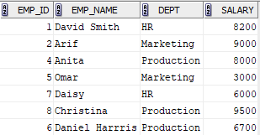

select * from employee where emp_name not like 'D%' and emp_name not like'O%';

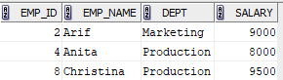

select dept,sum(salary) from employee group by dept;

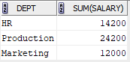

update employee set salary=(salary+(5/100)*(salary)) where dept='Production';

select * from employee;

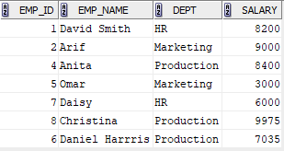

delete from employee where salary<7000;

select * from employee;

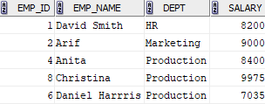

select emp_name,salary from employee where salary=(select min(salary) from employee);



update employee set salary=8200 where dept='Marketing';

select * from employee;

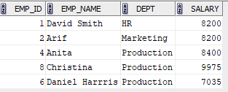

select emp_name from employee where emp_name like 'A%';

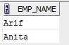

select emp_name from employee where emp_name like '%it%';

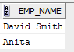

select distinct (upper(dept)) from employee;

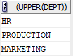

select * from employee where dept like 'M%' and dept like '__r%' and dept like '%ket%';



select distinct reverse((upper(dept))) from employee;

